Bild:
Location Ort: Nieder-Ofleiden, Deutschland
Graphics Grafik: SENNEBOGEN
Editor Autor: Annette Brato
Date Datum: 07/2026

Demolition Excavators at Steinexpo 2026: SENNEBOGEN Showcases Flexible Solutions for Demolition
From September 2 to 5, 2026, SENNEBOGEN will present two demolition machines designed for a variety of demolition requirements at Steinexpo in Homberg/Nieder-Ofleiden. At the SENNEBOGEN outdoor area A39, the 830 E Demolition Vario Tool with Longfront equipment will take center stage. In addition, SENNEBOGEN will showcase the 825 E Demolition at MBI’s booth C15.
Trade visitors will gain practical insight into the SENNEBOGEN demolition product portfolio at the Mitteldeutsche Hartstein-Industrie quarry. The focus is on flexible equipment concepts, high stability, precise operation, and efficient construction site logistics.

What demands does modern demolition place on demolition machinery?
Demolition companies often need to perform multiple tasks with a single machine on construction sites: demolition at greater heights, selective demolition, sorting, material handling, and earthwork. At the same time, short setup times, simple transport processes, and high machine utilization are crucial for cost-effective operations.
At Steinexpo 2026, SENNEBOGEN will demonstrate how robust demolition excavators with variable attachments help carry out various demolition tasks efficiently and precisely.

How does the 830 E Demolition Vario Tool support larger demolition projects?
At the SENNEBOGEN booth (A39), visitors can experience the 830 E Demolition Vario Tool as a multifunctional demolition excavator for demanding demolition work. The machine’s design allows for quick switching between three boom variants:
- two-piece boom variant with a 17 m bolt height
- three-piece Longfront configuration with a 23 m bolt height
- earthmoving configuration with a 12 m reach
The hydraulic quick-coupler for the booms enables rapid adaptation to varying job site requirements. This allows a single base machine to handle multiple work steps that would otherwise require additional machines.
For demolition contractors, this can reduce investment and operating costs, minimize logistical effort, and improve the utilization rate of the machine in use. Especially for larger demolition projects, the 830 E Demolition Vario Tool thus offers a flexible solution for changing project phases.
Schlüter Baumaschinen, a long-standing SENNEBOGEN sales and service partner, complements the exhibit at the booth with attachments from NPK, including a concrete breaker, hydraulic hammer, and sorting grapple.

825 E Demolition for Selective Demolition and Confined Construction Sites
At MBI’s booth C15, SENNEBOGEN is going to present the 825 E Demolition. The 38-ton demolition excavator is designed for selective demolition, sorting work, and operations on confined construction sites.
With a 14-meter reach and high maneuverability, the machine is particularly well-suited for typical demolition tasks on inner-city construction sites. The telescoping crawler track ensures high stability during demanding operations.
Another advantage is its rapid deployment without additional setup effort. The hydraulically retractable counterweight allows for transport without a special permit. The equipment does not need to be dismantled for this purpose, so the machine can be transported in one piece on a flatbed trailer.

SENNEBOGEN at Steinexpo 2026 in Nieder-Ofleiden
SENNEBOGEN will be exhibiting at Steinexpo 2026 in the quarry of Mitteldeutsche Hartstein-Industrie in Homberg/Nieder-Ofleiden.
- Exhibition dates: September 2–5, 2026
- SENNEBOGEN booth number: A39
- Additional exhibit: SENNEBOGEN 825 E Demolition at MBI’s booth C15
- Machines on display: SENNEBOGEN 830 E Demolition Vario Tool and SENNEBOGEN 825 E Demolition
- Key applications: precise demolition, selective demolition, sorting operations, and flexible construction site logistics

Captions:
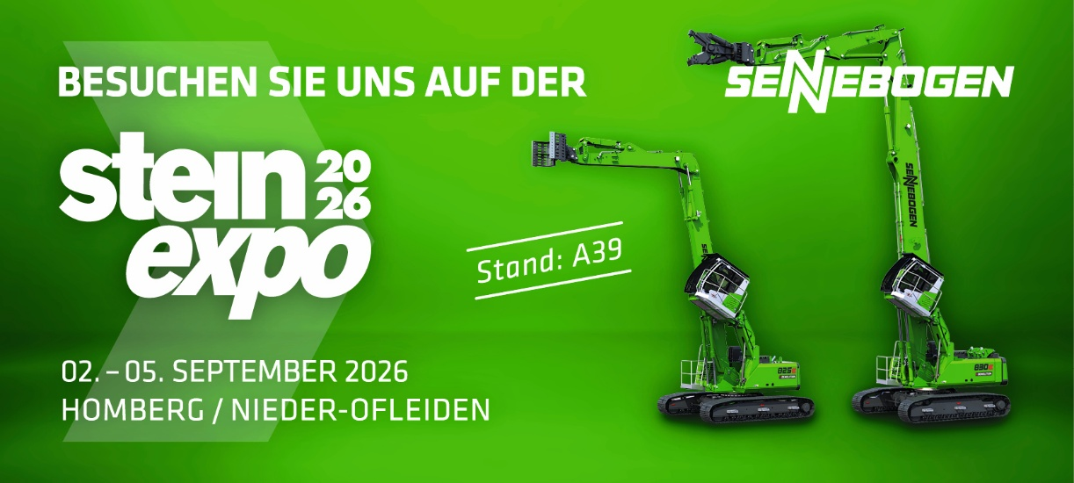

Image 1: At booth A39, SENNEBOGEN is going to showcase its 830 E Demolition Vario Tool demolition excavator with Longfront equipment, as well as the 825 E Demolition at MBI’s booth C15.

