Bild:
Photos Fotos: Louwers Media
Location Ort: Belgium
Product Marketing Manager Scrap & Recycling
Editor Autor: Luc Ophals, Lisa-Maria Heigl
Date Datum: 04/2026

End-of-Life Vehicle Recycling with Powerhand: Precise Dismantling with the SENNEBOGEN 821 E
Efficiently recycling end-of-life vehicles, recovering valuable materials, and reducing manual labor: At Recycar in Belgium, daily operations are consistently focused on achieving the highest possible recycling rate. Since 2025, the company has relied on a combination of performance, precision, and flexibility provided by the SENNEBOGEN 821 E and a Powerhand system.
Key Figures at a Glance
Operational Structure | Two locations: Châtelet in Belgium and Auto2000 in Boussois, France
Annual Volume | Approximately 2,500 vehicles in Châtelet and about 3,000 to 4,000 vehicles in Boussois
Daily Throughput | Approximately 50 vehicles per day
Recovery Rate | Up to 98 percent
Maintenance Intervals | Up to 4,000 operating hours
What are the requirements for end-of-life vehicle dismantling?
Recycar has specialized in the oil removal and dismantling of end-of-life vehicles since 1993 and is part of the Comet Group. At its Châtelet facility in Belgium, the company processes approximately 2,500 vehicles annually. Its French facility, Auto2000 in Boussois, processes an additional 3,000 to 4,000 vehicles.
The recycling process begins with the removal of all operating fluids, as well as batteries, tires, particulate filters, and oil filters. Intact body and mechanical components are resold as used parts. Only then is the degreased body sent to the shredder facility in Obourg, where the materials it contains are recovered. Recycar thus achieves a recycling rate of up to 98 percent.
“We go far beyond simply collecting, de-oiling, and dismantling end-of-life vehicles. Within the Comet Group, the vehicles undergo a comprehensive recycling process,” explains Maxime Grosjean, Managing Director of Recycar.

SENNEBOGEN 821 E and Powerhand System as a Solution
To separate materials and components more precisely, Recycar 2025 invested in a SENNEBOGEN 821 E through its partner SMT. The machine previously used, equipped with a simple grab, was primarily used for loading and unloading. The new material handling machine, on the other hand, is directly integrated into the dismantling process. Equipped with the Powerhand system, the SENNEBOGEN 821 E precisely removes engines, cables, starters, catalytic converters, axles, shock absorbers, and differentials from vehicles. This enables Recycar to selectively separate recyclable components and significantly reduce heavy, time-consuming manual sorting work.
“Our previous machine, equipped with a simple grab, could mainly be used for loading and unloading. With the new SENNEBOGEN, we can selectively separate the recyclable materials from one another,” reports Grosjean.
How does the machine support operations at two locations?
Thanks to its rugged tires, the mobile material handling machine moves flexibly around the facility. In addition to dismantling, the SENNEBOGEN 821 E also loads trucks and semi-trucks. Depending on the volume of vehicles, the machine can be moved between Châtelet and Boussois to wherever it is currently needed.
“Since the machine is mobile, I can easily move it from one location to another depending on deliveries and the number of vehicles. Today, we can process around 50 vehicles per day,” explains Grosjean.
Performance, Operating Costs, and Operator Comfort
For SMT, too, the combination of performance, durability, and precision was a decisive factor.
“For Recycar, we were looking for a machine that is powerful, mobile, robust, and at the same time extremely precise. We chose the SENNEBOGEN 821 E with the Powerhand system. It is the first machine of this type in Belgium,” says Dirk Philippe, Account Manager at SMT.
In addition to its high performance, the 821 E impresses with low operating costs, low fuel consumption, and reduced noise levels. The comfortable MaxCab offers the operator excellent all-around visibility, supported by modern camera systems. Ease of maintenance also plays an important role in daily operation: Maintenance intervals are up to 4,000 operating hours
What results does Recycar achieve in its day-to-day operations?
About 50 vehicles per day, a recycling rate of up to 98 percent, and significantly less manual sorting work: Since 2025, the SENNEBOGEN 821 E has been supporting Recycar at full capacity in recovering as much value as possible from every end-of-life vehicle.

Captions
Header image: SENNEBOGEN 821 E with the Powerhand system being used to dismantle end-of-life vehicles at the Recycar facility.
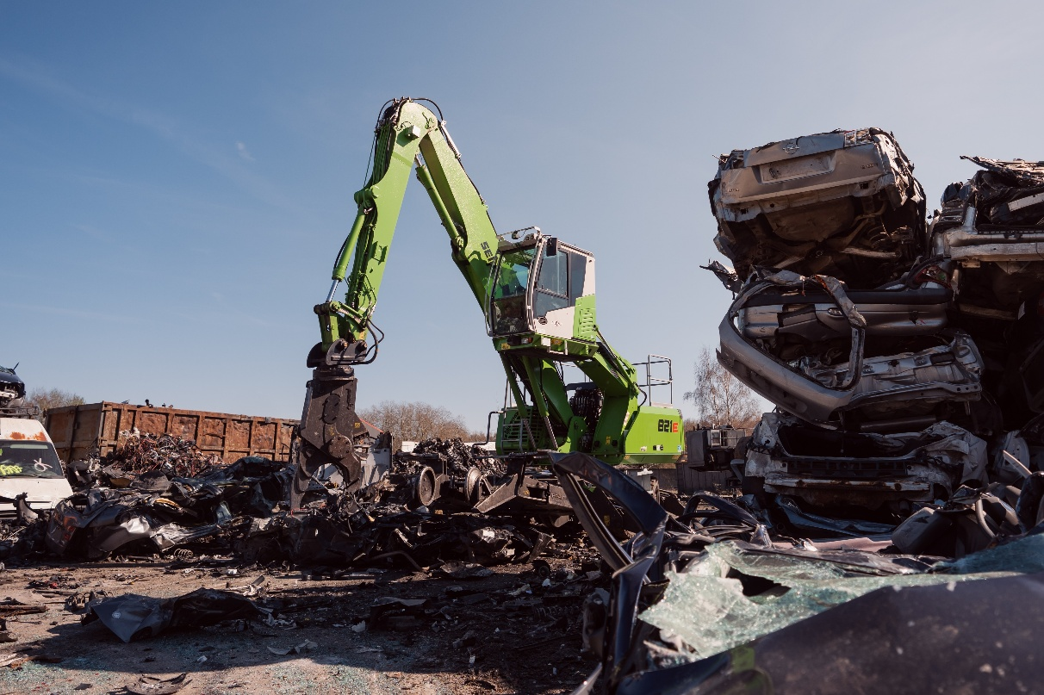

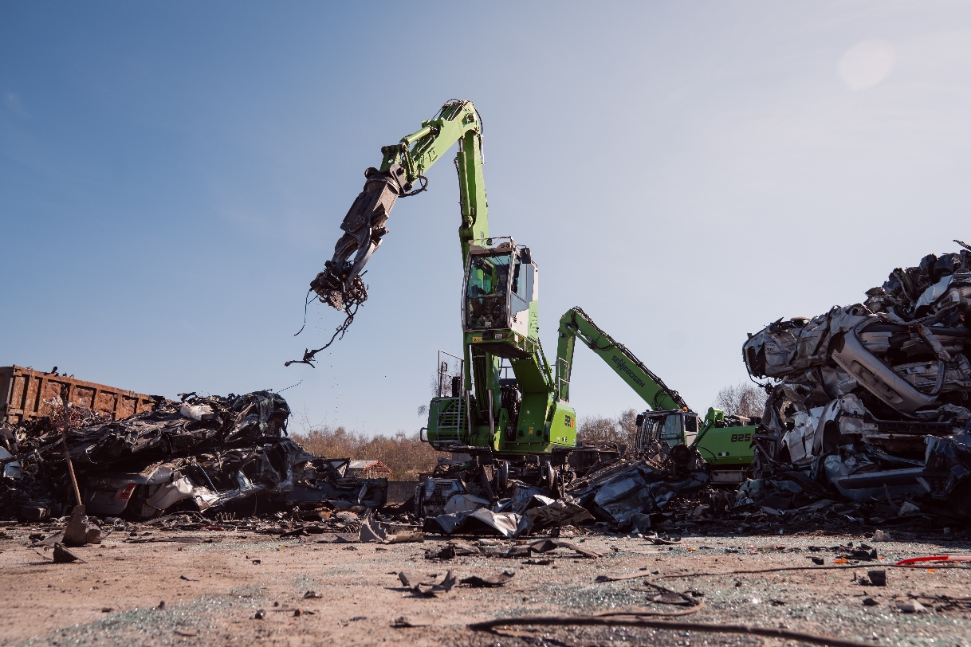
At Recycar, the SENNEBOGEN 821 E uses the Powerhand system to lift vehicle components that have been dismantled from an end-of-life vehicle.
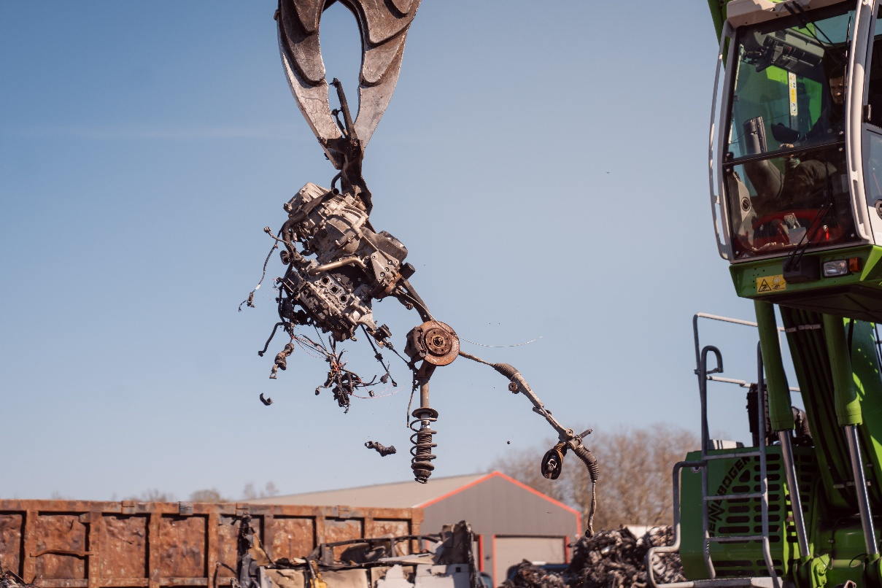
The SENNEBOGEN 821 E's Powerhand system precisely cuts removed vehicle components for further recycling.

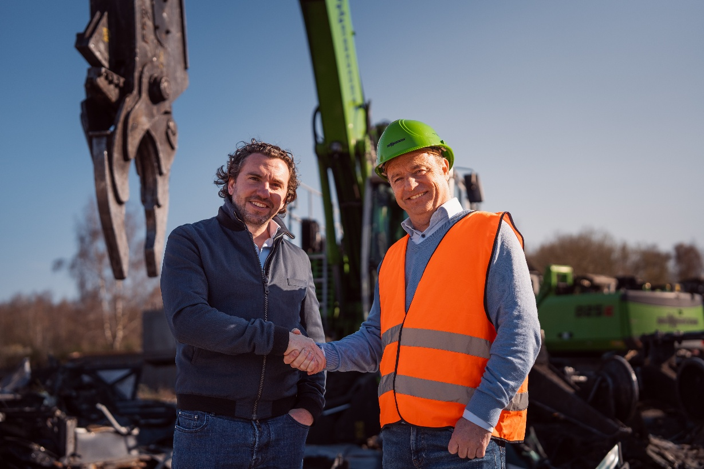
Working Together for Efficient End-of-Life Vehicle Recycling: Maxime Grosjean, CEO of Recycar, and Dirk Philippe, Account Manager at SMT.

