SENNEBOGEN at IFAT 2026: Sustainable Technologies and Intelligent Process Solutions in Focus
“The IFAT 2026 once again demonstrated the growing global importance of environmental and recycling technologies. We were very pleased with the international atmosphere, the positive industry sentiment and the intensive personal exchange with customers and partners from all over the world,” summarizes shareholder Erich Sennebogen after the show. “Especially in times of increasing demands for resource efficiency and circular economy, we clearly see the growing need for sustainable yet economically efficient machine solutions.”
With the company’s largest IFAT appearance to date, SENNEBOGEN presented a total of nine machines and innovative solutions for modern recycling, demolition and material handling on more than 526 m² of exhibition space in Hall C5 and at the VDMA outdoor demonstration area. The exhibition focused on emission-free drive technologies, intelligent assistance systems and the increasing integration of machines and processes.

Sustainable Technologies for the Recycling Industry
IFAT Munich 2026 clearly showed that circular economy and recycling technologies are gaining strategic importance worldwide. This is exactly where SENNEBOGEN’s machine solutions come into play: efficient, resource-saving and designed for maximum availability in daily operation.
Particular attention was paid to the new Electro Battery machines. With the battery-powered material handlers of the G-Series, SENNEBOGEN now offers a complete range of emission-free recycling material handlers from 17 to 31 tonnes operating weight. Thanks to the modular battery concept and Dual Power Management, the machines can operate both battery-powered and cable-connected, while being flexibly adapted to a wide variety of operating conditions.
One of the major highlights of the trade show was the world premiere of the SENNEBOGEN 826 G Electro Battery at the VDMA outdoor area. There, SENNEBOGEN demonstrated a semi-autonomous shredder feeding application live on site, in which modern machine communication actively supports material flow and optimizes process sequences. The live demonstration showed how modern material handlers can increasingly be integrated into intelligent overall process solutions in the future.

World Premiere of the New MG4.1 Orange Peel Grab
The presentation of the new five-tine orange peel grab MG4.1 also attracted great interest among visitors. The grab, which was presented to the public for the first time, was fully developed by SENNEBOGEN and expands the manufacturer’s portfolio in the scrap and recycling sector.
Designed and manufactured at the company headquarters in Straubing, the MG4.1 combines high robustness, low wear and a service-friendly design with a perfectly matched system solution consisting of machine and attachment from a single source.
At the same time, SENNEBOGEN is making a targeted investment in the Straubing production site with the new grab series. A dedicated production line was established for manufacturing the new attachments, creating additional capacities and new jobs in the region.

More Comfort and Efficiency in Daily Operation
SENNEBOGEN also presented numerous further developments in the telehandler segment. The 360 G industrial telehandler impressed visitors with new comfort and safety features as well as an optional joystick steering system for precise maneuvering and ergonomic operation.
The flexible combination of conventional steering wheel control and modern joystick steering offers maximum flexibility for individual machine configuration. The concept is complemented by new assistance systems, an expanded attachment portfolio and numerous optimizations for demanding industrial and recycling applications.

International Platform for Future Technologies
With around 142,000 visitors from nearly 160 countries and regions as well as approximately 3,400 exhibitors, IFAT 2026 achieved new record figures. Topics such as circular economy, resource efficiency and resilient environmental technologies were at the center of the world’s leading trade fair. For SENNEBOGEN, the exhibition once again provided an important platform for international exchange with customers, partners and industry representatives.
“IFAT has shown that sustainable environmental and recycling technologies are continuing to gain importance worldwide,” Erich Sennebogen concludes. “At the same time, we clearly see the growing demand for efficient, intelligent and resource-saving machine solutions. The positive response to our trade fair appearance confirms that we are heading in the right direction.”

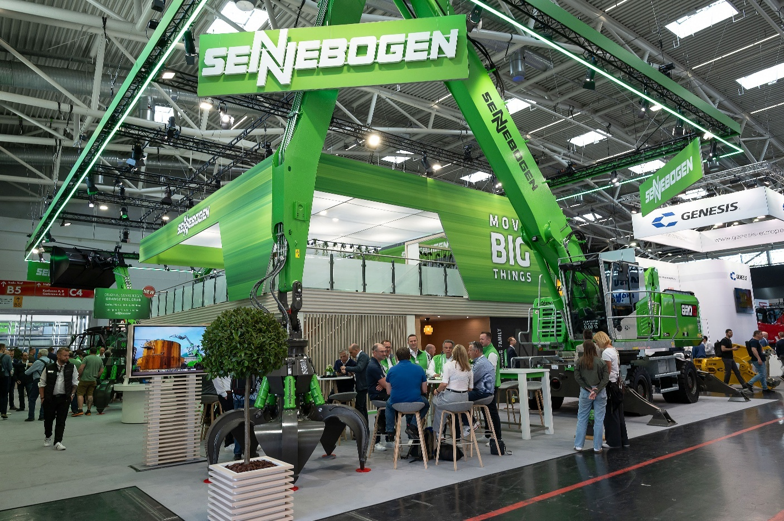
Bildunterschriften:

Picture 1: With the company’s largest IFAT trade fair appearance to date, SENNEBOGEN presented innovative machine and technology solutions for modern recycling and material handling on more than 526 m² of exhibition space.

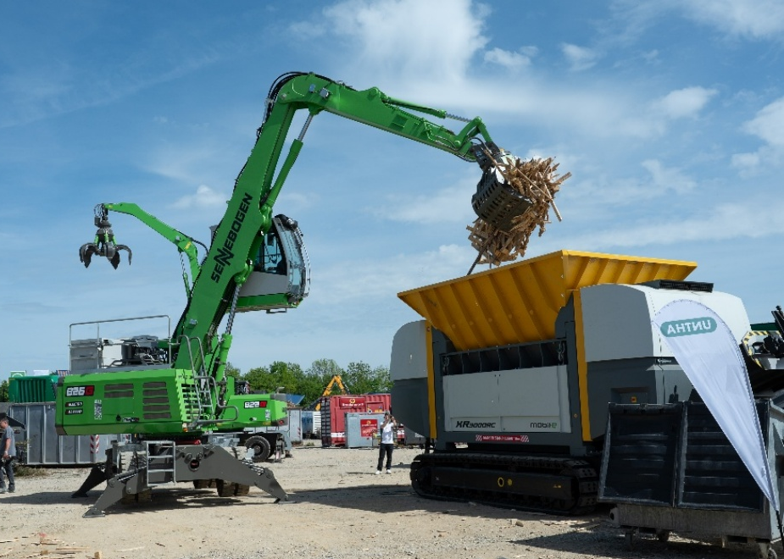

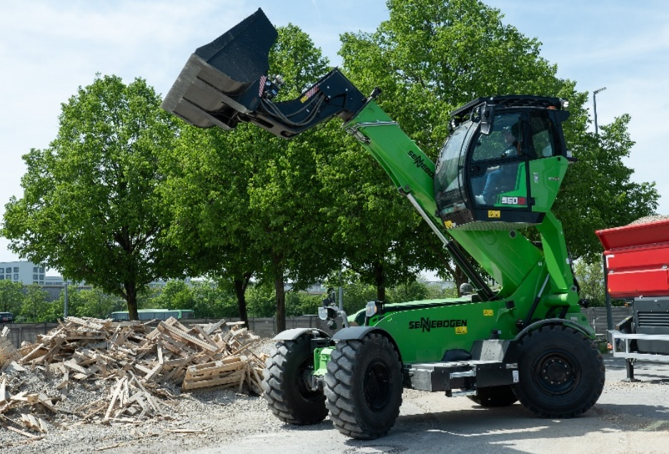
B Picture 2: At the VDMA outdoor demonstration area, SENNEBOGEN and UNTHA demonstrated a semi-autonomous shredder feeding application with the new 826 G Electro Battery, showcasing the intelligent integration of modern recycling processes in practice.

Picture 3: The further developed SENNEBOGEN 360 G industrial telehandler impressed visitors at IFAT 2026 with new comfort, safety and assistance systems as well as the optional joystick steering system for precise and ergonomic operation.
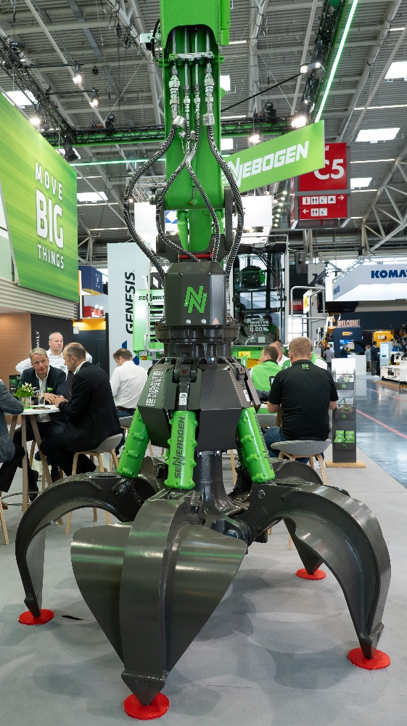

Picture 4: The new SENNEBOGEN MG4.1 orange peel grab celebrated its trade fair premiere at IFAT 2026 and attracted strong interest from visitors in the recycling and scrap handling sector.

