IFAT 2026 in Munich: SENNEBOGEN showcases the future of material handling in recycling
SENNEBOGEN will be presenting efficient and sustainable solutions for modern material handling in recycling at IFAT 2026 in Munich. Visitors will gain comprehensive insight into the broad portfolio of recycling and demolition machines and experience the world premiere of the SENNEBOGEN MG4.1 orange peel grab.
SENNEBOGEN at IFAT 2026: Experience the big recycling future
From May 4 to 7, 2026, SENNEBOGEN will be presenting the diversity of its recycling and demolition machines live at the world's leading trade fair for water, sewage, waste, and raw materials management on a booth area of over 526 m² in Hall C5, Booth No. 451, as well as on the VDMA outdoor area. Eight different machines, including material handlers, demolition excavators, and telescopic handlers, will demonstrate the performance and flexibility of SENNEBOGEN solutions for the recycling industry. In addition, the machine manufacturer will present the first MG4.1 orange peel grab, which it developed and produced in-house, to the public.
In addition, there will be a separate presentation at booth 551 for the LINDE YH60 telescopic handler, which is manufactured by SENNEBOGEN and distributed via the LINDE network in Germany and Austria.

World premiere: The original SENNEBOGEN MG4.1 orange peel grab
A special highlight of IFAT 2026 in Munich will be the presentation of the first five-shell orange peel grab MG4.1 with a volume of 600–1,200 liters developed by SENNEBOGEN. The grab, which is typically used for scrap handling, further expands the manufacturer's portfolio in the recycling sector. Here, too, SENNEBOGEN has drawn on its more than 30 years of experience in material handling to offer an optimally coordinated solution from a single source: for maximum performance, high availability, and a perfectly matched combination of machine and attachment.
Further details about the new grab will be announced during the trade fair.

Complete machine portfolio for efficient recycling processes
Visitors to the SENNEBOGEN booth can expect to see three particularly powerful and individually configurable machines:
The 830 recycling all-rounder in the new G series, exhibited with a 17 m compact boom and the new MG 4.1 orange peel grab, can now be made even more sustainable thanks to two new options: Firstly, like all SENNEBOGEN recycling and material handlers, it will in future also be available with CO2-reduced steel, which already accounts for up to 70% less CO2 emissions during production (more information on the cooperation with Salzgitter AG in this regard can be found here: https://www.sennebogen.com/en/news/news-press/sennebogen-presents-material-handler-made-from-green-steel). Secondly, it can be equipped with the SENNEBOGEN hybrid system. The energy recovery system consists of a gas pressure accumulator integrated in the rear and an additional hydraulic cylinder on the boom. When the boom is lowered, the energy generated – comparable to a tensioned spring – is temporarily stored in the nitrogen accumulator. During the subsequent lifting process, it is then made available to the lift cylinders again. This technology has already proven itself in large machines for many years and enables fuel savings of around 30%.
It is accompanied by the battery-powered 824 G Electro Battery recycling handler with 12 m reach. This battery-powered machine enables completely CO2-free material handling. Thanks to the modular battery concept, the machine can be precisely tailored to different application profiles. Depending on requirements, up to four battery packs can be integrated and added later if necessary – for maximum adaptability and investment security. In addition, the material handler can operate either in pure battery mode or with a wired power supply during charging. This makes it ideal for efficient use in shift operation.
Another highlight of the exhibition is the 6 t 360 G telescopic loader, which is presented with a 6 m³ bucket and impresses with many new features and options. These include, above all, the new, optional joystick steering system, which is unique in this machine class and is available either as the sole control option or in combination with a classic steering wheel as part of a dual control concept. This gives the customer maximum flexibility in machine configuration: depending on the specific application profile and driver preference, they can choose whether the telescopic loader should be equipped with classic steering wheel control, pure joystick steering, or the combined dual system. Other new features include a completely new comfort seat with a high backrest as standard, a camera with person recognition, a revised boom design with improved load capacity and robustness, an optional front guard, and an expanded range of tires and attachments to choose from.

LINDE YH60 with optional Dücker boom
SENNEBOGEN is also presenting the 6 t telescopic loader in a LINDE version. In addition to the new features also found on the green version, this model is equipped with a Dücker UNA 450 boom. This allows a wide variety of attachments to be used, from embankment mowers and hedge trimmers to sweepers, enabling year-round use of the machine, especially in the municipal sector.

SENNEBOGEN action on the VDMA outdoor exhibition area
SENNEBGOEN has a lot to offer, not only at its booth, but also at the demonstrations on the VDMA outdoor area. In the biomass sector, the 822 G recycling handler with a 10 m reach, which will also be available in electric and battery versions in the future, as well as the 826 G Electro Battery and the 4t LINDE YH40 telehandler will be demonstrating their capabilities.
The VDMA Crushing Zone features the most versatile demolition excavator, the 830 Demolition Vario Tool, and the 6-ton telehandler 360 G with digging bucket. The 45-ton demolition excavator is equipped with both the three-piece long front attachment with a 23-meter reach and the new digging boom with a digging bucket, demonstrating not only its versatility but also the ease with which attachments can be changed.

Visit SENNEBOGEN at IFAT 2026 in Munich, booth no. 451/551, hall C5, and at the VDMA outdoor area from May 4–7, 2026. Experience innovative solutions for sustainable material handling in recycling.

Captions:
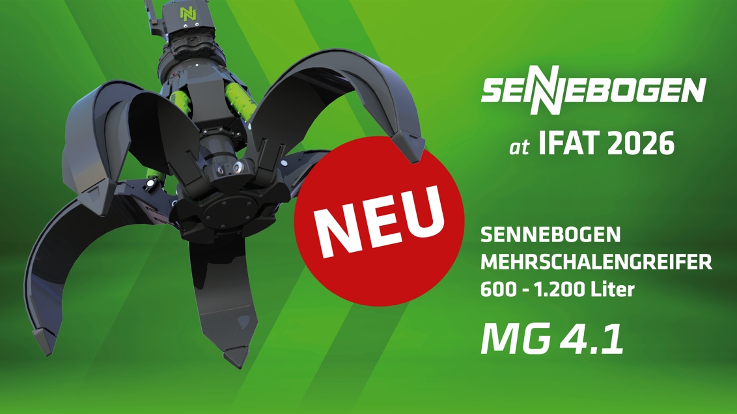
Image 1: Celebrating its premiere at IFAT 2026: the new SENNEBOGEN MG 4.1 orange peel grab.

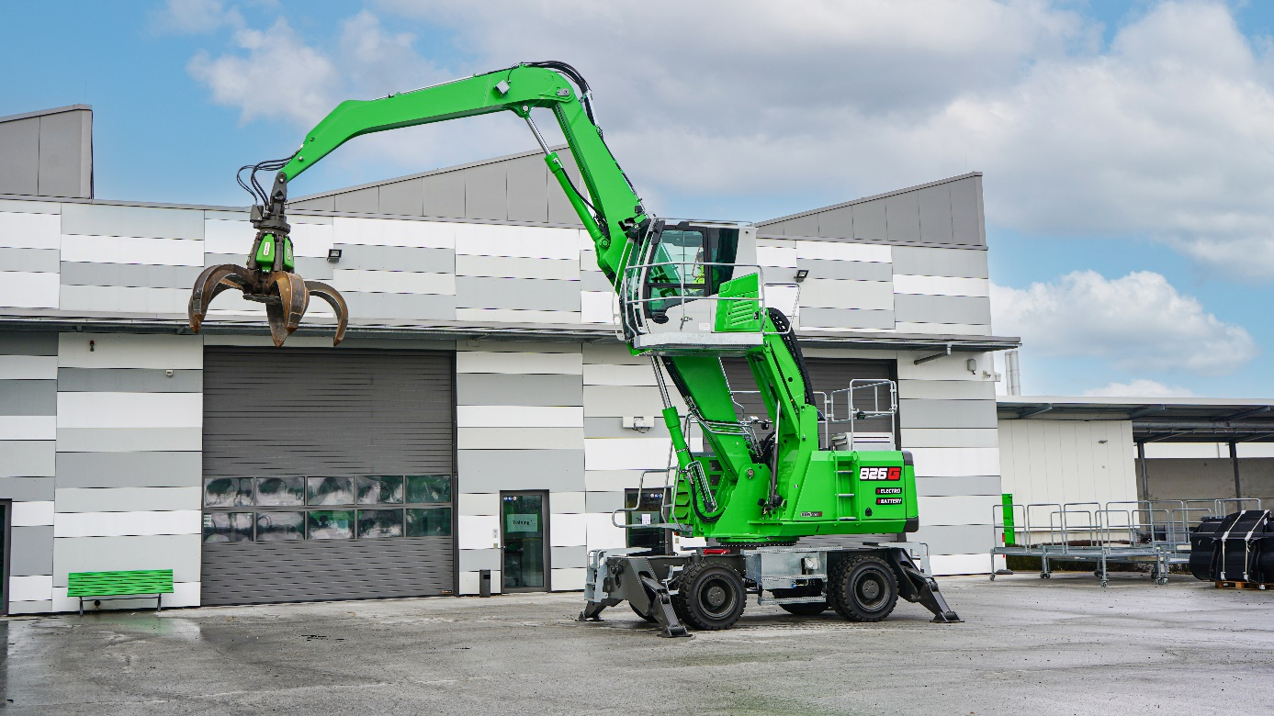
Image 2: SENNEBOGEN recently began offering a complete series of battery-powered recycling material handlers with operating weights ranging from 17 t to 31 t.

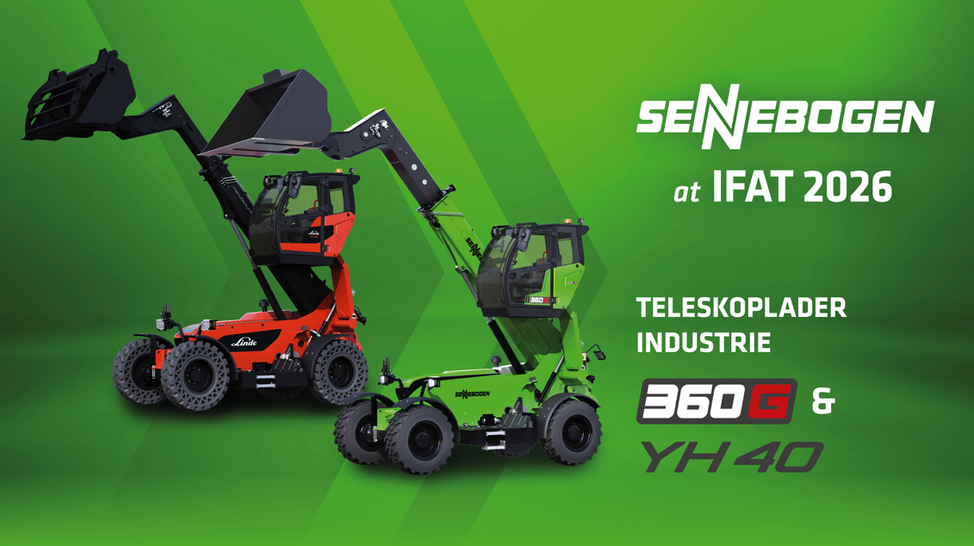
Image 3: At its booth in Hall C5, Booth No. 451/551, SENNEBOGEN will also be showcasing its flexible and powerful telescopic handlers in SENNEBOGEN green and LINDE red.

