Full battery-powered range of SENNEBOGEN material handlers in recycling: Completely emission-free in operation
SENNEBOGEN has been manufacturing electric-powered material handlers for over 30 years – primarily wire-connected until now. With the new G-Series models, the German manufacturer has recently begun offering an entire line of recycling machines as battery-powered solutions as well. Particularly practical: These models offer great flexibility, both in terms of the machines’ battery capacity and in operation via Dual Power Management.
The key features of SENNEBOGEN’s battery-powered material handlers at a glance:
1. Thanks to their modular battery design, the machines can be operated with 1, 2, 3, or 4 battery packs as desired, thereby achieving the battery capacity and runtime specified by the operator – up to 7 hours of operation without recharging.
2. The machines can be recharged flexibly during operation as needed, since the charging point is located on the undercarriage; this means that the onboard chargers can recharge the batteries even while the machine is in operation, using an industry-standard 125 A CEE plug with a charging power of up to 88 kW.
This range of SENNEBOGEN material handlers for the recycling industry remains unique on the market to this day, both in terms of offering a complete product line and in terms of variable battery capacity and flexible recharging during operation.
These unique features make it possible to meet a wide range of operator needs, whether the machine is used in different locations or for varying durations. Thanks to the Dual Power Management system, the machines operate without any time or location restrictions and can be easily charged using a standard industrial plug. Even if a customer wishes to adjust their machine’s battery capacity after a certain period due to changed operating parameters, the flexible battery configuration allows for retrofitting with additional battery packs. This safeguards the operator’s investment, even if the operational situation changes. Furthermore, each machine saves approximately 60 tons of CO2 per year during operation – depending on the number of operating hours.
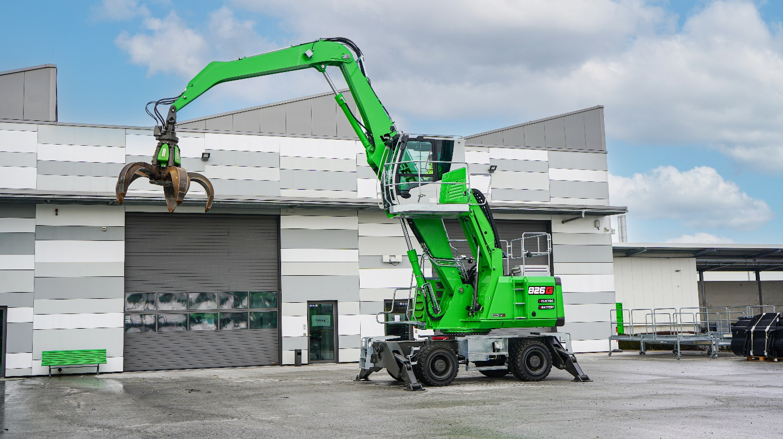
Captions:
Image 1: From small to large: SENNEBOGEN offers four battery-powered recycling machines with operating weights ranging from 17 to 31 tons.

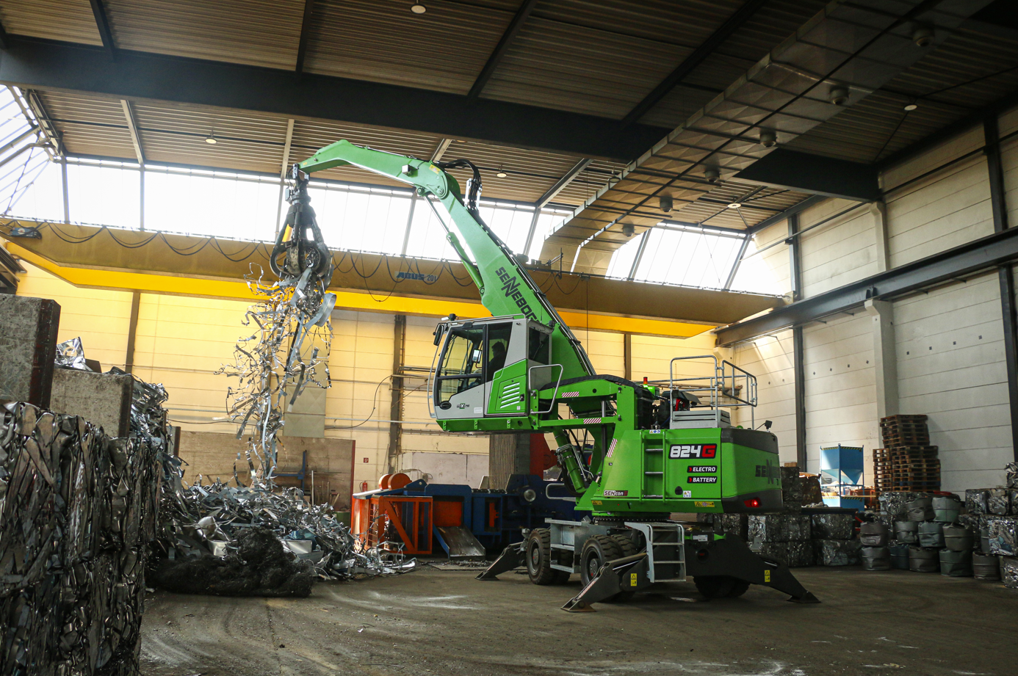
Image 2: SENNEBOGEN’s battery-powered material handlers are exceptionally flexible, both in terms of battery capacity and thanks to their Dual Power Management System.

