New material handler for scrap handling: SENNEBOGEN 828 G with a reach of up to 15 meters

The SENNEBOGEN 828 G is a new material handler for scrap handling and recycling. As the successor to the widely used 825 E, it is designed for tasks such as loading, sorting and feeding. A reach of up to 15 meters, an operating weight starting at 31 tonnes, modular configuration options and the systems of the G Series combine proven material handling technology with state-of-the-art machine control.

From the 825 E to the 828 G

The SENNEBOGEN 828 G carries forward the legacy of the 825 E. In its weight class, the predecessor was used at scrap yards across the globe: in North and South America, Europe, the Middle East, Africa, Asia and Oceania. The 828 G builds on this established application profile and adds the control, assistance and communication systems of the latest G Series.

These include the SENcon control system and connected functions for the operator, machine and service team. The material handler is designed for operators who need a machine that can be configured flexibly for demanding recycling and scrap handling tasks.

Key specifications

Feature | Specification
Application | Recycling and scrap handling
Typical tasks | Loading, sorting and feeding
Reach | Up to 15 m
Operating weight | From 31 t
Undercarriage | Mobile or crawler undercarriage
Equipment lengths  (mobile) | K12 to K15
Engine | Cummins B6.7, Stage V
Rated power | 129 kW
Cab | Hydraulically elevating Maxcab, viewing height of approx. 5.60 m

What tasks is the SENNEBOGEN 828 G designed for?
The 828 G is designed for loading, sorting and feeding in daily recycling and scrap handling operations. With a reach of up to 15 meters and high load capacities, it can handle a range of material flows and work processes.
The modular design allows the machine to be configured for the specific application. It is available with a mobile or crawler undercarriage. For the mobile undercarriage, equipment lengths from K12 to K15 are available. Depending on the task, the 828 G can be equipped with an orange peel grab, clamshell grab, magnet or sorting grab. A ULM version with tipping kinematics is also available.
The robust machine design and high-quality components are built for a long service life, even in demanding continuous-duty applications.

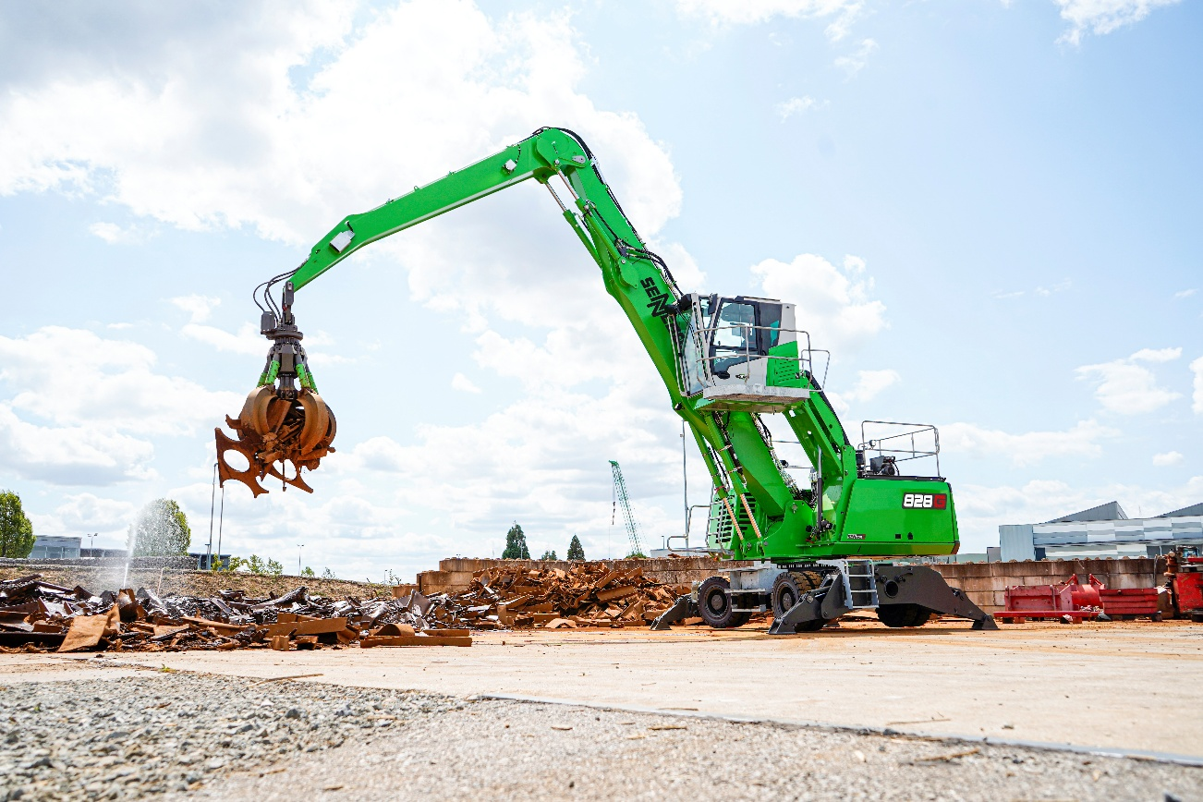

Image 1: The SENNEBOGEN 828 G on a mobile undercarriage with an orange peel grab handling scrap at a recycling facility.

Engine and hydraulics for daily material handling
The SENNEBOGEN 828 G is powered by a Cummins B6.7 diesel engine that meets Stage V emissions standards. Its rated power is 129 kW; the ECO operating point is 145 kW. The engine can also run on HVO.
An automatic idle/stop function, optimized hydraulics and large-dimensioned lines support efficient operation.
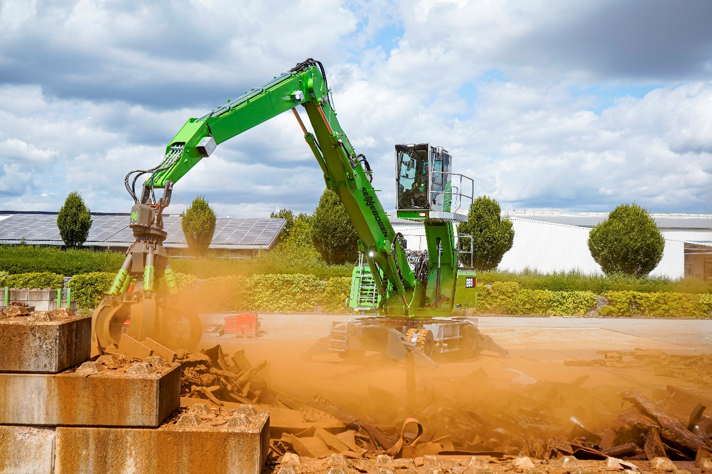

Image 2: The SENNEBOGEN 828 G picking up scrap from a material box. A reach of up to 15 meters and a range of equipment options allow the machine to be configured for the application.

How does the Maxcab improve visibility and operator comfort?
The standard hydraulically elevating Maxcab provides a viewing height of approximately 5.60 meters. Large glass panels, safety cameras and a modern monitor system support all-round visibility and monitoring of the working area.
The redesigned cab interior is built for ergonomic operation. Automatic climate control and an air-suspended comfort seat are part of the equipment. The central 10-inch touchscreen gives the operator access to key machine functions. Individual operator profiles and freely configurable joystick assignments allow the controls to be tailored to each operator.
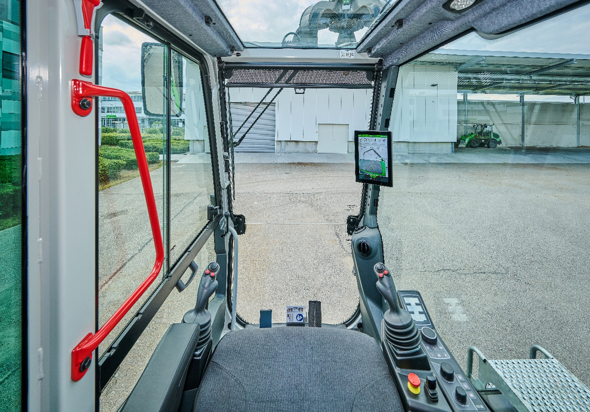

Image 3: Interior view of the SENNEBOGEN 828 G Maxcab, showing the joysticks and the 10-inch touchscreen of the SENcon control system.

SENcon and SENtrack connect machine and service
The SENcon control system displays information on machine condition and energy consumption. It also provides access to assistance functions such as adjustable height and radius limitations.
In combination with SENtrack, operators can analyze machine data to better assess work processes and machine utilization. Remote diagnostics and over-the-air software updates can support service processes and help maintain machine availability.
Maintenance is also designed around daily operation: service points are clearly arranged and easily accessible. Daily service work and refueling can be carried out from ground level.
With the 828 G, SENNEBOGEN carries the 825 E’s application profile into the G Series, combining flexible configuration options for scrap handling with modern controls, assistance systems and connectivity.

