SENNEBOGEN at bauma 2025: innovation, sustainability and hospitality
‘bauma 2025 - with SENNEBOGEN as the green heart - showed a strong heartbeat of the industry. We are delighted with the positive mood in the industries, which was not to be expected in this form. For us, the trade fair is and remains every three years not only an important place for progress and innovation, but above all for meetings and personal dialogue. In recent years, we have worked intensively on innovative and sustainable technologies and have been able to inspire customers and prospects from all over the world,” summarized shareholder Erich Sennebogen about the trade fair. SENNEBOGEN presented a total of 10 machine exhibits on more than 2100 m² in the center of the outdoor area, including seven world premieres, accompanied by future-oriented software solutions and the familiar warmth of the family business.
SENNEBOGEN once again demonstrated its innovative strength at bauma 2025 and presented pioneering new products for material handling and crane technology. The highlights of the exhibition were characterized by innovation, customer focus and sustainability. In addition, the emotional brand presence was once again convincing: “Looking back on bauma 2025, we can be proud. It was a great week at the trade fair, full of emotions and valuable encounters,” enthuses also shareholder Walter Sennebogen.

Driving forward future oriented topics: Decarbonization and software solutions
Zero emissions and energy efficiency, paired with customer-oriented software solutions. These aspects were reflected in every detail of the booth. The new 40 t 830 G-series material handler with 17 m reach presented there is not only an all-rounder for recycling, scrap and timber, but also combines a variety of future-oriented methods in terms of CO₂ reduction and machine control. As a representative of the new G series, it is particularly efficient and fuel-saving and saves 18.5 tons of CO₂ per year in operation compared to its predecessor model. The special feature of the bauma exhibit is that it was also built largely from “green” steel, i.e. steel produced with reduced CO₂ emissions. This means that this machine already saves significant amounts of CO₂ during production. Equipped with SENcon, the latest generation control system, the machine is not only highly customizable to the operator or the application, it is also highly communicative. It provides valuable and operationally supportive data for operators and fleet managers and avoids on-site customer service visits, as machine diagnostics and software installations can be carried out remotely.
The fact that the green material handlers can even be controlled completely remotely was demonstrated directly at the booth. With the help of a remote control, a real 830 G material handler could be moved conveniently from the SENNEBOGEN booth in Munich at the demonstration area of the SENNEBOGEN plant in Straubing.
The newly launched 62 t material handler for scrap and port applications, the 850 G Hybrid, also features the new SENcon control system, as do all new machines in the G series. It is also the first machine in this size class to be equipped with the proven Green Hybrid energy recovery system. This enables fuel savings of around 30% and therefore also around 22 tons of CO₂ per year.
With the first battery-powered material handlers in the G series, the 824 G Electro Battery and the 826 G Electro Battery, SENNEBOGEN is setting a strong example for sustainable and flexible electromobility. The battery-powered recycling machines not only enable CO₂ emission-free use, but can also be flexibly adapted to different requirements thanks to their modular battery concept: depending on requirements, 1 to 4 battery packs can be configured and even retrofitted at a later date.
The new 6 t 360 G telehandler, which was also presented at the trade fair, is a representative of the G series and is also extremely powerful and economical in terms of fuel consumption. Thanks to its robust design, this highly efficient machine is particularly impressive in demanding industrial applications.

Large machine highlights in crane technology and material handling
There was also plenty on offer at the SENNEBOGEN booth in the large machine sector. In addition to the colossal 320 t 885 G Hybrid port material handler, visitors were impressed by the two new crane giants: the new 200 t telescopic crawler crane with a boom length of up to 78 m, the 6203 E, and the 220 t duty cycle crawler crane 6220 E, which impress with their high load capacity and versatility even under difficult conditions. In addition to the exhibits on the booth, a new 195 t port material handler, the 875 G Hybrid, was also launched on the market. This could be viewed at the same time as the trade fair at the demonstration site of the SENNEBOGEN plant in Straubing. Interested visitors were offered a bus shuttle directly from the trade fair in Munich.

Solutions for all industries: From demolition to tree care and special financing
Another highlight at the booth was the new, multifunctional 51 t demolition machine 830 Demolition Vario Tool, which was shown with a 12 m digging boom and digging bucket. In addition to the digging boom, the machine can be quickly converted and equipped with the two-part 17 m demolition equipment or the three-part 23 m long front equipment.
The proven 16 t telescopic mobile crane with a boom length of up to 24 m, the 613 E, and the popular 21 t tree care handler, 718 E, with a reach of up to 13 m were also on display. The latter is perfect for professional wood and tree maintenance along traffic routes and was equipped for bauma in the version with crawler tracks for off-road use.
To round off the all-round carefree package for customers from all industries, SENNEBOGEN Finance also presented very attractive special financing options from 0.00% interest during bauma, which support customers with investments and provide them with planning security. The offer is still valid for incoming orders until May 31, 2025.

Positive signal for the future
In times of transformation, bauma once again proved that progress is primarily the result of encounters and cooperation. “The optimism that the industry is spreading has a positive signal effect and is an important stimulus for a revival in the construction industry, but also in the material handling sectors, for Germany and internationally. Our booth was always well attended and we were able to close significant business deals,” concludes Erich Sennebogen. “Nowhere else are so many valuable discussions held with business partners from all over the world and emotional experiences created in such a short space of time.” Because beyond the machine presentation, the personal exchange and interaction is a central point at the trade fair. The visitors, who this year once again increasingly came from abroad, were welcomed by a large SENNEBOGEN team from various departments, as well as by the manufacturer's sales and service partners from more than 60 countries, so that everyone could be looked after individually in their own language and according to their needs.

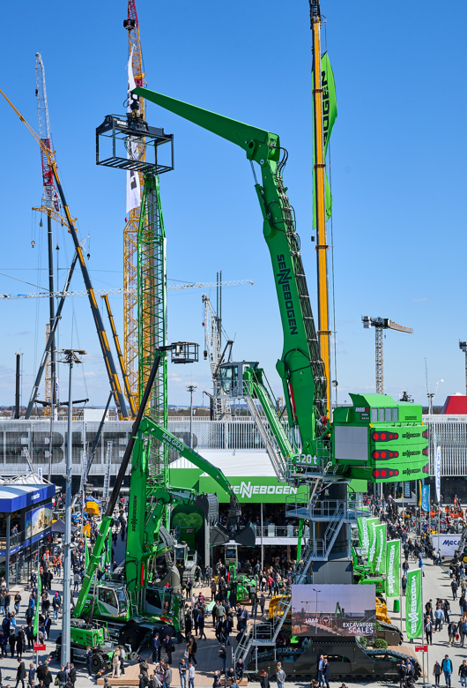
Captions:
Image 1: As the “green heart of bauma”, SENNEBOGEN once again attracted many visitors this year with an impressive range of machines and technological innovations. The large machine highlight directly at the booth: the SENNEBOGEN 885 G Hybrid port material handler with an operating weight of 320 t.
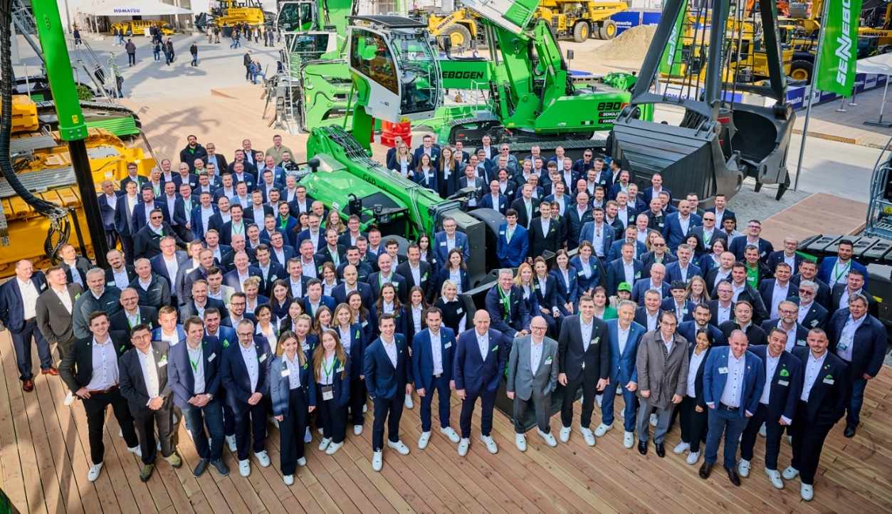
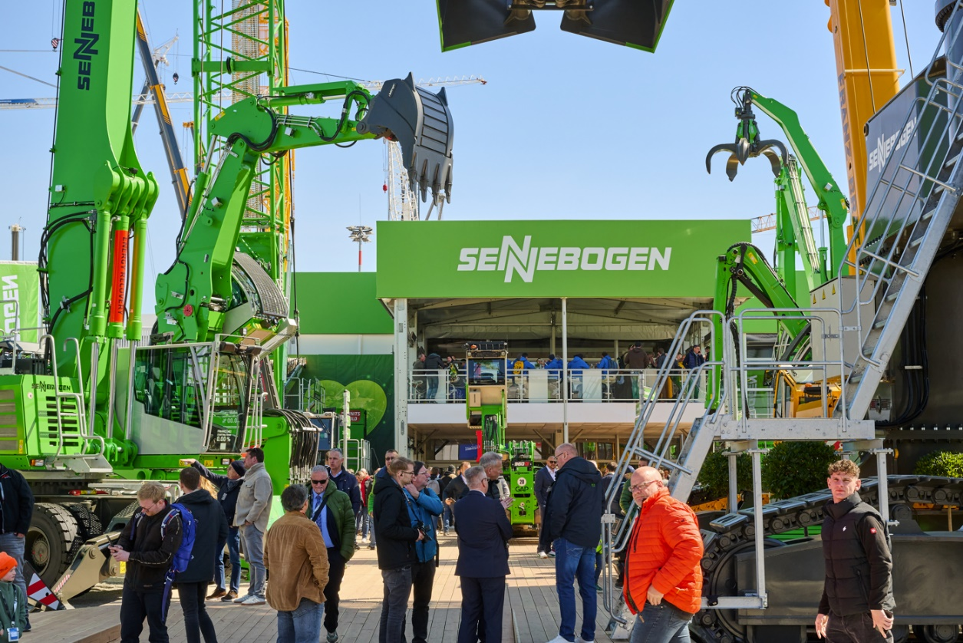
Images 2 and 3: With a large, international team and a total of 10 machine exhibits from all application areas, SENNEBOGEN welcomed the many bauma trade fair visitors from all over the world.
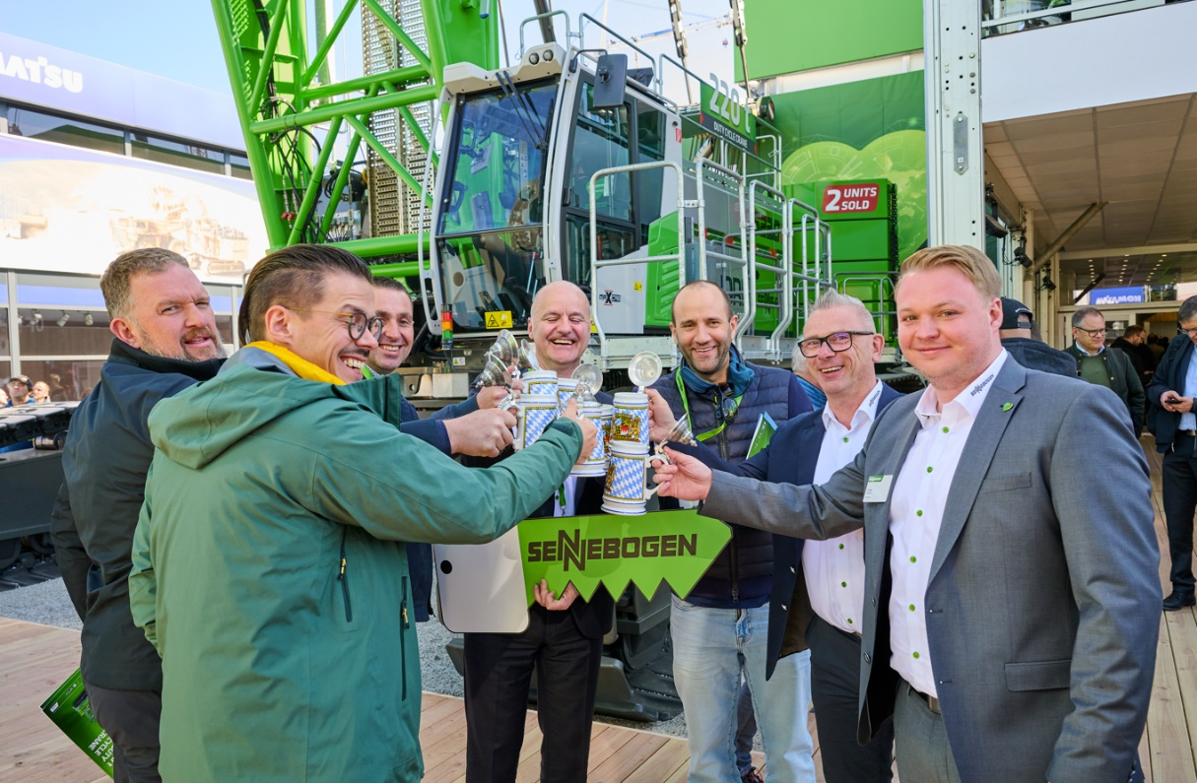
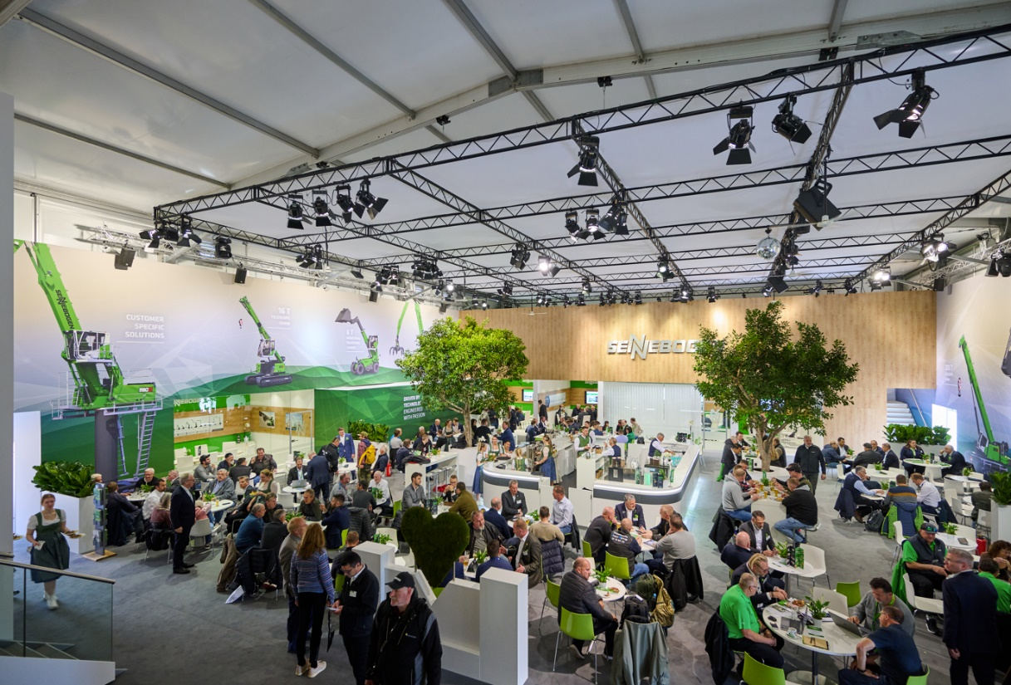
Images 4 and 5: Hospitality and personal interaction are very important at the “green heart of bauma”.

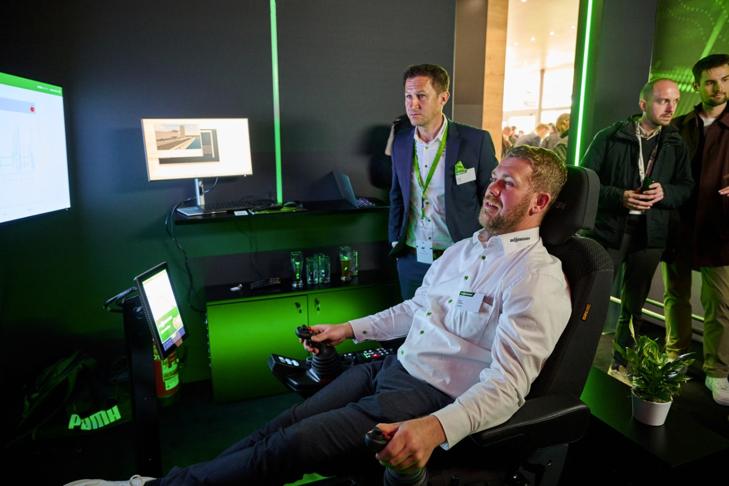
Image 6: The new SENcon machine control system could be tested directly at the booth using a remote application. Visitors were able to move a material handler in Straubing.

