New management for SENNEBOGEN Vertriebsgesellschaft
SENNEBOGEN Vertriebsgesellschaft (SVG) is entering the future with a new dual leadership team: Christian Kaiser (Managing Director Commercial) and Peter Kröninger (Managing Director Sales) have recently taken over joint responsibility for the business. The SVG is part of the SENNEBOGEN Group, generally responsible for sales in some parts of Bavaria as well as international point of contact for rental and used machines as well as demolition machines.
In the first eight years after the founding of SVG, Dr Andreas Maurer and Alfred Endl carried out the management of the company with great commitment and foresight as part-time managers alongside their full-time activities as managing directors of SENNEBOGEN Maschinenfabrik GmbH. In view of the pleasing development and the increased demands, the time has now come when a full-time dual leadership is necessary and Maurer and Endl will once again focus fully on their tasks at SENNEBOGEN Maschinenfabrik. The aim of the new SVG managing directors Christian Kaiser and Peter Kröninger is to further raise the company's profile as an independent, customer-focussed unit and to significantly strengthen its market presence. Since its foundation, SVG has acted as the exclusive sales and service partner for SENNEBOGEN in the manufacturer's home territory. In addition, it bears full responsibility for the SENNEBOGEN demolition machine product segment - a significant step, with which this exclusive area was deliberately spun off from the machine factory and bundled in SVG.
“With SVG, we offer our customers not only sales, but above all reliable support over the entire machine life cycle - from initial consultation to rental or used solutions, through to comprehensive maintenance and remanufacturing,' emphasises Peter Kröninger, who manages all sales activities. ‘Especially in our core sectors of material handling, demolition and recycling, responsiveness, technical expertise and service availability are crucial - this is where we see our great strength.“
At its site in Steinach, Germany, the company maintains an efficient workshop for machine remanufacturing, carries out targeted functional repairs and also offers a wide range of rental machines and used machines for customers and SENNEBOGEN dealers worldwide. This range of services is complemented by a dedicated team of service technicians and specialists in the office and in the field.
Christian Kaiser, who will be responsible for commercial matters in the future, adds: "We want to further establish SVG as a strong brand in the market - with clear responsibility for defined product areas, high technical quality and economic reliability. In close co-operation with SENNEBOGEN Maschinenfabrik, we see great opportunities for development here - both regionally and internationally."

Captions:
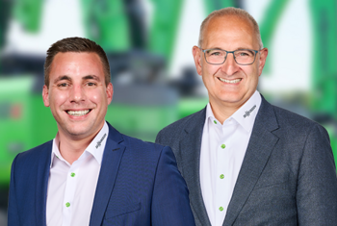
Bild 1: The new managing directors of SENNEBOGEN Vertriebs GmbH & Co. KG in Steinach: Peter Kröninger (left) and Christian Kaiser (right).

