SENNEBOGEN presents itself with 9 machines at IFAT 2024
Visit us from May 13 to 17, 2024 at the World's Leading Trade Fair for Water, Sewage, Waste and Raw Materials Management in Munich. We will be presenting the almost complete family of SENNEBOGEN recycling machines on site and once again setting important standards for the future.
Recycling is one of the biggest challenges of our future. SENNEBOGEN takes up this challenge and presents its efficient and sustainable solutions for material handling in the recycling industry at IFAT. Discover our newest members of the SENNEBOGEN family at our more than 400 m² booth in hall C5, no. 451/550 and at the VDMA outdoor demo area (LIVE demos: Biomass & Construction Materials Recycling). SENNEBOGEN will be presenting a total of 8 different machines in Munich.
The right machine for every recycling challenge
Experience our powerful and individually configurable machines to make your recycling process even more efficient. In addition to the 4-tonne 340 G telehandler, the 824 G material handler from the new G-series, the 825 E Electro Battery and the brand new 826 G, which is celebrating its world premiere at IFAT, will be on display. The additional demo area in the inner courtyard between halls C5 and C6 will also feature the 825 Demolition for recycling construction materials, which enables simple and cost-effective transportation thanks to its discardable counterweight.
The recently launched 824 G is also celebrating its trade fair premiere. The completely new development is not only a real visual highlight. With a reach of 12 meters and an operating weight of 26.3 tonnes, the recycling material handler is a real all-rounder in the recycling and scrap yard. In addition to the impressive performance data, the machine also impresses with the MaxCab comfort cab, which can be raised by 2.8 meters – ensuring a pleasant workplace with the best all-round visibility in recycling operations.
We will also be presenting another model from our new generation of machines: the 340 G-series. The Multiline telehandler with a load capacity of up to 4 tons and a reach height of 7.70 meters combines the advantages of telehandler and wheel loader technology in a unique machine and shines in particular with its unique selling point, the Multicab cab. The most modern cab of its kind can be continuously raised to an eye level of 4.10 meters and impresses with its large glass surfaces including a 360-degree all-round view. This ensures maximum safety when loading material and maneuvering.
Electric material handler with Powerhand
The 825 Electro Battery with Powerhand and Vario Tool complements our recycling family at the trade fair stand. The battery-powered electric material handler exhibited with this equipment for the first time at a trade fair is a master of flexibility with its fully hydraulic and multifunctional quick-change system. Various attachments such as scrap shears and orange peel grabs can be used flexibly with the same machine and can be changed very easily by the driver from the cab in a very short time. The modern 825 E with a reach of 14 meters and an operating weight of 30.4 tons works without restrictions thanks to the Dual Power Management both in battery mode and with cable-operated power supply and is therefore highly practical for the recycling industry, with the exhibited Powerhand especially for car recycling.
Machines live in action at VDMA Demonstration Days and Crushing Zone
See the power of our machines in action for yourself. During the VDMA Demonstration Days and Crushing Zone, SENNEBOGEN will be presenting four more machines. Experience the 825 Electro Battery and the 822 G and marvel at our recycling experts demonstrating their skills in the field of biomass recycling and also see our 830 Demolition and 340 G machines for yourself as part of the Crushing Zone in building materials recycling.

Caption:
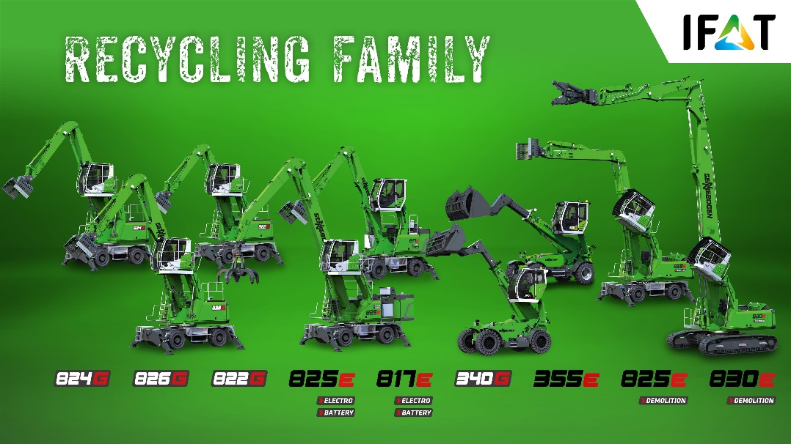
The SENNEBOGEN recycling family – discover a large part of it at IFAT 2024.
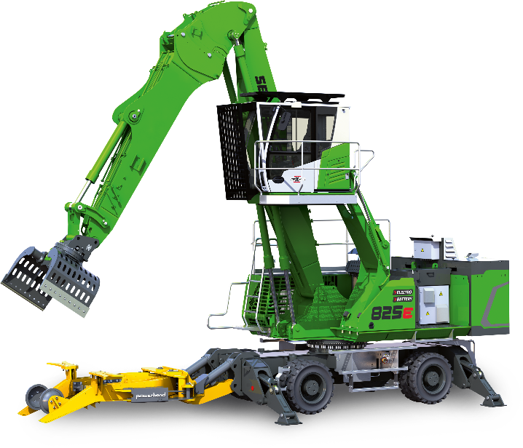

The 825 E Electro Battery with Powerhand and Vario Tool complements the SENNEBOGEN Recycling family at the trade fair stand.

