71 years of SENNEBOGEN: Corporate growth – technologies – sustainability
Established in 1952, SENNEBOGEN is very well positioned after 71 years and is now larger, more innovative and more interesting than ever before. Since the last big in-house exhibition in 2017, not only have the number of employees and locations worldwide grown to an impressive level, but also the broad portfolio of handling and crane technology, which includes numerous size classes and technologies. In this year’s in-house exhibition, the WE SHOW 71, which will take place from September 19 – 22, the latest technological developments and the various investments in new and existing locations will be celebrated.
71 years of SENNEBOGEN, which currently means 2200 employees at five locations in Bavaria (Germany), two steel plants in Hungary and branches in the USA and Singapore. The sales and support for the green material handlers, cranes and telehandlers from Straubing and Wackersdorf are carried out by a comprehensive network of dealers with over 180 sales and service partners at over 300 service centers worldwide. The past few years have not only recorded average sales growth of 16% to now more than 600 million euros in annual sales, but have also seen continuous investments in existing and new locations. At the same time, the workforce grew dynamically to its current size. However, despite all this growth, one thing always remains the same: SENNEBOGEN is and remains a family company – now managed in the second generation by Erich and Walter Sennebogen and in the third generation by Anton and Sebastian Sennebogen. The two other grandchildren of the company founder are already in the starting blocks and are involved in all the important appointments and events.
Shareholder Erich Sennebogen is optimistic about the future: "Our customers are amazed by the dynamic approach and agility of the company, and we are sure that the investments will have a very positive impact on further development. The business areas have become more diverse and customer demand for quality products and services is growing constantly. To stay ahead of the competition, we invest in our product portfolio and locations every year."

Construction measures at many locations
And that's obvious: One of the largest construction projects in recent years was the Customer Service Center in Steinach, which opened in September 2021 and bundles all activities from the areas of spare parts, customer service, as well as the rental and used machine fleet of SENNEBOGEN Vertriebs GmbH & Co. KG. Over an area of 87,000 m² there are now two office buildings, spacious halls and a state-of-the-art spare parts warehouse with automated warehouse technology and optimized logistics processes.
There were also expansions at the Wackersdorf site. In addition to the new shipping area, a new 1,000 m² electrical test center was built, which is used specifically for testing and finishing the electric machines.
A second steel plant in Litér (Hungary) has also been created completely from scratch. A 29,000 m² production hall and an office building were built on an area of over 13 ha. The new plant is designed for handling large and heavy components up to approx. 30 m in length and 25 t in weight and offers capacity for 20,000 t of steel structures per year in the current expansion stage. "With this investment in Hungary, we are not only expanding our capacities for steel structures to meet the growing demand, but also building reserves for the future," explains shareholder Walter Sennebogen.
The brand-new product development campus at the Straubing/Port site will also be officially inaugurated for the in-house exhibition, consisting of the new 1,200 m² prototype center, a 1,300 m² research and test center and a 3,000 m² design and technology center. Here, new machine development, testing and prototype construction are brought together in a central place to enable a more intensive focus on the development of new technologies. This was accompanied by the establishment of a separate department for prototype construction. The open concept of the new buildings creates synergies between the research halls and offices and enables an agile and innovative response to the increasingly complex requirements on technology. "Modern control systems, electromobility, battery technology and innovative drive systems are topics that employees can focus on even more intensively in the future," says Erich Sennebogen, explaining the background. This is because continuous expansion of our own development work in the company and an ever-increasing focus on new drives, automation and digitalization of machines require not only innovative power, but also space to optimize processes and fulfill the increased order volume.

Sustainable investments for the future
The family-owned company SENNEBOGEN thinks long-term and in generations. This includes responsible use of resources. SENNEBOGEN is clearly committed to its goal of becoming climate neutral by 2030. This is why the ecological mindset is a key focus in all construction projects. All new buildings are built in accordance with the KfW 55 standard (reduces energy consumption by 45%) and are therefore particularly energy-efficient and environmentally friendly. Energy-saving LED lighting, heating buildings with low-temperature heating via concrete core activation and environmentally friendly cooling using groundwater play a role here, as does the extraction of renewable energies at the sites themselves. In recent years, investments have been made in photovoltaic systems with more than 4 megawatts of output and wood chip heating systems with 4 megawatts. The diesel generators for the tests on the electric machines in Straubing and Wackersdorf replace battery storage systems that are filled with PV.

Bildunterschriften:
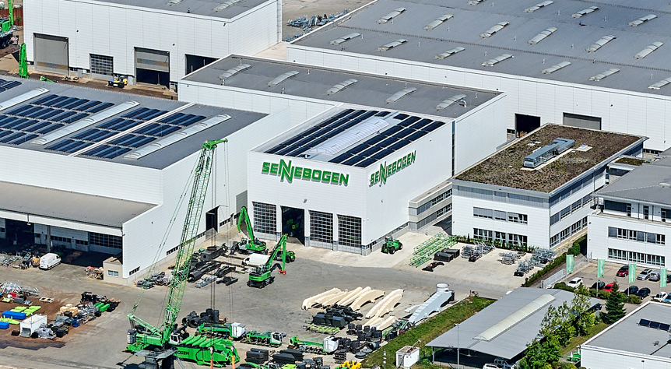
Image 1: The new product development campus at Plant 2 in Straubing/Port brings new machine development, testing and prototype construction together in a central location to create synergies and enable a more intensive focus on the new technologies.
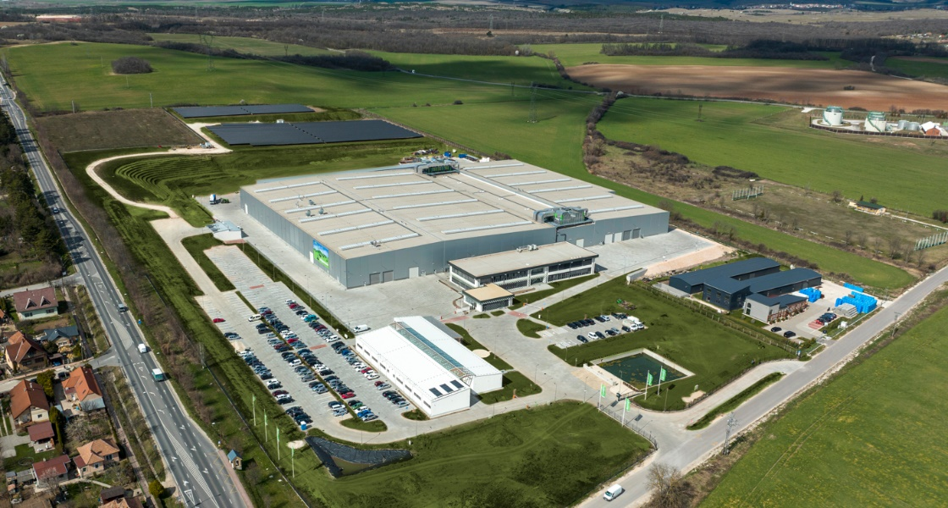

Image 2: SENNEBOGEN is expanding its capacities for steel assemblies and welded structures with the new 13 ha steel structure site in Hungary.
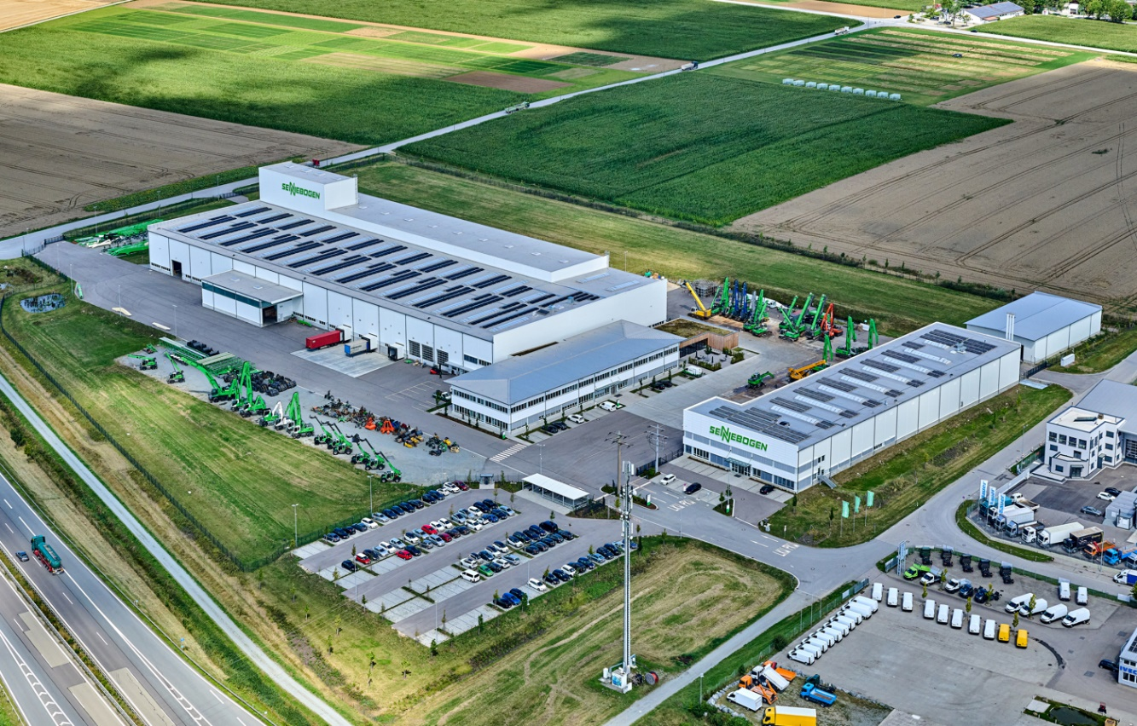
Image 3: Over an area of 87,000 m², the new Customer Service Center in Steinach bundles all activities from the After Sales area.

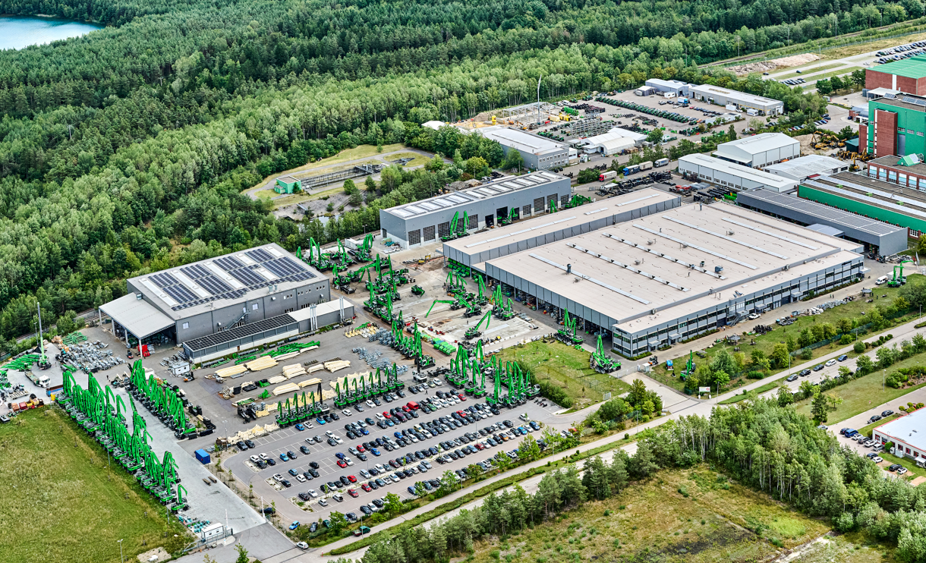
Image 4: The site in Wackersdorf was recently expanded to include a larger shipping area and a test center for electric machines.

