Large machines in material handling: globally proven technology from Straubing
For decades, SENNEBOGEN has made a name for itself with customer-specific material handlers, especially in the demanding port segment. SENNEBOGEN’s versatile port handling machines are particularly useful for unloading ships with bulk or general cargo in the shortest possible time. SENNEBOGEN offers a wide range of products, especially for large machines, ranging through to the largest material handler in the world, the 895 E, with an operating weight of up to 420 t and a reach of 40 m.

Large variety of size classes and equipment variants
Just at the last bauma, the manufacturer’s range in the upper size class was expanded once again with another port giant, the 885 G Hybrid with 320 t operating weight and 38 m range. Thanks to the tried-and-tested modular principle, SENNEBOGEN offers a wide range of customer-specific equipment options for this model as well as for all other material handlers. This enables the customer to individually optimize the machine to the handling requirements and conditions on site. For the drive system, for example, you can always choose between diesel or electric, the undercarriage can be designed in a crawler, mobile or rail version, and the flexibly adjustable Skylift cab elevations can also be designed to suit the usage location and the application, so that the 895 E can achieve a viewing height of up to 22 m, for example. SENNEBOGEN also offers an enormous variety of boom equipment and configurations – with different ranges, load capacities and attachments – precisely tailored to the relevant application. The Tool Control system ensures simple and reliable operation and optimal presetting of the hydraulic parameters of up to 10 pieces of equipment. Thanks to the variety of equipment typical of SENNEBOGEN, heavy container lifts and crane lifts are therefore also possible depending on the machine.

The new large-capacity cab for ports: SENNEBOGEN Portcab
The new, completely redesigned large-capacity Portcab is also available especially for ports, which is characterized by excellent all-round visibility, a sophisticated heating/air conditioning concept and ergonomic seating and operating elements. Large glass surfaces to the front and sides as well as safety glass bottom panels provide a clear view of the entire working area and the ship. The driver is also supported by cameras for monitoring the safety zones. More information on the cab, including 360° visualization, can be found here: https://www.sennebogen.com/en/technology/portcab

Low operating costs, high handling capacity and safety
In addition to a high handling capacity, SENNEBOGEN material handlers are also characterized by efficient and resource-saving operation. Programmable control modes for the operator, equipment and application facilitate effective and safe handling of the machine and help to reduce operating costs. The service-friendly and easily accessible technology with high-quality drive and control components also ensures consistently high performance and excellent availability.
SENNEBOGEN material handlers from an operating weight of 47 t are also equipped with the Green Hybrid energy recovery system, which has successfully established itself for large machines. With one or more additional hydraulic cylinders on the boom and a nitrogen accumulator in the rear, the machine stores the energy generated when the boom is lowered and releases it when it is raised again. The savings achieved in operating costs of up to 50 percent have been confirmed for many years.

Captions:
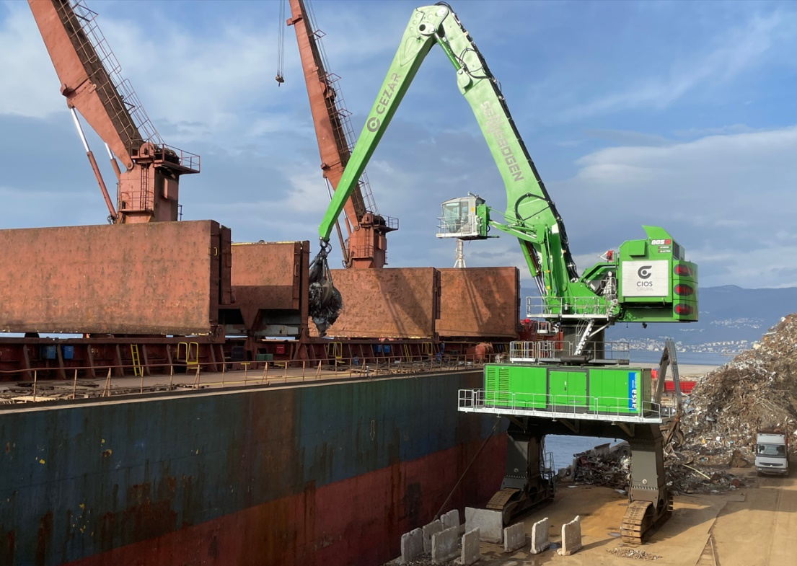

Image 1: The new port giant in the portfolio, the 885 G Hybrid, in operation in Croatia.
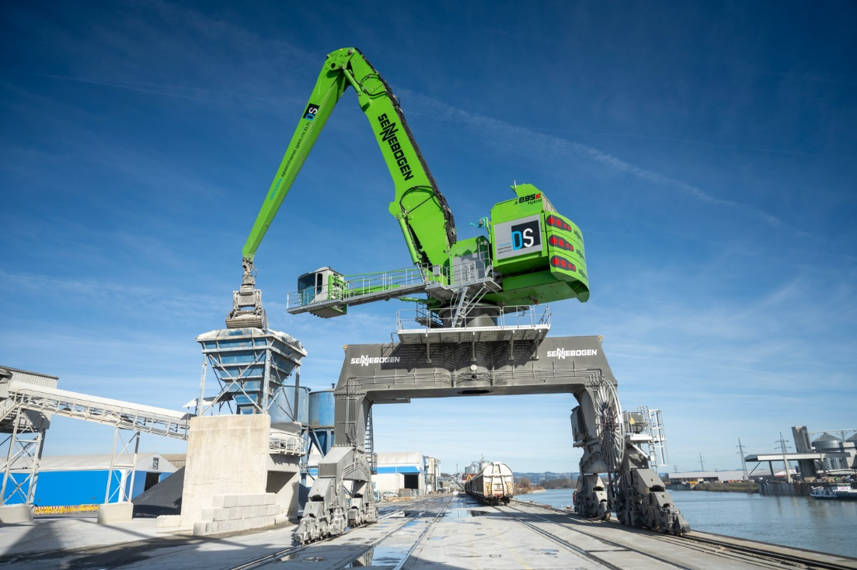

Image 2: The world’s largest 895 E Hybrid port material handler with 420 t operating weight. Here in the version with rail gantry in Austria.

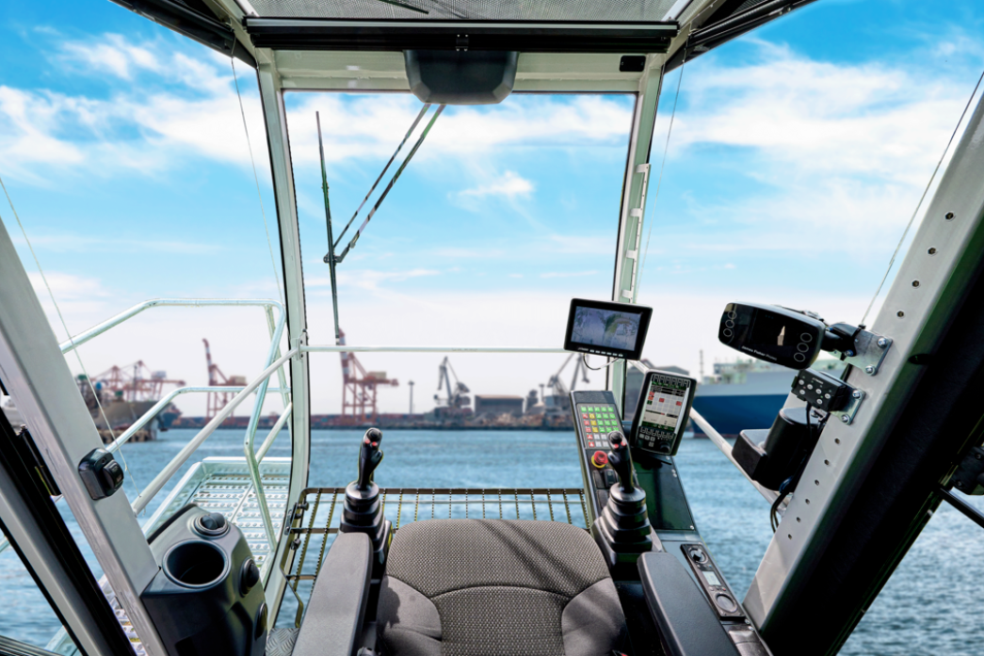

Image 3: The new Portcab large-capacity cab for ports offers excellent visibility and ergonomically optimized seating and operating elements.

