Digital services at SENNEBOGEN: Networking and data-driven optimization of machines for the benefit of the customer
In addition to operators and machines as the most important asset, the topic of data is also becoming increasingly important in ports, scrap yards and sawmills, not least because of the optimization potential they hold. Machines should consume less, work more efficiently and faults should be rectified faster. As a manufacturer, SENNEBOGEN covers important topics of digitalization in the handling industry itself with its digital services SENtrack, TROUBLESHOOTER and the SUPPORT system. This means that the customer receives everything from a single source and can access all applications easily via the mySENNEBOGEN portal.

Focus: user-friendliness
Product Manager Laszlo Dudas explains: "Digital services depend on their users. We believe it is important to make the user experience as simple and attractive as possible. If it is easy for a user to find their way around the portals and find the information relevant to them on operating hours, consumption values and machine utilization quickly, they will be happy to use it." This is why the mySENNEBOGEN portal also provides customers and dealers with a central platform where they can access all applications conveniently via a single sign-on. This means that you only need one login or password for all applications.

Valuable networking of systems: from fleet management to troubleshooting
The SENtrack telemetry system is software for monitoring machine data, locating positions or planning maintenance more effectively. The clear dashboard shows the machine status in real time and offers machine managers and maintenance personnel an appealing user interface for fleet management – from their desk or directly on their smartphone. The customer also benefits from an integrated maintenance overview in SENtrack as a “digital check book” and sees all fault codes at a glance.

If there is a problem with the machine, the TROUBLESHOOTER also makes the right application available for remedying the fault available right away and the service technician has all solution steps ready on site via his mobile phone, even in locations without an Internet connection. With the offline-capable app, the fitters are not reliant on the network coverage at the place of use. The artificial intelligence of the TROUBLESHOOTER sorts the instructions based on the worldwide user data so that the most likely step for the respective error code is always displayed. Thanks to the questions integrated there, the problems can often be reduced to simple errors – e.g. broken fuse – which can also be solved by the operator. "With artificial intelligence in the background, the program continuously learns and thus adapts the solution path individually to each machine. The number of guides also grows weekly," Dudas explains the mechanism behind it.

If a troubleshooting guide does not lead to the desired result, the technician is forwarded directly to the SUPPORT system. The interface between the TROUBLESHOOTER and the SUPPORT ticket system provides SENNEBOGEN experts with an overview of the steps already carried out on site. This means that they can identify the cause of the problem in a targeted and fast manner and address the issue based on the list of actions sent – all thanks to the networking of the three digital services. If direct contact with the service personnel is necessary, an expert provides audiovisual assistance via Remote SUPPORT. Further information can also be exchanged via the screen sharing function and chat function, which also includes a translation function.

The positive feedback from customers and dealers confirms SENNEBOGEN’s extensive range of services. “We want to show our proximity to our customers, advise them on finding the fastest and best solution and then implement it,” says Dudas. “The high availability of our machines and the cost savings that can be achieved are key components of our SENNEBOGEN overall package, which makes us even more valuable as a partner for our customers.”

Captions:
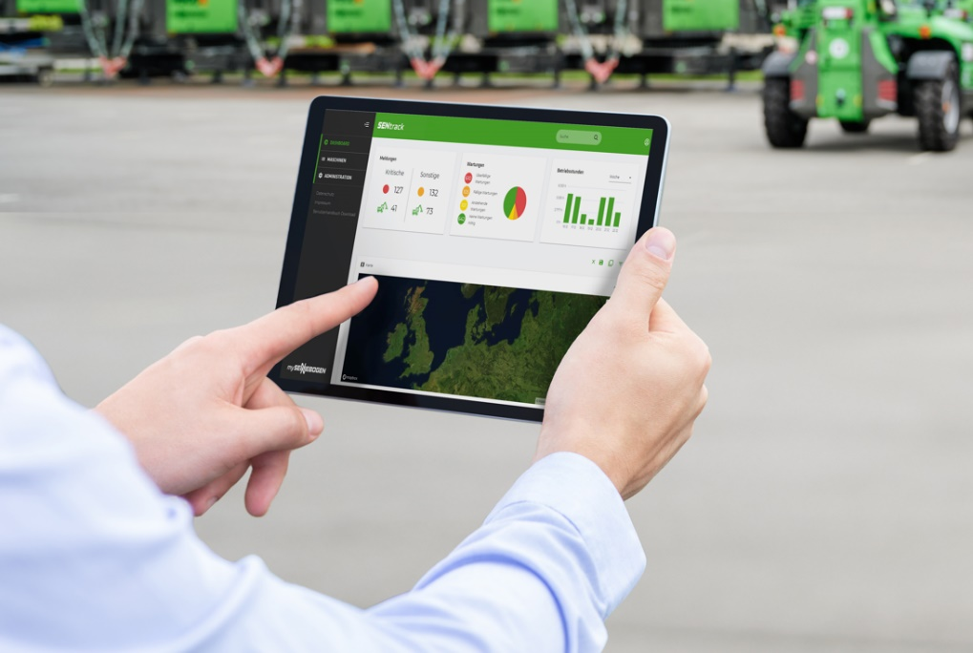

Image 1: SENNEBOGEN’s range of digital services focuses on user-friendliness and clarity. All applications are accessed centrally via the mySENNEBOGEN portal.
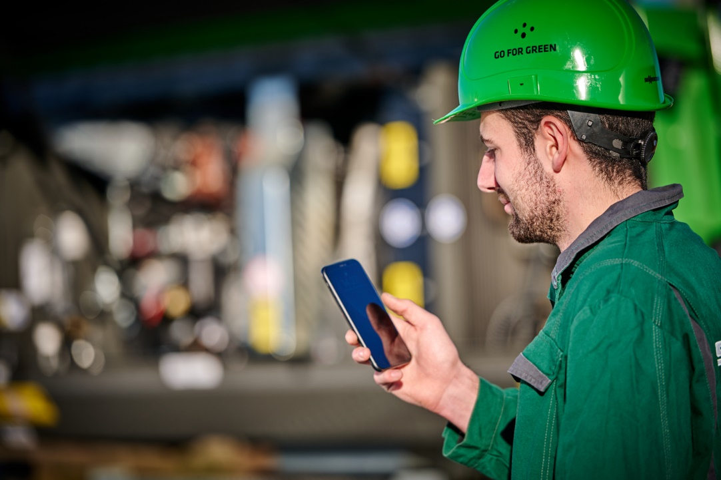

Image 2: Diagnosis made easy: via the instructions in the TROUBLESHOOTER or via the SUPPORT system.

