transport logistic 2023: SENNEBOGEN presented as a full-liner for port handling
transport logistic in Munich is the international trade fair for the port and logistics industry. Visit SENNEBOGEN from May 9 until May 12, 2023 in Hall B4 at Stand 323 and experience our comprehensive product portfolio for port handling. SENNEBOGEN offers a wide range of both economical and powerful material handlers and port cranes thanks to the modular machine concept.
The ports of the world are central transshipment hubs for the global flow of goods. With increasing demand and capacity utilization at ports, the demands on the machines used are also rising, with more extremely specific solutions required. Whether it’s traditional port cranes, mobile material handlers or energy-saving balance machines: SENNEBOGEN offers interesting solutions for all challenges in demanding port handling.
Customer-specific, state-of-the-art port handling machines
SENNEBOGEN’s Green Line material handlers impress with their reliable technology, low operating costs and innovative, customer-specific concepts. Another port giant, now in the sixth machine generation – the 885 G series, with an operating weight of 320 t and a reach of up to 38 m – was just recently successfully launched on the market.
With its wide range of material handlers – with operating weights of 38 t to 420 t and reach of between 13 and 40 m – SENNEBOGEN covers all applications in the port, from bulk material and general cargo, through to container handling. Customers can choose flexibly between mobile and crawler undercarriages, and portal solutions can also be implemented on an individual basis. Almost all port material handlers are also equipped with the energy-saving Green Hybrid recuperation system, which enables the machine to achieve fuel savings of around 30%. In the version with an electric motor, which is available for all SENNEBOGEN material handlers, operating costs can be reduced by a further 50%. The hydraulics have been completely redesigned in the latest machine generation, the G series, which also increases the efficiency of the machines, enabling even more handling performance to be achieved with lower consumption.

Port handling with the balance principle
The innovative concept of the EQ balancers provides the basis for an extremely efficient, productive and cost-effective logistics system at the port. The machine equipment is balanced in every working position by the directly coupled rear weight, which means that the energy consumption can be kept low even with high load capacities and long ranges of up to 42 m. In combination with an electric drive, up to 75% of the operating costs can be saved compared to conventional diesel-powered machines. Various individual equipment variants are also possible here according to the SENNEBOGEN modular system.
Mobile port cranes with a load capacity of up to 90 t
Mobile port cranes can also be the perfect solution for a large number of ports, as their performance data covers a wide range of applications. Here, the SENNEBOGEN portfolio begins with compact mobile cranes and runs right through to the 9300 E, which covers ships up to the Post-Panamax size class with its 40 m working radius. At the same time, the load capacity of 90 t at a radius of 20 m makes it perfectly suited for heavy-duty lifts and container handling.
The best work place in the port: The new SENNEBOGEN Portcab
The Portcab large-capacity cab, which has been completely redesigned just recently, offers the best all-round visibility and comfort on all port machines. A new heating/air conditioning concept with a total of 14 air nozzles distributed throughout the cab ensures pleasant temperatures and optimal air conditions. Generous front and floor windows made of safety glass allow an optimum view into the ship’s hull. Cameras also help to monitor the danger zones. An ergonomically optimized driver’s seat that promotes concentration during work, armrests and footrests that can be individually adjusted to suit the operator, as well as handy stowage and storage areas round off the new cab concept. The cab is extremely stable and safe, as a variety of flexibly adjustable Skylift cab elevations bring the operator to a viewing height of up to 22 m, depending on the machine. All access points to the cab and to the maintenance points on the uppercarriage are well protected by holding points and railings.
Visit us at Stand 323 in Hall B4 for advice in person.
Captions:
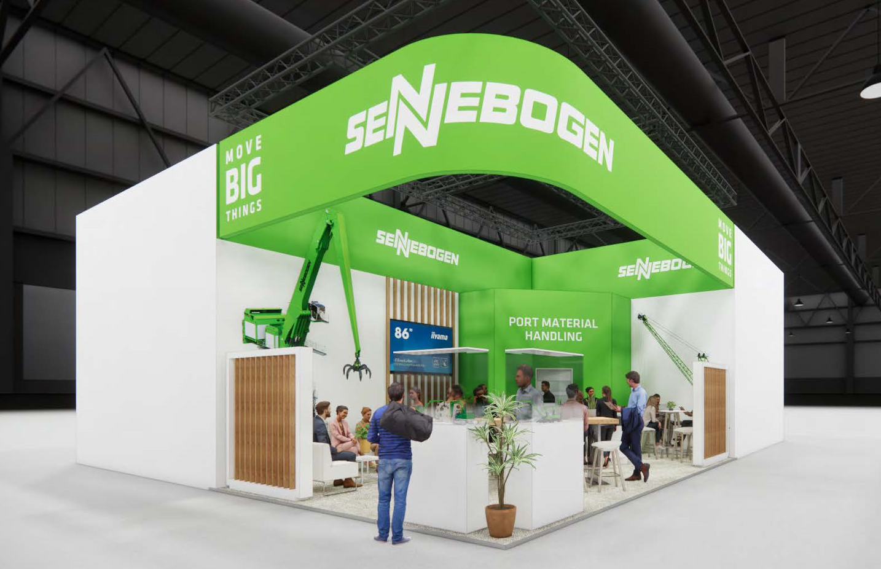
Picture 1: SENNEBOGEN will be exhibiting as a full liner in port handling at transport logistic 2023 and will be presenting individual solutions in the material handler and port crane sector.

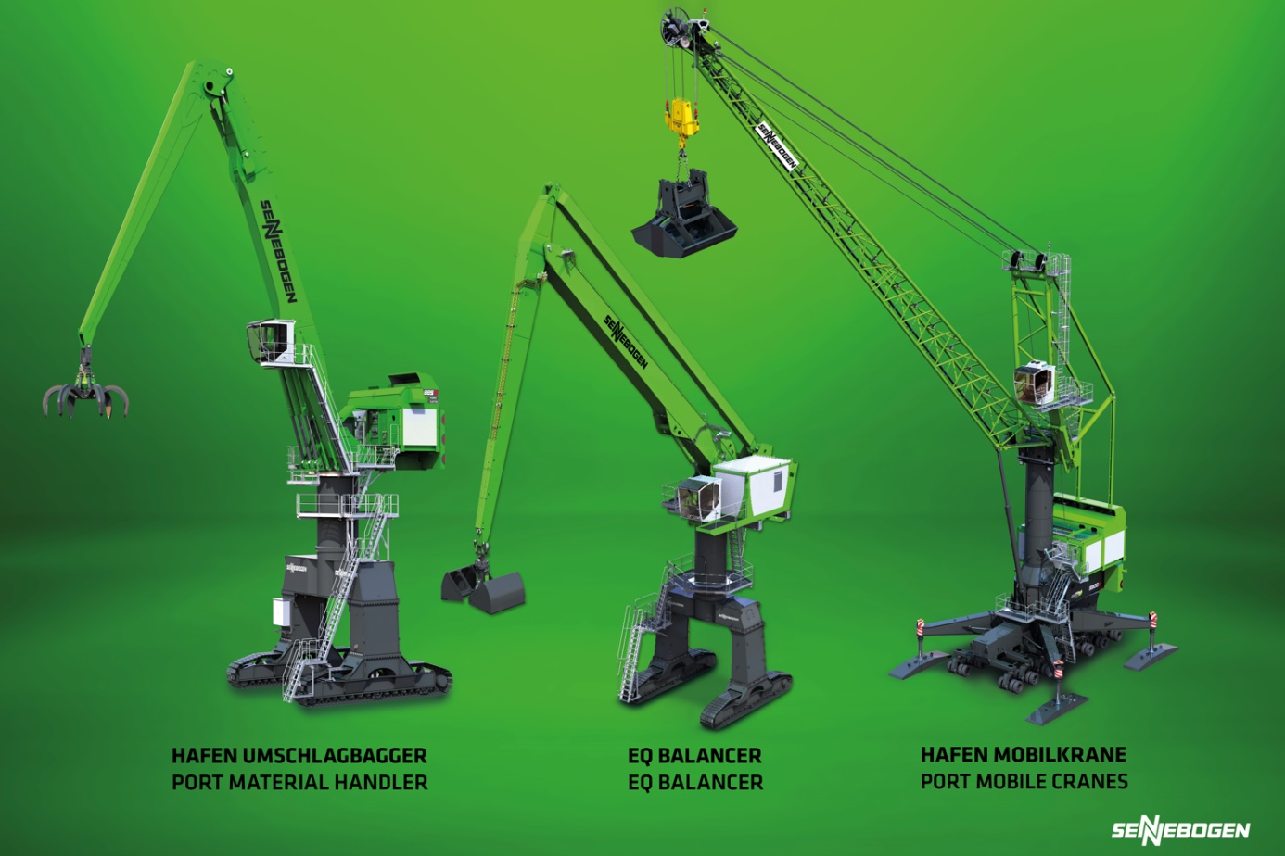
Picture 2: SENNEBOGEN offers customer-specific port machinery, whether it’s traditional port cranes, mobile material handlers or energy-saving balancers.

