Efficient solutions for timber handling: SENNEBOGEN at LIGNA 2023
Visit us from May 15 until May 19, 2023 at LIGNA, the world’s leading trade fair for tools, machines and systems for wood processing in Hanover. In the outdoor area at booth L62, SENNEBOGEN will have its largest ever timber trade fair presence and will set the BIG TIMBER TRENDS for timber handling with a total of three exhibits – including the new material handler with electric drive, the 735 E Green Efficiency Drive (GED).
Discover pioneering and efficient solutions for any task in the sawmill, log yard or in fuel wood processing: the new, economical Pick and Carry machine 735 GED with electric travel drive, the 43 t mobile material handler 830 E with trailer, and the 5.5 t telescopic handler 355E equipped with a timber grab. All this will be on display at our more than 500 m² SENNEBOGEN booth in the outdoor area.
BIG TIMBER TRENDS: from electrification to trailer solutions
With the Green Efficiency Drive being exhibited, SENNEBOGEN has developed a hybrid drive technology that represents a mix of diesel and electric drive, and recuperates the energy released during braking. This technology is particularly effective in sawmills, as the machines do a lot of driving there. Equipped with the electric travel drive, the 735 E Pick and Carry material handler uses up to 30% less energy for the same performance. This not only significantly reduces operating costs, but the machine is also more dynamic and quieter. However, electrification is not only found in the travel drive, but also in electric gantry solutions, which will also play an important role at LIGNA.
The SENNEBOGEN 830 E with trailer also enables you to work efficiently thanks to quick transport and loading cycles. In addition to a remarkable stacking height of 12 m and a working radius of up to 14 m, the material handler also features a rotatable uppercarriage, which enables the operator to travel forwards in any situation – for maximum precision and speed when working with a trailer. Thanks to its powerful all-wheel drive and reinforced mobile undercarriage, the 830 E is ideally suited to towing a trailer in tight spaces and on rough terrain.
Another trendsetter in timber handling is the SENNEBOGEN 355 E. This particularly robust and powerful telehandler with 5.5 t load capacity and the series standard cab, which can be raised to a viewing height of 4.25 m, also proves its versatility here. Thanks to the hydraulic quick-change system, the equipment can be changed at the push of a button: with a bucket of up to 4 m³, for example, it plays to its strengths when loading wood chips. Equipped with a lifting fork, it stacks pallets up to a height of 8.45 m. It will be on display at the SENNEBOGEN booth with a special timber grab that makes the telescopic handler perfect for transporting and loading fuel wood and logs.

All this can be seen from May 15-19, 2023 at LIGNA in Hanover, SENNEBOGEN booth L62 in the outdoor area. We look forward to seeing you.

Caption:
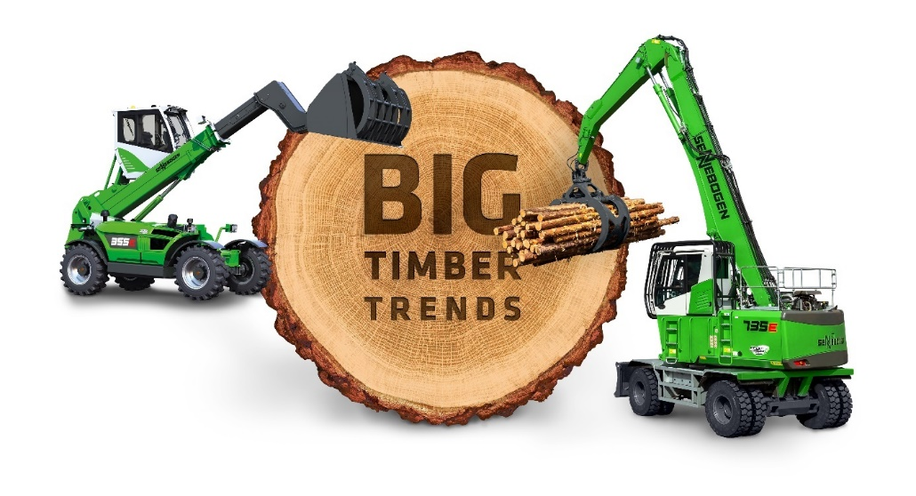
Picture 1: SENNEBOGEN will be presenting the BIG TIMBER TRENDS for timber handling, from electrification to trailer solutions, at LIGNA 2023 in Hanover.

