SENNEBOGEN OPENS NEW STEEL PLANT IN HUNGARY TO MEET GROWING DEMAND
With the official opening of the new steel plant of Termelés-Logistic-Centrum GmbH in Litér (Hungary), SENNEBOGEN, the German manufacturer of material handlers and crane technology, is continuing its growth strategy and expanding its capacities for steel assemblies and welded constructions. A 29,000 m² production hall and an office building were built on an area of over 13 ha. Around 80 new jobs were also created, meaning that the TLC now has over 700 employees. The plant was officially opened on May 26, 2023, together with representatives from politics.
The engineering company SENNEBOGEN has grown significantly in recent years. "Termelés-Logistic-Centrum GmbH is our most important supplier of steel assemblies. With this investment in Hungary, we are not only expanding our capacities to meet the growing demand, but also building reserves for the future," says shareholder Walter Sennebogen. About half an hour’s drive from the first SENNEBOGEN steel plant in Balatonfüred, the new site in Litér was commissioned in July 2022 after only 2.5 years of construction. On May 26, 2023, the project sponsored by the Hungarian government was officially inaugurated by shareholder Walter Sennebogen and the Managing Director of the site Michael Seiferling, together with the Hungarian Minister for Foreign Affairs and Trade Péter Szijjártó and MP Károly Kontrát.

Increase in capacity thanks to greenfield approach
The new steel plant in Litér is designed for handling large and heavy components up to approx. 30 m in length and 25 t in weight and offers a capacity for 20,000 t of steel structures per year in the current expansion stage. The “greenfield” production facility with 29,000 m² of hall space not only offers increased capacity due to the expanded area, but also due to the high throughput, as warehousing, work preparation and intralogistics are optimized and geared towards the particularly large components of the construction equipment industry. Investments were also made in modern machine tools and machining centers for mechanical processing as well as for flame and laser cutting. In addition, there is an ergonomically sophisticated welding area for the production of welded structures and a paint shop equipped to the latest standards. "With the new plant, we are supplementing our previous steel component production in Balatonfüred. The locations are also logistically connected via plant traffic," says Managing Director Michael Seiferling.

Modern workplaces and sustainability
The investment created 80 new jobs in an attractive working environment for qualified specialists, in particular construction mechanics and welding technology specialists. In addition to the production hall, modern office space and a canteen for employees were also created on the 13 ha area.
The sustainability aspect also played a key role in the design of the new location. For example, the plant was equipped with a photovoltaic system with an output of 2.4 megawatts, so that it will be energy self-sufficient with the electrical power generated from the PV system. The office building is also heated with energy-efficient underfloor heating and the production hall with low-temperature heating via concrete core activation.

Captions:
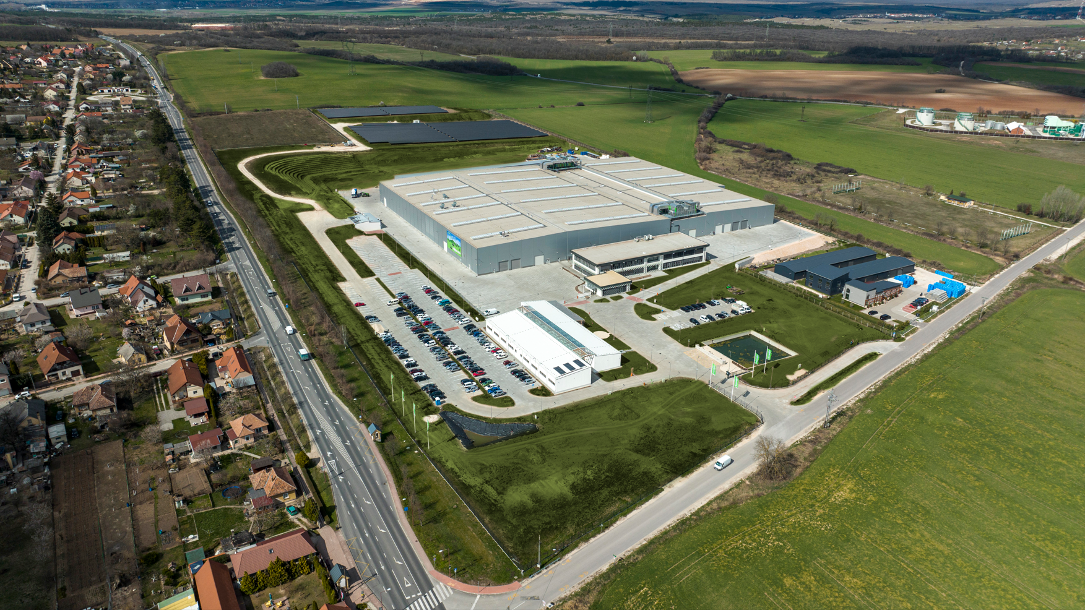
Picture 1: In order to meet the growing demand, SENNEBOGEN has built a new, state-of-the-art steel plant in Litér (Hungary) on an area of around 13 ha.
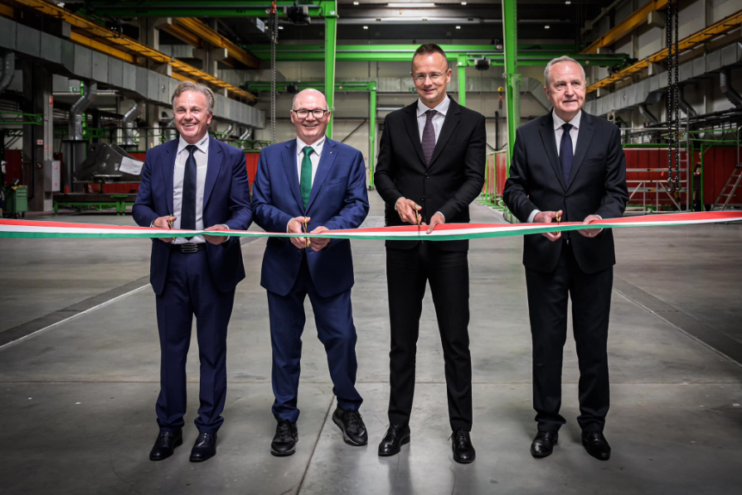

Picture 2: Managing Director of the site Michael Seiferling, Shareholder Walter Sennebogen, Foreign Minister Péter Szijjártó and Member of Parliament Károly Kontrát (from left to right) opened the plant on May 26, 2023.

