Bauma 2022: SENNEBOGEN presents its own lubricants and auxiliary materials
High-quality lubricants have a significant influence on the performance and service life of a machine. That is why SENNEBOGEN is continuing to expand its range of original spare parts and now offers its own series of lubricants and auxiliary materials. They are perfectly tailored to the needs of the green machines from Straubing.
SENNEBOGEN is expanding its range of original spare parts at bauma 2022 and is launching both the SENlube lubricant series and the SENprotect series of auxiliary and material protection agents.

SENlube: genuine, premium quality lubricating oils and greases for engines, gearboxes, hydraulics and axles
The new series of lubricating oils and greases includes engine oil SENlube Engine Longlife 5W-30-LA, which has a particularly wide temperature range. It also saves fuel and reduces emissions. With long oil change intervals and protective additives, using the oil also reduces maintenance costs.
SENNEBOGEN offers a hydraulic oil specifically for hydraulics, the longlife multi-grade hydraulic oil SENlube HYDRO D46, which enables efficient operation of hydraulic systems, and the SENlube HYDRO POLAR, a special oil for low temperatures of down to -30° C. The special oil SENlube Gear Longlife not only lubricates hydraulic systems in conjunction with freefall winches, such as those used in duty cycle cranes, but its friction-reducing additives also make it suitable for axles.
In terms of gearbox oils, there is SENlube Gear Hypoid LS axle oil which has very good limited slip additives and SENlube Gear Synth 220 synthetic gearbox oil for winch gearboxes. Synthetic oils are manufactured with particularly high-quality base oils and special additives and ensure a long component service life, even under impact loads or in contact with water or solids.
When it comes to lubricating greases, the SENlube Multi Grease has proven to be an absolute all-rounder for any lubricated mounting points. The resilient high-performance grease is versatile and stands out from the range of conventional greases with its green color. SENNEBOGEN customers can now also rely on a lubricating grease directly from the manufacturer when lubricating their telescopic booms. Special grease SENlube Tele Grease with its partial synthesis technology prevents jerking during telescoping.

Value retention and protection with SENprotect
The SENprotect series focuses on value retention and protection. The range includes the long-term coolant SENprotect Antifreeze as well as protective fluids for piston rods and electrical plug connectors, SENprotect Chrome/Electric Plug. SENprotect Paint offers optimal protection for painted surfaces, even under extreme operating conditions such as sea transport.

Ordering is done via relevant local sales and service partners and customers are then supplied centrally via the spare parts warehouse at the Customer Service Center at the Steinach site, which started operations around a year ago. Automated warehouse technology and an established logistics network ensure a fast supply of original spare parts and components worldwide.

Captions:
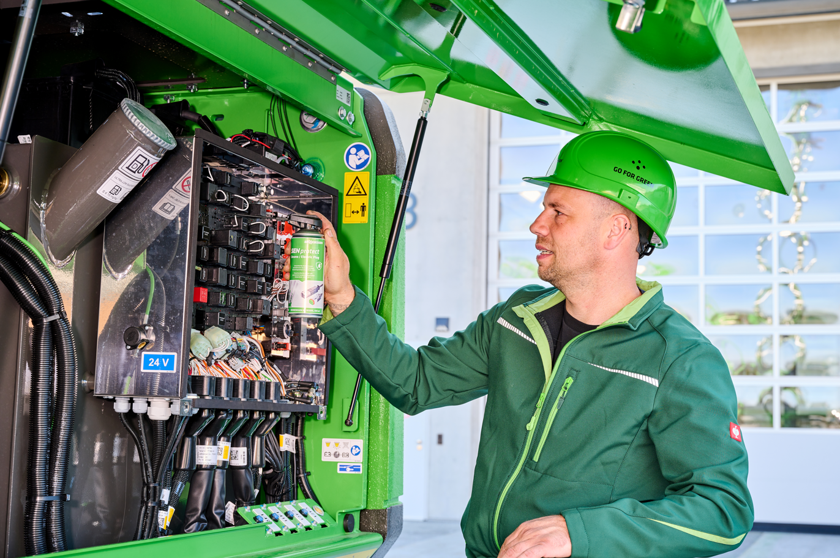

Picture 1: Perfect match: the new original lubricants and auxiliary materials are perfectly tailored to the needs of SENNEBOGEN machines.
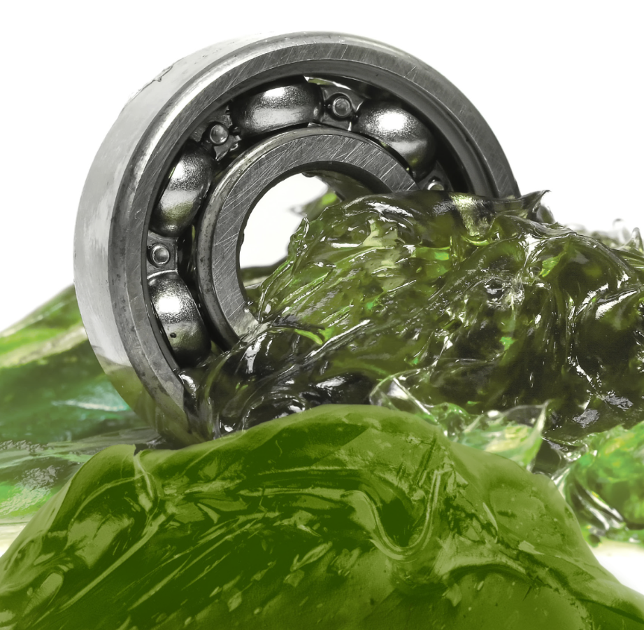
Picture 2: SENNEBOGEN’s resilient high-performance grease, SENlube Multi Grease, is versatile and stands out from the range of conventional greases thanks to its green color.

