SENNEBOGEN at bauma 2022: strong appearance of the INNOVATION PACEMAKER
With its more than 2100 m² stand in the center of the outdoor area, SENNEBOGEN was not only once again the "Green Heart of bauma" in 2022, but also impressively asserted its position as INNOVATION PACEMAKER in the 70th year of the company's history. "I never believed that a face-to-face encounter could be replaced by a digital experience, and I am immensely pleased that bauma proved just that. With our strong brand presence, we were able to inspire many customers and prospects. Our 12 exhibits were more than impressive, both with the 885 G in size and technologically with many innovations on the topics of user-friendliness, efficiency and zero emissions," said a delighted CEO Erich Sennebogen.
At bauma 2022, which was a record-breaking event for SENNEBOGEN in every respect, the highlights of the exhibition were therefore dominated by the topics of energy efficiency, sustainability, and operator and maintenance friendliness.

Large-scale machine highlight: the 320 t port material handler 885 G
The largest material handler ever exhibited at a bauma with an operating weight of 320 t, the SENNEBOGEN 885 G, was an absolute visitor magnet this year due to its dimensions alone. With its operating weight of around 320 t and a reach of up to 38 m, the machine can be used primarily in the demanding port segment and shines with around 30% higher load capacities compared to the competition. Equipped with the new Portcab and representing the new generation of machines, the G series, it is also particularly user-friendly and efficient.

Zero emission and individually designed energy saving solutions: from electric travel drive to battery technology
SENNEBOGEN has been committed to the topic of energy saving and electrification for more than thirty years - and so in 2022 trade fair visitors were once again able to learn about various innovative solutions for many areas of application.
The Green Hybrid energy recovery system is used in the boom movements of large material handlers and has recently been installed in medium-sized machines with operating weights of 47 t and above, such as the 835 G Hybrid. It stores the energy generated when the boom is lowered and releases it again when it is subsequently raised, thus saving up to 30% in fuel.
For predominantly traveling machines such as the 735 E pick and carry timber handling machine, the Green Efficiency Drive (GED) electric travel drive, which was also presented, proves to be the ideal solution. In addition to lower emissions, the GED also brings energy savings of up to 30%. This not only significantly reduces operating costs, but the machine is also more dynamic and quieter.
Another technological highlight were the two battery-powered machines both in the crane and in the material handling area: the 30-t 825 Electro Battery recycling material handler and the 50-t 653 Electro Battery telescopic crawler crane. Thanks to the Dual Power Management System, which permits both battery-powered and mains-powered operation, these machines can be used with zero emissions without any restrictions. Further advantages are the flexible charging capability at conventional industrial power sockets, the reduced service work and the increased comfort for the employees, who appreciate not only the special sensitivity but also the reduced noise and vibrations of the machines.
Finally, the SENtrack telematics software presented at the booth also helps to save costs and energy by allowing operators to keep an eye on all key figures such as utilization and consumption in real time, thus enabling them to manage their fleet optimally.

The new G-series machine generation: The plus in efficiency and user-friendliness
In addition, a number of machines from the new machine generation, the G-series, were also presented at bauma, including the 4 t telehandler 340 G, the brand new 24 t recycling material handler 824 G, and the port material handlers 835 G and 885 G. The 6th machine generation is characterized first and foremost by increased efficiency, enhanced responsiveness, optimum serviceability and improved operator comfort. The new Maxcab and Portcab were not only on display on the machines, but could also be explored separately as exhibits at the trade show booth or via virtual reality glasses.

Machine innovations for all industries: from demolition to specialized civil engineering
Other highlights included the multifunctional 48 t demolition machine 830 Demolition, which celebrated its trade show premiere with two new equipment features: a 3-part longfront equipment with 23 m reach and a 10 t counterweight that can be hydraulically unloaded to reduce transport weight. Also on display was the 728 E tree care handler with up to 21 m reach, which was recently launched on the market. This machine is perfectly suited for professional landscape and tree maintenance along traffic routes.
A broad portfolio of machines was also exhibited for the construction industry, which primarily impresses with its reliability and state-of-the-art safety and environmental standards. In addition to the 200 t 5500 G crawler crane, two models were on display in the popular 100 tonne performance class: the 6100 E crawler crane with diaphragm wall grab, which is ideally suited for specialized civil engineering, and the 100 t 6103 E telescopic crawler crane, which was recently launched on the market.

A record bauma in every respect
All in all, bauma 2022 was marked by records in every respect for SENNEBOGEN. With 12 machines, there were more exhibits on the booth than ever before, and more dealers and stand personnel were present than ever before to look after customers – who also came in large numbers, as the frequency of contact and the number of requests for quotations were also uniquely high.
In addition to the machine highlights, bauma is and always will be simply a great celebration, Erich Sennebogen also confirms: "Almost nowhere do you experience as much emotion as at the trade fair. You create memorable experiences for customers, dealers and employees. These shared experiences that we created over the seven days were very valuable for everyone involved. The high-quality contacts and numerous discussions with customers and business partners, who once again traveled from almost all over the world this year, radiate optimism and are a clear signal of the stability and forward-looking nature of the construction machinery industry."

Captions:
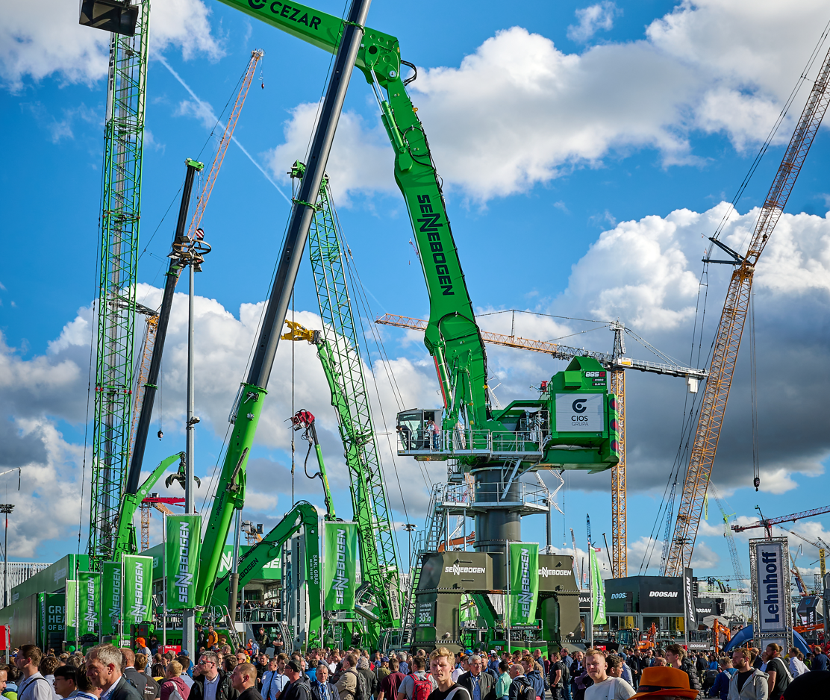
Picture 1: SENNEBOGEN again attracted many bauma visitors this year with an impressive range of machines and technological innovations. Absolute large-scale machine highlight and visitor magnet: the largest material handler ever exhibited at a bauma with an operating weight of 320 t, SENNEBOGEN 885 G.
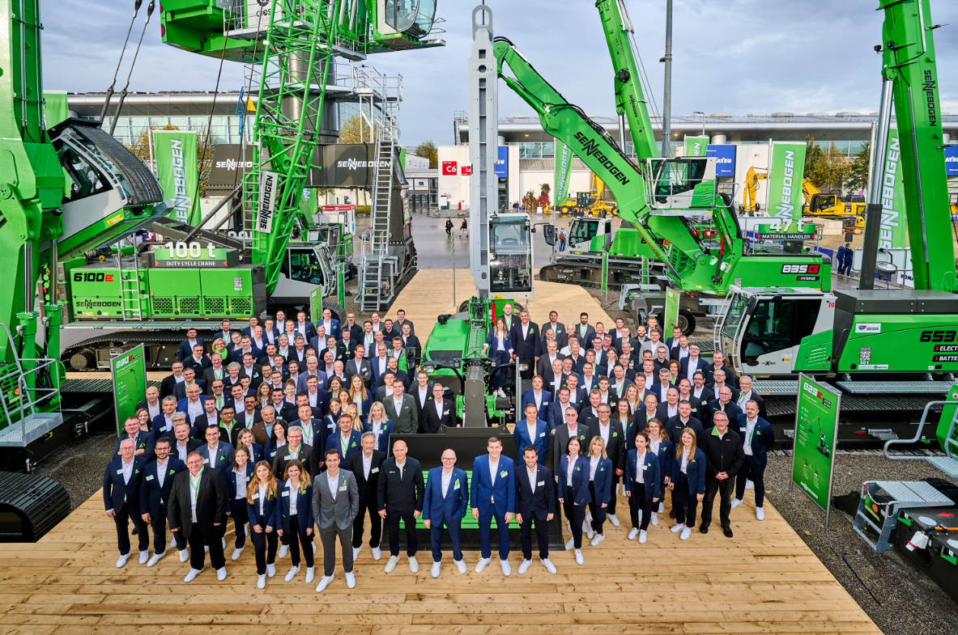

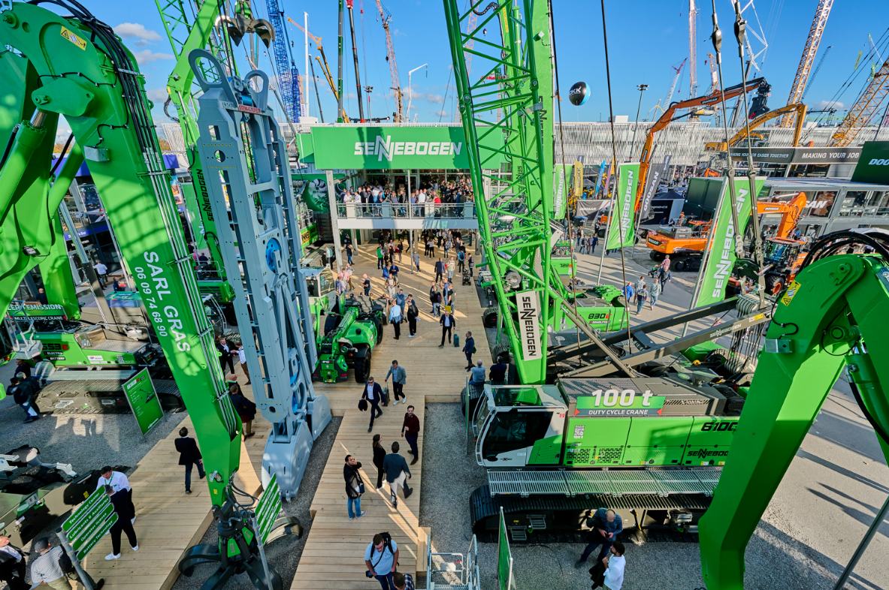
Pictures 2 and 3: SENNEBOGEN guarantees worldwide presence with more than 180 international sales partners and with over 300 service points. With a large, international team and a total of 12 machine exhibits from all application areas, SENNEBOGEN also welcomed the large number of bauma trade fair visitors, which exceeded all industry expectations.
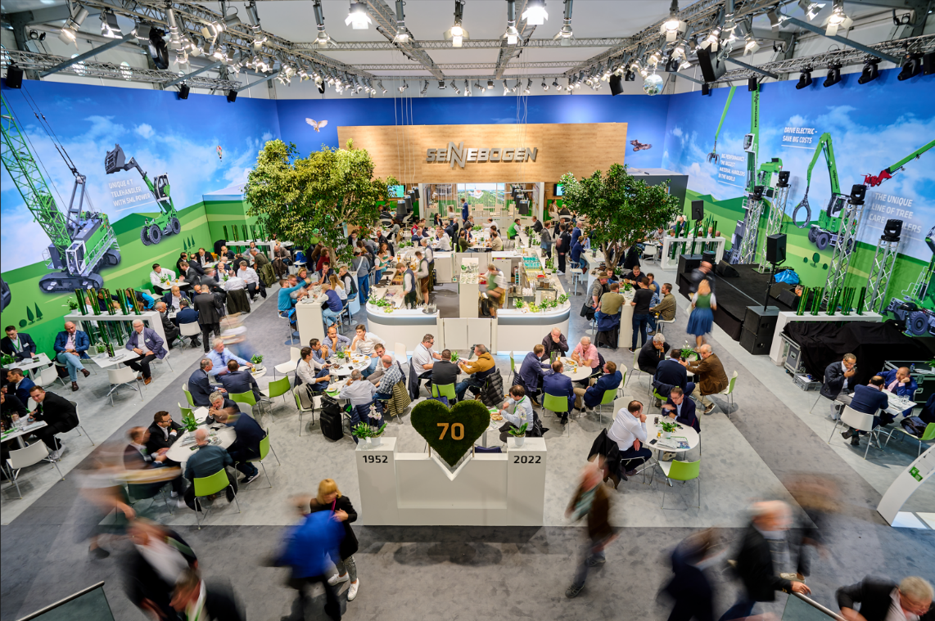
Picture 4: At bauma, not only the latest technological innovations were celebrated, but also the 70th anniversary of the machine manufacturer.
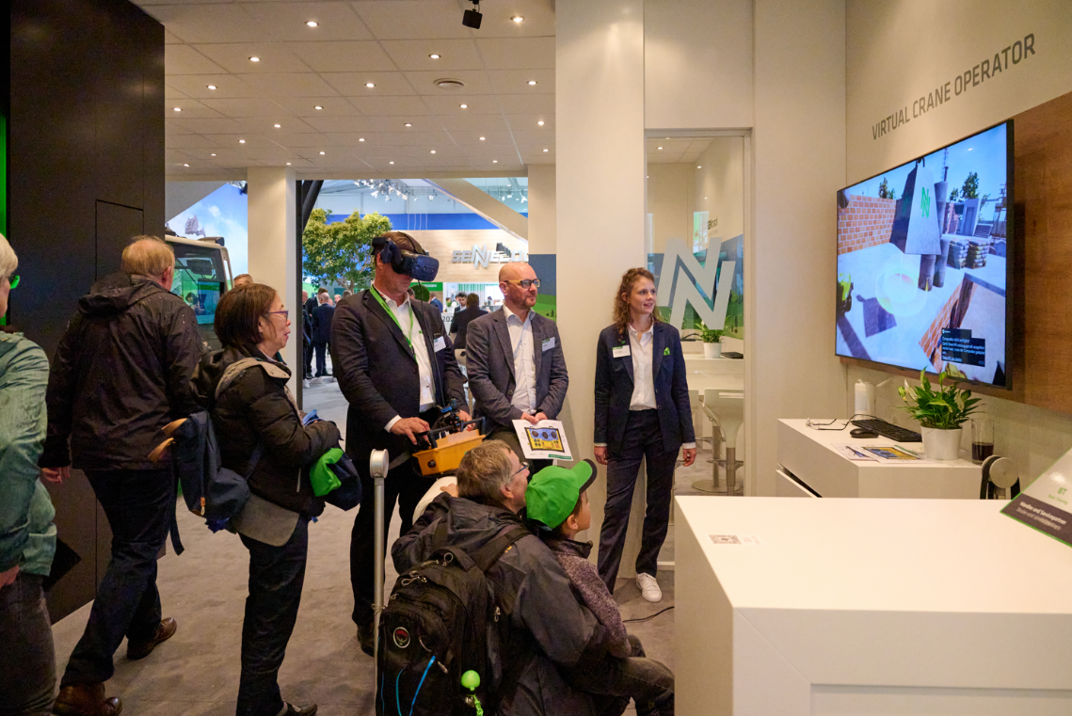
Picture 5: Various virtual reality attractions such as the Virtual Crane Operator also made it possible for visitors to the trade show to experience the products on site.
