New 320-tonne material handler for demanding port handling: the SENNEBOGEN 885 G
At bauma 2022, SENNEBOGEN will be presenting the largest material handler ever exhibited at a bauma: the 885 G series. The port material handling giant impresses with an operating weight of around 320 t and a reach of up to 38 m. It is a machine with impressive dimensions and state-of-the-art technology for the port.
With the new port material handler, which will be presented to the public at bauma, SENNEBOGEN is adding another large material handler to its portfolio, which, with its operating weight of around 320 t, will be used primarily in the port segment.
Around 30 % higher load capacity
The 885G fits perfectly into the gap between the existing 875E and the world’s largest material handler, the 895E, and thus caters for the increasing size of ships, especially at inland ports. Compared to its competitors, the SENNEBOGEN machine has an average of around 30% higher load capacities. Not only does the 885G work with the highest levels of precision and speed, but it is also particularly efficient and economical.
Numerous equipment options
Thanks to the variety of equipment typical of SENNEBOGEN, the machine can be individually configured according to the respective customer requirements and used for all port handling activities. For example, there is a choice of five different equipment variants with reaches ranging from 24 to 38 m, and the quick-changer on the stick and the powerful hydraulics allow a wide variety of attachments to be operated flexibly. In addition, it is ideally suited for heavy-duty general cargo use and can handle both heavy container lifts and lifts in the heavy-duty range up to 50 t.
Lower operating costs with higher handling performance
As a further development of the latest generation of machines, the G series, special attention has also been paid to energy efficiency and operator comfort in the 885G. Not only is the sophisticated machine design itself resource-saving, the new material handler is also equipped with the globally renowned SENNEBOGEN Green Hybrid recuperation system, which has already been successfully established for material handlers with an operating weight of 47 t or more. This innovative recuperation method not only works extremely reliably and safely, but also saves up to 30% in operating costs. The machine is also available with both diesel and energy-saving electric drive.
The low operating costs go hand in hand with the high handling capacity of up to 1,800 t per hour. This significantly reduces the waiting time of ships in the port and in turn has a positive effect on the port operator’s figures. A robust steel construction and manageable and service-friendly technology with high-quality drive and control components also ensure long-term consistent performance and maximum availability. The state-of-the-art Safety Boom Lift automatic grab protects equipment, the ship hull and port areas, for example, by means of the automatic lift when closing the grab.
The new SENNEBOGEN Portcab: the best work place in the port
The completely reworked large-capacity Portcab offers the best all-round visibility and comfort. Generous front and floor windows made of safety glass allow an optimum view into the ship’s hull. In addition, cameras, whose image is shown on a large 10.2" monitor in the cabin, assist in monitoring hazardous areas. A new heating/air-conditioning design with a total of 14 air nozzles distributed throughout the cab with fresh air and recirculated air filter ensures optimum temperature and air conditions in the cab. The optimized cab design is rounded off with easy-to-adjust armrests and footrests, practical storage and stowage areas as well as an ergonomically sophisticated operator's seat, which promotes operator concentration.
It is also particularly stable and safe at heights. A variety of flexibly adjustable Skylift cab elevations bring the operator to a viewing height of up to 22 m. A sophisticated system of steps, ascents and railings make it easy to access to the cab and maintenance points on the uppercarriage and carefully secure the ascent and descent.

To be seen at bauma 2022
See the SENNEBOGEN 885 G port giant live from 24 October to 31 October at the SENNEBOGEN booth at the FM.712 open-air site, Messe München.

Captions:
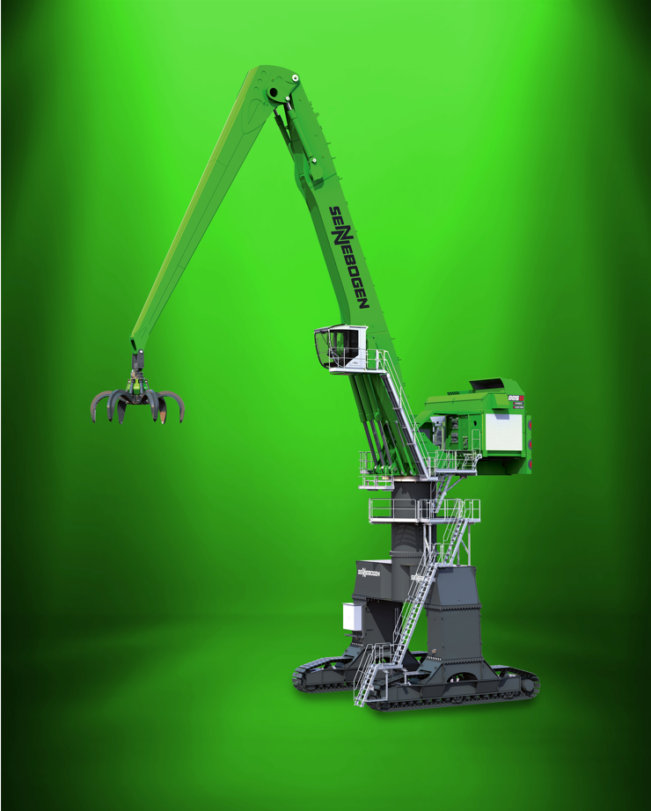
Picture 1: SENNEBOGEN is presenting a gigantic 320-tonne port handling machine with Green Hybrid energy recovery system at bauma 2022.

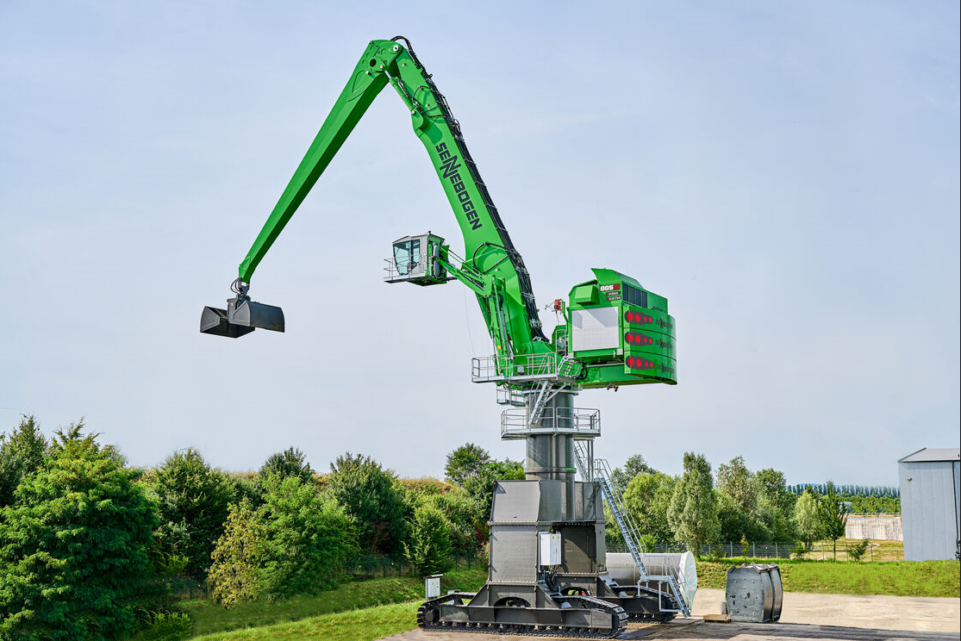
Picture 2: The SENNEBOGEN 885G has a reach of up to 38 m and can be used for all tasks in demanding port handling.

