SENNEBOGEN 835 G Hybrid – New machine generation for maximum efficiency
Efficient, comfortable and maintenance-friendly – these are the keywords for SENNEBOGEN’s new generation of material handler. The popular 835 was the first medium-sized material handler to be further developed into the new G series and equipped with the Green Hybrid system – for maximum efficiency in use.
The new 835 G Hybrid is designed with an operating weight of up to 47 t and various equipment variants with ranges of 16 m to 20 m for use in scrap, timber and port handling. Equipped with the Green Hybrid recuperation system, the machine saves around 30% in fuel, and the electric version reduces operating costs by an additional 50%. SENNEBOGEN's tried-and-tested modular principle also enables customer-specific configuration of the 835 G Hybrid, with undercarriage variants ranging from mobile to stationary, and through to various drive systems.

Lower consumption and higher handling capacity
The main focus of the 835 G Hybrid is on saving energy. This is reflected, for example, in the fact that the well-known Green Hybrid energy recovery system has been installed in a machine of this size for the first time. The system, which consists of a gas accumulator in the rear of the machine and a third hydraulic cylinder on the boom, stores the energy generated when the boom is lowered, like a tensioned spring, and releases it for the next lift. This innovative recuperation method not only works extremely reliably and safely, but also saves up to 1/3 in operating costs. Together with the extensively redesigned hydraulics, this increases the efficiency of the machine, so that even more handling capacity can be achieved with lower consumption.
In the 160 kW electric engine version, not only are exhaust gases completely eliminated, but resources and maintenance work are also reduced, meaning that operating costs can be cut by a further 50%.
Fully optimized for operator and servicing
This brings us to another major advantage of the G series - operator and maintenance friendliness. The new comfort Maxcab guarantees permanently relaxed and focused working with hydraulic elevation of 2.80 m as standard – optionally up to 3.50 m – a revised control panel, all-round visibility thanks to continuous front and side windows, and new safety features.
In terms of service, the clear structure and intelligent, easily accessible maintenance points are particularly valuable, as they make the machine even more reliable in daily operations.

See for yourself the latest generation of material handling technology, right with us at the SENNEBOGEN stand at bauma 2022.

Captions:
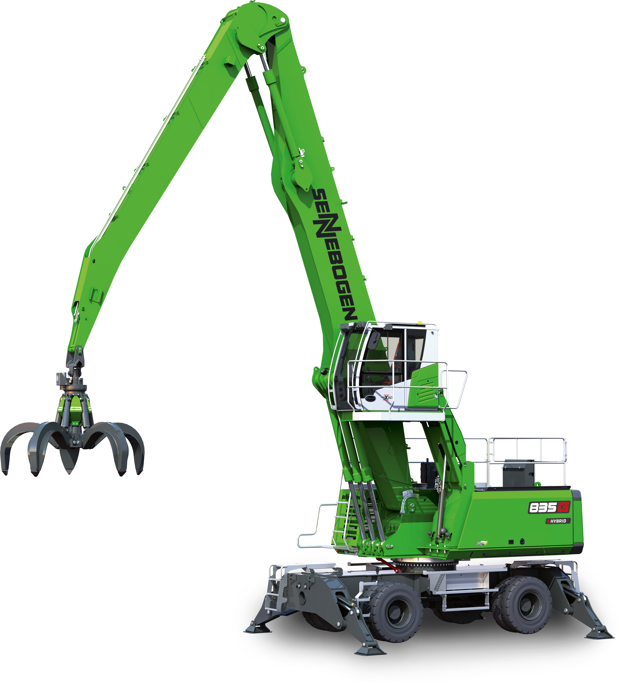
Picture 1: SENNEBOGEN will present the new 835 G Hybrid at bauma 2022 – a 47 t material handler from the latest generation of machines, equipped with the Green Hybrid energy recovery system.
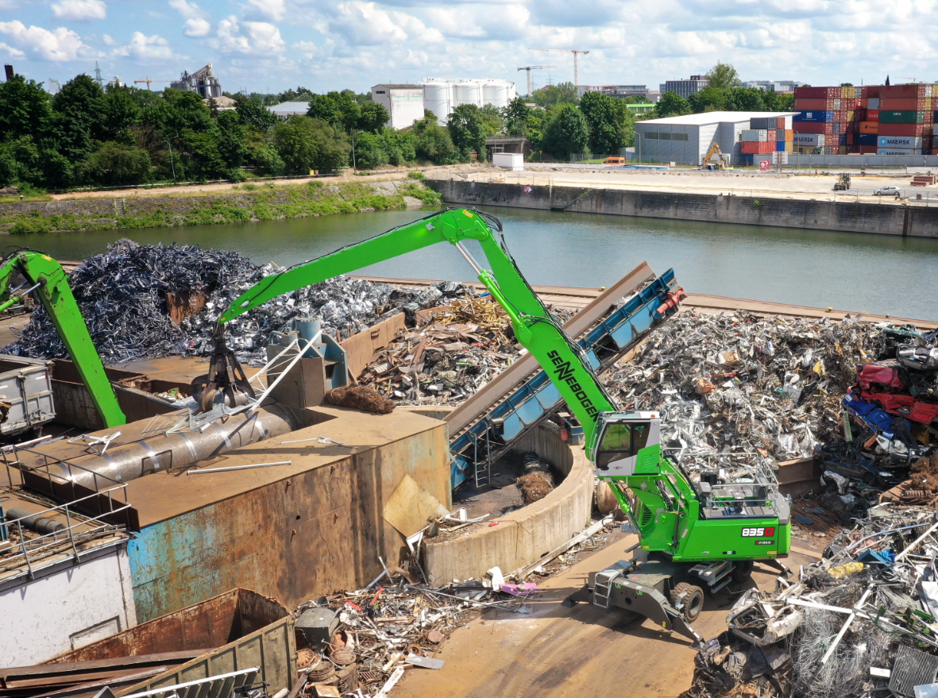
Picture 2: Powerful, precise and fast – the 835 G Hybrid material handler with a reach of up to 20 m sets new standards for efficiency in demanding scrap and port handling.

