Multifunctional SENNEBOGEN 830 Demolition machine with two new equipment features: The multi-tool among demolition machines
At the demolition site, two factors determine the success of a project: high safety and time- and cost-saving solutions. SENNEBOGEN meets both requirements in particular with the multifunctional 830 Demolition machine. The tried-and-tested 48 t demolition machine will be on show at bauma with two new equipment features that make it extremely versatile. In addition to three-part demolition equipment with a maximum pin height of 23 meters, SENNEBOGEN also presents a fully hydraulically unloadable counterweight, which can be removed at the push of a button.

SENNEBOGEN 830 Demolition: Safe dismantling in confined spaces
Demolition work often takes place in urban areas to create space for new construction projects. Urban demolition sites are therefore characterized primarily by confined spaces or limited working areas for the machines used. The 830 Demolition is perfect for work in cramped, inner-city construction sites thanks to state-of-the-art, environmentally friendly engine technology, its compact dimensions, flexible operation in 360-degree swivel mode and various equipment options. In addition to numerous other safety features, the machine has the widest outrigger in its class with a standing width of up to 4.50 meters, thus guaranteeing optimal stability and vibration-free working, even for dismantling tasks at great height. The elevating cab, which can be tilted up to 30 degrees, not only gives the operator an excellent overview of the work, but also keeps them at a safe distance from the danger zone.
With the machine’s powerful hydraulics, a wide variety of equipment can be operated, from demolition cutters to pulverizers, and can also be changed in the shortest possible time thanks to the optional quick-changer. The machine also impresses with its excellent sorting performance in the increasingly important field of demolition recycling and effortlessly separates the construction waste that accumulates.

New: Three-part longfront equipment for more flexibility and a reach height of 23 m
The new longfront equipment for the 830 Demolition enables even greater distance from the demolition object and thus even more safety: With the AB23 three-part demolition equipment, SENNEBOGEN presents an equipment option that not only increases the safety distance, but also makes the machine even more flexible in use. The 830 Demolition easily masters higher reach heights (23 m) and work over projecting edges with the new articulated boom. With the help of the fully hydraulic quick-change system, equipment can be picked up or put down at the push of a button and quickly and safely switched to a shorter handling equipment without the operator having to leave the cab. With just one machine, you can carry out a wide range of tasks and thus save time, fuel and transport costs.

New: Hydraulically unloadable counterweight for cost-effective transport
Thanks to the new equipment option with removable counterweight, the 830 Demolition can also be transported even faster and more cost-effectively – in up to three parts, which are transported to the next demolition project by low loader. A button on the remote control reduces the transport weight of the 830 Demolition by around 10 tons using the fully hydraulic ballast rack. In addition, the transport width of the telescopic crawler undercarriage can be reduced to 2.90 meters and the three-part demolition equipment is transported to the next job in a transport frame – simple, cost-saving and efficient.

Presentation at bauma 2022
The new SENNEBOGEN 830 Demolition, equipped with a three-part boom and unloadable counterweight, will be presented to the public for the first time at bauma 2022, directly at the SENNEBOGEN stand, FM.712 open-air site, Messe München.

Captions:

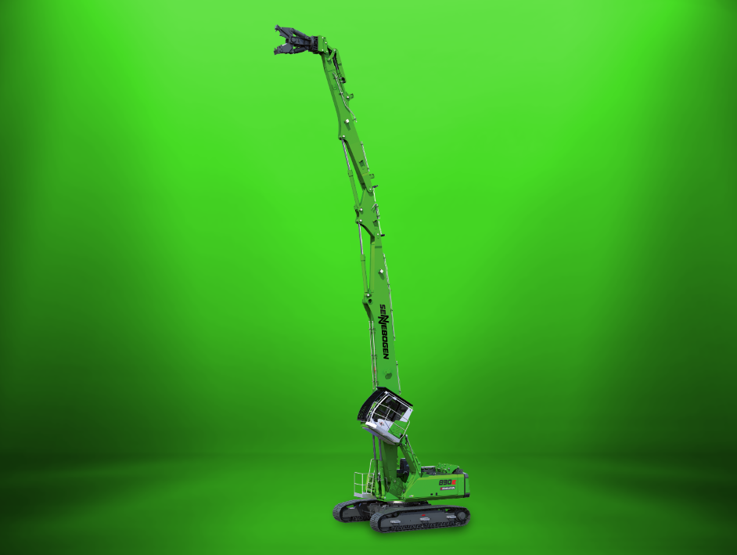
Picture 1: The SENNEBOGEN 830 Demolition machine will be on show at bauma with two new equipment features: the three-part longfront equipment with intermediate joint and an unloadable counterweight.

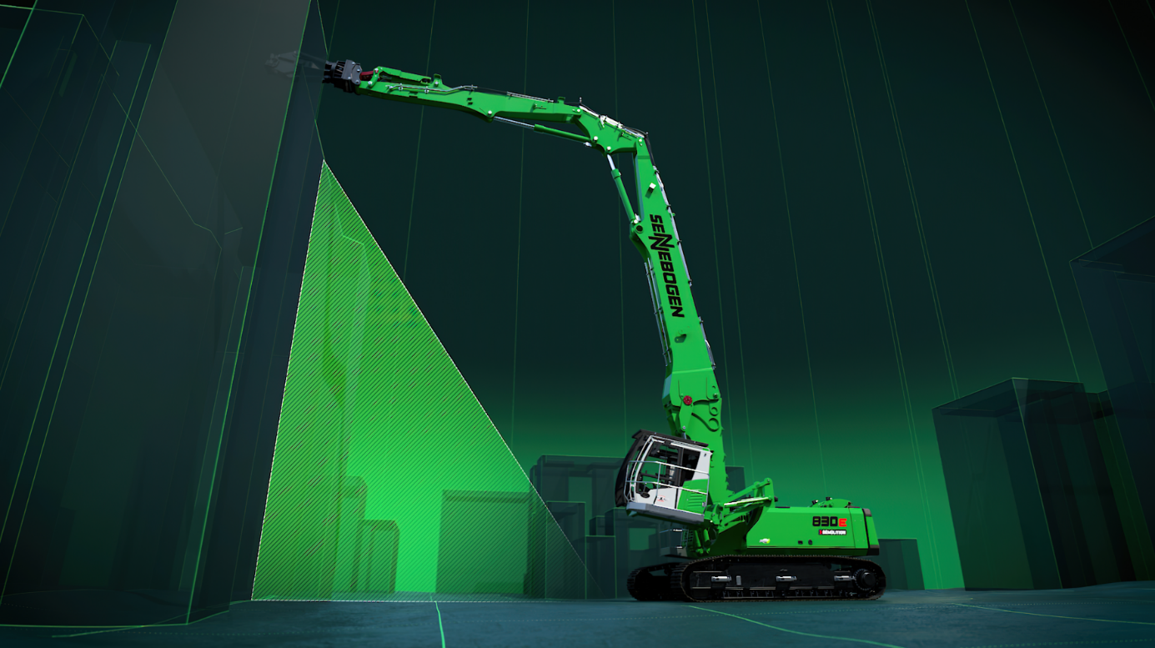
Picture 2: With the new SENNEBOGEN 830 Demolition, projecting edges can be safely and effortlessly overcome during selective dismantling.

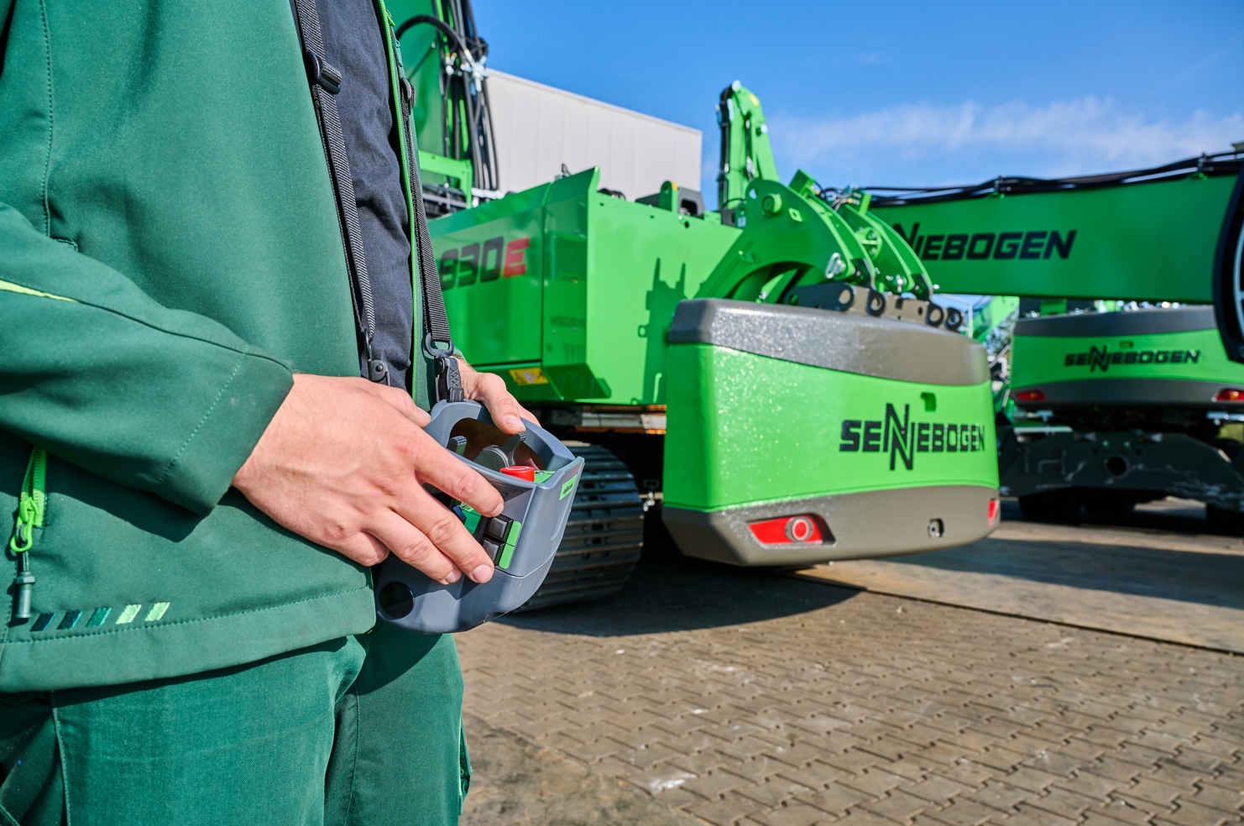
Picture 3: Thanks to the optional unloadable counterweight, the transport weight is reduced by around 10 tons at the push of a button.

