New recycling material handler with 12 m reach: The SENNEBOGEN 821E becomes the 824 G series
The SENNEBOGEN 821 E, with its operating weight of approx. 24 tons and a reach of 12 m, has been shaping the machine landscape in waste recycling for years. It is precisely this machine, which can be universally used for recycling, that the developers at SENNEBOGEN have set out to transform into a new generation of machines. True to the motto "Try new things, make tried-and-tested things even better", the 824 G series now impresses with increased performance and even lower fuel consumption.

SENNEBOGEN 824 G: universal recycling material handler with impressive service concept
The new 824 G series serves the smaller material handler segment and, with its reach of 12 m and the wide range of different equipment options, proves to be a versatile all-rounder in the recycling or scrap yard. Whether equipped with crawler or mobile undercarriage, equipment lengths from 10 to 12 m and/or ULM rod variants – equipment with a special deflection mechanism for sorting grabs – the 824G can be used to implement a wide variety of application-specific solutions. In addition to sorting activities, the robust machine is thus also perfect for loading tasks and can cope with demanding continuous use in challenging working environments, such as high dust levels, heat or extreme weather.
The newly implemented service concept of the SENNEBOGEN G series, with clear and simplified access to service points such as the central lubrication system and tanks, makes everyday maintenance easier. Further technological innovations also ensure that the service intervals have been extended once again overall.

Higher load capacity, lower consumption
The load capacities of the SENNEBOGEN 824G have also been increased by more than 10 percent compared to its predecessor. This means that the machine not only lifts more, but can also handle more material per work cycle with the right equipment. The machine also has a highly efficient and environmentally friendly Stage V diesel engine with 118 kW of power. By rightsizing the engine, which now runs at a speed of 1,725 rpm as standard, both noise emissions and the consumption of the machine have been reduced, thereby also sustainably reducing operating costs. Special eco-settings as well as large-scale lines and hydraulic valves relieve the pressure on the pump system, ensure optimal efficiency and make the material handler particularly efficient and resource-saving overall.

Increased speed and precision
With the consistently enhanced machine concept, the 824G impresses as another representative of the 6th generation thanks to excellent responsiveness, making sensitive sorting work at the recycling or scrap yard child’s play in the future. Thanks to the state-of-the-art control technology of the latest machine generation, the working clearance of the machine is perfectly coordinated: combined or overlapping movements with optimal swivel speeds enable fast working processes without having to compromise on precision. Thanks to the memory-based operator profiles, where the hydraulics can be adjusted precisely to the respective operator, valuable time can also be saved at the start of the shift when changing operators.

New comfort cab and safety features
In addition to numerous optimizations in terms of seating comfort, air conditioning and control panel, the spacious Maxcab now offers even more options for making day-to-day work particularly comfortable and safe. The large window elements provide a clear view to the front and sides. The windscreen is even made of bulletproof glass as standard, providing optimal protection for the operator. The new elevating cab, which is also installed as standard, is not only even higher than before with a height adjustment of 2.80 m, but is also particularly robust and stable in dynamic use. It allows an eye height of up to 3 m and thus an optimal overview or a direct view into the shredder or scrap press.
An extensive camera system and intelligent control and diagnostic systems also provide support in the daily handling of the machine. The new SENtrack telematic system is also installed as standard, providing the most important machine data such as maintenance requirements, utilization, fuel consumption and hydraulic pressures in a user-friendly manner, thus facilitating service management of the machine or the entire fleet.

Premiere at bauma 2022 in Munich
The SENNEBOGEN 824G will be premiered at bauma 2022. Experience the new machine live at the SENNEBOGEN stand at the FM.712 open-air site, Messe München.

Captions:
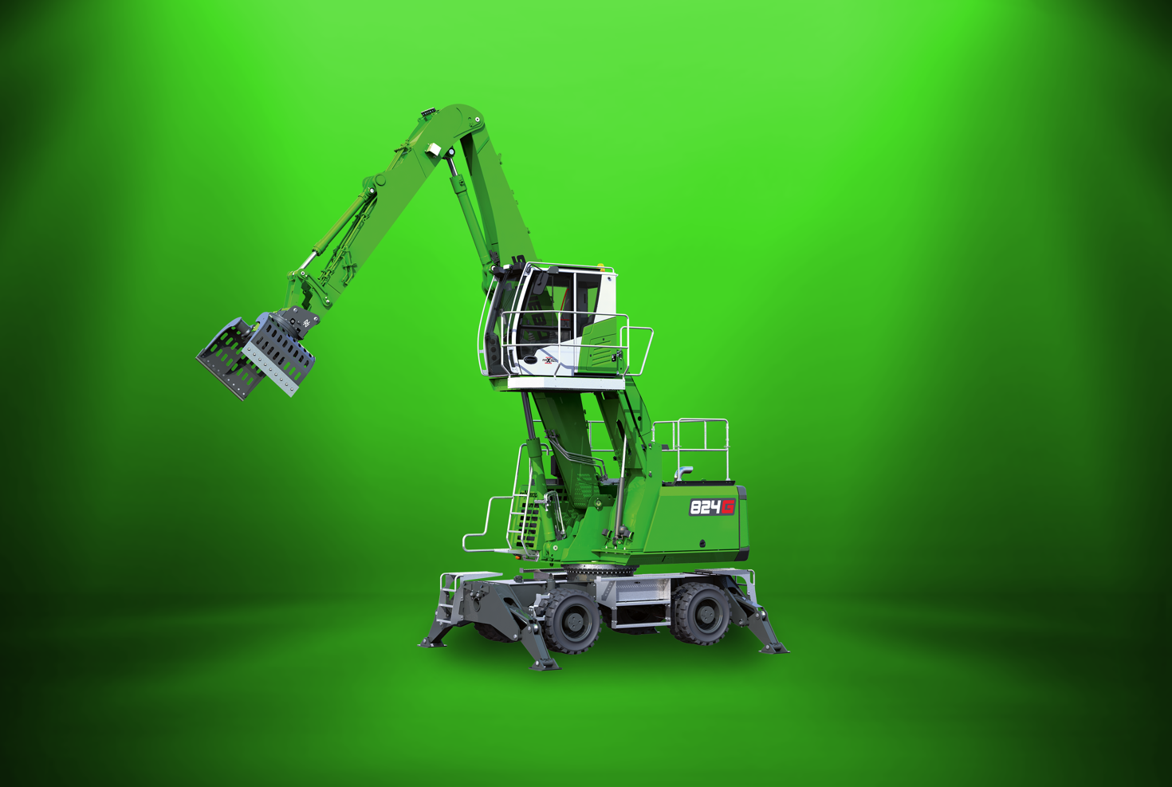
Picture 1: New recycling material handler of the 6th machine generation with 12 m reach: The SENNEBOGEN 824 G will be presented to the public at bauma, from 24-30 October 2022 at the FM.712 open-air site.

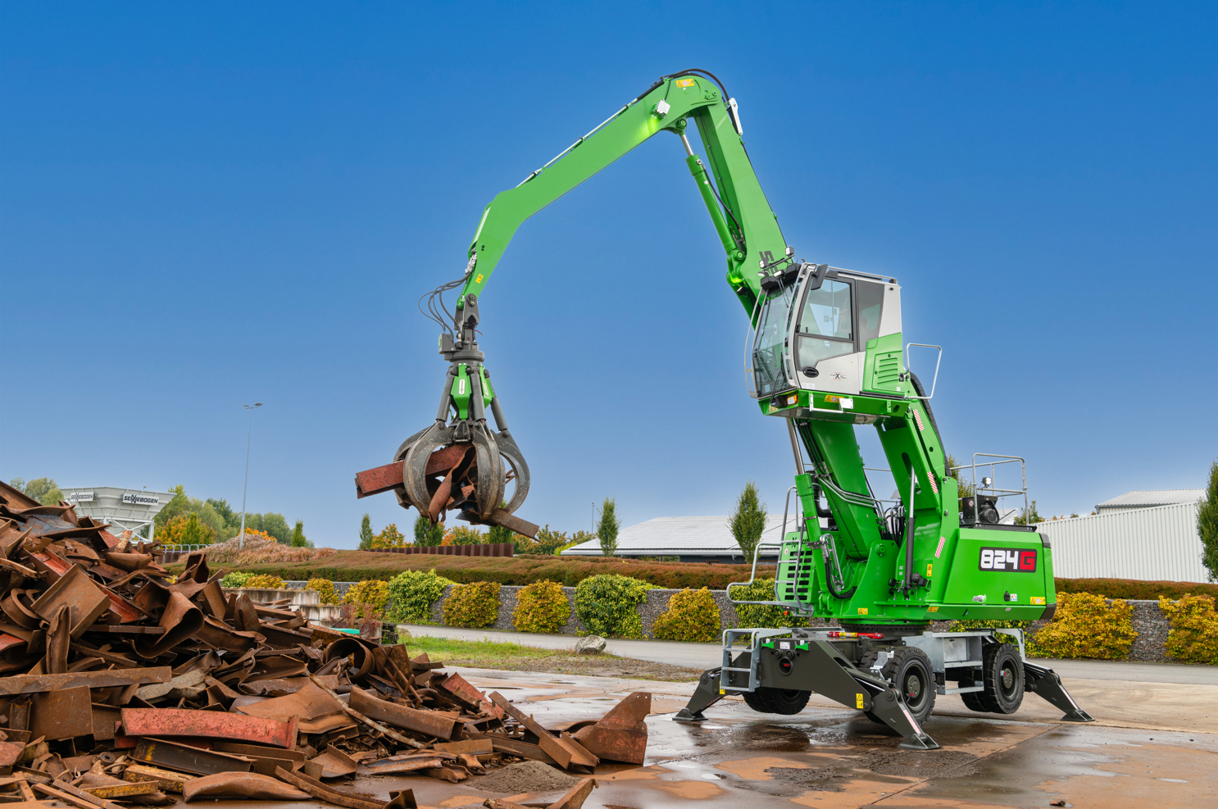Picture 2: The new SENNEBOGEN 824 G impresses with increased performance and low consumption in recycling or scrap.

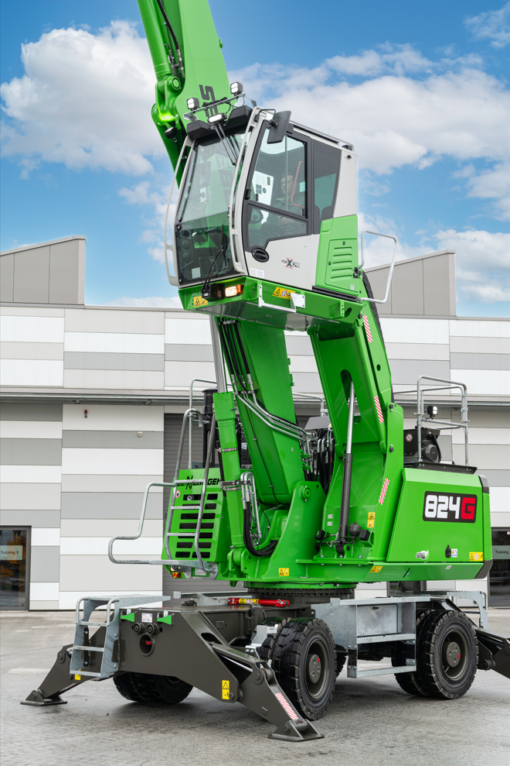

Picture 3: The new elevating cab with its height-adjustment capability of 2.80 m is not only even higher than before, but also particularly robust and stable for dynamic uses.

