Efficient timber handling: Material handler with electric travel drive for Pick & Carry
Hybrid technologies are not only on trend, they can also significantly save energy if used correctly. With the Green Efficiency Drive (GED), SENNEBOGEN has developed a drive technology that represents a hybrid system with a mix of diesel and electric drive. The GED is an electric travel drive for material handlers, which is particularly useful when the machines are designed for continuous operation, for example in sawmills, timber handling or log yards. The 735 GED saves up to 30% in energy with the same performance. This not only significantly reduces operating costs, but the machine is also more dynamic and quieter.
The Green Efficiency Drive is used where the largest share of energy demand is generated - when driving. Material handlers in particular do quite a lot of driving, which is why there is the greatest potential for savings here.
Energy recovery via electric travel drive
The system solution, based on Bosch Rexroth components, was jointly developed into a marketable product, and was launched by SENNEBOGEN under the name 'Green Efficiency Drive'. The Pick & Carry material handler 735 E is the first machine to contain the series production technology for electric travel.
While the machine is moving around the log yard, the diesel engine drives a generator, which generates the necessary electricity for the electric engines. During deceleration, the electric drive engines act as generators. This means that they supply the auxiliary equipment with the energy required and relieve the diesel engine. The recuperated energy can even be stored for a short time, increasing the drive power.
Another advantage is that the use of modern components in the electrical system reduces heat loss. This can also save engine power for system cooling and achieve higher working dynamics.

Good for nature and wallets - up to 30% energy savings and lower emissions
Over the entire product life cycle, the 735 GED saves up to 30% energy with the same performance level and therefore saves operating and service costs on a large scale. Rightsizing the engine makes it possible to save on the machine's consumption and thus also on emissions. Vibrations and noise are also significantly reduced – for pleasant and quiet operation, which relieves strain on people and the environment in the long term.

Impressive handling
Thanks to the electric drive motors, the 735 GED also has outstanding responsiveness when moving off and positioning. This results in a vehicle that can be moved dynamically and precisely, but that is also a pleasure to drive.

Caption:
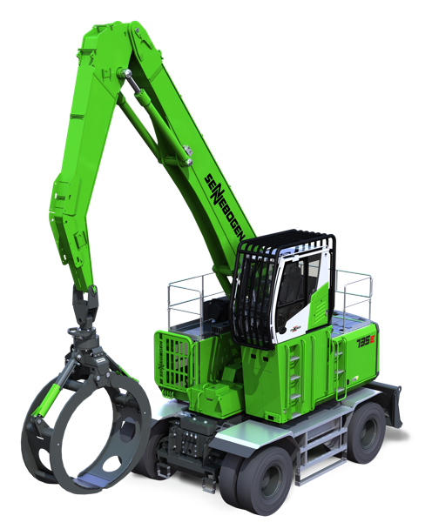
Picture 1: SENNEBOGEN will be presenting the 735E with the Green Efficiency Drive electric travel drive at bauma 2022.
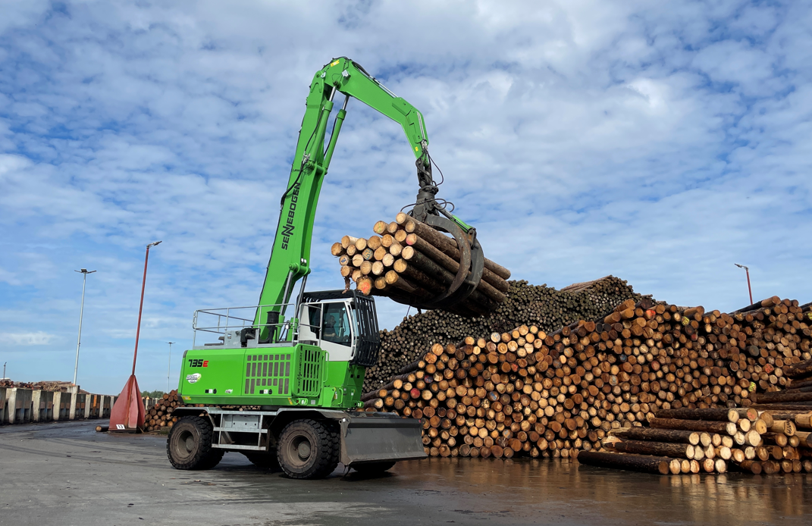
Picture 2: Equipped with the GED electric travel drive, the 735E saves up to 30% energy and therefore significantly reduces operating and service costs.

