The tree care handler for professional tree maintenance: SENNEBOGEN 728 E
Tree felling, embankment maintenance, problem tree felling and municipal tree maintenance are usually associated with hazards. Nevertheless, trees on traffic routes in particular are subject to traffic safety obligations and must be professionally maintained on a regular basis. Where the manual use of chainsaws reaches its limits, tree care handlers prove to be the perfect solution. They can safely and efficiently grab, saw and place trees and shrubs. Launched onto the market a few months ago, the SENNEBOGEN 728 E tree care handler has already proven itself in many applications and is now celebrating its trade fair premiere at bauma 2022.
With an operating weight of up to 34.5 t and a reach of up to 21 m, the new 728 E is a perfect addition to the SENNEBOGEN tree care handler range. This fills the important gap between the slightly smaller 718 E and the 738 E, which is particularly popular in the USA. Equipped with a 9.2 m compact boom and the 6 m telescopic stick, which can be extended by a further 2.5 m at the push of a button thanks to the telescopic extension, it covers an impressive working radius. This means that the compact machine can reach timber that is still far away, even in particularly challenging environments, for example on a slope, and at the same time remain safely on the road. The separate hydraulic circuit, which is tailored to the respective attachment, can be used to drive other equipment, such as cutting devices, grabs and flail mowers, in addition to the grab saw.
The tree care handler machine concept as the perfect solution for demanding tree maintenance
The advantages of the tree care handler are obvious. On the one hand, it increases efficiency. Thanks to its compact dimensions, the machine is easy to transport, and with individually applied for road approval, the mobile-tired machine can even drive to its place of use. With a support width of only 4 m, there is also no need for complex road closures on site. The SENNEBOGEN 728 also enables fast, controlled tree felling along roads and forest paths, even with minimal personnel. Supported by the powerful 140 kW Stage V diesel engine and the high-performance hydraulics, experienced personnel work with the 728 E tree care handler in a uniquely precise and fast manner.
On the other hand, a tree care handler is clearly the safe alternative to manual tree maintenance. The machine can be used to avoid high-risk manual work at height, as the operator is in the cab all the time during tree maintenance and felling work, protected by protective guards on the roof and front as well as windshields and side windows made of bulletproof glass. The latest version of the Maxcab offers a perfect view of the entire working area thanks to its large window elements and the option of elevating 2.70 m and tilting 30°. Cameras in safety areas provide additional support.
Tree and landscape maintenance is not just about speed, but above all about the principle of “safety first” - both components combined in one machine make the 728 E tree care handler the perfect solution.

Caption:
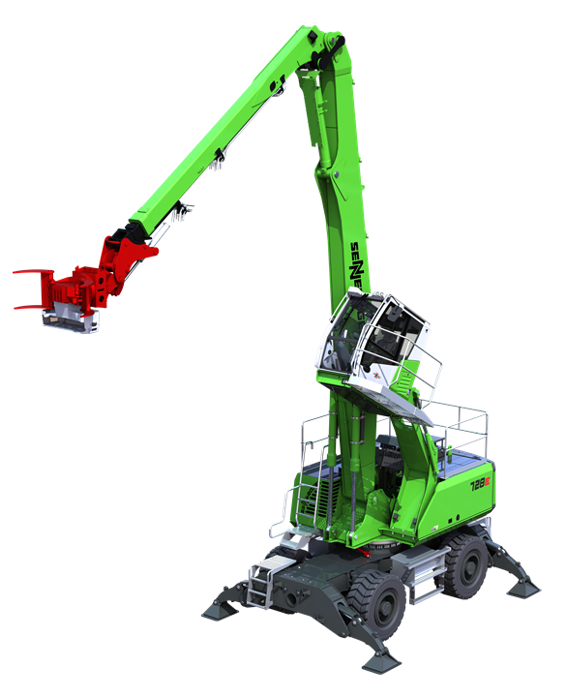
Picture 1: The new SENNEBOGEN 728 E tree care handler with a reach of 21 m has already proven itself in various applications and is celebrating its premiere at bauma 2022.
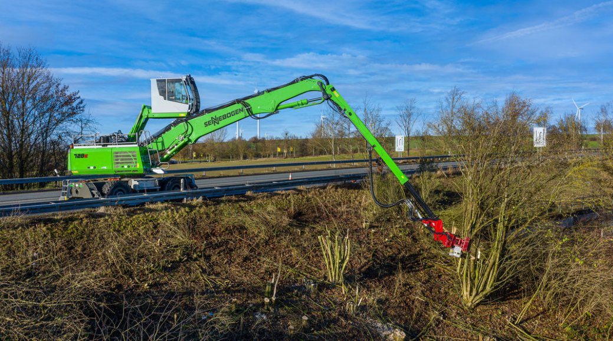
Picture 2: With a reach of up to 21 m, the SENNEBOGEN 728 E tree care handler is particularly suitable for tree felling and tree maintenance along traffic routes.

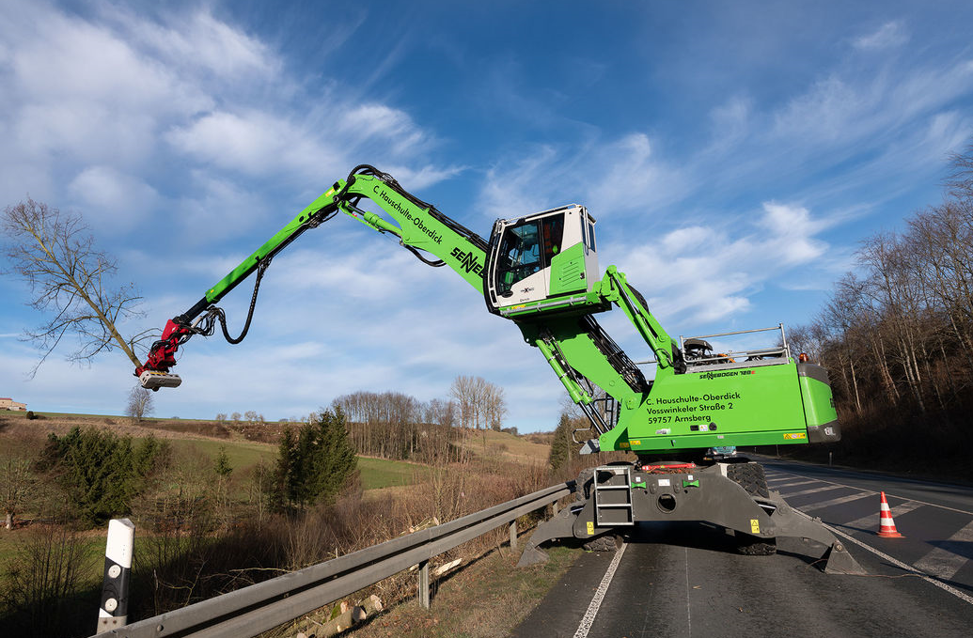
Picture 3: The SENNEBOGNE 728E tree care handler enables controlled grabbing, sawing and placing of wood all in one go.

