New 50-tonne SENNEBOGEN battery-powered crane presented at bauma
SENNEBOGEN will be presenting its first battery-powered telescopic crawler crane at bauma 2022: the 653 E Electro Battery. The new 50-tonne battery-powered crane combines the benefits of battery technology with the proven advantages of the telescopic crawler crane design. This means you work completely emission-free and retain maximum flexibility thanks to the Dual Power Management system.
Developed in collaboration with Dutch dealer Van den Heuvel, the machine is the first battery-powered telescopic crawler crane in the range.
Especially in inner-city areas, environmental requirements are becoming increasingly stringent in Europe, and these are increasingly including construction machinery. SENNEBOGEN already has two battery-powered material handlers in its material handling product portfolio. Thanks to sales partner Van den Heuvel working closely with Dutch crane rental companies and construction companies, the valuable market requirements from the progressive Dutch market have now been factored into in a development partnership and a 50 t telescopic battery-powered crane has been developed in collaboration with the dealer. With coordinated battery technology and analog charging management, this crane is perfectly adapted to applications in the construction industry thanks to the collaboration.

New, battery-powered version of the SENNEBOGEN 653 E
The battery-powered version of the 50-tonne SENNEBOGEN 653 telescopic crawler crane, the 653 Electro Battery, has a powerful 130 kW electric motor instead of the diesel engine, powered by a lithium-ion battery in the uppercarriage. The high-quality, liquid-cooled battery system, which is particularly durable and has already proven itself on- and off-road under the toughest conditions, has a capacity of 210 kWh and is connected to an intelligent battery management system (BMS). Depending on the type of use, the crane operates in battery mode for up to 14 hours. For charging, the machine simply needs to be connected to a standardized 32 A CEE industrial socket, which is usually available on any construction site. Thanks to the 22 kW on-board charger, there is no need to invest in additional charging stations. The integrated power electronics also ensure a particularly smooth motor start-up that is gentle on the mains power grid.

Maximum flexibility thanks to Dual Power Management system
The machine’s Dual Power Management system guarantees maximum mobility and uninterrupted work, all with the same performance as usual. Like the SENNEBOGEN battery-powered material handlers, 817 and 825 Electro Battery, the electric crane can continue working whilst charging from the power grid. As soon as the machine is connected, the mains power is used for the lifting operations, while excess energy is simultaneously used to recharge the batteries.
In the future, you will not only continue to benefit from the flexibility of the telescopic crawler crane itself on the construction site, which is characterized by unique off-road capability and maneuverability – even with a load on the hook – but will now combine this with the technological advantages of state-of-the-art battery technology. The crane's hydraulics have basically remained the same, but the control of the battery-powered machine has proven to be even more sensitive due to the more directly acting torque, which customers and crane operators find very pleasant.

Zero emissions on site
The 653 Electro Battery is not only free of fossil fuels such as diesel and engine oil, but also works noticeably more quietly and with less vibration than its diesel-powered counterparts. When generating energy from renewable energy sources, the battery-powered crane also saves more than 23 t CO₂ per year in single-shift operation. In addition to the positive CO₂ footprint, the machine also has a further significant advantage - it requires less service work, as maintenance procedures such as engine oil changes are completely eliminated.

The implementation of the battery technology in the jointly developed solution of the 50-tonne telescopic crawler crane with new and modern drive technology will be carried out by the Dutch sales and service partner Van den Heuvel. Sales will take place as usual via the well-known SENNEBOGEN dealer network. This means that interested customers can contact their regional SENNEBOGEN sales partner for inquiries.

Captions:
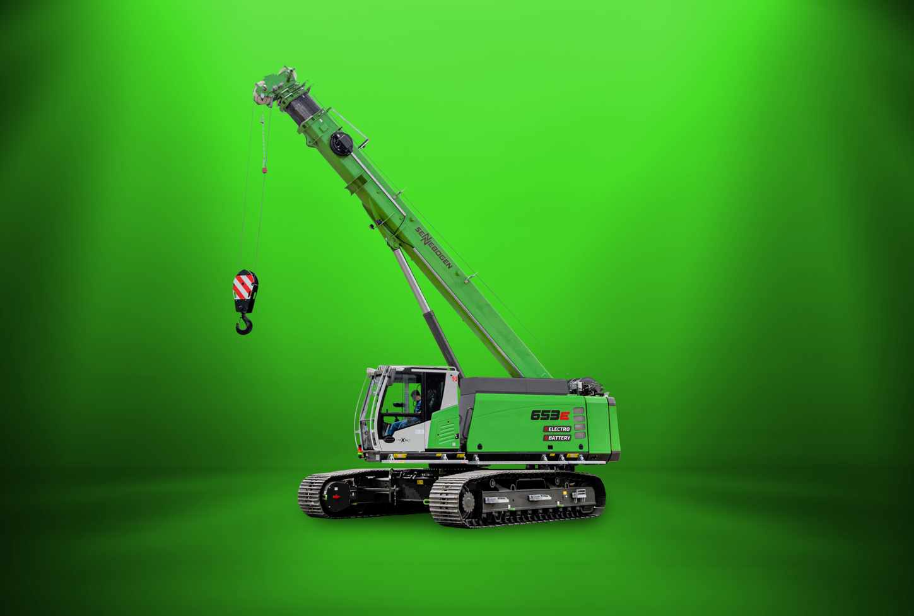
Picture 1: Same performance – fully electric. The SENNEBOGEN 653 Electro Battery has all the advantages of a telescopic crawler crane, combined with state-of-the-art battery technology.
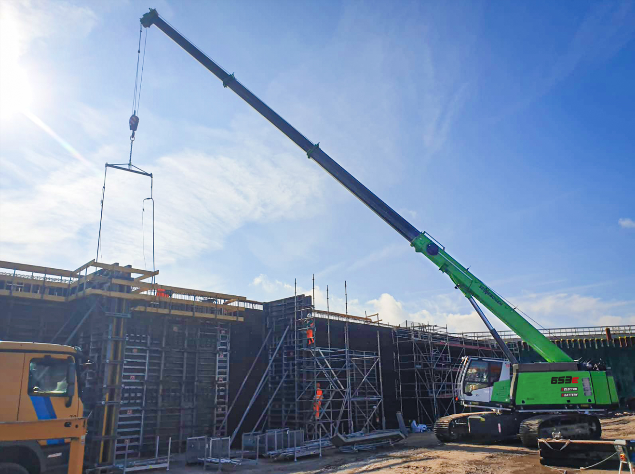

Picture 2: The sensitive controls, and the noise and vibration reduction of the battery-powered crane noticeably relieves strain on people and the environment.

