4 t telehandler 340 G – compact machine for large tasks
Developed for use as a telehandler and powerful multi-function machine, the 340 G was added to the SENNEBOGEN Multi Line in spring 2022. The new 4-ton machine impresses with its robust design and the standard elevating comfort cab, especially for challenging tasks in the recycling industry.
Built to meet the demands of tough material handling, the 340 G is, above all else, robust and high-performing. A solid steel frame and a well-thought-out telescopic boom design ensure reliability and durability in demanding continuous operation. The combination of compact machine dimensions, 4 t load capacity, a stacking height of 7.70 m and a remarkably long wheelbase of 3.10 m, which guarantees stability in every situation, make the telehandler a true all-rounder in recycling plants, composting plants, municipalities and industry.

A telehandler like no other: the advantages of SML power
The completely newly developed SENNEBOGEN telehandler combines the advantages of telescopic handler and wheel loader technology in one machine. This unique concept is summarized in the term SML power. SML power stands for the best power transmission and maximum breakaway torque thanks to Z kinematics. In addition, there is the powerful drive train, which enables high tractive forces and driving speeds, as well as the multifunctional versatility, as the powerful hydraulics enable the operation of numerous attachments. The reversible fan installed as standard ensures optimal air intake even in dusty locations and thus the best cooling output and performance in hard continuous operation.

The unique selling point: the elevating cab
The unique machine concept is rounded off by the elevating comfort Multicab, which is installed as standard in the 340 G. Generous glass surfaces provide a 360° all-round view, and the cab elevation can also be controlled variably and conveniently via foot pedals in the cab. With an eye level of up to 4.10 m, the operator can enjoy optimum visibility in the loading process, with a good view over the boom as well as a direct view from above into the trucks and containers.
Of course, the new Multicab also offers operator comfort – supported by ergonomically arranged, resonant control elements and the air-sprung comfort seat, as well as protection against excessive noise and movement vibrations, the operator can concentrate on the essentials. The standard air-conditioning system ensures a pleasant workplace all year round.

Flexible and multifunctional
The 340 G shows it is flexible in more than just working modes. In street mode, the telehandler can reach speeds of up to 40 km/h in variable travel drive with its modern 100 kW Stage V diesel engine. In forklift mode, it proves to be particularly maneuverable, works more sensitively and more energy-efficiently, while in loading mode it mobilizes all power reserves in order to optimally load and transport bulk goods.
In addition, the machine is generally individually configurable and can be specialized for the requirements of industry, demanding material handling, recycling, biogas plants or contractors. With the SENNEBOGEN hydraulic quick-changer, a wide variety of equipment can be changed at the push of a button, and it is also easy to equip them with trailers.

To be seen at bauma 2022
The SENNEBOGEN 340 G will be on display at bauma 2022 - to be seen from 24 to 31 October at the SENNEBOGEN stand at the FM.712 outdoor area, Messe München.

Caption:
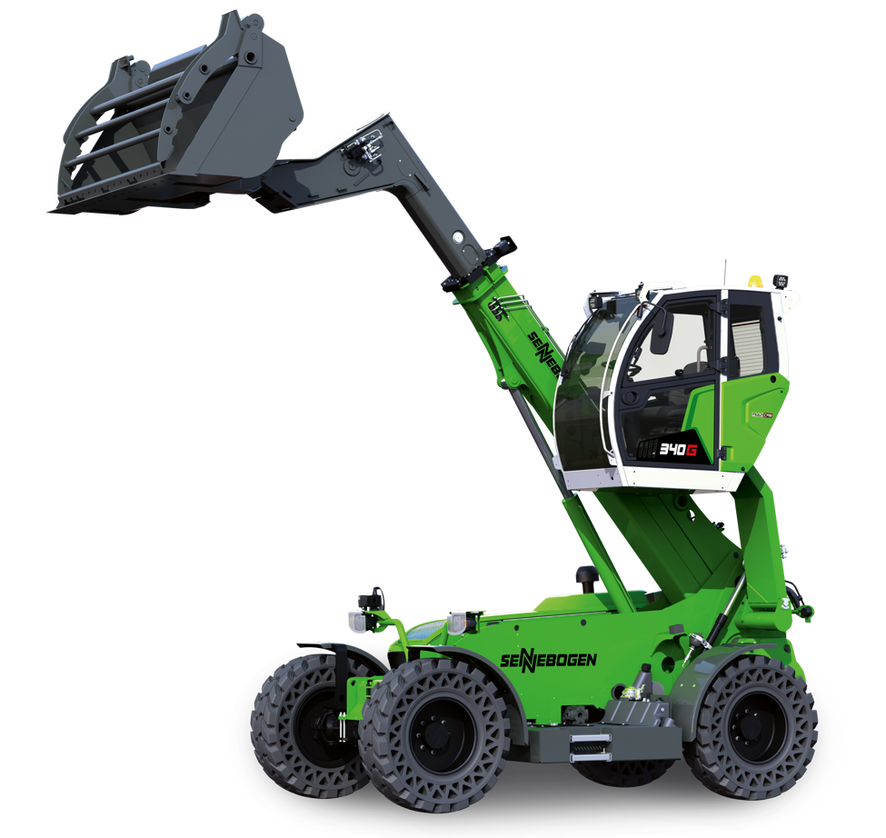
Picture 1: Built to meet the demands of tough material handling: the new SENNEBOGEN 340 G 4-tonne telehandler. To be seen at bauma 2022.
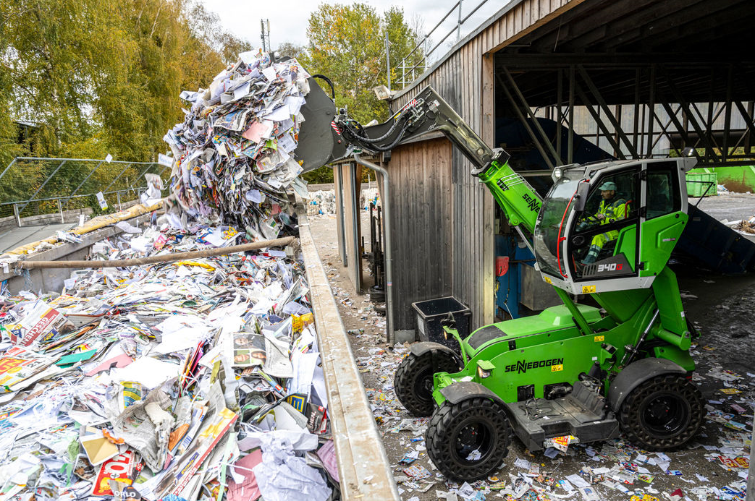
Picture 2: The viewing height of up to 4.10 m allows the operator optimal visibility in the loading process.

