SENNEBOGEN at bauma 2022: Broad range of machinery for the construction industry on display
With more than 70 years of experience in the design and construction of high-quality crane and lifting technology, the green SENNEBOGEN machines have been impressing customers worldwide for decades. Experience the stunning machine portfolio that SENNEBOGEN offers for the construction industry at bauma 2022 - reliable and with the latest safety and environmental standards. In the popular 100 tonne performance class, SENNEBOGEN will be showing two models at once: the 6100E duty cycle crane with diaphragm wall grab and the 100 t 6103E telescopic crawler crane recently launched on the market.
The durability and reliability of SENNEBOGEN cranes is based on decades of experience in the design of high-quality crane technology. The portfolio of the German mechanical engineering company ranges from compact telescopic mobile cranes to telescopic crawler cranes and lattice boom crawler cranes with high lifting capacities to duty cycle cranes built for dynamic continuous operation. Centrally located on the open-air site, SENNEBOGEN, as "the green heart of bauma", will once again present an enormous range of sophisticated crane technology for the construction industry.
Flexible telescopic cranes for any construction site: The 100 ton machine 6103E and the mobile compact crane 613E
Worldwide, SENNEBOGEN offers the largest selection of telescopic crawler cranes with maximum lifting capacities from 16 to 130 tons. Whether in the mobile version or with crawler undercarriage, their compact design and flexible and cost-effective transport make telescopic cranes sought-after machines for many construction companies and the optimal crane concept for rental. At the trade fair, you will experience the flexible crane concept by the example of the 100 t telescopic crawler crane 6103E, which was recently launched on the market. The model covers a popular performance class and shines here not only with a boom length of up to 62 m, but above all with its outstanding pick and carry capabilities, especially on rough terrain. Thanks to a wide range of equipment variants, this telecrane, like all SENNEBOGEN telescopic cranes, can be configured to meet the most diverse requirements in hydraulic engineering or special civil engineering.
The telecrane range on display at the booth is rounded off by the 16 t telescopic mobile crane 613E, which, with a transport width of just 2.55 m and a strong boom length of up to 23.8 m, is compact and maneuverable and enriches every building construction and loading site. The hydraulic cab elevation (on the 613 Mobile to an impressive 4.30 m viewing height), which is available on every SENNEBOGEN telescopic crane, is even installed as standard on this compact crane.
Sophisticated technology also in crawler cranes: the 200 t crawler crane 5500 G series
The topics of environmental friendliness and safety are important benchmarks for innovation at bauma 2022. With the 200 t crawler crane 5500 G, SENNEBOGEN is presenting an impressive representative of its latest generation of machines in the G series, to which all of the brand's crawler cranes have already been updated. Proven over many years in civil engineering, the 5500 in the G series version features state-of-the-art engine, drive and exhaust systems (Stage V), as well as large-diameter piping and valves that ensure the best efficiency in operation and reduce emissions and consumption to an absolute minimum. Another plus point of the machine is that, thanks to the reinforced boom structure and higher ballasting, the payloads have been increased by values between 15 and 50 percent compared to the E series, depending on the boom configuration.
Heavy Duty - versatile and safe: the 100 t duty cycle crane 6100E with diaphragm wall grab
Robust and safe are also the right keywords for the 6100E. The 100 t HD duty cycle crane has been specially designed for demanding applications with dynamic loads and is therefore particularly suitable for special civil engineering. With its powerful 451 kW stage V diesel engine and a high-performance multi-circuit hydraulic system, the operation of hydraulic piping machines can be realized just as reliably as the use with leader masts or with a diaphragm wall grab, with which it will be on display at bauma. Numerous safety features and a particularly stable wide-gauge undercarriage ensure maximum safety during operation.

Comfort highlight: operator cabs
A highlight of all SENNEBOGEN cranes in terms of user-friendliness and comfort are also the particularly spacious cabs, which impress with their outstandingly open feeling of space, optimized ergonomics and numerous individual equipment options. True to the motto: Get in and feel good.

See for yourself the latest crane technology from SENNEBOGEN and stop by. From October 24 to 30, 2022, SENNEBOGEN will be exhibiting a total of 12 machines from the crane and material handling sector on its more than 2100 m² booth in the open-air area FM.712. Among them are many new developments that will be officially presented to the public at bauma 2022.

Caption:
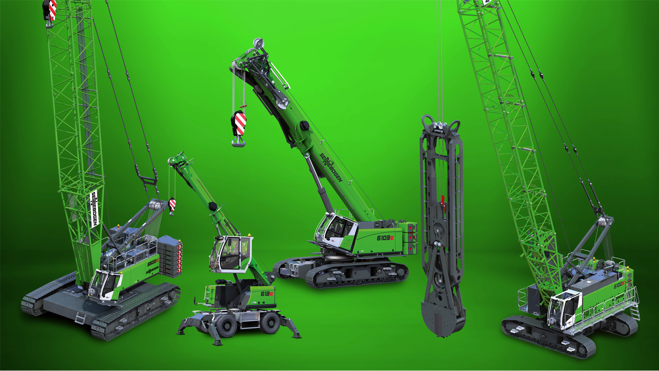
Image 1: At bauma 2022, SENNEBOGEN will present an extensive portfolio of machines for the construction industry directly at its booth. In addition, interested customers can see many other machines during a factory visit in Straubing. The nearby plant will be conveniently accessible from the trade fair by bus shuttle.

