IFAT 2022: Live demo of SENNEBOGEN recycling and demolition machines at VDMA Demonstration Days and Crushing Zone
In addition to the innovations in the exhibition hall, SENNEBOGEN will present four more machines live in action at the VDMA Demonstration Days and the VDMA Crushing Zone. Be curious and experience the full range of the recycling experts - from demolition machines to telehandlers.
Just a few hundred meters from the exhibition hall, the VDMA Demonstration Days and VDMA Crushing Zone will be taking place parallel to IFAT from May 30th to June 3rd, 2022. The live demonstrations offer guests the opportunity to experience the technical solutions of the manufacturers in an application-related way while working. SENNEBOGEN's extensive machine portfolio includes not only recycling machines and telehandlers for professional waste handling, but also demolition machines for effective deconstruction, each of which will show what they are capable of in 8 demonstrations over 5 exhibition days. Product experts will explain the machines in detail during demonstration times.
Demolition machine and telehandler at the Crushing Zone
The 830 R-HDD demolition machine with an operating weight of 45 t and the 355 E series telehandler take care of the construction and demolition waste at the Crushing Zone. The flexible demolition machine 830 R-HDD, which has a unique stability thanks to its telescopic wide track undercarriage, demonstrates not only the professional dismantlement of buildings by means of demolition shears, but above all its innovative quick-changer, with which it can be equipped with a sorting grab and the pulverizer in a very short time. The 5.5 t telehandler picks up the construction waste weighing several tons and feeds the screening machines.
Two mobile material handlers in wood recycling
Experience how simple and efficient shredder feeding can be. At the Biomass Demonstration Days, the two compact 821 E and 825 E material handlers use a sorting grab to feed a shredder with green waste and scrap wood, respectively. They impress not only with their remarkable reach of 9 to 14 m, but also with the outstanding viewing heights offered by the cabs, which can be elevated hydraulically by 2.70 m.

Captions:
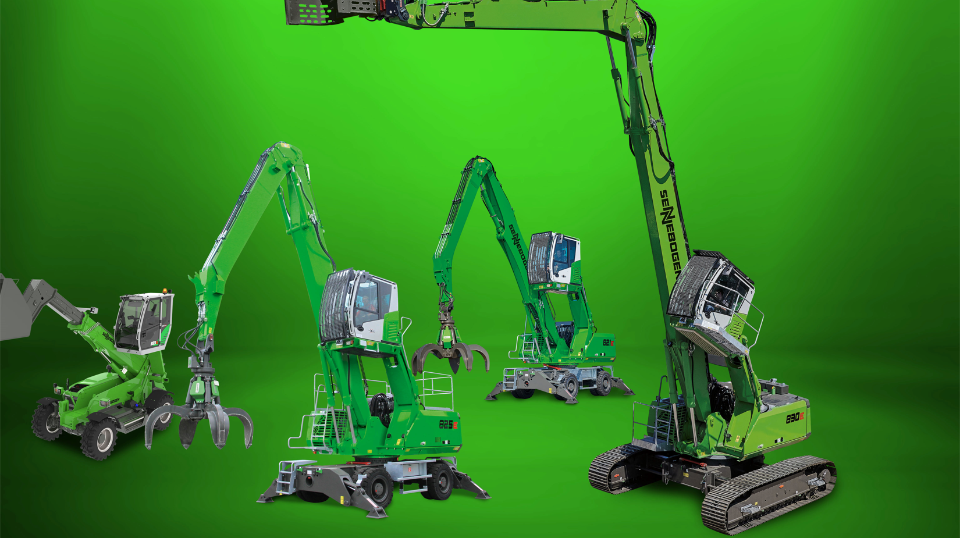
Image 1: VDMA Practice Days and Crushing Zone at IFAT 2022: The SENNEBOGEN 821 E & 825 E recycling machines feed the shredder with biomass, the 830 R-HDD demolition specialist and the versatile 355 E telehandler are used in the recycling of construction materials.

