Experience SENNEBOGEN's BIG RECYCLING FUTURE at IFAT 2022 – World premiere of the new battery-powered material handlers
Visit us from May 30th - June 3rd 2022 at the world's leading trade fair for water, sewage, waste and raw materials management in Munich. As big and with as many innovations as never before, SENNEBOGEN is once again setting significant standards for the future of the recycling industry at IFAT and will be presenting, among other things, the new battery-powered material handlers.
Discover the brand new SENNEBOGEN 19 t battery-powered material handler, the 22 t recycling material handler 822 of our new G-series as well as the 4 t telehandler 340 G that has just been launched on the market. Everything can be found at our more than 300 m³ booth in hall C5, No. 241/340 and at the VDMA outdoor area (LIVE demos: biomass & construction material recycling).
Three new machines will be presented at the fair
Experience an absolute market innovation: With the new battery-powered material handlers, SENNEBOGEN supplements its electric series with free-moving models that combine the best of both machine concepts. This is because with our mobile battery models, you can continue working even when the machine is connected to the power grid for recharging.
The 4 t telescopic loader SENNEBOGEN 340 G, which was recently launched on the market, will also celebrate its trade show premiere. The completely new development is not only visually a real highlight. In addition to the impressive performance data and the stacking height of 7.70 m, the machine shines in particular with its unique selling point, the Multicab. The most modern cab of its kind can be raised infinitely to an eye level of 4.10 m and guarantees the best all-round visibility in recycling operations.
We are also presenting another model from our new machine generation: the 822 G-Series. The new edition of the popular 22 t recycling all-rounder 818 E not only impresses with its great system performance and reach, but also offers maximum operator comfort and safety, as do all machines in the G series.
Even more SENNEBOGEN machines: Live in action at the VDMA Demonstration Days
You can also see the power of our machines in action. At the VDMA Demonstration Days, our recycling experts will be demonstrating their skills in biomass recycling and construction materials recycling.

Caption:
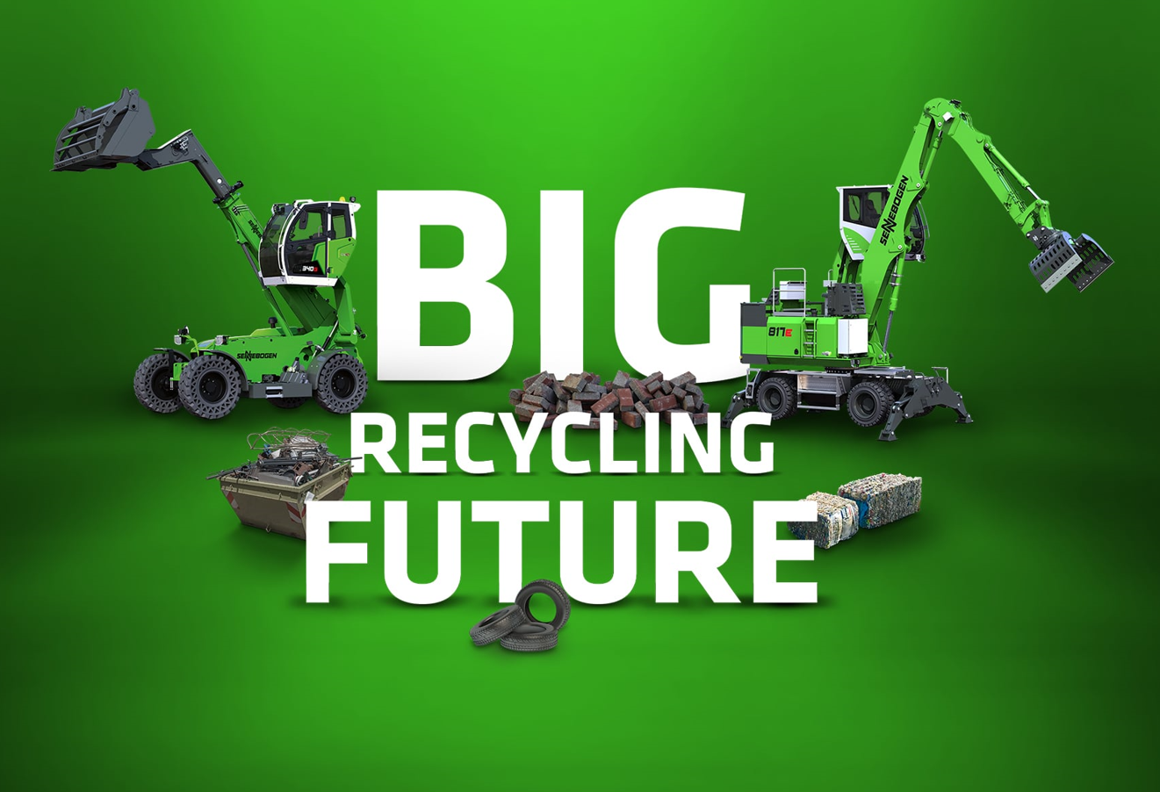
Image 1: SENNEBOGEN presents itself at IFAT 2022 and the VDMA Demonstration Days with a total of 7 machines bigger than ever before.

