The new 22 t G series recycling material handler: the SENNEBOGEN 822 G

As the next material handler, the popular 22 t recycling machine has now also received its update to the latest G series machine generation at SENNEBOGEN and shines with various technological innovations. The completely revamped 822 G features intelligent and resource-saving machine technology and has everything that could be desired in terms of operator comfort and safety.
The latest generation of material handling technology for use with recycling or scrap. The optimized new edition of the popular 22 t 818 E recycling all-rounder makes it possible to handle and sort material in a particularly environmentally friendly and economical way. The compact material handler's high system performance and outstanding ease of maintenance are impressive, as is the operator's comfort cab, the design and function of which have been reworked.
Sustainable solution for harsh environments
With a reach of up to 10 m and a comfort cab that can be elevated as standard, the compact 822 G material handler is a true professional when it comes to recycling. Thanks to its tried-and-tested modular system, it can be individually configured and, with its numerous equipment variants, also makes light work of handling scrap. With this machine, it is clear that once again SENNEBOGEN has focused 100% on material handling during development. The 822 G boasts outstanding responsiveness – the hydraulics can be adjusted very precisely by the operator – and fast, overlapping movements with a hydraulic system that is optimized for demanding tasks in recycling and scrap yards.
At the same time, the machine uses Green Efficiency Technology to save resources and work efficiently. Powerful pumps and large-scale hydraulic valves and lines ensure optimum efficiency. Rightsizing was also on the agenda for the engine. The new 822 G now has an economical 110 kW Stage V diesel engine with 3.8 l displacement, which is ideally suited in terms of power and consumption to the operating conditions in recycling and scrap. In addition to the low operating costs, the G series is also synonymous with SENNEBOGEN’s sophisticated 6th generation material handling technology based on decades of experience. Durability and reliability are guaranteed thanks to its robust components and intelligent design – a significant advantage for demanding continuous use.
Cab update: operator comfort and safety further optimized
The Maxcab comfort cab has also been redeveloped. All in all, the operator will be even more comfortable going forward. In addition to a fresh design, SENNEBOGEN has also incorporated feedback from customers and dealers with regard to comfort and functionality into the new Maxcab. The backrest has been raised, the seat area has been widened by 3 cm and the suspension has been reinforced to give the operator maximum seating comfort. Furthermore, the series standard air conditioning with a total of 12 individually adjustable air nozzles, and the view to the front and side have been optimized. The full-length windshield, which runs from the roof to the floor, is made of bullet proof glass as standard. All switch elements can be conveniently operated from the seat on a clearly arranged membrane keypad that is in the operator’s direct field of vision. Customized and stored operator profiles not only increase efficiency in multi-shift operation, but also make the cab a very personal space for each operator – for fatigue-free and focused work with a feel-good guarantee all day long. The infinitely variable cab elevation – 2.80 m for the 822G – is and will remain standard for this SENNEBOGEN material handler. Here in particular, the improvements are noticeable in the truest sense of the word, as the new control and particularly torsion-resistant design moves the Maxcab to the desired height even more stably and smoothly.
Features such as the tried-and-tested sliding door, new, color-coded grab handles and an even stronger LED spotlight on the cab roof also ensure maximum safety when handling the machine.

Focus on ease of maintenance
Particular focus has been placed on maintenance and service with the G series. The result is a coherent service concept that is characterized by reliability and ease of access. Sophisticated details such as the outward-folding lubrication system and an improved refueling situation make servicing the machine extremely convenient and safe. The technological innovations have also made it possible to extend the overall maintenance intervals once again. Thanks to the large-scale e-box, the central electrical distributors and electronic modules are protected from environmental influences even in extreme conditions and ensure maximum machine availability.
Now on show at IFAT 2022 in Munich
The world premiere of the 822 G will take place from 30 May to 3 June at IFAT 2022 in Munich. Discover the new G series and many other innovations at our trade fair stand in hall C5, stand 241/340.

Captions:

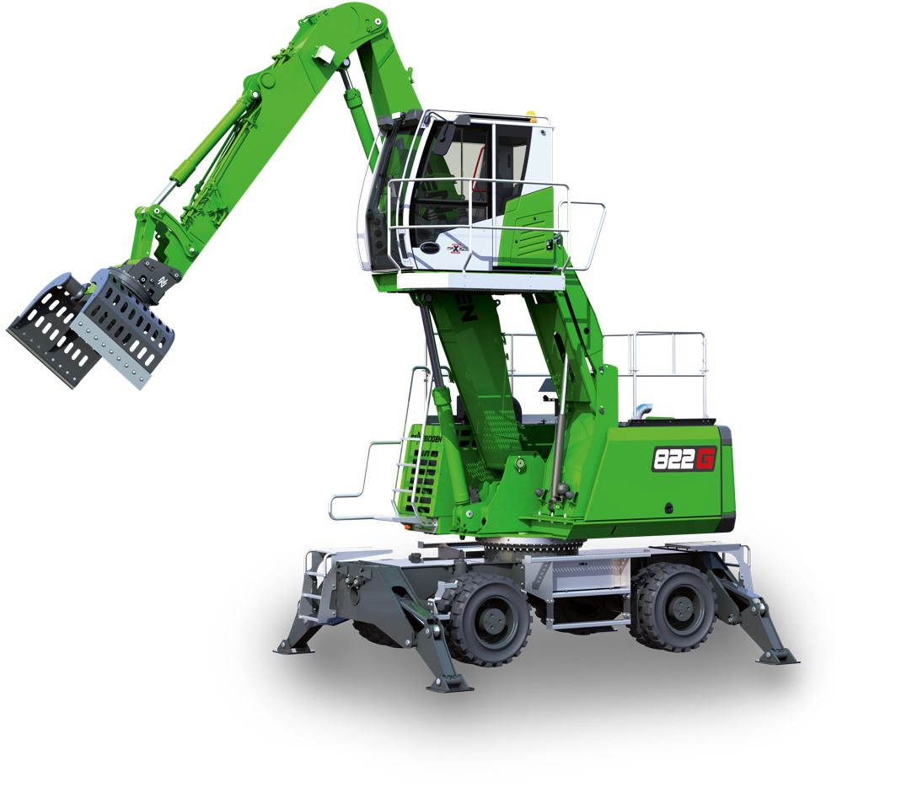

Picture 1: SENNEBOGEN presents another material handler from the new G series. Thanks to Green Efficiency Technology, the 22 t 822 G recycling material handler is particularly resource-saving and efficient and can be seen for the first time at IFAT 2022.

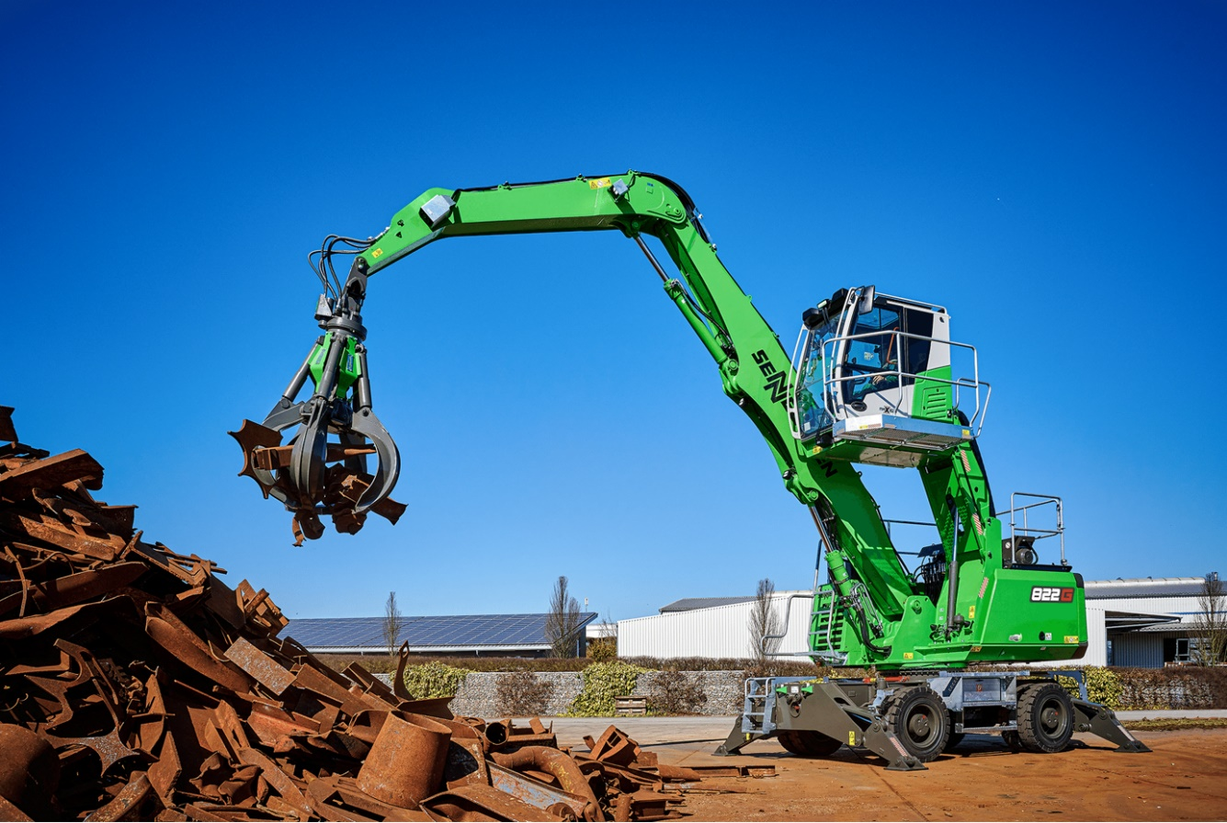

Picture 2: For demanding recycling and scrap applications. The new SENNEBOGEN 822 G can be individually configured and has a range of up to 10 m. The redesigned Maxcab impresses with its operator comfort and user-friendliness.

