Date / Datum: Jul-26
Location / Ort: Pori, Finland
Photo / Foto: Sebastian Mißler
Editor / Autor: Sebastian Mißler (Produktmanager Hafen)
Saving Fuel in Port Operations: Stevedoring Company Reduces CO₂ Emissions by 15 Tonnes Per Year
It is late April in southwestern Finland. The sun is shining over the port of Pori. But appearances can be deceiving. Just moments earlier, rain and snow showers had alternated across the harbor. Icy gusts of wind sweep over the quay walls at speeds of up to 50 km/h. Finnish weather is showing its harsh and unpredictable side. The stevedoring company Ahtauskone defies these challenging conditions. One constant in the company’s operations is a SENNEBOGEN 870 E, which achieves impressive results even under these demanding circumstances.
The material handler supports Ahtauskone in handling scrap metal, general cargo, and bulk materials. In day-to-day operation, one measurable advantage stands out in particular: the machine consumes around 20% less fuel than the comparable material handler from a competitor that was previously used. As a result, Ahtauskone saves approximately 5,600 liters of fuel and avoids around 15 tonnes of CO₂ emissions per year.
Stevedoring Company Ahtauskone in the Port of Pori
Ahtauskone Oy is a Finnish stevedoring company operating a terminal at the Port of Pori in southwestern Finland. Founded in 2010, the company specializes in loading and unloading vessels carrying a wide range of materials. “In terms of volume, peat is our main cargo, followed by scrap metal and crushed stone,” explains CEO Timo Harjula. “But we are highly flexible and can handle all types of break bulk and bulk materials depending on our customers’ needs,” he adds.
To handle this broad variety of cargo, Ahtauskone operates wheel loaders in different sizes and has also relied on a SENNEBOGEN 870 E for the past five years.
Flexible Cargo Handling with the SENNEBOGEN 870 E
Thanks to its mobile undercarriage, the SENNEBOGEN material handler can be deployed flexibly across the entire port area. At Ahtauskone, it proves to be a true all-rounder, handling a wide variety of materials.
CEO Timo Harjula is particularly impressed by the machine’s high handling capacity: “With the SENNEBOGEN 870 E, we handle around 1,000 tonnes of scrap metal per hour” – an impressive figure for a machine of this size.
How Does Ahtauskone Save Fuel in Port Operations?
Despite its high handling performance, the SENNEBOGEN material handler is extremely fuel-efficient. “We are very satisfied. The SENNEBOGEN consumes around 20% less fuel than the comparable material handler from a competitor that we used previously,” explains Ronny Ala-Tuori, who is responsible for equipment operations at the site.
This results in annual fuel savings of around 5,600 liters and avoids approximately 15 tonnes of CO₂ emissions per year.
Which Technologies Reduce Fuel Consumption and CO₂ Emissions?
The efficiency of the SENNEBOGEN 870 E is based on several technical factors that work together in daily handling operations.
- SENNEBOGEN Green Hybrid Energy Recovery System
The system stores energy from the lowering movements of the boom and makes it available again for subsequent lifting movements. Depending on the application, this can achieve savings of up to 35%.
- Optimized Hydraulic Flow
The hydraulic components and lines are designed for efficient flow characteristics. As a result, less energy is required, and the engine can be operated at a lower speed.
- Weight-Reduced Components
High-strength materials and structural reinforcements on the undercarriage, boom, and stick reduce the moving masses. This supports efficient operation, even in demanding material handling applications.
Service Partner Rotator Ensures Availability in Finland
Ahtauskone Oy is supported by Rotator, the responsible SENNEBOGEN sales and service partner. With numerous service locations throughout Finland, Rotator helps ensure maximum machine availability.
High performance, low fuel consumption, and reliable operation under harsh weather conditions make the SENNEBOGEN 870 E a key success factor for Ahtauskone. At the same time, the machine makes a measurable contribution to reducing emissions.

Captions:
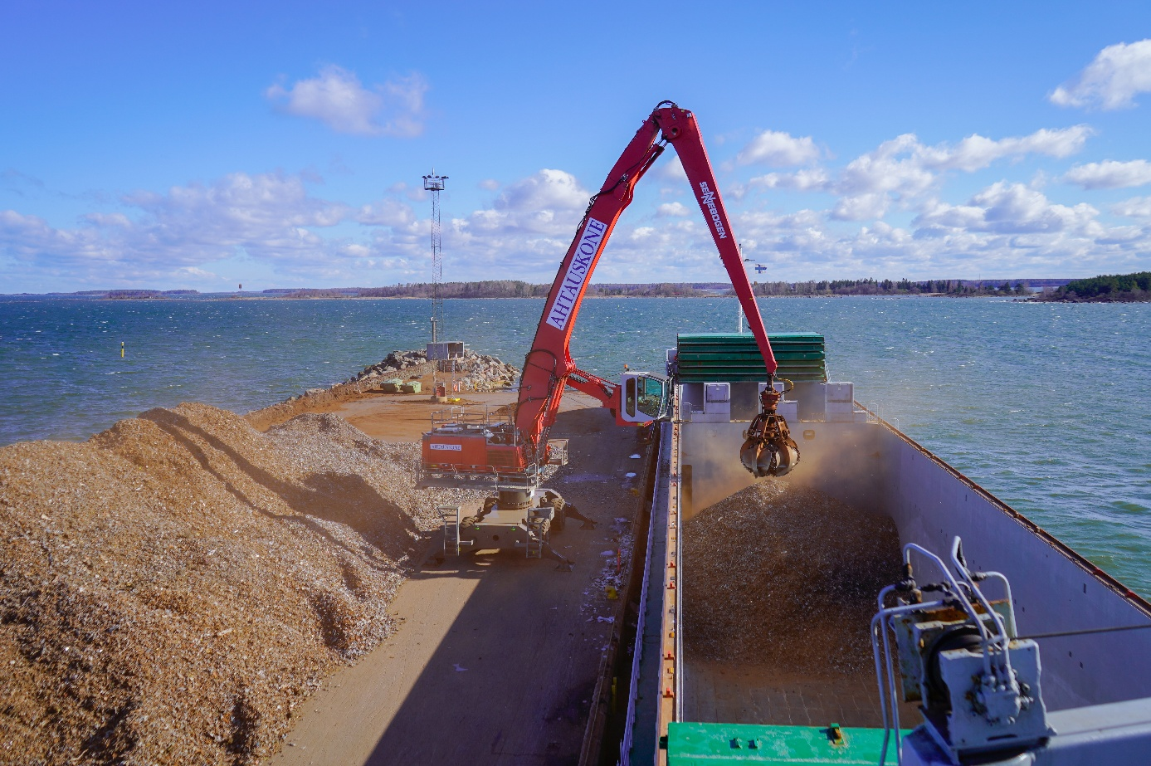
Header

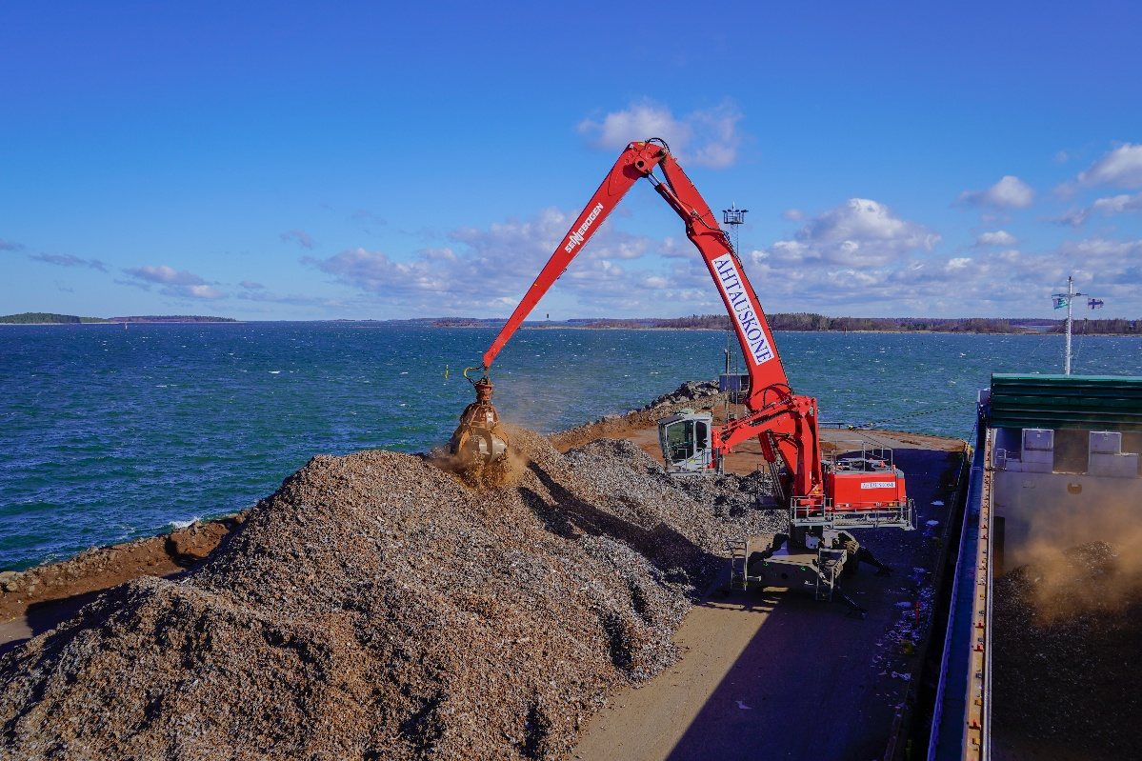

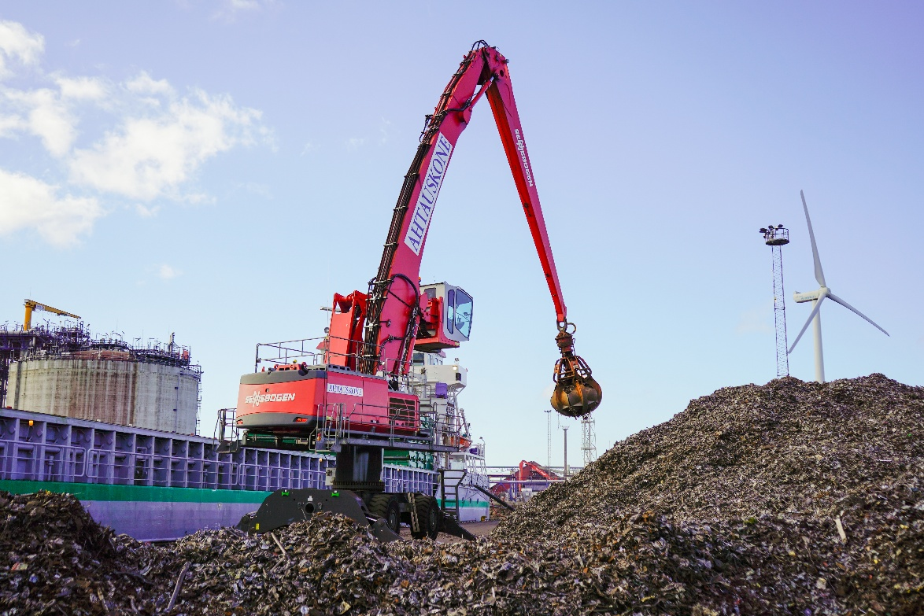
A versatile all-rounder – The SENNEBOGEN 870 E handles a variety of general cargo, bulk materials, and scrap metal at Ahtauskone in Finland.

In its current configuration at Ahtauskone, the SENNEBOGEN material handler handles up to 1,000 tons of scrap per hour.
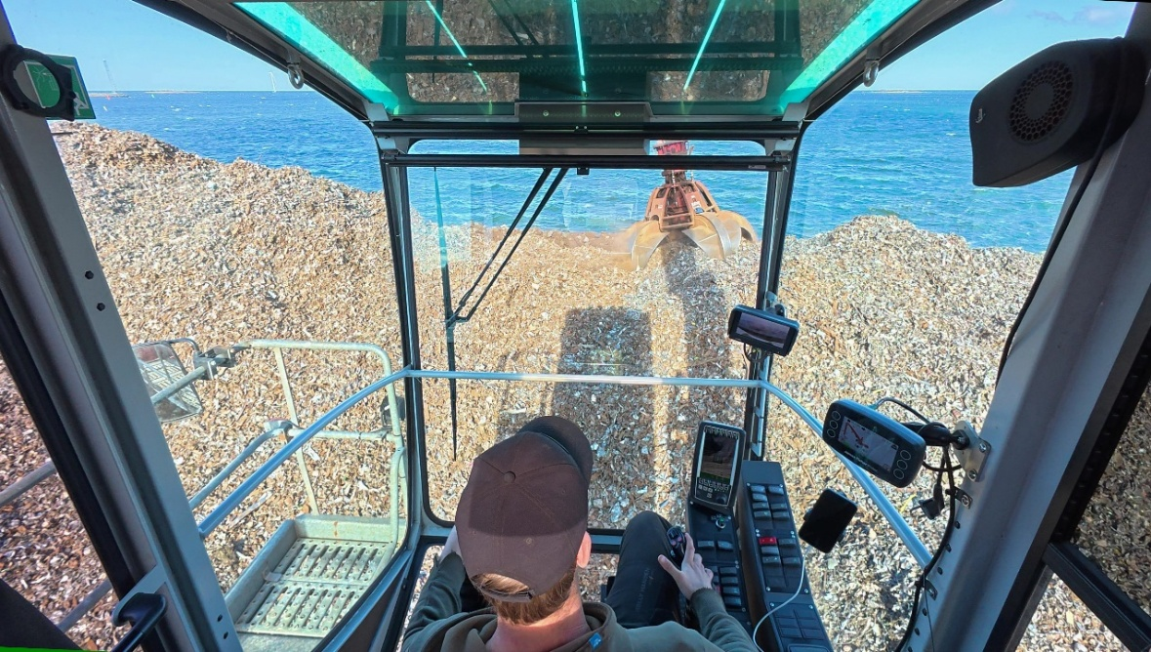

Equipped with the Portcab drivers cab and a Skylift cab extension, the operator has an optimal view of the work area.
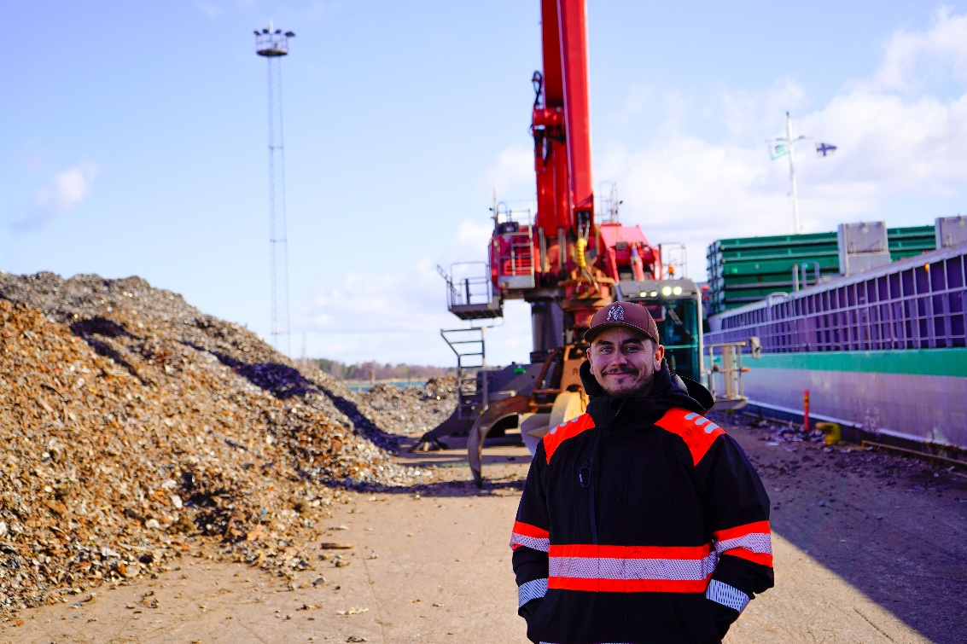

“We are very satisfied. The SENNEBOGEN consumes around 20% less fuel than the comparable material handler from a competitor that we previously operated,” – Ronny Ala-Tuori, Senior Machine Operator.

