Bild:
Photo Foto: Bruno Cohen
Location Ort: France
Lisa-Maria Heigl
Editor Autor: Estelle Peyret,
Date Datum: 04/2026

Hybrid material handler expands the port's fleet

Société Gras, based in northern France, handles around one million tonnes of goods annually – the majority of which is bulk cargo transported via waterways. To reliably meet the growing demands of port handling, the company has specifically expanded its fleet: a SENNEBOGEN 850 G Hybrid has been in operation since 2025.

Logistics with a focus on waterways

The company, based in Beugny (Pas-de-Calais), was founded around 20 years ago by Maximilien Gras and now employs around 20 people. Its main focus is on organising complex logistics flows – particularly those involving both road and water transport.

This involves not only the handling of bulk goods, but also palletised goods and industrial products. The demands placed on the technology used are correspondingly high.

A high-performance fleet for daily handling

When it comes to its fleet of machinery, Société Gras has relied predominantly on SENNEBOGEN for many years. In total, around 15 material handling machines in the 50 to 70-tonne weight class are in operation.

The key factors behind this decision are, above all, the robust construction, high load-bearing capacity and the efficiency of the Green Hybrid technology.

The equipment also plays an important role in day-to-day use:
- The SENcon control system allows for customisation of operating parameters and defined working areas
- The spacious cab ensures a comfortable working environment even during long shifts
- The mobile version offers advantages when moving between different locations within the port

The 850 G Hybrid expands the fleet

The addition of the SENNEBOGEN 850 G Hybrid has specifically expanded the fleet with a high-performance material-handling solution for demanding applications. The machine has a reach of up to 21 meters, making it particularly suitable for loading and unloading operations in the port.

Thanks to the integrated Green Hybrid technology, some of the energy generated during deceleration can be recovered and reused. This has a positive effect on fuel consumption, reducing it by around 30 %.

“The material handler is exactly what we need to work efficiently and cost-effectively. It allows us to offer our customers a reliable service whilst providing our operators with a well-designed piece of equipment,” explains Maximilien Gras.

Collaboration with Sygmat

Société Gras is supported by Sygmat, SENNEBOGEN’s French sales partner. In addition to supplying the machines, long-term support plays a key role – from commissioning through to ongoing maintenance.

“We are united by a shared understanding of efficient and sustainable handling technology. This close collaboration pays off in day-to-day operations,” says Jérémy Sobczak, Sales Manager at Sygmat.

Captions:

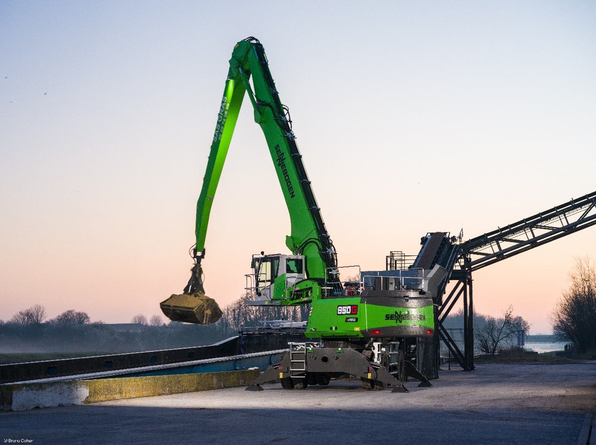
Header picture

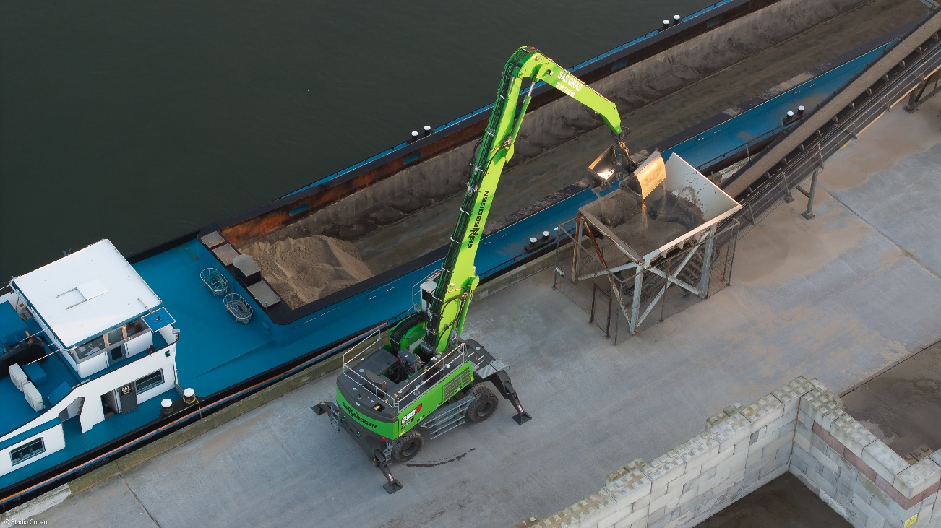

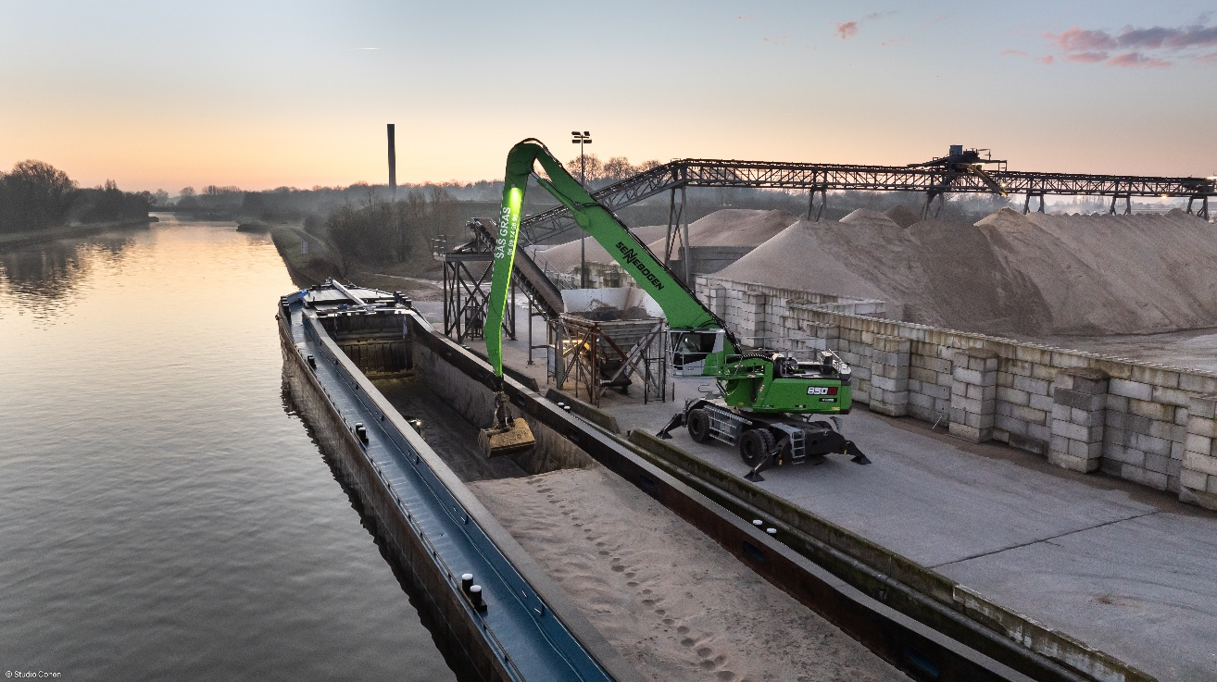
With a reach of up to 21 meters and a high load capacity, the SENNEBOGEN 850 G Hybrid delivers the performance required for demanding loading and unloading operations in port handling.

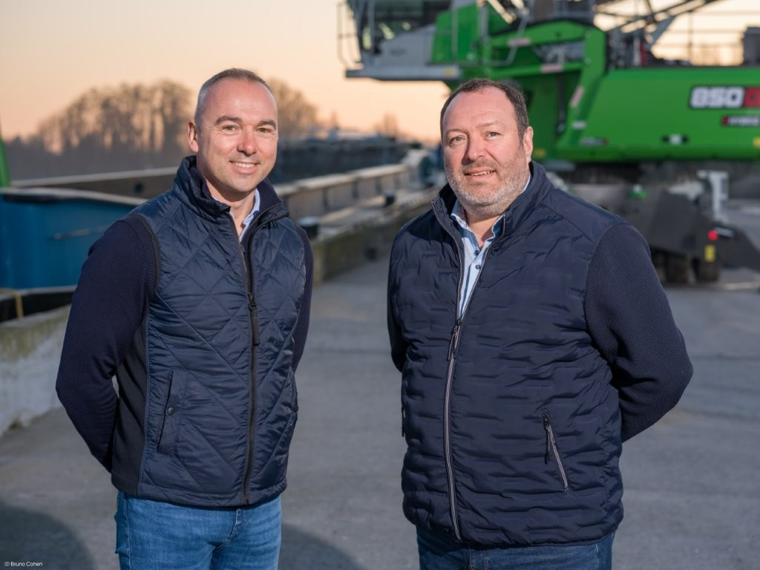
Maximilien Gras (left) highlights not only the technology but also the close collaboration with Sygmat, represented by Jérémy Sobczak (right), sales manager for handling machines.

