Bild:
Photo Foto: Léon Huizinga
Editor Autor: Lisa-Maria Heigl
Location Ort: Netherlands
Date Datum: 03/2026

Hybrid system makes the 830 G suitable for port operations

At the Port of Amsterdam, the loading and unloading of inland waterway vessels is an integral part of day-to-day operations at Verhoeks Overslag. The company organises comprehensive handling and transport solutions for bulk and general cargo such as sand, gravel and cellulose – always with the aim of providing customers with a seamless and reliable service. To meet these requirements, Verhoeks Overslag relies on the SENNEBOGEN 830 G with hybrid system – designed for high-performance port operations.

Efficient material handling with a 17-metre reach

Two or three ships have to be unloaded at this site every week. This requires fast, consistent workflows. With a reach of 17 metres and a cycle time of just 17 seconds, the handling machine ensures a constant flow of material.
It is particularly when unloading inland waterway vessels that the crucial interplay between reach and power becomes apparent. The boom must reach deep into the hull to fully access the material without losing any power in the process.

Hybrid system for more lifting capacity

A key feature is the third hybrid cylinder. The system stores energy as the boom is lowered and uses it to lift the equipment when the boom is raised. This advanced Green Hybrid energy recovery system is a new addition to this class of machinery and is now available as an optional extra on the 830 G. This ensures that performance remains consistent even at great depths – a clear advantage in port operations.
“We chose this machine because of the third hybrid cylinder. The system ensures that we can reach the ship’s floor with ease, even with a fully loaded bucket. We have additional lifting capacity when raising weights. This enables us to achieve a high handling capacity per hour.” – says André Verhoeks, owner of Verhoeks Overslag.

The system ensures consistently efficient handling, particularly with materials such as sand and gravel, which are packed tightly in the ship’s hold.

Significant savings in day-to-day operations

In addition to performance, cost-effectiveness also plays an important role. Compared to existing machines, there is a clear difference in fuel consumption:
“Our fuel consumption per tonne is around 10 per cent lower than that of our previous machines.”
This saving has a direct impact on operating costs, particularly in the case of regularly recurring cargo-handling processes such as those in Amsterdam.

Cab with an excellent view of the work area

Another key focus is the driver’s cab. The cab of the 830 G offers plenty of space and a significantly improved view of the working area.
“The material handler is very comfortable. The cab is spacious and the visibility is really good. That’s important to us.”
The removal of steel struts from the driver’s field of vision, along with larger front and side windows, further improves visibility. The display on the 830 in the G-Series can also be customised:
“The display can be adjusted so that every driver can set their ideal viewing angle. This makes day-to-day work more comfortable.”

Reliability in port operations

In day-to-day operations, it is not just individual performance figures that matter, but the overall package comprising technology, service and reliability.
“SENNEBOGEN delivers top performance. The material handlers are robustly built and reliable, and the service both from the manufacturer and the dealer is excellent.”
For Verhoeks Overslag, that is precisely what matters – a material handling machine that delivers consistent performance and integrates seamlessly into the port’s operations.

Captions:

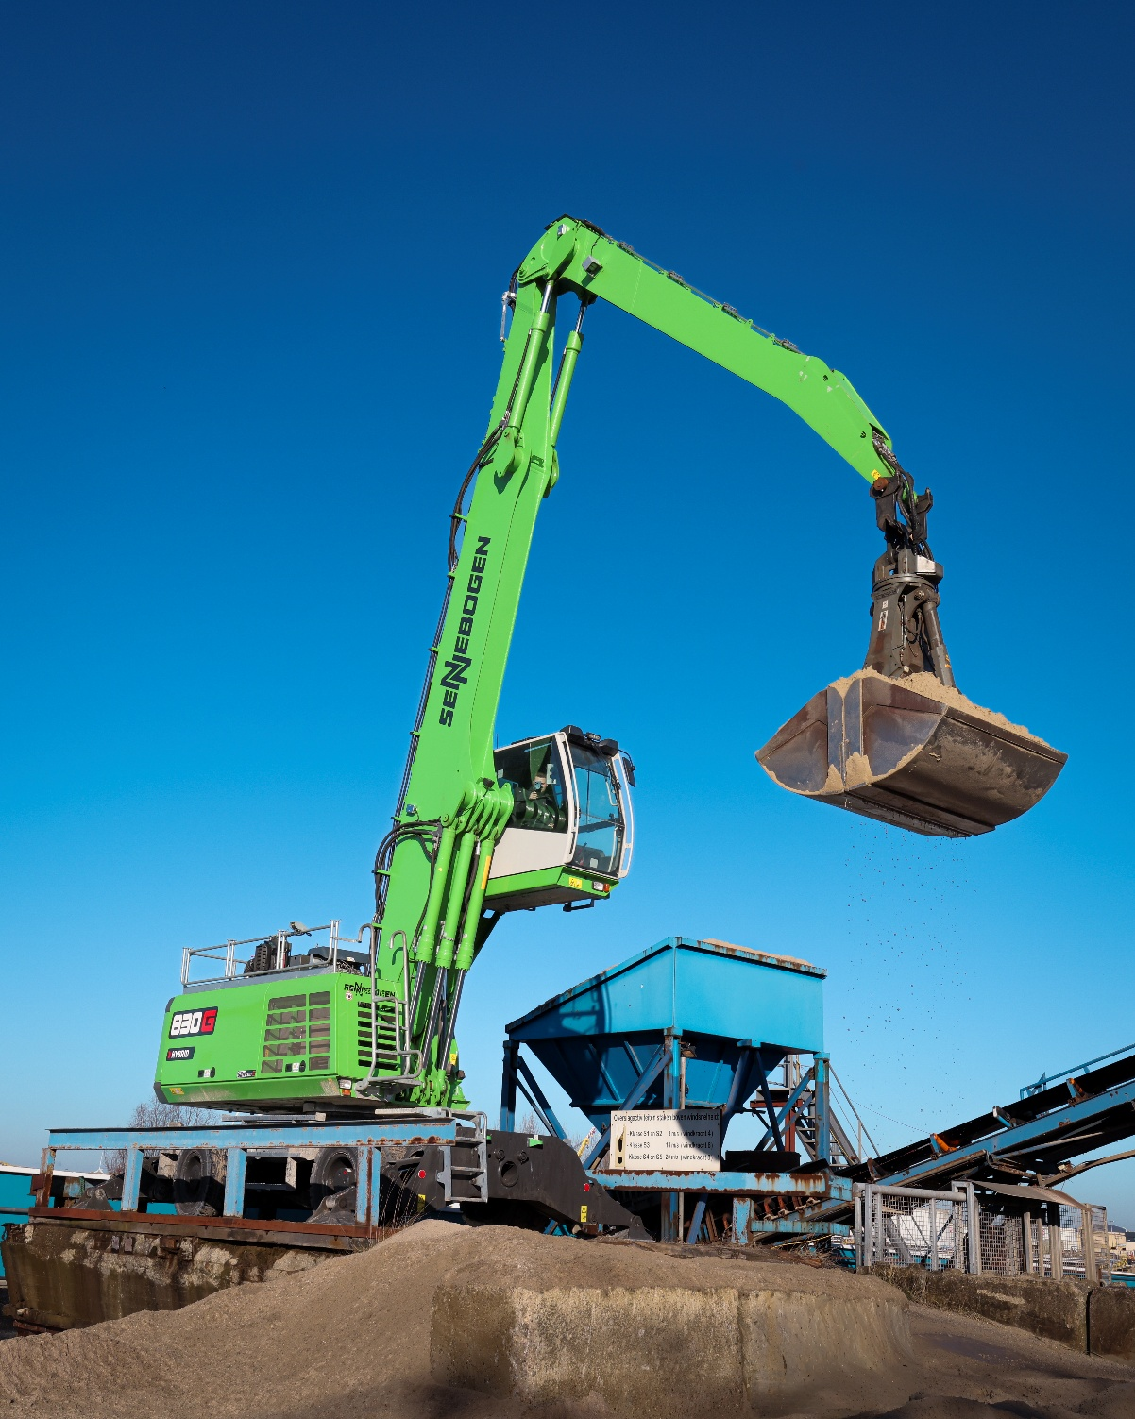
Header picture

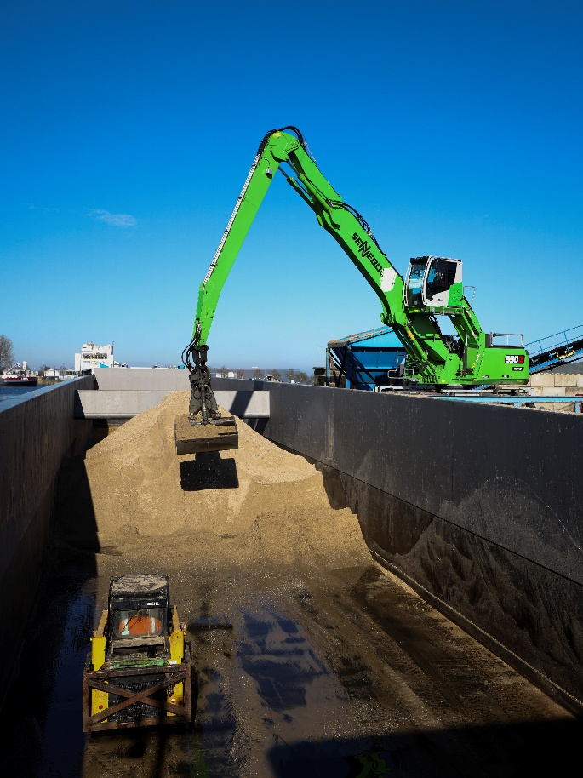
With a reach of 17 metres, the 830 G Hybrid can easily reach low-lying material in the ship’s hold.

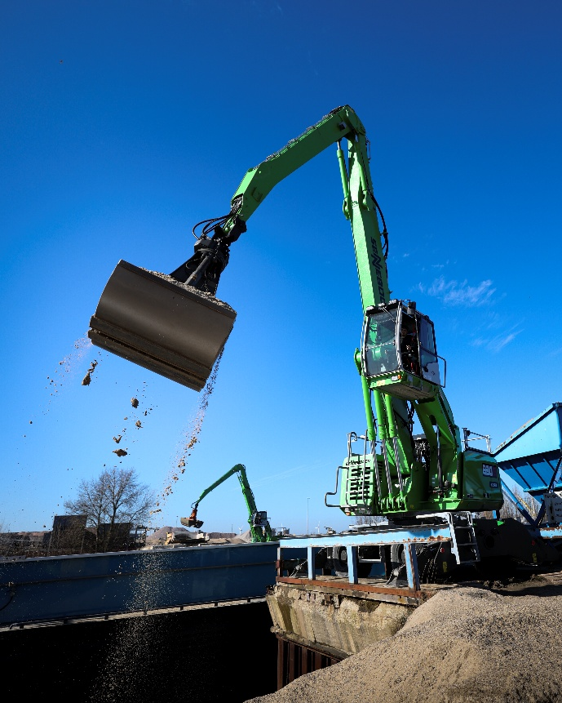
Efficient handling of sand and gravel with consistently short work cycles.

