Bild:
Location Ort: Radom, PL
Editor Autor: Lisa-Maria Heigl, Product Marketing Manager Scrap & Recycling
Date Datum: 06/2026

Material handling machine with tool-change capability for grab and scrap shear

In material handling, smaller scrap yards often have to handle a wide variety of tasks with limited resources. Metal fractions are sorted, moved, loaded, and, if necessary, processed directly on site. To meet these varying demands, ROMBUD, based in Radom, Poland, relies on the SENNEBOGEN 825 E Vario Tool.
The material handling machine with tool-change capability helps the family-run business organize multiple work steps using a single machine. Depending on the task, the 825 E Vario Tool operates with a grab or a scrap shear, allowing it to adapt flexibly to the material, process step, and day-to-day operations.

ROMBUD specializes in the purchase and sale of steel and non-ferrous metal scrap. The materials processed include, among others, steel scrap, shavings, cables, motors, and various metal fractions. In addition, the company offers transportation, loading, and unloading services. The volumes of material are manageable, but the day-to-day operational requirements are diverse. For ROMBUD, it was therefore crucial not to maintain multiple specialized machines, but rather to use a flexible solution capable of handling various material-handling tasks.

How does a material handler with tool change capabilities help in day-to-day operations?

The SENNEBOGEN 825 E Vario Tool handles various process steps at ROMBUD. Using its grap, the machine sorts, moves, and loads various materials. With the Trevibenne CS 40RS scrap shear, it can also process scrap metal directly on the company premises.

The operating principle is clear: one operator, one material handler, and various attachments for each specific task. This allows ROMBUD to make efficient use of its existing fleet and respond flexibly to changing requirements.

Operational Facts at a Glance

- Customer: ROMBUD, Radom, Poland
- Industry: Steel and non-ferrous metal scrap
- Machine: SENNEBOGEN 825 E Vario Tool
- Attachments: Grab and Trevibenne CS 40RS scrap shear
- Tasks: Sorting, moving, loading, and processing metal scrap
- Support: SENNEBOGEN sales partner KOMATSU Poland

Solution: Tool changes instead of additional specialized machines

For ROMBUD, the focus was not on purchasing multiple specialized machines, but rather on a single machine capable of reliably handling various work steps. The quick switch between the grap and the scrap shear makes the SENNEBOGEN 825 E Vario Tool the ideal solution for this application.

Long changeover times can be avoided, while the flow of material remains stable in day-to-day operations. This flexibility is particularly important in a family-run business, because machine availability and resource allocation directly impact the organization of daily operations.

Why are availability and minimal downtime so important?

In material handling, unplanned downtime quickly affects the entire process. When sorting, loading, or processing are delayed, the flow of materials on the premises comes to a standstill.

In addition to versatility, reliability and durability were therefore key criteria in selecting the machine. The SENNEBOGEN 825 E Vario Tool is designed to meet the daily demands of material handling operations and helps ROMBUD reliably organize its workflows. On site, the company is supported by the SENNEBOGEN sales partner KOMATSU Poland.

Captions:
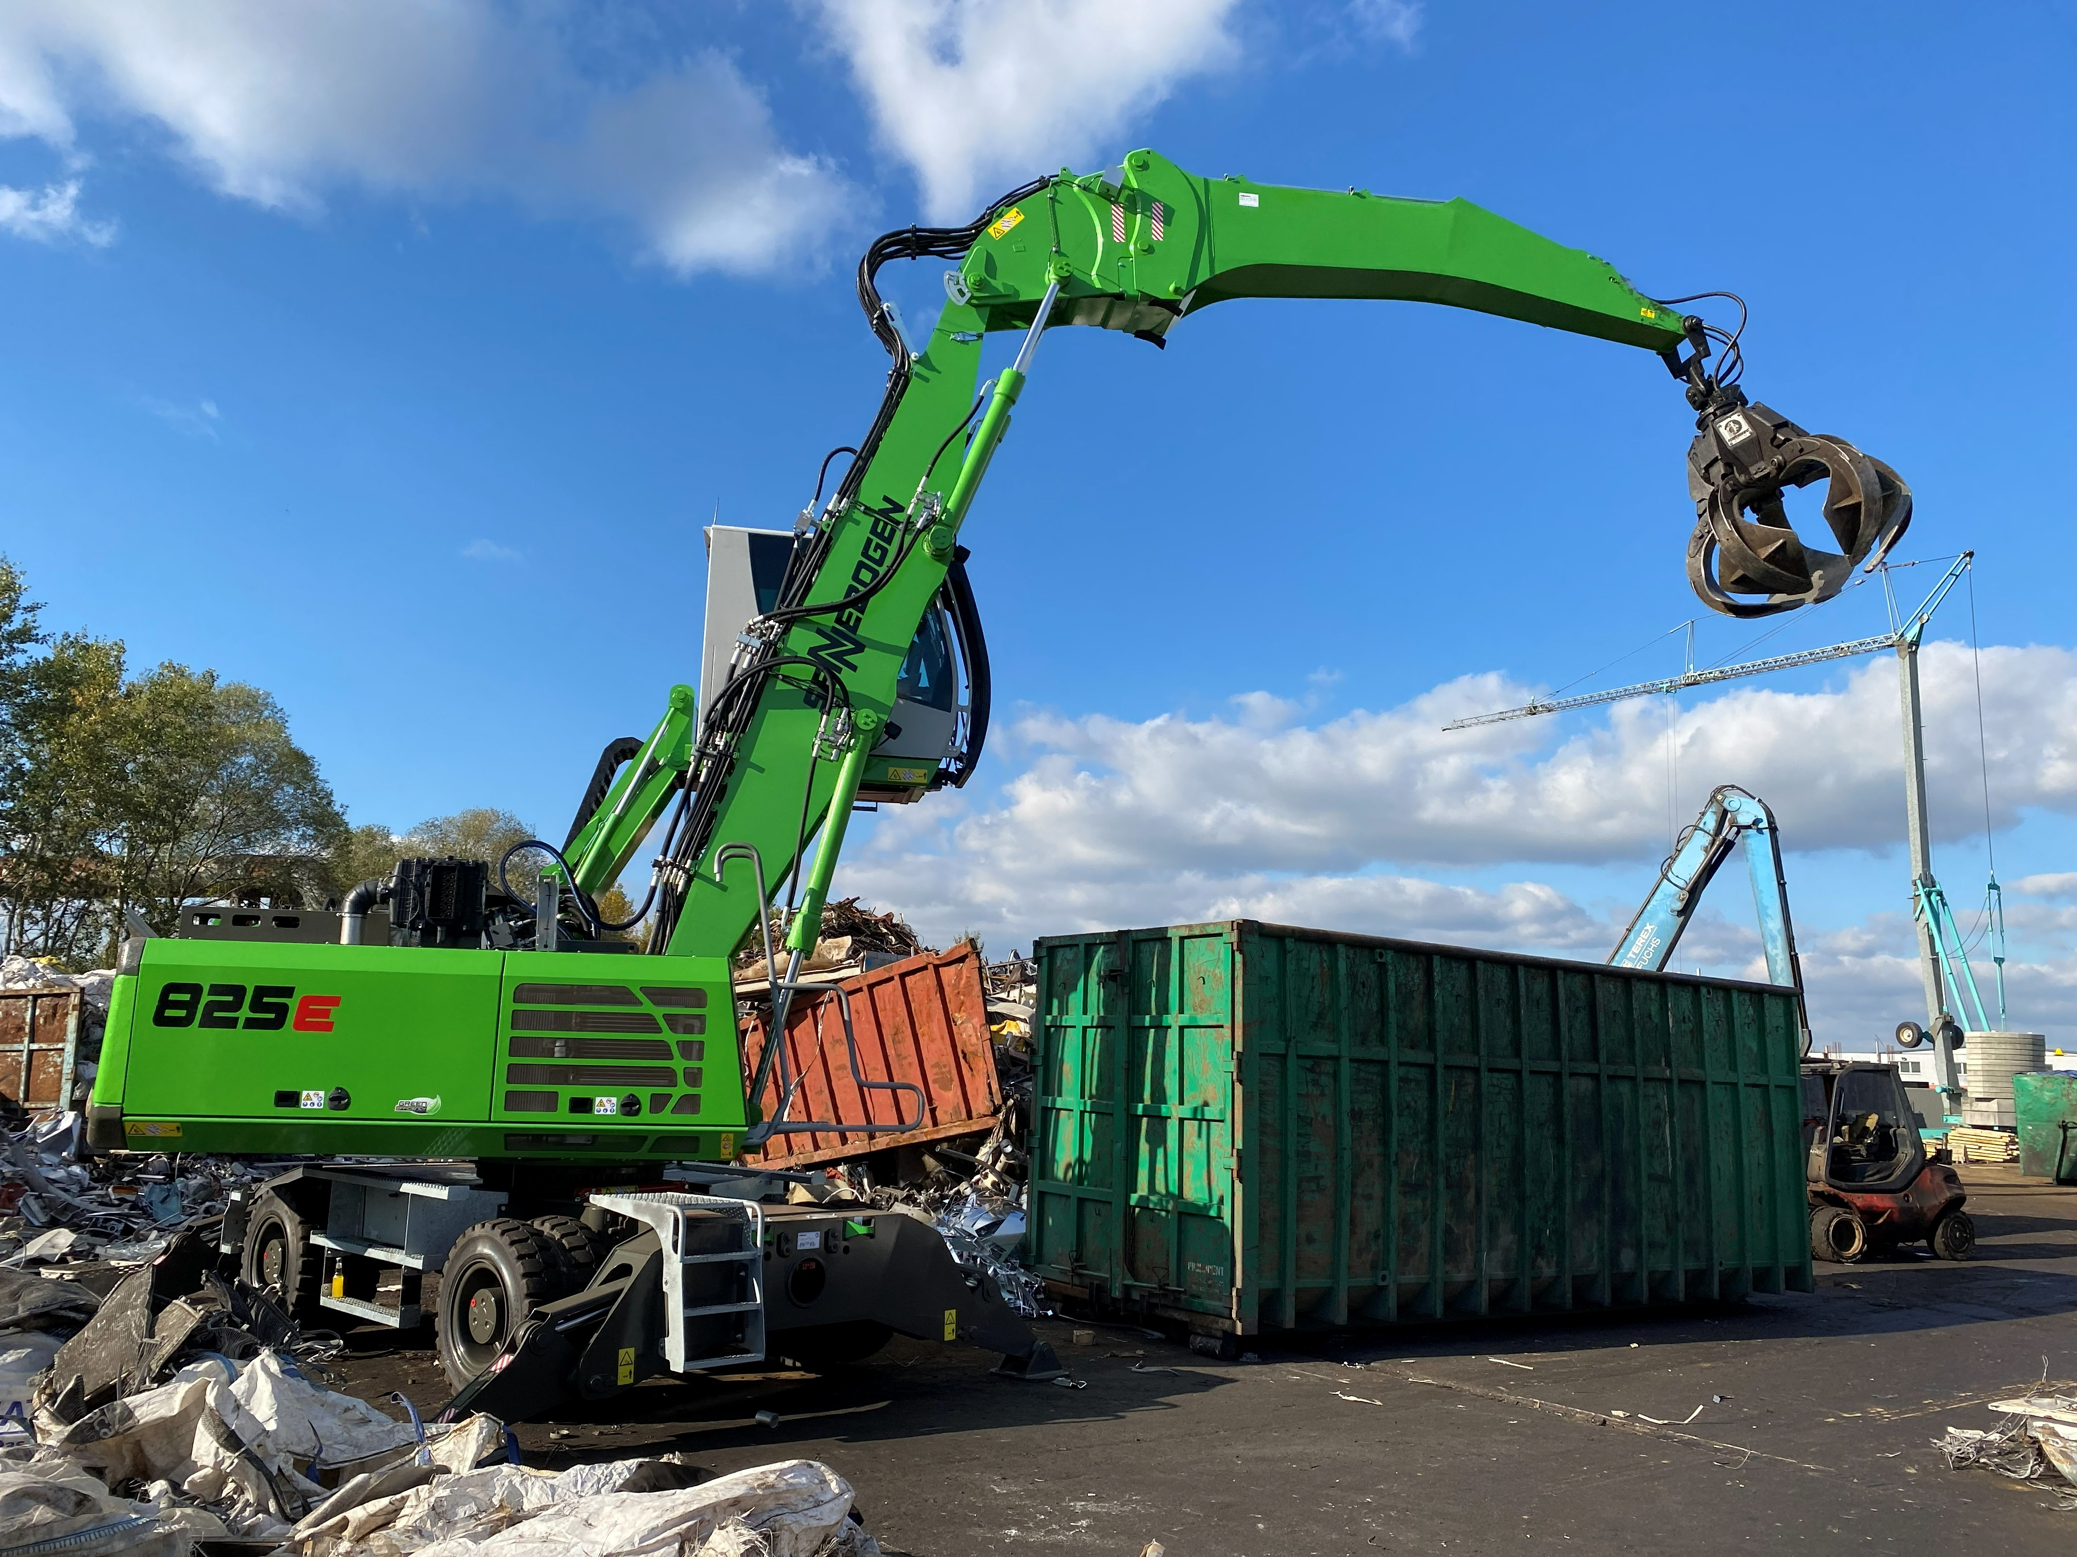
Equipped with the grap, the 825 E Vario Tool sorts, moves, and loads materials efficiently and precisely.
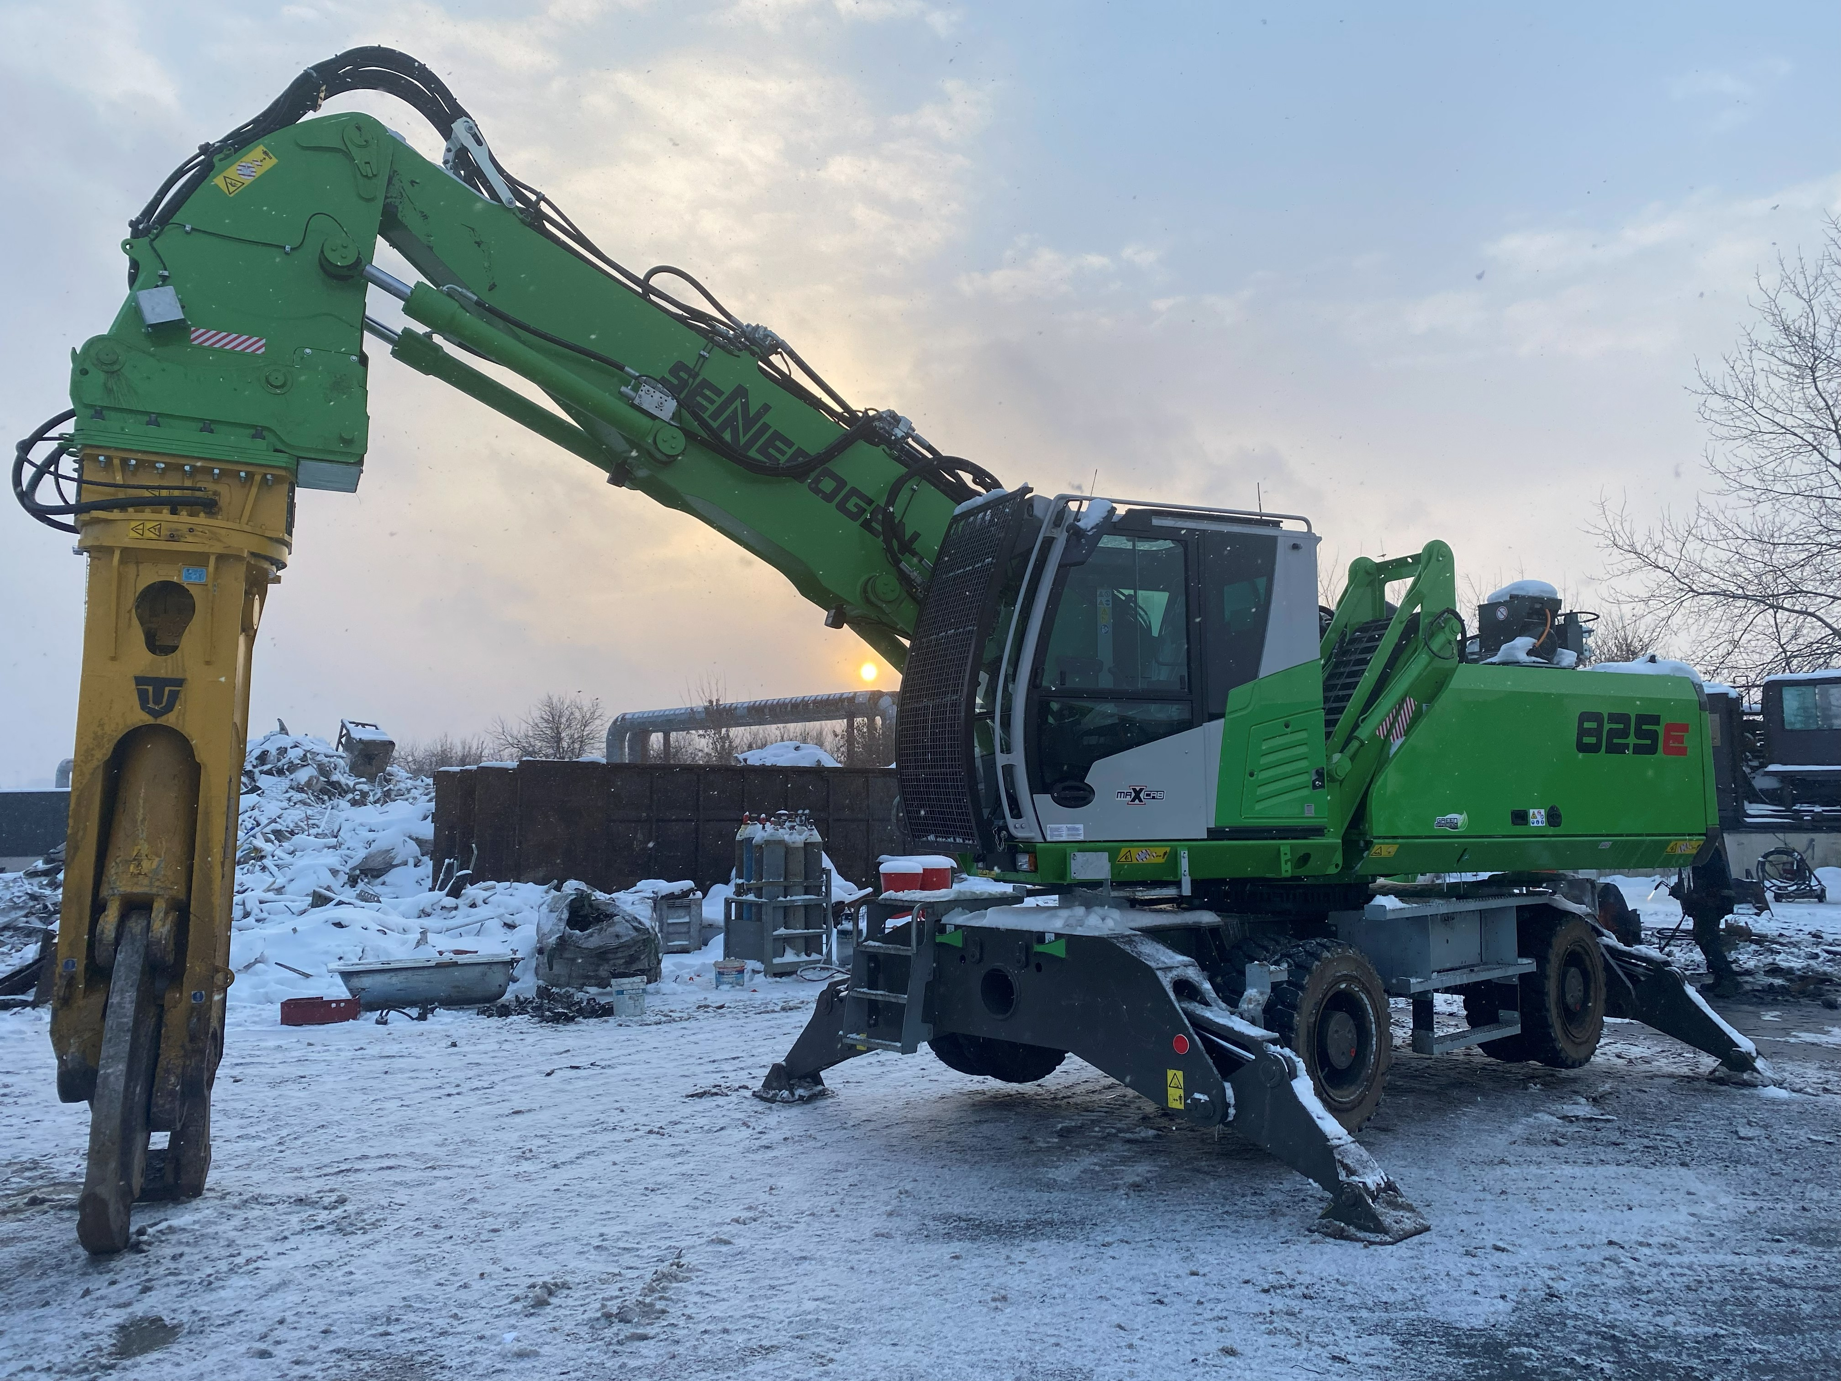
The SENNEBOGEN 825 E Vario Tool with a Trevibenne CS 40RS scrap shear.

