Bild:
Location Ort: Germany
Meike Kleegraf
Editor Autor: Lisa-Maria Heigl, Product Marketing Managerin
Date Datum: 06/2026

The new generation of the SENNEBOGEN 822 G for efficient material handling

For more than 30 years, Entsorgungswirtschaft Soest GmbH (ESG) has been responsible for the recycling and disposal of waste from the Soest district. Approximately 66 employees process more than 150,000 metric tons of waste annually from the district’s 14 cities and municipalities. To manage material flows reliably and cost-effectively over the long term at its Werl and Erwitte sites, ESG is investing in two new SENNEBOGEN 822 G material handlers. The machines will replace two proven SENNEBOGEN 818 E models, which are being taken out of service after more than ten years of daily use.

The new material handling machines perform key tasks in feeding processing plants, loading recyclable materials and waste, and handling materials within the facility. High handling capacity, reliability, and short work cycles are crucial prerequisites for cost-effective plant operation.

Proven technology consistently refined

The decision to choose the SENNEBOGEN 822 G is based on many years of positive experience. The two 818 E models we’ve had so far have proven their reliability and cost-effectiveness over many years. With the new G Series, ESG is committed to the consistent further development of its proven material handling technology.

Both machines have a reach of ten meters and are equipped with an integrated weighing system. This allows material quantities to be measured directly during handling, eliminating the need for additional process steps. The equipment is complemented by a dozer blade on the undercarriage and a protective ventilation system that reliably shields the operator and the cab from dust – an important advantage in daily use at waste disposal and recycling facilities.

The new SENcon control system provides additional ease of use. It allows for individually configurable machine functions and helps operators work intuitively, efficiently, and comfortably throughout the workday.

Operators confirm better visibility and greater ease of use

Right after the training session, the operators were particularly impressed by the improved all-around visibility. “We’re really thrilled with the new SENNEBOGEN 822 G. The clear visibility from the cab, in particular, makes our work much easier and safer. It allows us to maintain a full overview of the material and our surroundings at all times. That makes our day-to-day work a lot easier.”

Especially at recycling centers and waste disposal facilities with continuous material handling and heavy truck traffic, optimal visibility improves both workplace safety and the efficiency of daily operations. At the same time, the ergonomic layout of the controls makes the transition to the new generation of machines easier.

Modern Handling Technology for Municipal Waste Management

By investing in two SENNEBOGEN 822 G material handling machines, ESG is sustainably modernizing its material handling equipment at its Werl and Erwitte sites. The machines seamlessly take over the tasks of their predecessors and lay the groundwork for reliable, cost-effective, and high-performance material handling in municipal waste management.

The project was supported by Schlüter für Baumaschinen, the regional SENNEBOGEN sales partner.
Captions:

Header picture
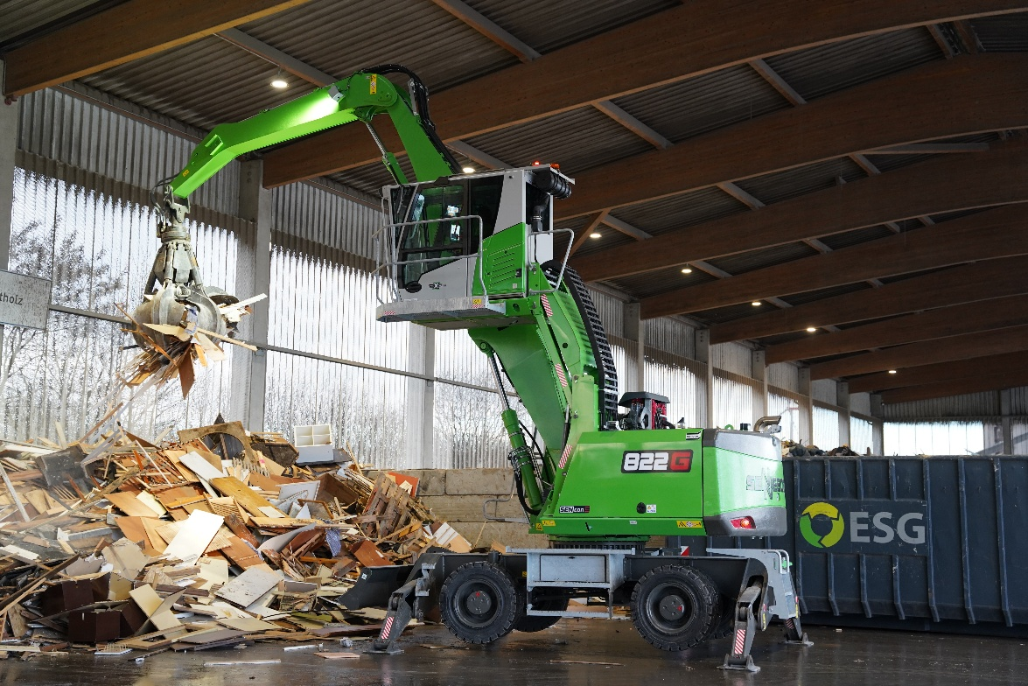

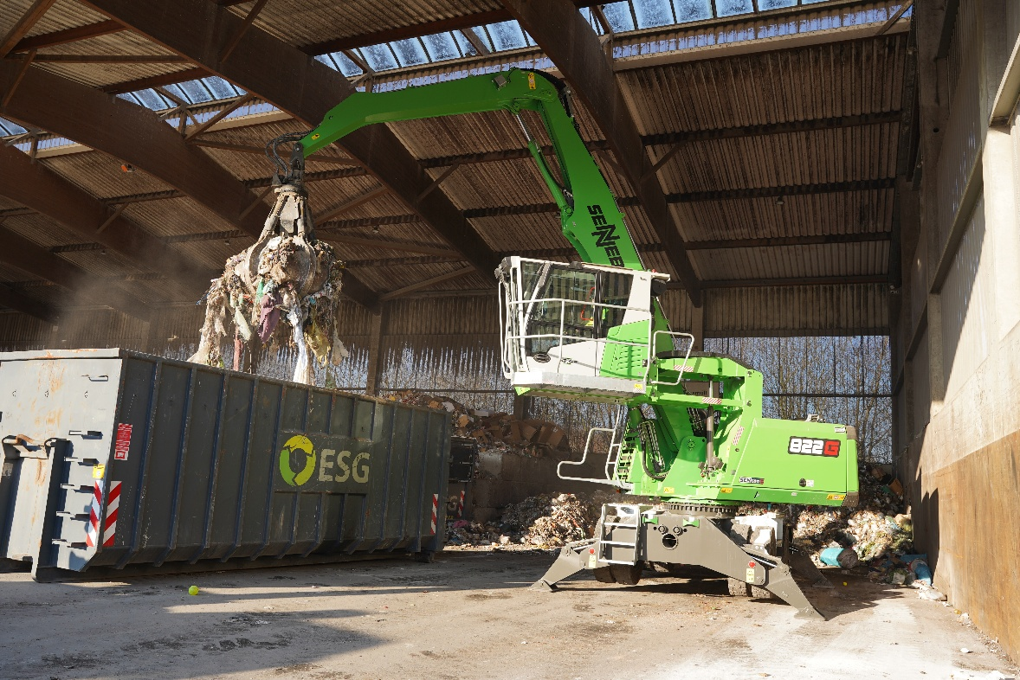

The two new material handling machines are used daily to feed materials into plants, as well as to load and transfer a wide variety of materials.

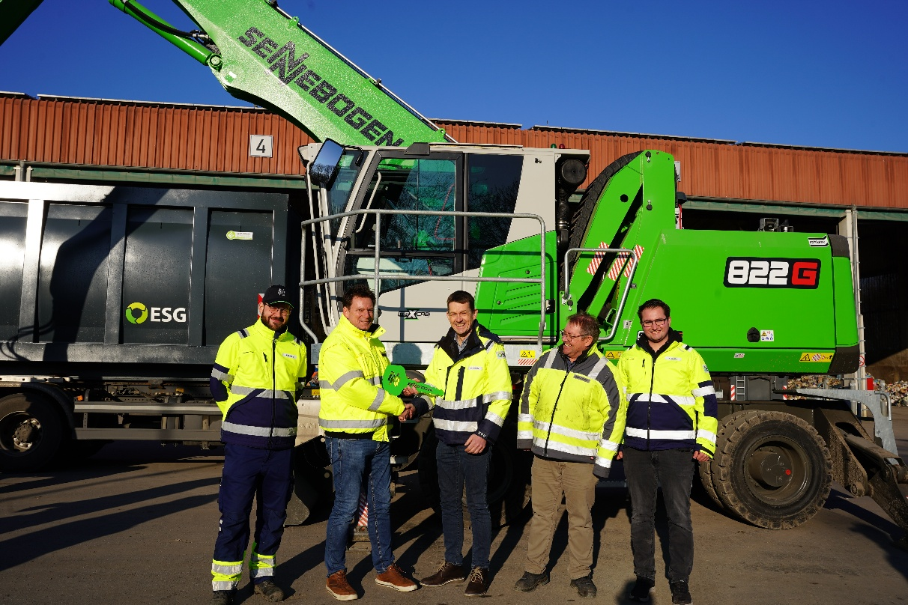

With its two SENNEBOGEN 822 G machines, ESG is investing in modern material handling technology to ensure reliable operations at its Werl and Erwitte sites.

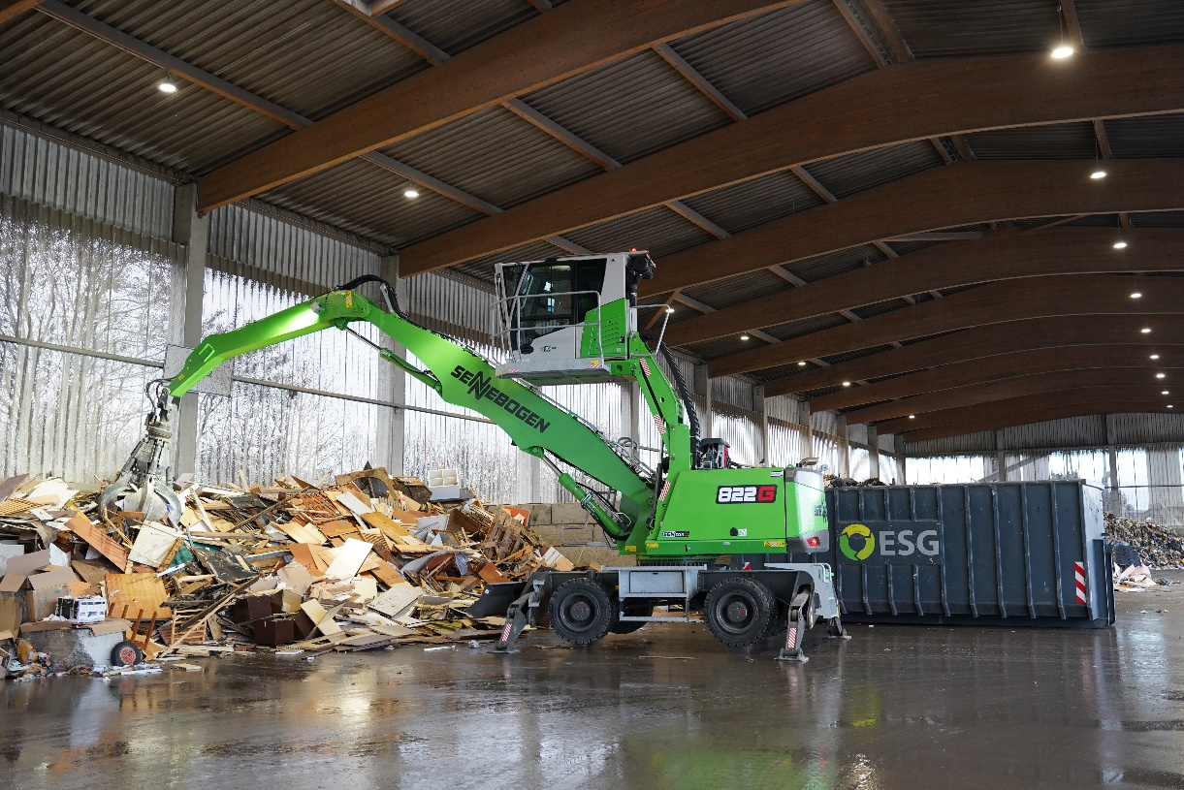

The spacious, glass-enclosed cab offers excellent all-around visibility and helps drivers handle materials safely and precisely.

