Bild:
Date Datum: 11/2025
Photo Foto: Sandra Hartl
Location Ort: Lettland
Editor Autor: Isabella Wild

Optimising timber handling for sustainability and efficiency
The internationally active wood-processing company SIA Krauzers is optimizing material flow in its newly constructed sawmill with two SENNEBOGEN 730 E Pick & Carry machines. In addition to a classic 730 E used for in-plant logistics, the company operates a second machine with a trailer – ideal for longer travel distances between the roundwood yard and the sorting line.

Modern Sawmill Sets New Standards in Timber Logistics
SIA Krauzers, headquartered in Talsi (Latvia), has more than 25 years of experience in forestry, roundwood handling, and wood processing. With a strong export orientation – 100% of its products are shipped to destinations including the UK, USA, Canada, India, and the United Arab Emirates – the company continuously invests in modern technology. After commissioning a new sorting line in 2020, the next strategic step followed in 2025: a modern sawmill with two roundwood yards.

SIA Krauzers Increases Sawmill Efficiency with SENNEBOGEN Pick & Carry
The idea to invest in the SENNEBOGEN 730 E series emerged after a delegation trip to German-speaking countries. During visits to several sawmills in Germany and Austria, the Pick & Carry concept immediately impressed.
“The maneuverability, the flexible applications, and above all the stability when transporting heavy loads convinced us right away. With Pick & Carry, we can use our storage areas far more efficiently,” explains Andis Araks, Managing Director of SIA Krauzers.

Two SENNEBOGEN 730 E Machines – Perfectly Matched to Different Applications
At the first roundwood yard, Krauzers uses a SENNEBOGEN 730 E without a trailer. The machine handles sorting, repositioning, and feeding the line directly on site. The elevating cab provides optimal visibility and enables efficient operation even in confined areas.
For the second roundwood yard, the company chose a SENNEBOGEN 730 E Pick & Carry machine with a specially dimensioned trailer. This allows the team to manage longer distances of 300 to 600 meters per trip particularly efficiently.
The trailer transports more wood per cycle than a conventional wheel loader while providing better traction, greater stability, and fewer travel cycles.

Why Pick & Carry Improves Timber Handling Efficiency in the Long Term
• higher handling performance in roundwood operations
• reduced travel cycles thanks to greater transport capacity
• flexible and safe machine operation even in restricted plant areas
• optimal use of space in storage, logistics, and sorting areas

With this approach, SIA Krauzers relies on a future-proof logistics solution for its sawmill. The combination of high efficiency, flexibility, and robust “Made in Germany” technology makes a significant contribution to the company’s sustainable and economically sound development.

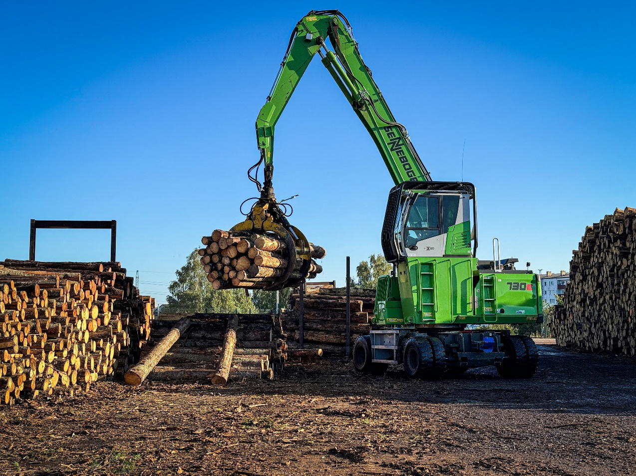
Headerbild

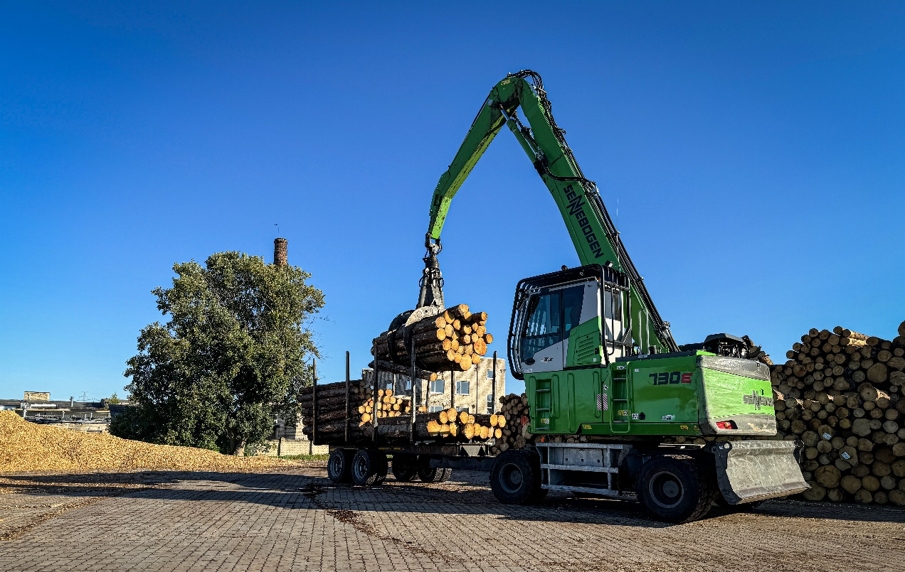
With the trailer concept, four times the amount of timber can be transported in a single trip.
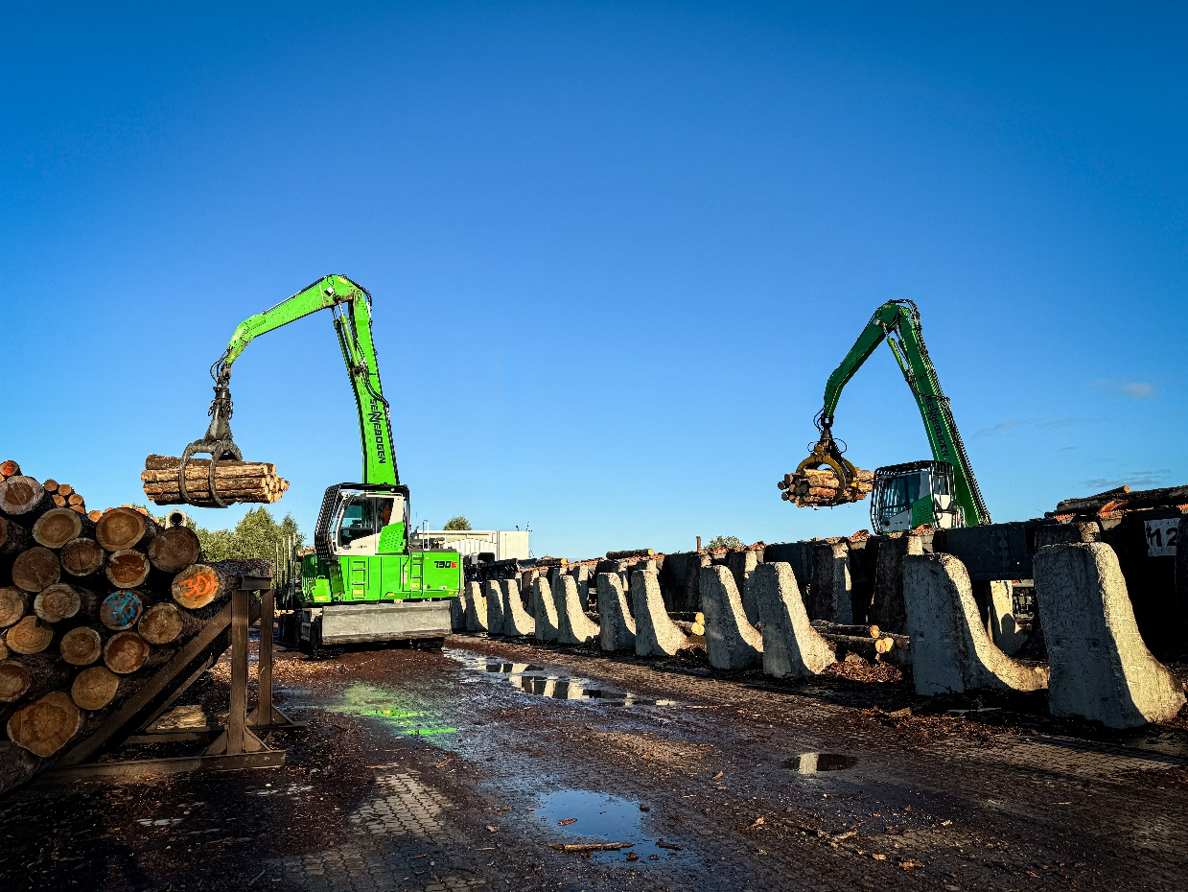

Thanks to a 360-degree continuously rotating upper carriage, the 730 E can drive forward out of narrow aisles without the need for complex maneuvering.

