Bild:
Date Datum: 07/2026
Photo Foto: Florian Schmid
Location Ort: Österreich
Editor Autor: Isabella Wild

Field Test in the Sawmill: Holzhof Schmidt Tests the New SENNEBOGEN G-Series
Holzhof Schmidt, based in Lower Austria, is a medium-sized sawmill specializing in demanding spruce, pine and larch cutting. With an impressive annual cutting capacity of around 100,000 solid cubic meters, the demands on internal logistics and material flow are enormous. For these tasks, Holzhof Schmidt has relied on material handling technology from SENNEBOGEN for years. Alongside the proven SENNEBOGEN 730 E machines, the new SENNEBOGEN 724 G from the G-Series is currently being tested in real-world operations. The field test demonstrates how the machine proves itself in everyday sawmill operations under challenging conditions.

What Demands Does Sawmill Operation Place on the Machine?
Holzhof Schmidt's log yard is long, spacious, and topographically demanding. In daily operations, machines must not only grab, stack, and transport logs, but also safely handle longer travel distances, inclines, and ramps while towing trailers.
During the test run, the SENNEBOGEN 724 G is primarily used at the sorting line and for the continuous feeding of the saw via trailer. As a result, the machine operates precisely where availability, driving dynamics, tractive power, and precise material handling have a direct impact on the production flow.
Mario Urmann, Product Specialist at SENNEBOGEN, describes the value of close communication with the customer:
"We are specifically testing the new 724 G-Series at Holzhof Schmidt in multi-shift and trailer operations under real, harsh conditions. For us as a manufacturer, the extremely close contact and the regular, bi-weekly feedback from drivers and maintenance staff are worth their weight in gold, allowing us to feed this feedback directly back into the factory."
This creates a reliable picture of how the new G-Series behaves in daily life: when driving, towing, lifting, grabbing, feeding, and during maintenance.

How Does the 724 G Prove Itself in Trailer Operation?
The generational shift from the E- to the G-Series brings tangible economic and ergonomic benefits. A central feature of the new machine is the dual-circuit travel drive. This ensures that the machine operates with much more agility, allowing the driver to achieve shorter cycle times. At the same time, the operator benefits from significantly reduced fuel consumption compared to previous models.
Thomas Taucher has been working at Holzhof Schmidt since 2016 and has been operating SENNEBOGEN machines since 2019. He describes the 724 G in test operation as follows:
"We've recently had the 724 G on the yard for testing, and both the travel speed and the working hydraulics are simply superb. The tractive and lifting power are incredible, as is the excellent stability. In terms of speed, I've already compared the machine to a Ferrari – it is extremely lively, maneuverable, and agile."

Safety and Maintenance in Daily Use
The redesigned machine layout ensures maximum safety. The boom is now pivoted further back, giving the SENNEBOGEN 724 G excellent stability and providing an extremely secure feeling while working. On the long travel routes and ramps of the Holzhof Schmidt yard, the new development is already showing its full potential: the tractive power significantly exceeds expectations. The test operation has shown that the machine achieves the hoped-for enormous tractive power, which almost reaches the level of the next largest 730 class.
The new service concept proves just as practical in daily testing. All filters can be easily accessed from the side, and all fluid levels can be checked from the ground. The operator can inspect the machine without having to climb onto the equipment—an enormous benefit for workplace safety and the daily maintenance routine.

Practical Feedback from Drivers
Feedback from the operators highlights which points matter most in practical use: travel speed, hydraulic performance, tractive power, lifting capacity, stability, and cabin comfort.
Christian Kronaus, who has been responsible for the sorting line and saw feeding at the yard for four years, particularly emphasizes the technical sophistication and hydraulic performance:
“My main task is to supply the sorting line and deliver logs to the saw. What I like most about the concept of the new 724 G are the two separate pump systems for the travel drive and the upper carriage. This separation provides noticeably more overall power when you are driving and handling material at the same time. In addition, the handling is very simple and offers many functions. I find it particularly positive that each driver can create an individual profile. This allows travel speed, the responsiveness of the slewing gear, and the slewing performance of the upper carriage to be perfectly tailored to one’s own working style.”

Comfort Cabin and SENcon Control System
During long working days, it is not just machine performance that matters, but also the driver's workspace. According to operator feedback, the cabin of the SENNEBOGEN 724 G is comfortably equipped and supports precise, focused work.
Christian Kronaus speaks very positively about the controls and cabin quality in particular:
"In everyday work, the cabin is absolutely top-tier in terms of comfort. I really like the equipment with heating, air conditioning, and seat ventilation. All functions can be controlled separately and intuitively via the touch display. Another major advantage is that the cabin is extremely well-sealed and therefore remains completely dust-free."
This is highly relevant for sawmill operations, as long working days, dust exposure, and changing tasks place high demands on ergonomics and operating comfort.

Results of the Field Test
The deployment at Holzhof Schmidt demonstrates several practice-relevant advantages of the new SENNEBOGEN G-Series in sawmill operations:
- Higher Productivity & Shorter Cycle Times: Thanks to the new dual-circuit travel drive, the machine operates more agilely and efficiently when driving and working simultaneously.
- Enormous Efficiency in Trailer Operation: The increased tractive power almost matches that of its larger brother, the 730 E, and effortlessly masters inclines even with a fully loaded trailer.
- Maximum Stability: The rearward-shifted boom pivot point guarantees optimal weight distribution and secure footing during log handling.
- Individual Customization: The SENcon control system allows for personalized driver profiles for tailor-made settings regarding power, speed, and sensitivity.
- First-Class Driver Comfort: A perfectly sealed, dust-free cabin including seat ventilation, heating, air conditioning, and modern touch controls protects the health of operators during long working days.
- Smart Maintenance: Increased service friendliness thanks to ground-level fluid checks without climbing, and filter components that are perfectly accessible from the side for workshop staff.

Practical Feedback Flows Directly into Further Development
The field test at Holzhof Schmidt provides SENNEBOGEN with concrete feedback from a demanding sawmill operation. Regular feedback from drivers and maintenance personnel helps to further adapt the new G-Series to real operating conditions.
For sawmill operators, this case report highlights what matters most for machines in log handling: reliable tractive power, precise hydraulics, dependable trailer operation, good maintenance accessibility, and a workspace that relieves drivers during long multi-shift operations.

Headerpicture
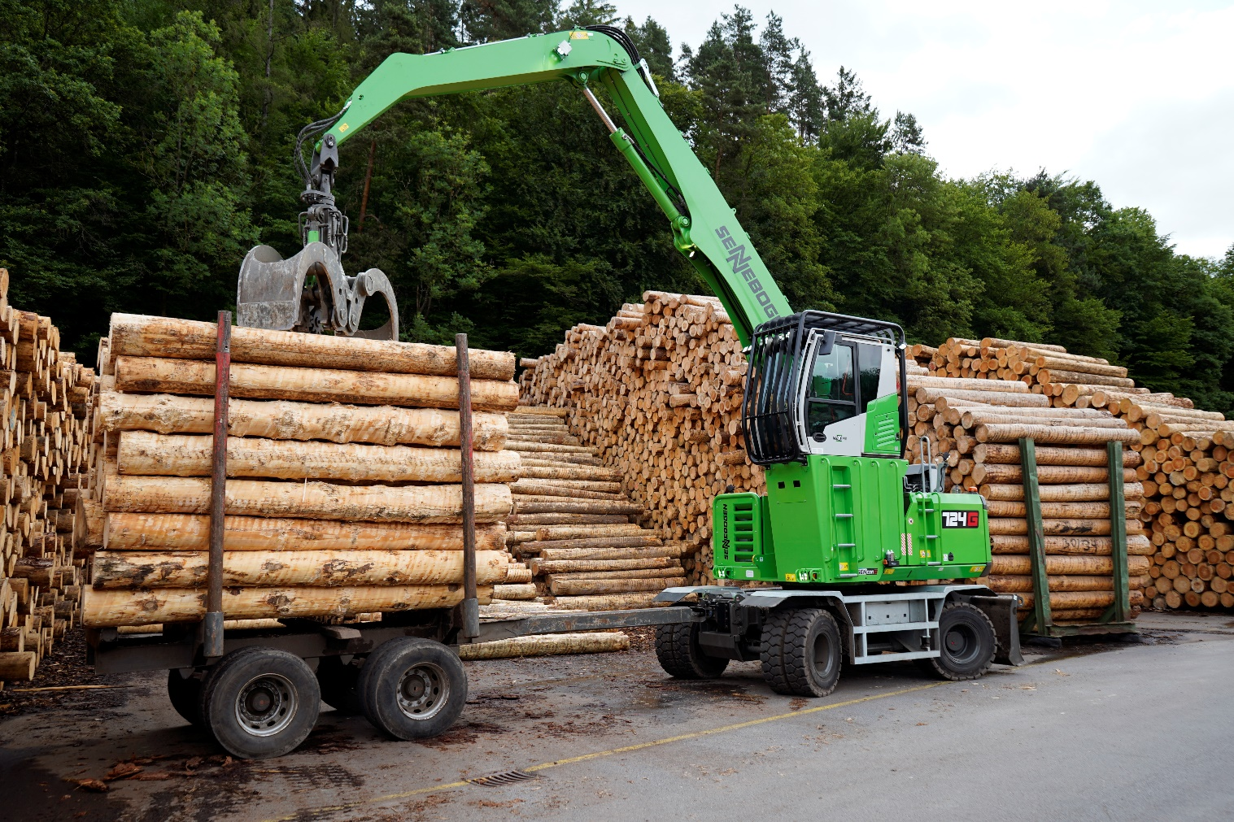

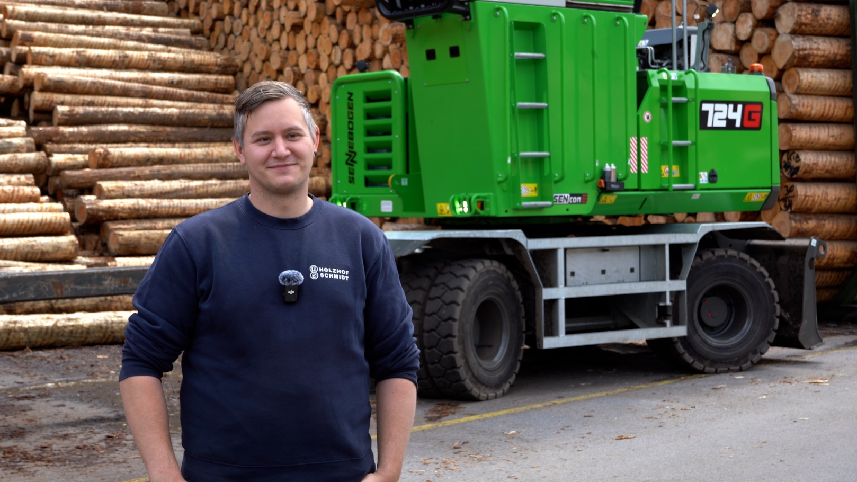

Quote from Thomas Taucher: "We've recently had the 724 G on the yard for testing, and both the travel speed and the working hydraulics are simply superb. The tractive and lifting power are incredible, as is the excellent stability. In terms of speed, I've already compared the machine to a Ferrari – it is extremely lively, maneuverable, and agile."

