Bild:
Photo Foto Isabella Wild
Isabella Wild
Editor Autor:
Date Datum: 12/2025
Location Ort: Deutschland

Hazardous tree removal with a tree care handler: Holz Nigl relies on the SENNEBOGEN 718 E
The forestry and arboriculture company Holz Nigl, based in Waldkirchen near Passau, regularly works in environments where conventional tree felling methods reach their limits: alongside roads, near buildings, in sensitive green spaces, or when dealing with difficult-to-access hazardous trees. For these demanding applications, the family-owned business relies on the SENNEBOGEN 718 E tree care handler.
The machine expands Holz Nigl's capabilities in professional tree care. It enables operators to securely grip, cut, and place branches and trunk sections with precision. As a result, challenging tree removal and maintenance work can be carried out more safely, accurately, and efficiently than with purely manual methods.

Challenge: hazardous tree removal in sensitive working environments
As a second-generation forestry company, Holz Nigl provides services for municipalities, forestry authorities, and private customers. In addition to conventional forestry work, the company specializes in crown reduction, deadwood removal, and hazardous tree felling.
Particularly when working near roads, buildings, and other infrastructure, controlled work processes are essential. Branches and trunk sections must be handled safely to prevent damage to surrounding areas, traffic routes, and adjacent property. At the same time, minimizing risk to employees is a top priority.

How does a tree care handler support safe hazardous tree removal?
The SENNEBOGEN 718 E tree care handler has been specifically designed for professional tree care and tree felling applications. Its telescopic boom provides an impressive working reach, while the elevating Maxcab, optionally tiltable by up to 30 degrees, offers excellent visibility of the tree, attachment, and work area.
Equipped with a grapple saw, the machine can grip, cut, and place timber in one continuous operation. This combined workflow reduces manual intervention and increases the distance between operators and the hazard zone. Compared with traditional methods such as rope climbing techniques, the tree care handler significantly improves workplace safety while providing a more ergonomic working environment.

From field testing to ownership
Holz Nigl's decision to invest in the SENNEBOGEN 718 E was based on practical experience. After initially renting the machine for several projects, the company was convinced by its high level of safety, precise controls, and versatile application possibilities.
Managing Director Max Nigl summarizes the benefits:
"With the SENNEBOGEN 718 E, we can carry out tree care work much faster and, above all, much more safely. Especially when removing hazardous trees, this is a major advantage, for both our employees and our customers."

Precise control and flexible attachments
The SENNEBOGEN 718 E is suitable for a wide range of working environments, from urban areas to landscape management and forestry operations. Its robust undercarriage and stabilizer outriggers ensure excellent stability, even on uneven ground or in confined spaces.
A rear swing radius of less than 2.4 metres allows efficient operation in tight working areas. The responsive joystick controls enable highly precise movements, while a separate hydraulic circuit allows the use of a wide variety of attachments, including grapple saws, grapples, mulchers, and cutting heads.
This versatility makes the machine suitable for numerous applications, including hazardous tree removal, roadside vegetation management, right-of-way clearing, and storm-damaged timber recovery.

Operator comfort as the foundation for safe working
In addition to performance and reach, operator ergonomics play a key role. The Maxcab provides a spacious workplace with a viewing height of almost six metres. An individually adjustable operator's seat, a comfortable cabin climate, and convenient access support the operator during long working days.
Depending on the application, the 718 E can be equipped with a range of protective features, including a FOPS roof guard, front protective guard, polycarbonate safety glazing, an armoured roof window, and an activated carbon cabin filter. These options provide maximum operator protection while maintaining excellent visibility of the attachment, cutting area, and surrounding environment.

Results: greater safety, flexibility, and application versatility
For Holz Nigl, the SENNEBOGEN 718 E is above all an investment in safer and more versatile tree care operations. The machine reduces hazardous manual work, supports controlled cutting in sensitive environments, and significantly expands the company's operational capabilities.

Key benefits at a glance
- Improved workplace safety: Less direct exposure to hazardous areas compared with purely manual tree removal methods.
- Controlled hazardous tree removal: Gripping, cutting, and placing timber in a single operation.
- Excellent visibility: Elevating and tilting Maxcab with a viewing height of nearly six metres.
- Flexible applications: Ideal for roadside work, urban environments, landscape maintenance, forestry operations, and storm-damaged sites.
- Versatile attachments: Compatible with grapple saws, grapples, mulchers, and cutting heads via a dedicated hydraulic circuit.

Headerbild

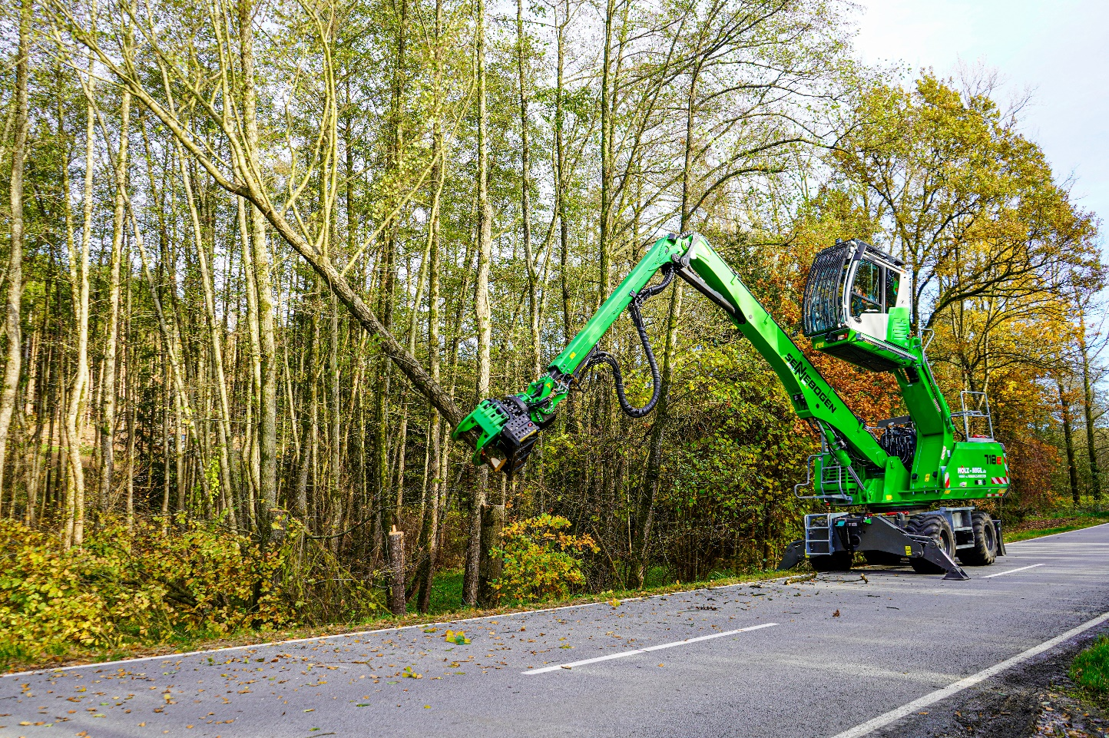

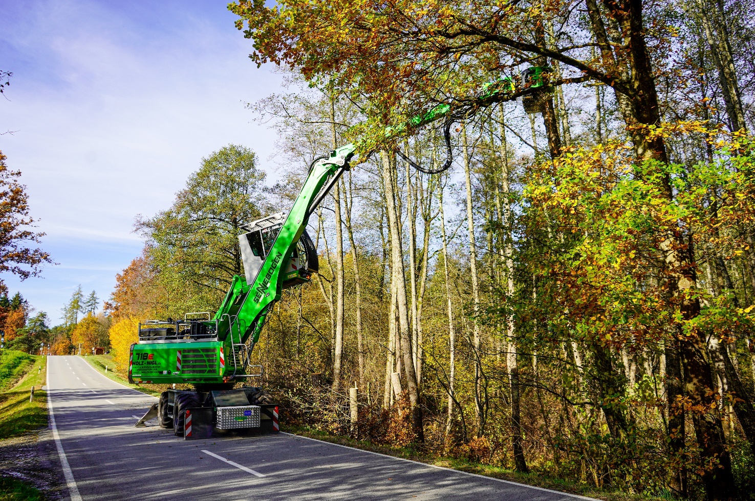

The 718 E impresses with its versatile and compact design. It is ideally suited for roadside operations and hazardous tree removals, even in confined working areas.
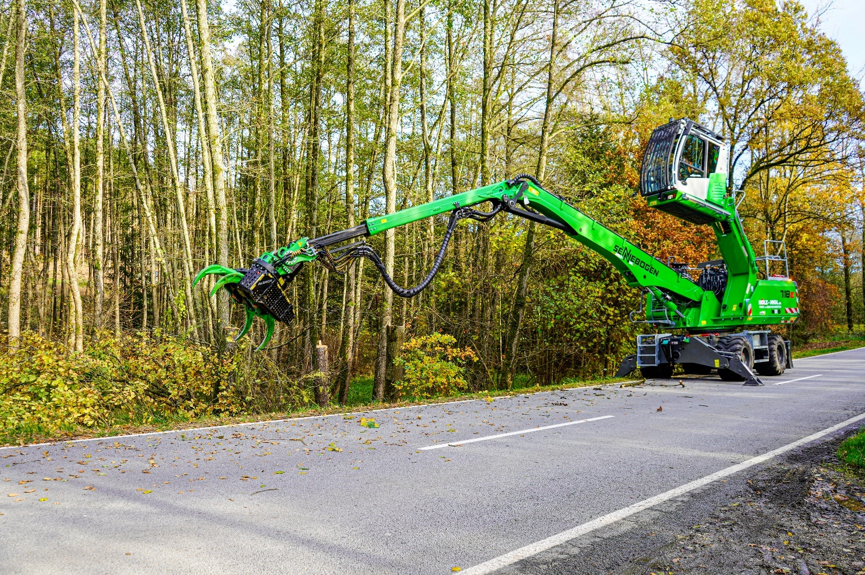

The 718 E offers excellent stability and robustness thanks to its outrigger support system. It also provides a high load capacity across a full 360-degree slewing range.

