Location Ort: Haren; Wörth/Wiesent; Deutschland
Date Datum: Feb-26
Photo Foto: Dr. Franziska Limbrunner
Editor Autor: Dr. Franziska Limbrunner
SENNEBOGEN and Hölscher: Specialized machines for effective well construction
SENNEBOGEN develops solutions that are as individual as its customers' applications. Close cooperation and intensive exchange not only enable the manufacturer to understand what matters in practice, but also make it a reliable sparring partner that offers tailor-made machine solutions. This is also the case with Hölscher Wasserbau, which SENNEBOGEN regularly supplies with special duty cycle crane solutions for demanding well construction projects.

Working together as equals – for over 40 years
Hölscher and SENNEBOGEN have enjoyed a strong, trusting partnership since the 1980s. Hölscher particularly values the reliability and the opportunity to directly address individual requirements – without intermediaries, in direct exchange. This regularly leads to tailor-made solutions, as demonstrated by the development of the 27-ton duty cycle crane according to the well builder's specific requirements. “This intensive exchange makes SENNEBOGEN a true partner on equal footing,” says Managing Director Heinz Hölscher.

Special tasks require special machines
Today, Hölscher has one of the largest fleets of duty cycle cranes with free-fall winches in the field of drilling technology/well construction in Germany. A key player in this fleet is the special duty cycle crane from SENNEBOGEN. With this machine in its fleet, Hölscher can take on tasks that not everyone can handle. “Our grab well technology is unrivaled. With SENNEBOGEN duty cycle cranes and our own tool development, we drill where others have long since given up – deep, precisely, and economically,” explains the managing director.

Groundwater level lowering for the South-East Link in Germany
A particularly impressive example of this is the groundwater lowering for the South-East Link – a planned direct current underground cable line that will run from the far north-east to the far south-east in Germany. The construction sites for the future power line next to the Wörth/Wiesent exit of the A3 motorway were already opened in March 2025 and will remain in operation for several months. In order for the pipes for the underground cable line to be laid, the groundwater must first be lowered and then raised again later. Hölscher Wasserbau, an absolute professional in well construction and water drainage, was commissioned to drill the wells. Heinz Hölscher also relies on the SENNEBOGEN duty cycle crane solution here: “The 27-ton duty cycle crane is the perfect solution for us for well construction. We were looking for a compact, powerful, and versatile machine that is easy to use and ready for immediate deployment on the construction site. SENNEBOGEN built it especially for us.”

Easy setup and user-friendly operation
The special machines prove to be quickly ready-to-use base units for rope operations and the attachment of casing machines. The folding box boom, with which the duty cycle cranes are equipped instead of the lattice boom, can be moved into the transport position in just a few steps, making the machine easy to transport — without any additional permits. This ensures flexibility on changing construction sites.

The intuitive operation is also highly appreciated by machine operators. It has been specially adapted to the customer's requirements. The same applies to the innovative design of the boom, which further improves Hölscher's typical work processes.

Maintenance, service, and usability — decisive advantages
One major advantage is the outstanding ease of maintenance. All areas are easily accessible for technicians, the documentation is clearly structured, and the machine can be set up and dismantled very quickly. Safety has also been further optimized: the bolts for the mast can be conveniently inserted from the ground.
Added to this is the high reliability of the special duty cycle cranes and the entire SENNEBOGEN portfolio. Even the older models owned by Hölscher are still running smoothly today. "With SENNEBOGEN and our specially developed grab and casing tools, we are opening up depths and dimensions that set new standards in well construction – unique in the market, reliable in results. Reliable machines and effective service are crucial factors in well construction. SENNEBOGEN offers us safety, efficiency, and precision — qualities that contribute directly to the success of our projects," summarizes Heinz Hölscher.

Well drilling with casing machine
At the current South-East Link construction site in Wörth/Wiesent, crane operators André Tinius and Hagen Fiebig are constructing around twelve wells per construction site. Equipped with the casing machine, the machine first drives the drill pipe into the ground. The soil material inside the drill pipe is then excavated with the grab before the well can be inserted. It is then filled with filter gravel and the drill pipe is pulled out again. All this is done with just one machine, which can precisely operate the attached implements and perform lifting operations. Thanks to various equipment options and variable mast lengths, which Hölscher itself helped to develop, the machine is extremely versatile and can be used both as a powerful cable excavator and as a crane. If everything goes according to plan, a well can be constructed within just a few hours. Once the 12 wells have been built, the next construction site will be tackled. Overall, the groundwater lowering project near Wörth/Wiesent is scheduled to run until the end of March 2026.

Once the groundwater has been lowered, the actual pipes for the underground cables can be welded together and laid. The wells are then removed and the groundwater can return. Finally, the power cable is pulled into the empty pipes. Well construction and water drainage are an important part of the challenging civil engineering work that will continue for several years.

Captions:
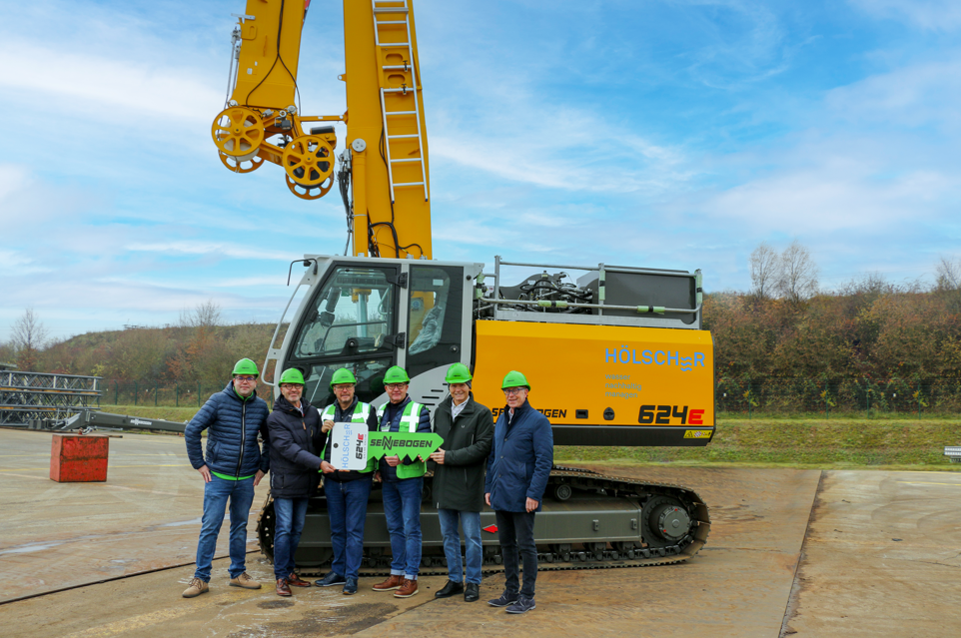
Image 1: Symbolic handover of keys from the SENNEBOGEN team to Hölscher (from left to right): Christian Thaller (SENNEBOGEN), Dirk von der Lieth (SENNEBOGEN), Heinz Hölscher (Hölscher Wasserbau), Dieter Tholen (Hölscher Wasserbau), Erich Sennebogen (SENNEBOGEN) und Bernhard Kraus (SENNEBOGEN).
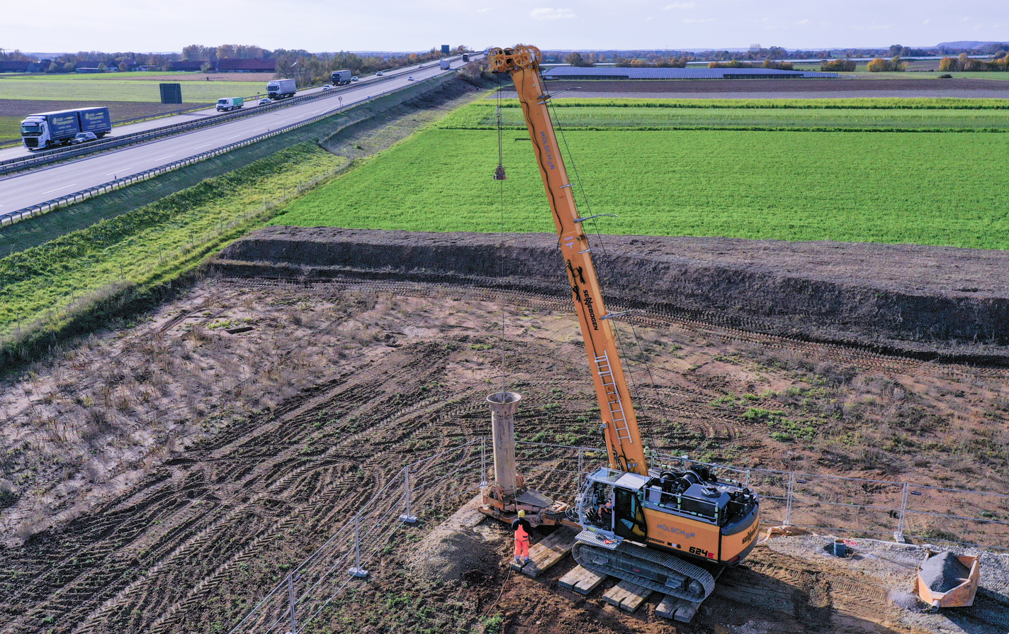
Image 2: Equipped with the casing machine, the duty cycle crane drives the drill pipes effortlessly into the ground.
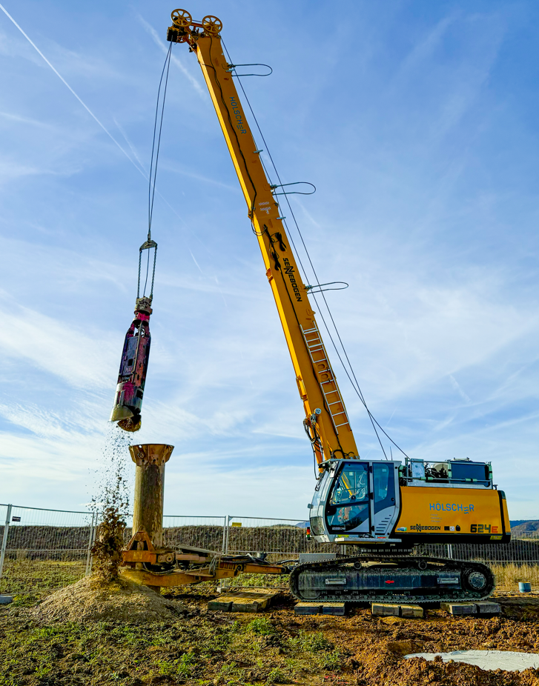
Image 3: The grab is then attached to excavate the soil material.
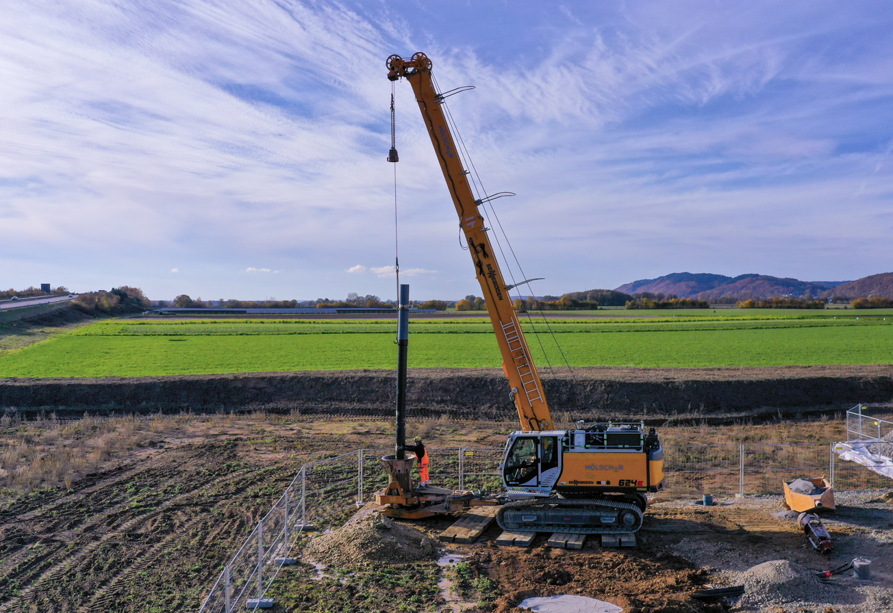
Image 4: The duty cycle crane precisely inserts the well pipes, which are a good 9 m long, into the drill pipe.
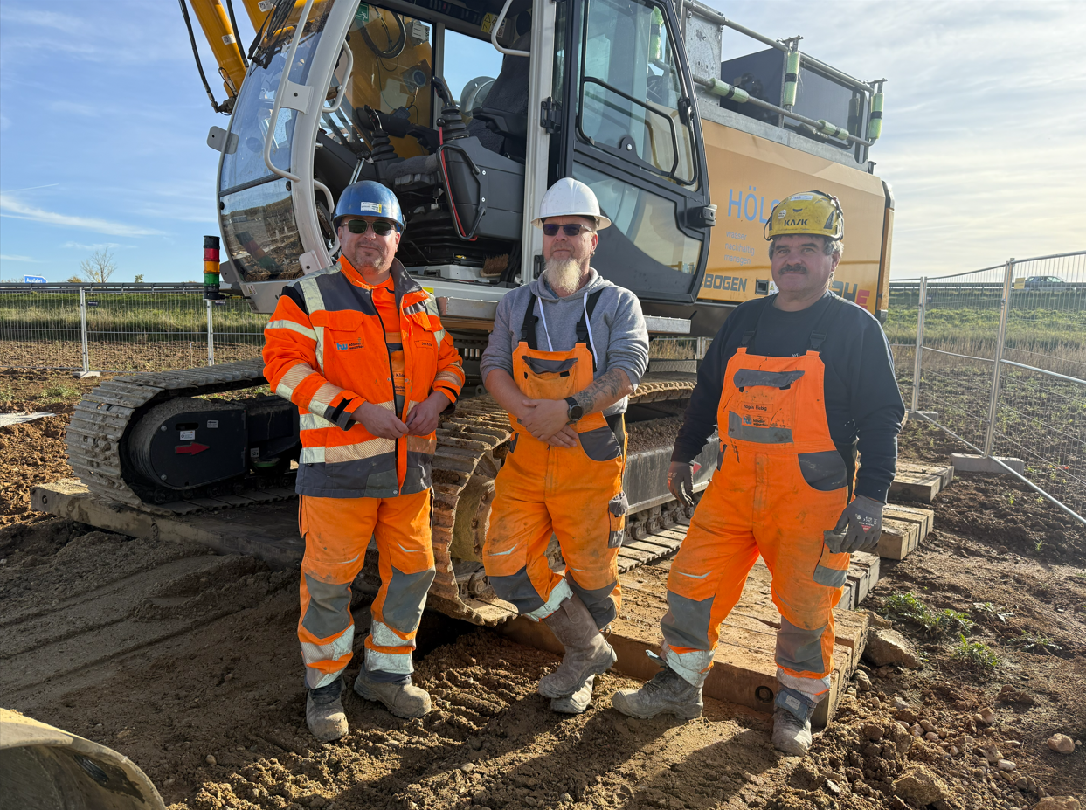
Image 5: Well construction specialists with their special machine: (from left to right) Foreman Jens Ködel and crane operators André Tinius and Hagen Fiebig.
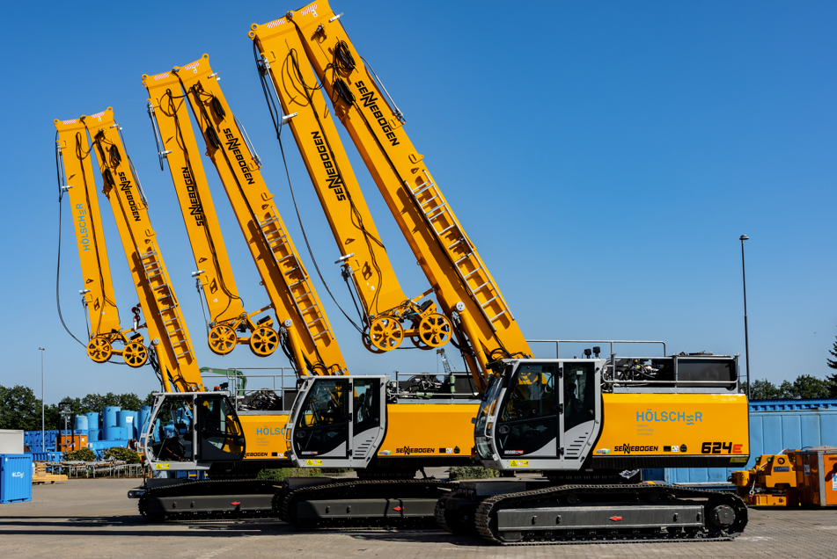
Image 6: SENNEBOGEN duty cycle cranes are an important part of Hölscher's machine fleet.

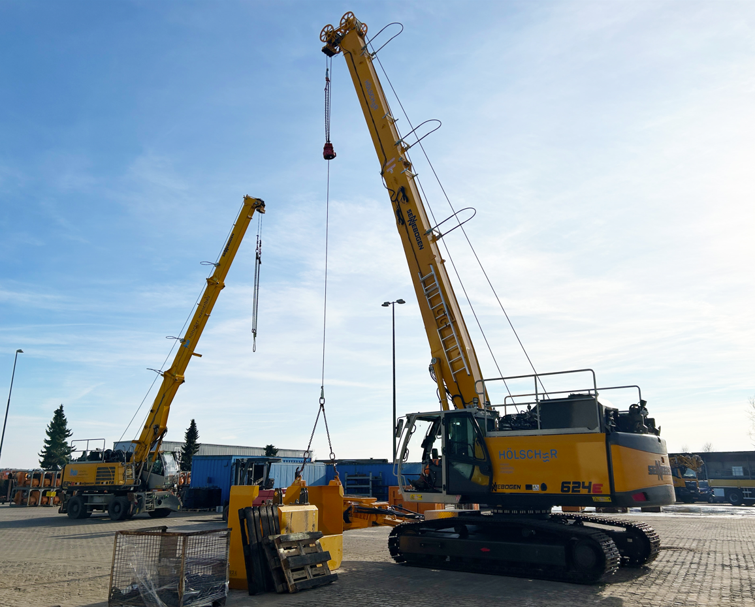
Image 7: The machines also perform traditional crane work, not only at Hölscher's headquarters in Haren.

More jobsite photos:
