**Date /** Datum**:** Dez-24

**Location /** Ort**:** Basel, Schweiz

**Photo /** Foto**:** Simon Gröschl

**Editor /** Autor**:** Sebastian Mißler

**INLAND PORT BASEL RELIES ON EQ BALANCER**

**In the Rhine port of Basel, near the tri-border area, a newly delivered SENNEBOGEN EQ Balancer in the inland port impresses with its efficiency and environmental friendliness. With an impressive cycle time of just 30 seconds, the machine sets new standards in port handling. With this new acquisition, Rhenus Port Logistics AG strengthens its partnership and, after the previous delivery of an identical balancer material handler, continues to rely on the proven technology from SENNEBOGEN.**

TRANS-EUROPEAN HUB

As the southernmost Rhine port, Basel's inland port plays a key role in trans-European freight transport. Its strategic location in the tri-border area, with access to Europe’s most important waterway, serves as a transshipment hub between major seaports such as Rotterdam, Antwerp, and Amsterdam and the European inland. Rhenus, a globally operating logistics provider, uses the site for loading bulk goods, general cargo, and heavy loads. This is where the SENNEBOGEN EQ Balancer shows its full potential with a reach of 30 meters and an impressive load capacity.

UP TO 14 TONS OF CO2 SAVINGS PER YEAR

The inland port makes a significant contribution to CO2 reduction by shifting goods from road and rail to the more environmentally friendly inland waterway transport. Rhenus Port Logistics AG is also pursuing environmentally friendly solutions at the site. With the construction of a new terminal in 2024, efficiency and sustainability have been further improved. Rhenus installed the largest solar system in the canton of Basel-Stadt on the roof, generating 2.4 million kilowatt-hours annually. The same requirements were set when selecting the new material handlers. The new SENNEBOGEN EQ Balancer combines an impressive 30-second cycle time with very low energy consumption of only 80 kWh. This enables annual CO2 savings of up to 14 tons compared to a conventional material handler.

ASYMMETRICAL PORTAL

The demanding conditions of the sloped quay at the Basel site required a customized solution. The SENNEBOGEN EQ Balancer was precisely adapted to the requirements with an asymmetrical portal, eliminating the need for costly structural modifications to the quay. The high reach of the new machine was an important criterion for Rhenus Port Logistics AG to accelerate handling between ship, rail, and road. The implementation was accompanied by SENNEBOGEN's sales and service partner, Kuhn Schweiz.

Technical highlights of the new EQ Balancer:

* **30-meter reach:** Perfect for flexible loading between ship, rail, and truck
* **High load capacity:** Ideal for handling heavy goods such as containers, coils, or bulk material
* **Short cycle time:** Only 30 seconds per loading cycle
* **4.5-meter pylon:** Optimum view of the working area
* **Portcab cabin:** Ergonomic and comfortable - with a retractable ladder to prevent unauthorized access
* **Versatile attachments:** Grabs with 1.5 and 3 m³ volume or spreaders enable handling of various goods
* **400 volt system:** Environmentally friendly and efficient operation with an energy consumption of only 80 kWh

The new SENNEBOGEN EQ Balancer impresses in Basel’s Rhine port with its 30 meter reach, 30 second cycle time, and minimal energy consumption of just 80 kWh. Tailored to the requirements of the sloped quay, it sets new benchmarks in efficiency, versatility, and environmental friendliness—a real future solution for port handling.

**Bildunterschriften:**

Header

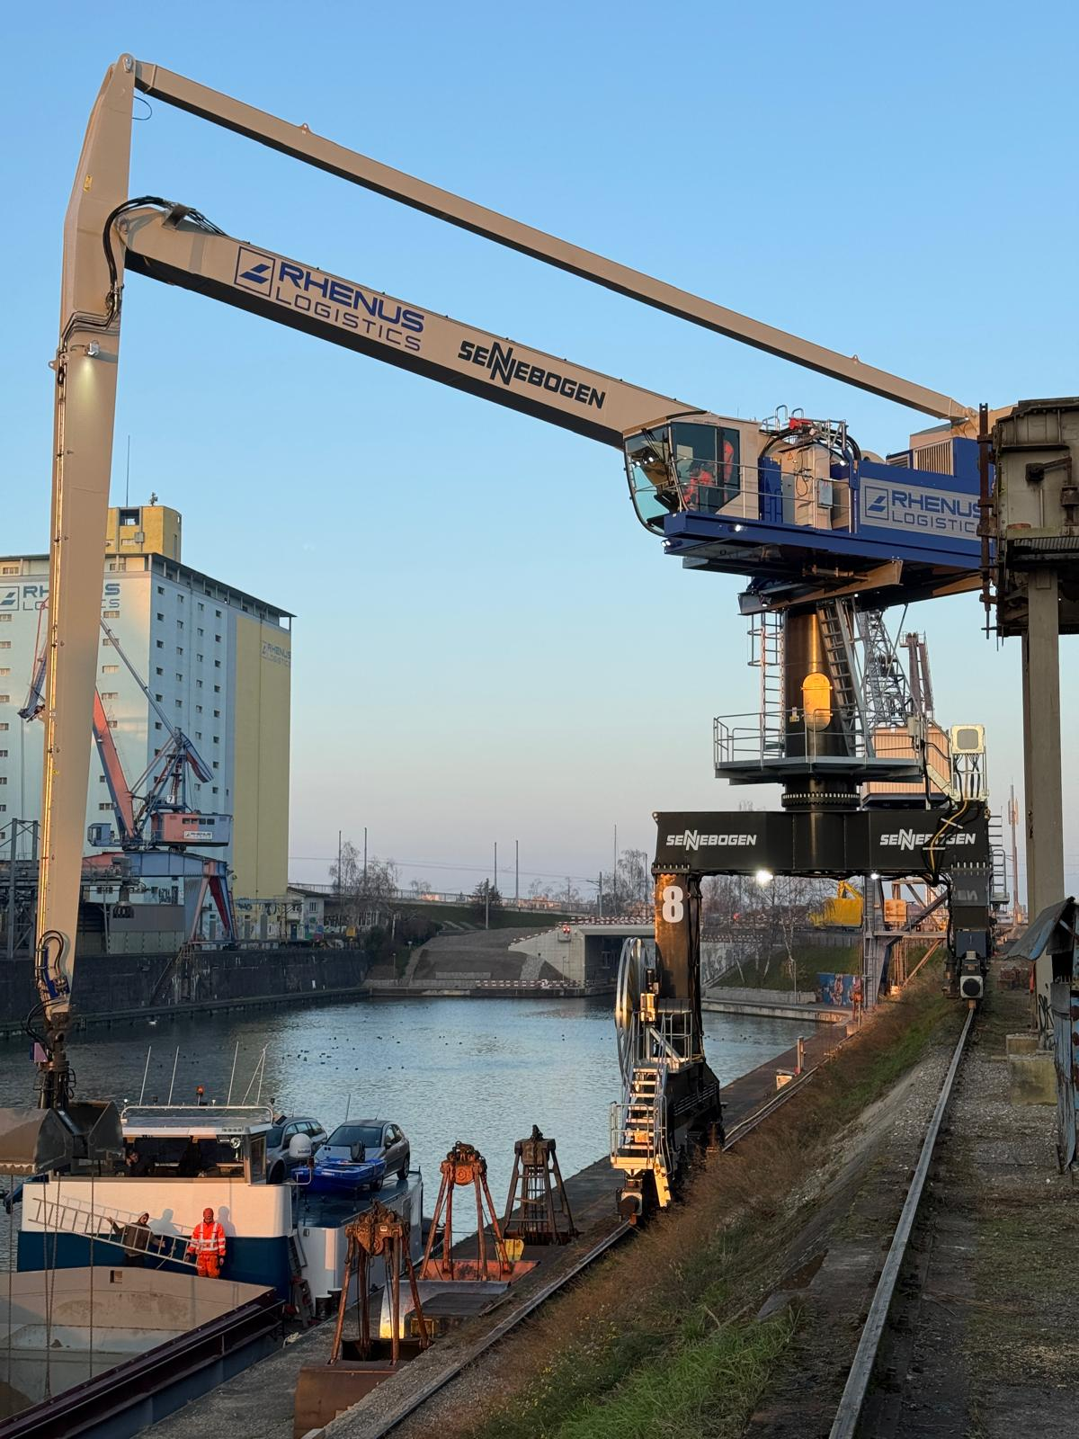

The Balancer principle reduces energy consumption by up to 75 % compared to a conventional handling machine – saving 14 tons of CO2 per year at the site.

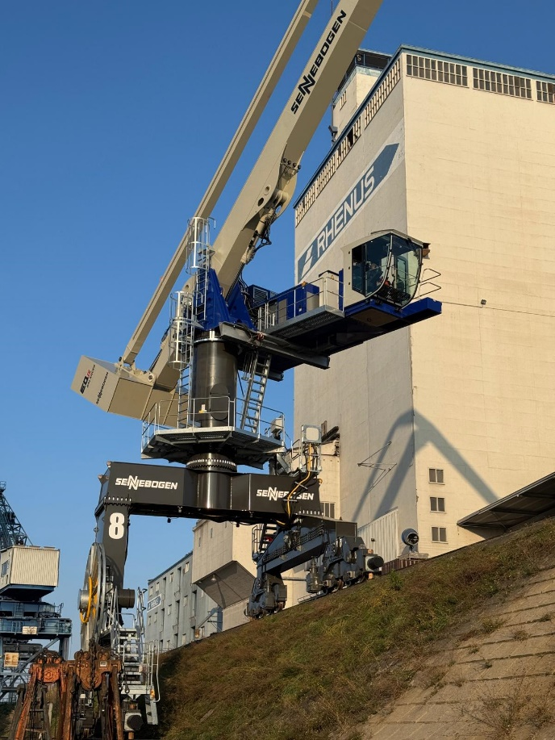

The asymmetrical portal of the Balancer was individually adapted to the conditions of the Basel harbor.

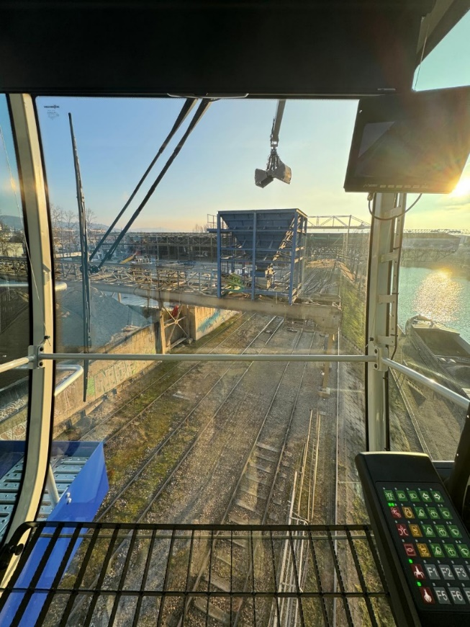

The continuous front and floor windows of the new Portcab cab ensure an excellent view of the working environment.