**Location /** Ort**:** Muuga, Estland

**Date /** Datum**:** Sep-25

**Photo /** Foto**:** Rain Rannala

**Editor /** Autor**:** Sebastian Mißler

**Handling of Steel Coils weighing up to 32 Tons**

The PK Terminal in the Estonian port of Muuga is continuing its steady growth trajectory by adding a new SENNEBOGEN 885 G to its fleet. Designed for port operations, the large material handler enables the terminal to efficiently handle even extremely heavy cargo such as steel coils weighing up to 32 tons in the future – all while maintaining low energy consumption.

With more than 50 years of experience in port handling, PK Terminal is one of the region’s logistics hubs. Since its founding in 2019 at the Muuga site, the terminal has grown steadily and now offers approximately 110,000 m2 of storage space and around 500 meters of quay length for cargo handling. To further expand its capabilities, the decision was made to invest in the powerful SENNEBOGEN 885 G material handler.

**Flexible in every handling situation**

Equipped with an Exstel quick coupler and a wide range of attachments, the SENNEBOGEN 885 G can be quickly adapted to different handling applications – from wood pellets and grain to heavy cargo such as steel coils. Attachments can be coupled directly from the cab, giving operators maximum convenience.

**Perfect for coil handling**

For board member Rain Rannala, the new material handler was a decisive step in the further development of the site: *“We wanted to expand our range and handle steel coils weighing up to 32 tons – the SENNEBOGEN 885 G is exactly the right machine for this.”*

Before the machine went into operation, SENNEBOGEN trainers provided on-site operator training with overwhelmingly positive feedback. *“The operators are very impressed. The 885 G is significantly stronger and quieter than the machines we have been using so far“,* says Rannala.

**Tailor-made for local needs**

To meet the high demands of daily port operations, the machine was customized for site-specific requirements. A rail-mounted undercarriage ensures low ground pressure and safe operations along the quay. The new Portcab operator cab with Skylift elevation provides excellent comfort even during long shifts. An additional boom-mounted camera also offers operators optimal visibility into the ship’s hold. Since its founding, PK Terminal has relied on SENNEBOGEN‘s service and sales partner ScanBalt Crane for both new equipment and ongoing service support.

**Average consumption: 100 kWh**

The 885 G is powered by a robust 500 kW electric motor connected via cable reel to the 10 kV power grid. The central power supply in the middle of the quay allows a travel distance of up to 320 meters – ideal for efficiently serving even large vessels. With an average energy consumption of just 100 kWh per operating hour, the machine runs with exceptional efficiency. A key contributor is the SENNEBOGEN Green Hybrid energy recovery system, which reduces operating costs by up to 50 %. In addition, the electric drive offers significant advantages in daily operations: service intervals are much longer compared to diesel-powered machines, time-consuming refueling is completely eliminated, and the material handler is always ready for use.

**30 seconds per loading cycle**

With the K32 boom, the 885 G can easily transfer material between ship, railcar and storage box. In demanding bulk material handling operations, the machine achieves an impressive 30 seconds per loading cycle, ensuring high throughput at the Estonian cargo terminal.

With the addition of the 885 G, PK Terminal expands its already comprehensive SENNEBOGEN fleet, which includes two 875 E, one 870 E, and one 835 E material handler, as well as a 355 E telehandler. The combination of high lifting capacity, long reach, and an efficient drive makes the material handler the ideal addition to the existing fleet and will enable PK Terminal to expand its range of heavy-duty handling operations in the future.

**Captions:**

Ein Bild, das Himmel, draußen, Transport, Fahrzeug enthält.

Header

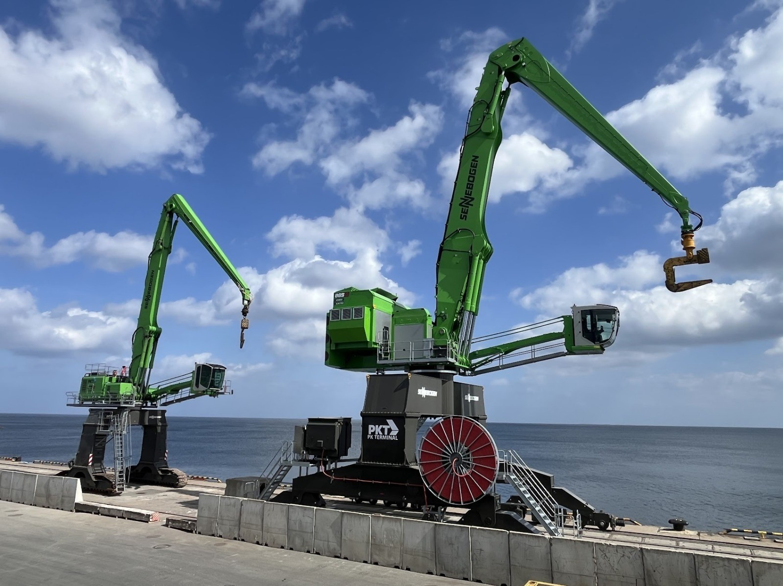

The new 885 G complements the existing SENNEBOGEN fleet for handling heavy-duty goods such as steel coils weighing up to 32 tons at the terminal.

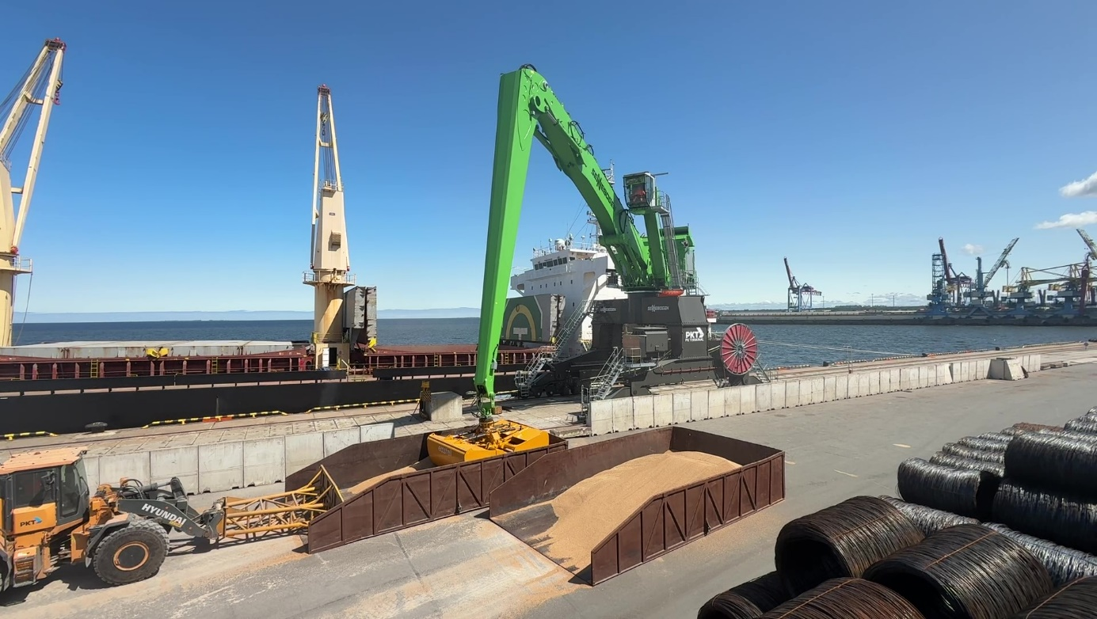

The SENNEBOGEN 885 G can be adapted to any handling situation thanks to its quick coupler and various attachments – from grain and wood pellets to steel coils.

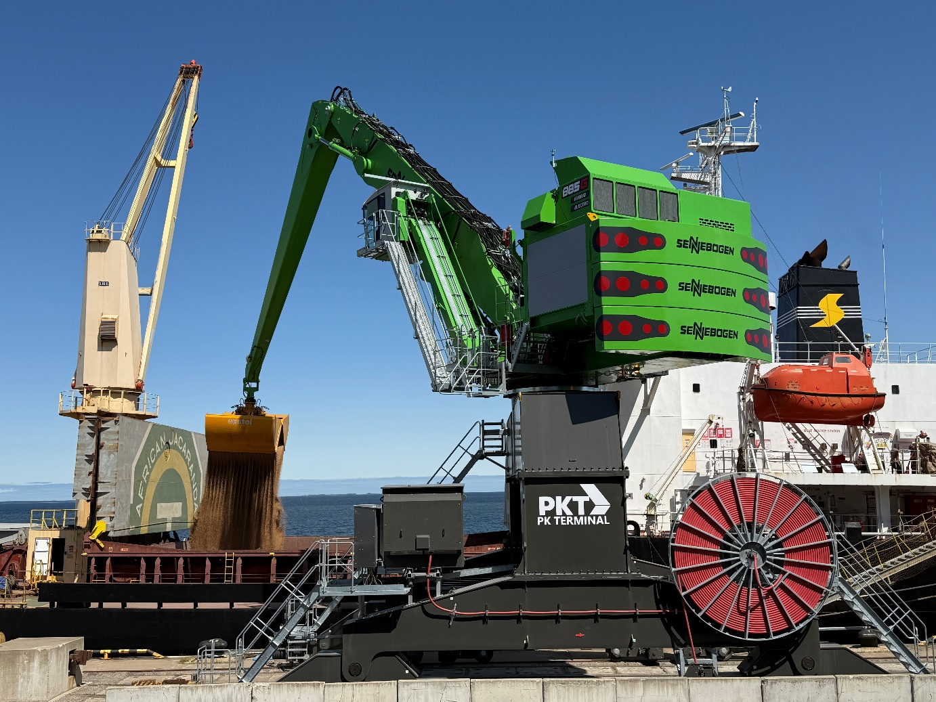

High handling performance guaranteed: The SENNEBOGEN 885 G convinces in bulk material handling with an impressive 30 seconds per loading cycle.