**Photo** Foto**:** *Cesaro Mac Import*

**Location** Ort: *Osoppo,* *Italy*

**Editor** Autor**:** *Lisa-Maria Heigl*

**Date** Datum**:** *07/2025*

**New SENNEBOGEN 850 G optimizes scrap logistics in steel mill**

**In Osoppo, Italy, the Pittini Group is relying on the new G Series from SENNEBOGEN: The 850 G has been part of the Ferriere Nord steelworks' fleet since April 2025. As a manufacturer of reinforcing steel and wire products, Pittini depends on high-performance technology – especially in scrap logistics, where several hundred tons have to be moved every day. The choice fell on a customized machine of the latest generation, supplied by SENNEBOGEN's long-standing sales partner** [**Cesaro Mac Import**](https://www.cesaromacimport.com/en/)**.**

**Strategic location for sustainable steel production**

The Pittini Group is one of Europe's leading suppliers of steel products for the construction and mechanical engineering industries. Its headquarters in Osoppo is home to one of its most important plants, which has its own steelworks, two rolling mills, and a cold processing facility. “Here, we process around 1.7 million tons of scrap metal annually and produce almost 1.5 million tons of steel,” explains Stefano Lui, plant manager at the site. Most of this is processed into reinforcing steel. The company's strategy focuses on sustainable processes along the entire value chain.

“Every investment must be in line with our ESG goals,” adds Enrico Clocchiatti, purchasing manager for the group. ESG stands for environmental, social, and governance and describes key sustainability goals. “In addition to environmental aspects, this also includes economic and organizational factors. That's precisely why we placed great emphasis on consumption, serviceability, and integration options when selecting the new material handler.”

**Powerful and low-maintenance at the same time**

The new machine was purchased to supplement the existing fleet – not to replace it. The 850 G performs tasks in the outdoor scrap yard, where different sizes of material are loaded and sorted. “For us, it was crucial that the machine operates at high performance on a permanent basis while remaining low-maintenance. Our machines are in heavy continuous use and must work reliably at all times”, says Stefano Lui.

In addition, the company deliberately wanted to test a new manufacturer. The decision in favor of SENNEBOGEN was made after careful comparison of two to three suppliers – with significant support from Cesaro Mac Import, as Clocchiatti emphasizes: “Cesaro impressed us with its technical expertise, fast response times, and clear service orientation. The team was also always on site during the initial months for training and machine adjustment.”

**Faster unloading of wagons**

An important factor in the choice of machine was the feedback from the operators – above all from Stefano Galasso, who has been working on material handling equipment for almost 20 years. He was involved right from the selection phase: “We were in Germany for a tour and tested a similar machine. I was immediately curious to see how the 850 G would perform in everyday use.” There was great enthusiasm after delivery: “It was love at first sight. The machine is fast, precise, and doesn't tire.” The new cab was particularly praised: spacious, with air conditioning, a large field of vision, and a high level of comfort – it even has a refrigerator for drinks.

The machine's performance pays off directly in operation. The 850 G moves around 600 tons of scrap metal every day at the outdoor scrap yard. “In addition, it used to take us 20 to 25 minutes to unload a wagon – now it only takes 17 to 18 minutes,” reports Galasso. Thanks to the **K21 boom**, the excavator can build higher piles and reach further into the wagons. This not only increases safety, but also the storage capacity of the yard.

**Digitally networked and individually configured**

The 850 G is also perfectly integrated into Pittini's technology. The machine has a **telematics system** that provides real-time data on fuel consumption, utilization, and maintenance. This allows it to fit seamlessly into the company's Industry 4.0 strategy.

“We deliberately chose a configuration that is tailored to our requirements, with a focus on ease of use, reliability, and technical integration,” says Lui. The investment is already paying off: the 850 G has been in operation for over 300 hours since delivery. The first 250-hour service was successfully carried out with close support from Cesaro.

**Captions:**

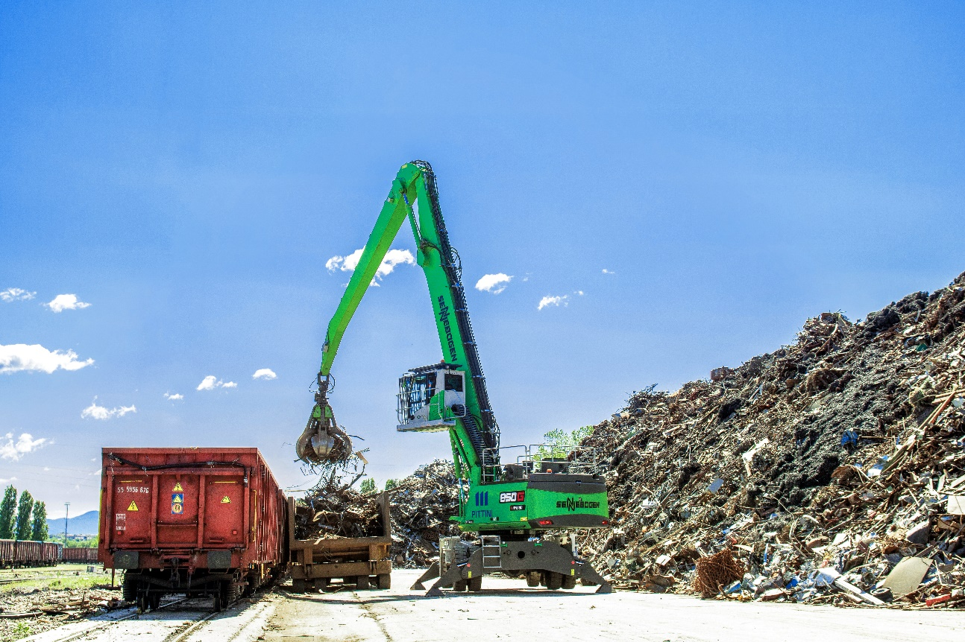

Header picture

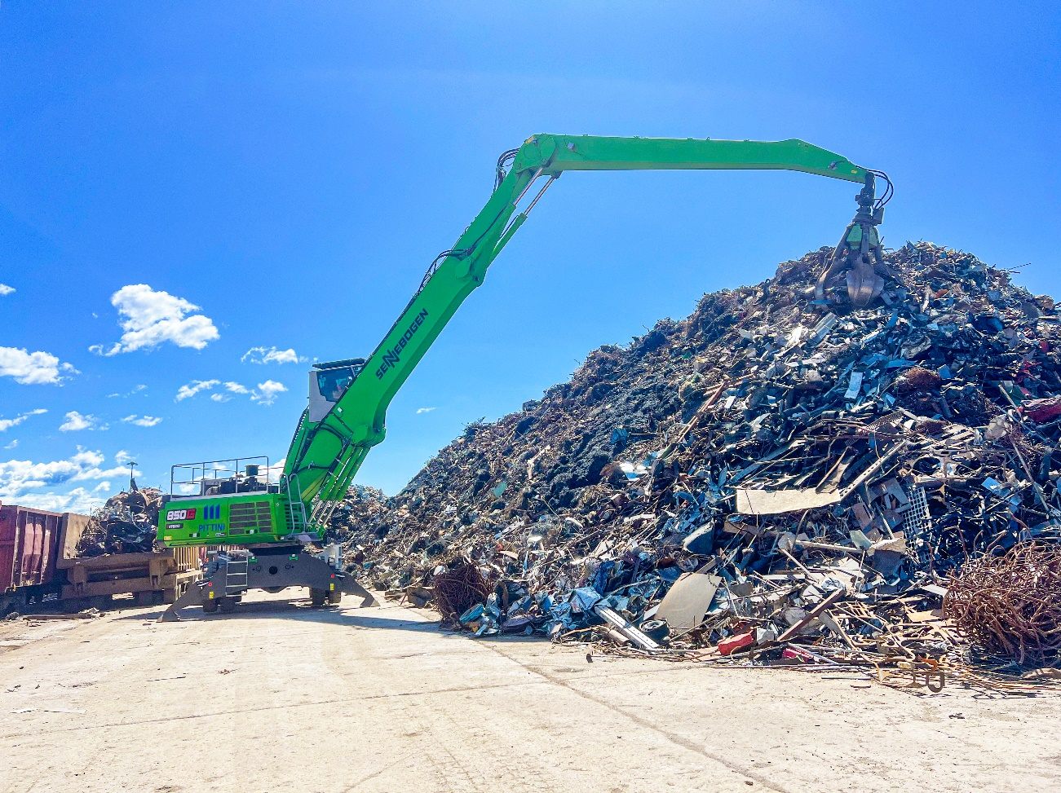

Thanks to the K21 boom, the SENNEBOGEN 850 G can reach up to 21 m and enable higher scrap piles.

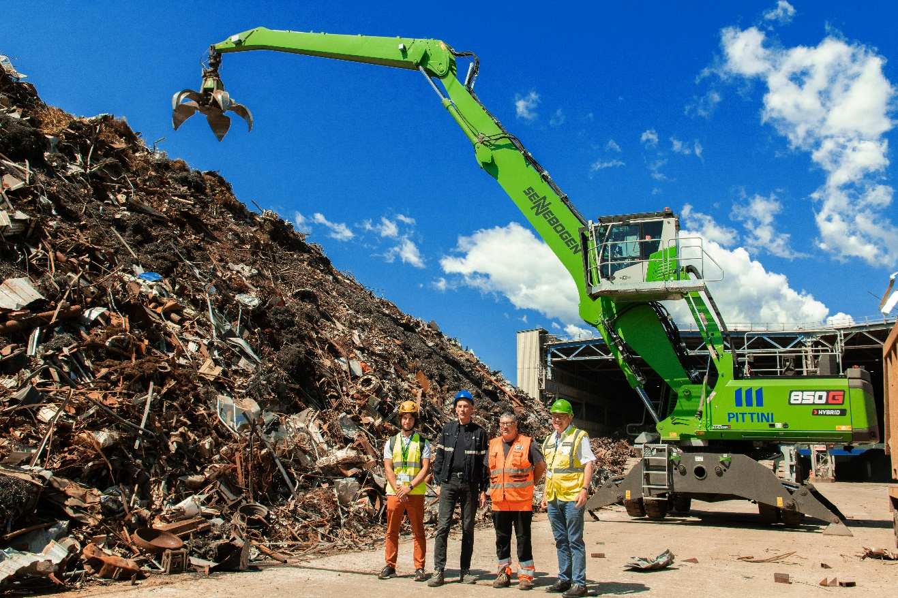

Pasqual Matteo from Cesaro Mac Import, plant manager at Pittini Osoppo Stefano Lui, operator at Pittini Osoppo Ennio Coppetti, and Sennebogen salesman Paolo Boscoscuro from Cesaro Mac Import (from left to right)