Bild:

**Photo** Foto**:** *Lisa-Maria Heigl*

**Editor** Autor**:** *Lisa-Maria Heigl*

**Location** Ort: *Italien*

**Date** Datum**:** *10/2024*

**Efficient scrap recycling with electric material handler**

**Padana Rottami Srl, a leading company in the metal scrap recycling sector and wholly owned by the Acciaierie Venete Group, is known for processing scrap iron and steel, which is mainly supplied to the Group's three steelworks. With 70 employees and a main warehouse in Castelfranco Veneto covering 50,000 square metres, the company specializes in the fast and efficient supply of ready mixes for foundries and steelworks throughout Italy.**

In September 2023, a SENNEBOGEN 840 E electric machine with pylon was successfully put into operation at the Castelfranco Veneto site. This machine plays a central role in feeding the new sliding shear, which was developed for the volumetric reduction of metals. With the aim of further increasing efficiency, Padana Rottami decided on the stationary SENNEBOGEN 840 E to optimize their processes and reduce operating costs.

**Customized technology for maximum productivity**

The SENNEBOGEN 840 E is equipped with a 5 meter high pylon and specially developed ground anchoring to ensure maximum stability with heavy loads. The electric drive ensures quiet and low-vibration operation, which not only improves operator comfort but also significantly reduces operating costs.

**Nicola Magaton,** the experienced machine operator at Padana Rottami, particularly praises the high level of comfort in the cab, the intuitive operation and the exceptional responsiveness of the machine. “It wasn't difficult to learn how to operate,” he reports, ”but it did take some time to get used to working at this height. The machine's movements are fluid, and the cabin offers plenty of space and a safe environment.”

**Fast cycle times in scrap handling**

The SENNEBOGEN 840 E impresses with fast cycle times and offers outstanding performance, especially when processing scrap, steel, slabs and pipes in the outdoor area. The machine was specially adapted to the requirements of Padana Rottami. The decision in favor of the Sennebogen machine was facilitated by the long-standing cooperation with the dealer Cesaro Mac Import, which has been providing innovative technologies for Padana Rottami for over 20 years.

Thanks to the made-to-measure design and reliability of the machine, Padana Rottami has been able to further increase its efficiency, while the electrical components not only reduce the environmental impact but also minimize noise pollution for employees at the site.

**Trust in long-term partnership and excellent service**

The cooperation with Cesaro Mac Import was a key factor in the decision to purchase the SENNEBOGEN 840 E. The dealer not only offers the latest technology, but also guarantees fast and efficient service whenever it is needed. The machine is thus always kept in optimum condition to avoid downtime. In November, Padana Rottami awaited the next delivery of another Sennebogen machine, the 835 G model, further cementing the close partnership.**Captions:**

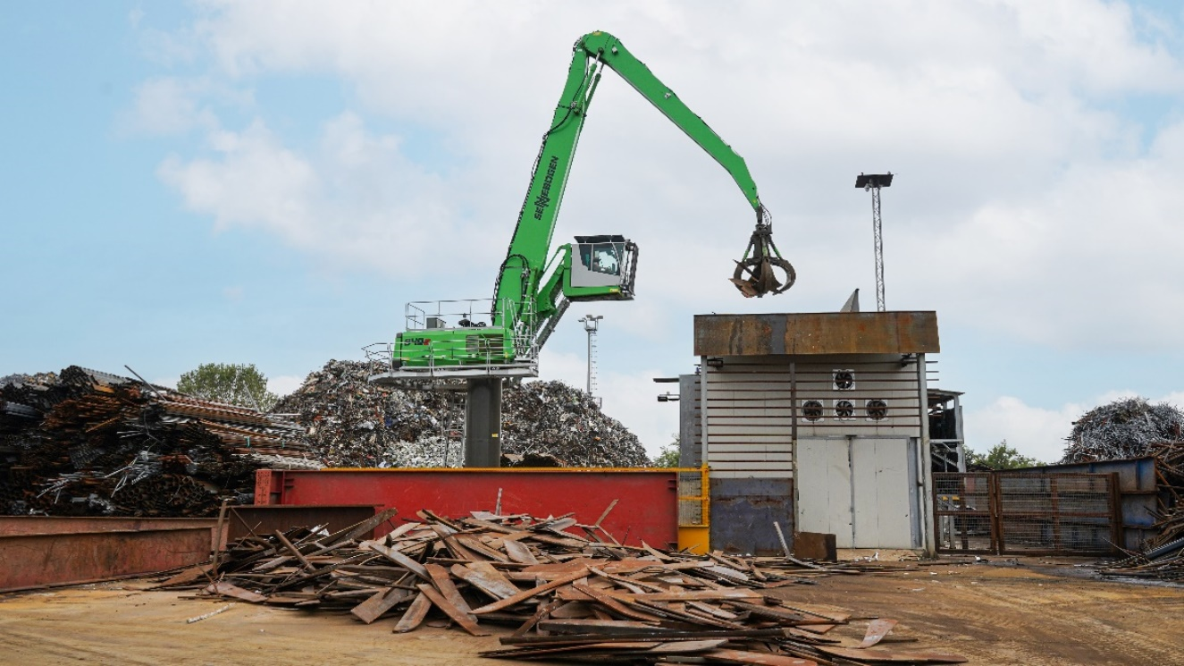

Header picture

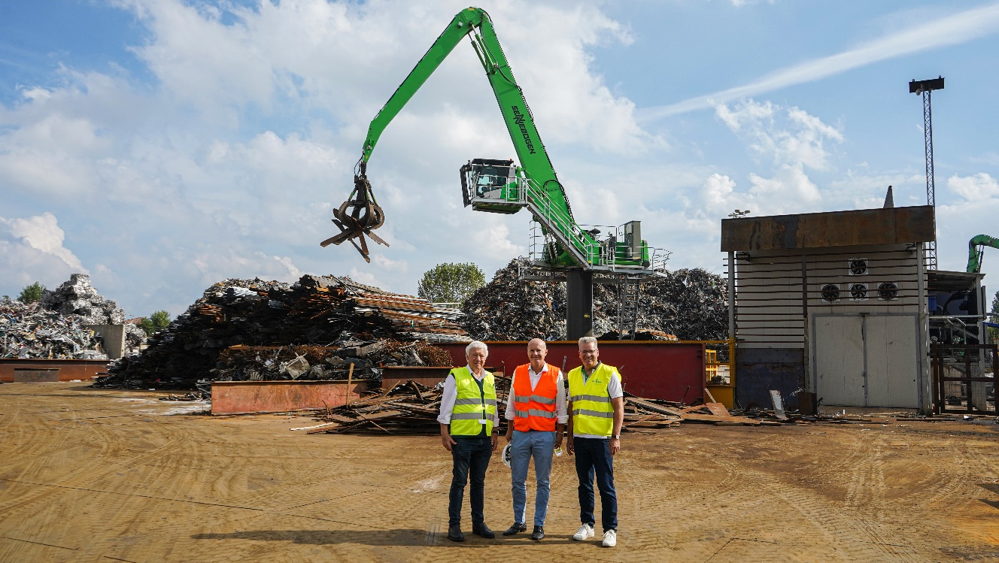

Sennebogen salesman Paolo Boscoscuro from Cesaro Mac Import, Padana Rottami managing director Simone Graziotto and marketing manager Michael Ibarth from Sennebogen (from left) 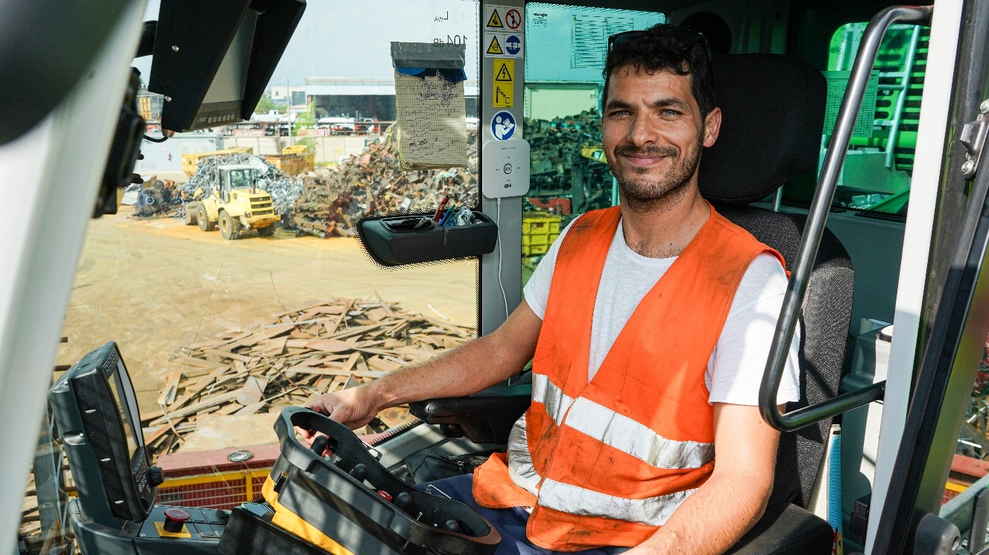

The driver Nicola Magaton praises the intuitive controls and the comfort of the spacious cab.

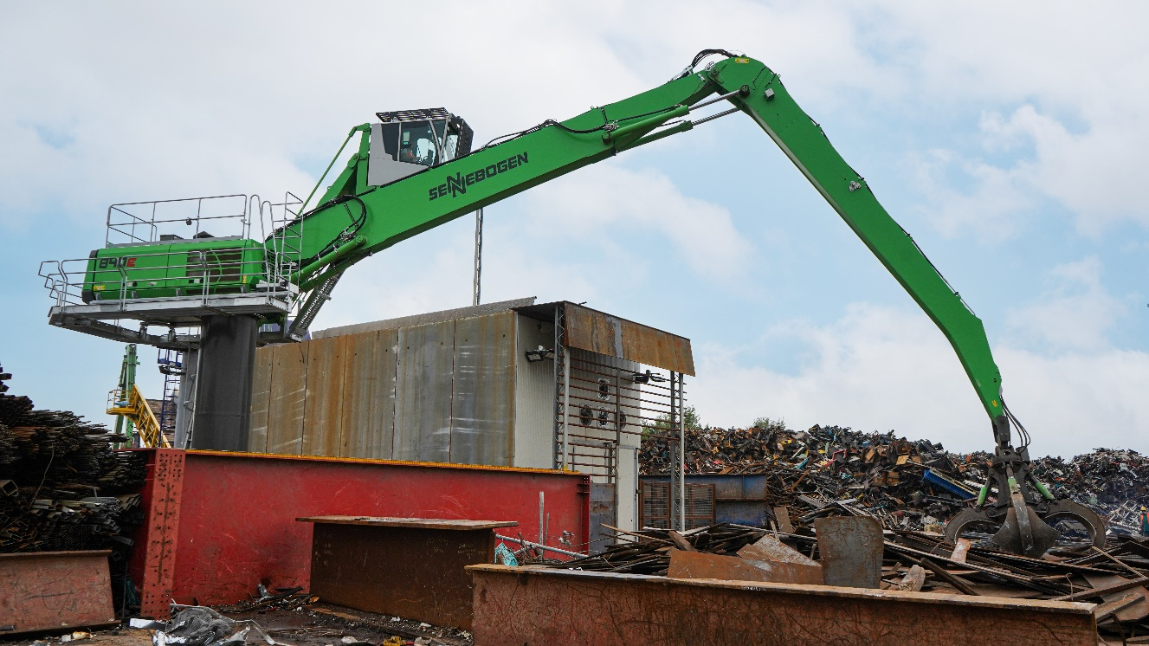

The 5-meter pylon of the SENNEBOGEN 840 E ensures optimum positioning even with heavy loads.