Bild:

*Lisa-Maria Heigl*

**Photo** Foto**:** *Niklas Kühle*

**Editor** Autor**:** *Niklas Kühle,*

**Location** Ort: *Deutschland*

**Date** Datum**:** *05/2025*

**SENNEBOGEN mobile excavator: the ideal recycling machine**

**As an experienced provider of waste disposal, container services, and raw materials trading, Rüschen GmbH & Co. KG has been serving customers in the region and beyond for around 35 years. More than 30 employees at the Lathen site ensure that waste management runs smoothly, from document destruction and grease trap disposal to scrap logistics. These diverse requirements call for not only expertise, but also the right technology.**

For this reason, Rüschen GmbH & Co. KG expanded its fleet at the end of 2024 with a SENNEBOGEN 824 G material handler. The investment in this modern recycling machine underscores the company's goal of making its material handling processes even more efficient and future-proof.

**SENNEBOGEN 824 G impresses in practice**

With the 824 G mobile excavator from SENNEBOGEN, a machine has now been put into operation that is specially designed for material handling in recycling and scrap management. Its robust construction, a reach of up to 12 meters, and a comfort cab that can be raised to a height of 3 meters make the 824 G the ideal helper for loading and sorting work.

“Our employees were immediately impressed – we were particularly impressed by the precise handling, the clear layout and the user-friendliness,” reports Managing Director Philipp Rüschen after several test drives and a demonstration on the company premises.

**Service from the region**

The material handler was selected and delivered by Schlüter für Baumaschinen, SENNEBOGEN's long-standing sales partner. The proximity to the branch in Geeste proved to be a particular advantage in the procurement process. “Short distances and fast response times in the event of service are crucial for us – and that's exactly what we get here,” says Managing Director Philipp Rüschen.

**Reliable and safe operation**

Whether wood, paper, green waste, or scrap metal, the 24-ton excavator delivers maximum efficiency with a wide variety of materials. Thanks to its modular equipment, low fuel consumption, and well-thought-out maintenance concepts, it is ideally suited for long-term use in waste disposal operations. In addition, modern safety features such as a comprehensive camera system ensure reliable and safe operation in everyday use.**Captions:**

Header picture

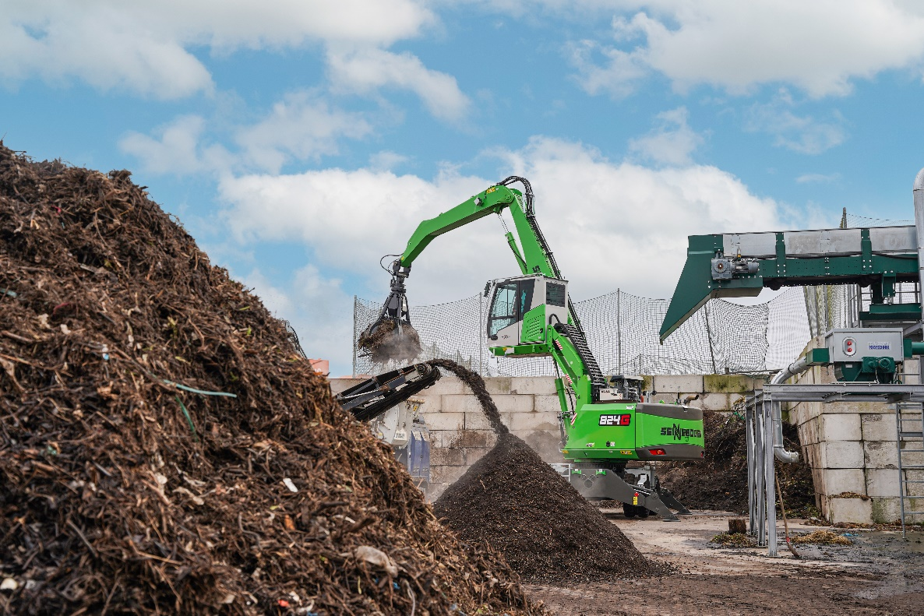

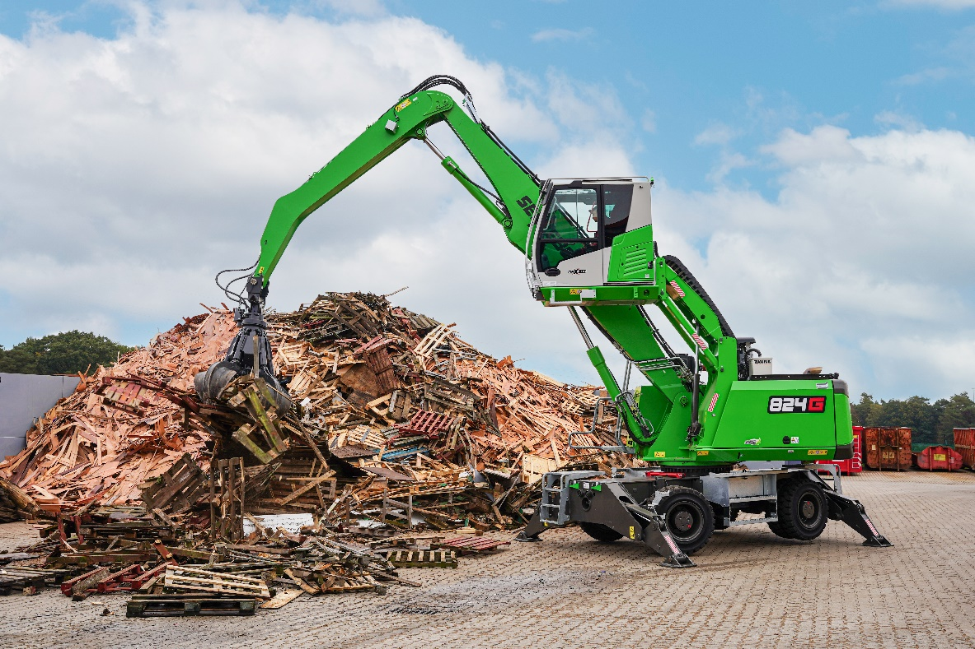

*Perfect overview: The elevating cab offers excellent visibility of the work area.*

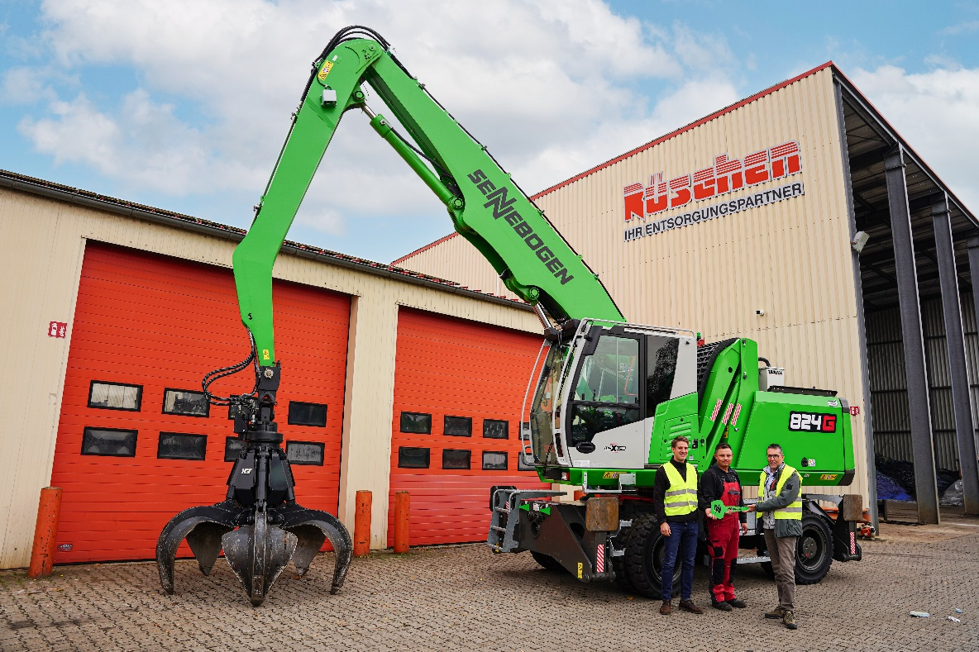

*Key handover by Norbert Hüsken (Schlüter Regional Sales Manager) to Managing Director Philipp Rüschen.*

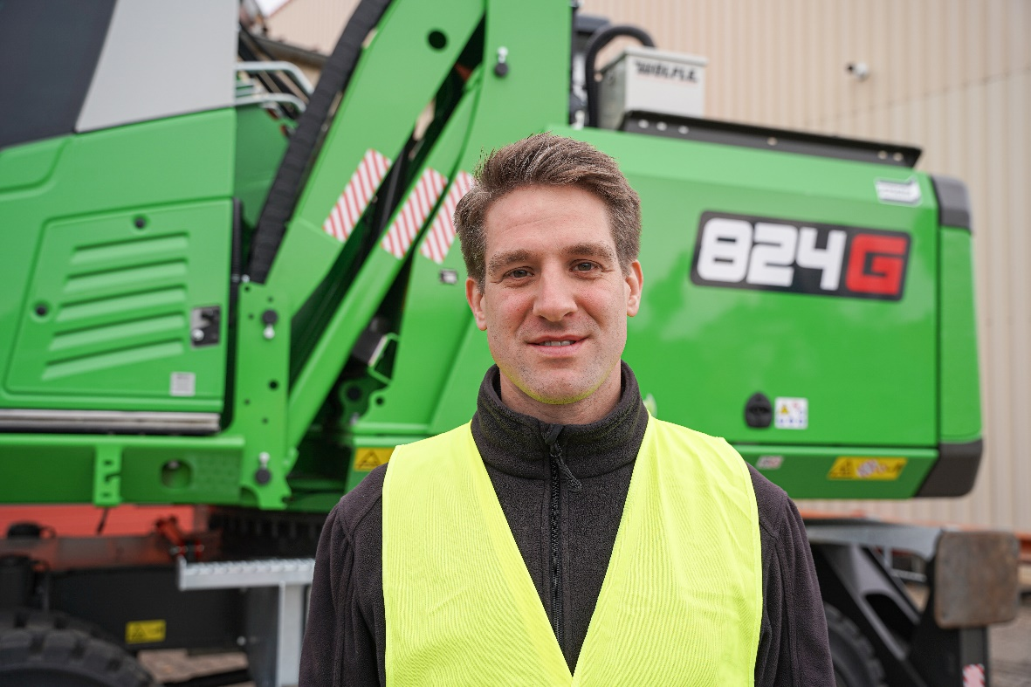

*“The 824 G is exactly the machine we need for our requirements.” – Philipp Rüschen*