Bild:

**Photo** Foto**:** *Andreas De Coninck*

*Lisa-Maria Heigl*

**Location** Ort: *Harelbeke, BE*

**Editor** Autor*: Lela Van Berkel,*

**Date** Datum**:** *06/2025*

**Sorting plant relies on emission-free material handler**

**Efficient, electric, and low-emission – since October 2024, the SENNEBOGEN 818 E Electro has been supporting the waste management company IMOG in Harelbeke, Belgium, in its resource-saving material sorting operations. The fully electric material handler is a central link in the state-of-the-art GV8 sorting plant and helps to optimally process waste streams – for consistent implementation of the circular economy.**

**Advanced waste management with sustainable technology**

IMOG – the “Intercommunale Maatschappij voor Openbare Gezondheid in Zuid-West-Vlaanderen” – serves 12 municipalities in the West and East Flanders region in the areas of waste prevention, collection, and processing. In recent years, the company has transformed itself from a traditional landfill site into a modern waste processing center with a throughput of around 60,000 tons per year.

“Environmental legislation has changed significantly. Today, the focus is on recycling solutions rather than pure disposal,” explains Managing Director Johan Bonnier. “With the investment in our new GV8 plant – around 15 million euros – we are not only increasing our processing capacities, but also enabling the recovery of valuable materials.”

**Precise pre-sorting according to VLAREMA 8 with electrical support**

In the past, a large proportion of bulky waste and industrial waste was sent directly for thermal recycling, resulting in the loss of many recyclable materials. This has changed fundamentally with the commissioning of the GV8 plant. Sorting is now carried out in accordance with the VLAREMA 8 guideline, a legal framework that sets out requirements for the separation, sorting, and recycling of waste.

The sorting process is supported by state-of-the-art technology such as drum and wind separators, infrared detection, magnetic separators, dust extraction, and the SENNEBOGEN 818 E Electro, supplied by Belgian sales and service partner [SMT](https://www.smt.network/belux/nl/).

**Electric material handler impresses in practice**

“The SENNEBOGEN 818 E best met all our requirements in the tender – load capacity, grab performance, and maneuverability were decisive factors,” says Bonnier. “And as the saying goes, ‘the proof of the pudding is in the eating’ – the machine impresses day after day in operation.”

The electric material handler reliably supplies the sorting plant with material and scores points with its hydraulically height-adjustable cab, which allows a direct view into the feed hopper. The emission-free drive is particularly advantageous for indoor use, adds Charlotte Martens, head of the GV8 plant: “This ensures a cleaner, quieter, and more pleasant working environment – a real plus for our team.”

**Circular economy taken to the next level – with electric drive and efficiency**

“Our goal is to convert up to 50% of waste into recyclable materials – from wood, paper, and cardboard to plastics and metals,” explains Bonnier. “What remains is used to generate energy. In this way, we are making an active contribution to CO₂ reduction and closing material cycles.”

Another plus point is that the project is creating new jobs. The plant team is currently being expanded to up to 18 employees, who are receiving targeted training from SMT on how to operate the technology safely and efficiently. For Bonnier, one thing is certain: “The electric material handler is an important piece of the puzzle on our journey toward more sustainable waste management.”

**Captions:**

**Header picture**

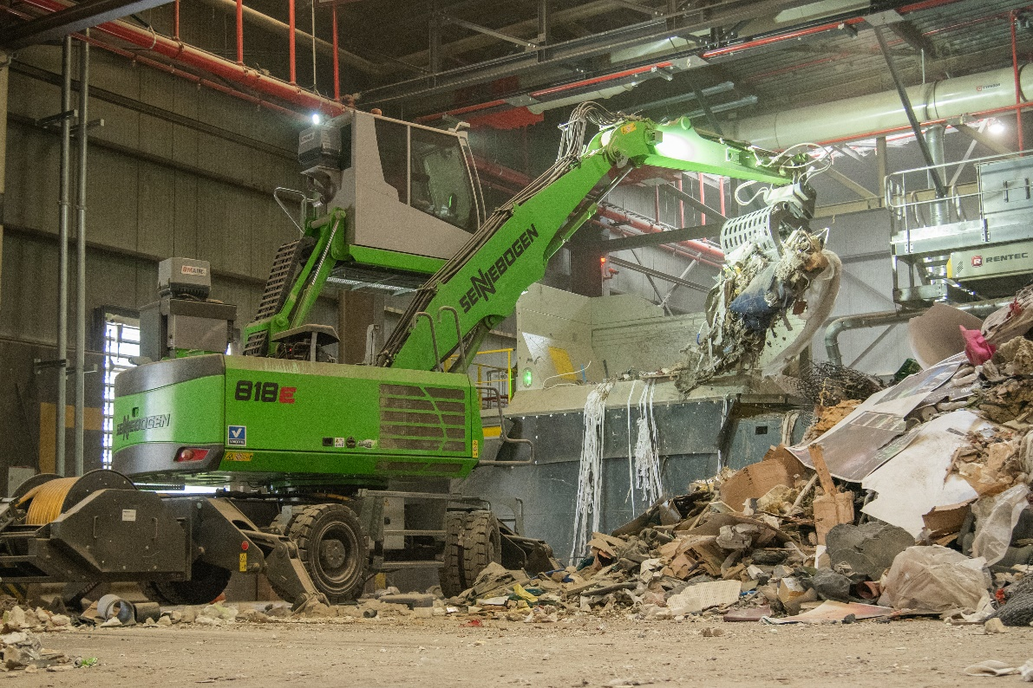

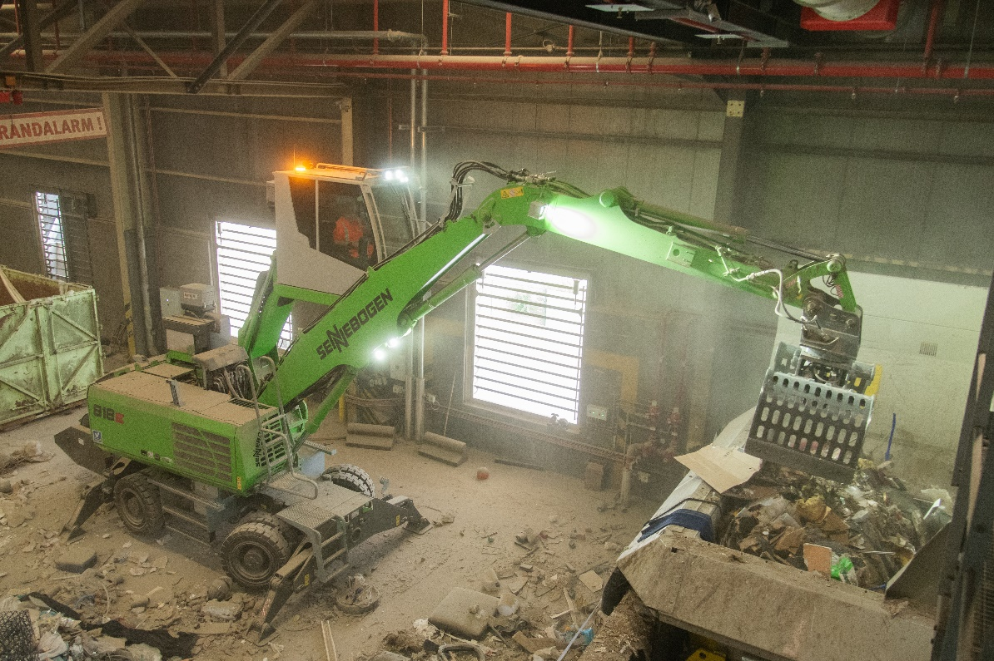

Reliable in continuous use: The 818 E Electro also masters dust-intensive hall areas.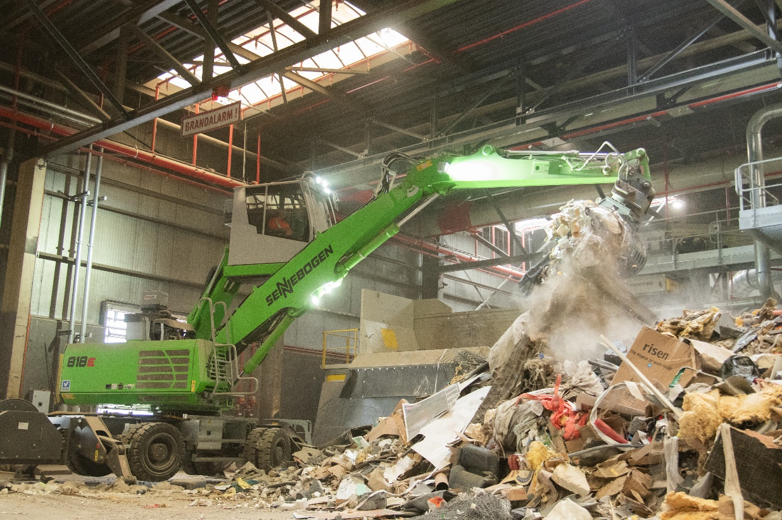

The SENNEBOGEN 818 E Electro feeding the GV8 plant in Harelbeke.

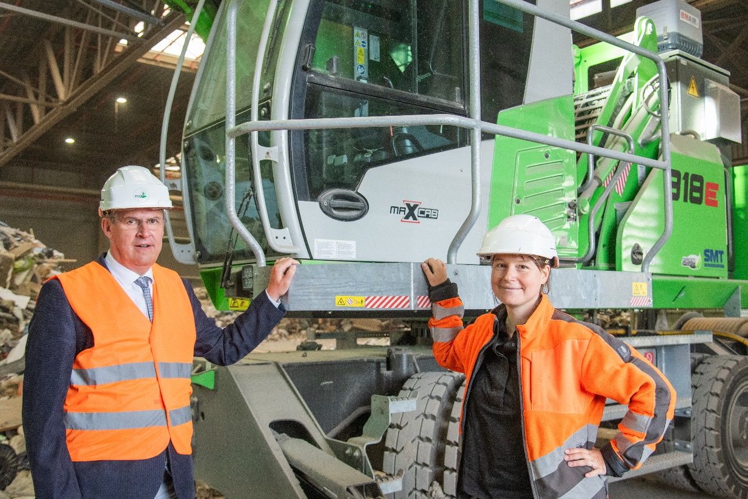

(f.l.t.r. IMOG Managing Director Johan Bonnier and GV8 Plant Manager Charlotte Martens)

“The SENNEBOGEN 818 E Electro is not only emission-free, but also ensures a quieter, cleaner working environment – ideal for indoor use,” says Martens.