Date / Datum: Jul-25
Location / Ort: Hereford, UK
Photo / Foto: Sebastian Mißler
Editor / Autor: Sebastian Mißler
Log processing at the sawmill
Hereford (UK) – Around 400,000 tons of round timber are processed annually by Pontrilas Sawmills, a family-owned company located in the west of England. With over 70 years of experience, the company ranks among the largest sawmills in the country. To handle the often demanding timber volumes, Pontrilas relies on three SENNEBOGEN 730 E Pick & Carry timber handling machines – with great success.
Production runs in two shifts between 6 a.m. and 10 p.m., seven days a week. Space on the site is limited and the logistical requirements are high. Different lengths of wood, large quantities of round timber, the processing of a wide variety of hard and soft woods, and a high throughput rate present the team with new challenges every day. Pontrilas is therefore demanding when it comes to selecting its machinery: the machines in the sawmill must be powerful, agile, reliable, and efficient.
Just the right size
With two machines in regular operation and a third as backup, the company now relies on a fleet of three SENNEBOGEN 730 E Pick & Carry material handlers. The decision to invest in these machines came after the previous models became too small for the job. “With the 730 E, we can now use a 2.0 m² grab instead of the 1.9 m² we had before. That might not sound like much, but it means we can unload a truck in two moves instead of three,” says Operations Manager Brian Pugh.
Agile – Perfect for round timber processing
The high handling volume on site constantly pushes storage capacity to its limits. “We often have a lot of wood on the ground at the same time. That creates space problems, and our previous machines, with their large counterweights, were frequently damaged, even by experienced operators,” Pugh continues.
With a turning radius of just 5.8 meters, the SENNEBOGEN 730 E is perfectly suited for tight working spaces. Thanks to all-wheel drive, four-wheel steering, and the center-mounted boom design, there is no need for large counterweights, and the machines remain stable and agile even when handling heavy loads. They are particularly effective on the softwood line, where two of the machines are in daily operation and benefit from their superior maneuverability.

Convincing operator comfort & maintenance concept
The machines are powered by 168 kW diesel engines – providing more than enough performance for all applications in the sawmill. A dozer blade supports quick repositioning of logs, and additional LED work lights ensure optimal visibility in all conditions. One key factor is the spacious Maxcab operator cab and the intuitive joystick control:
“Our team has responded very positively to the new SENNEBOGEN machines. The cabs are spacious, offer excellent all-around visibility, air conditioning, and intuitive operation. They’ve been a real asset to our operation and are extremely reliable – even after five years of use,” explains Yard Manager Remus Kairys.
Individual support from Molson
Sales and service for the UK are handled by SENNEBOGEN’s partner Molson Group, ensuring maximum availability. “Since we started using the machines, we have been extremely satisfied with Molson's service. If my foremen can't find a solution, it ends up with me. But I've never had to contact Molson – that speaks for itself,” reports Pugh. Pontrilas Sawmills uses SENtrack, SENNEBOGEN's telematics system, to monitor the machines in order to simplify maintenance and detect faults at an early stage. According to Pugh, this helps to plan maintenance optimally and schedule it outside of operating hours or avoid downtime altogether.

“We needed a machine with high lifting capacity, excellent maneuverability, and good operator comfort – the SENNEBOGEN 730 E meets all our requirements.”– Brian Pugh, Operations Manager, Pontrilas Sawmills

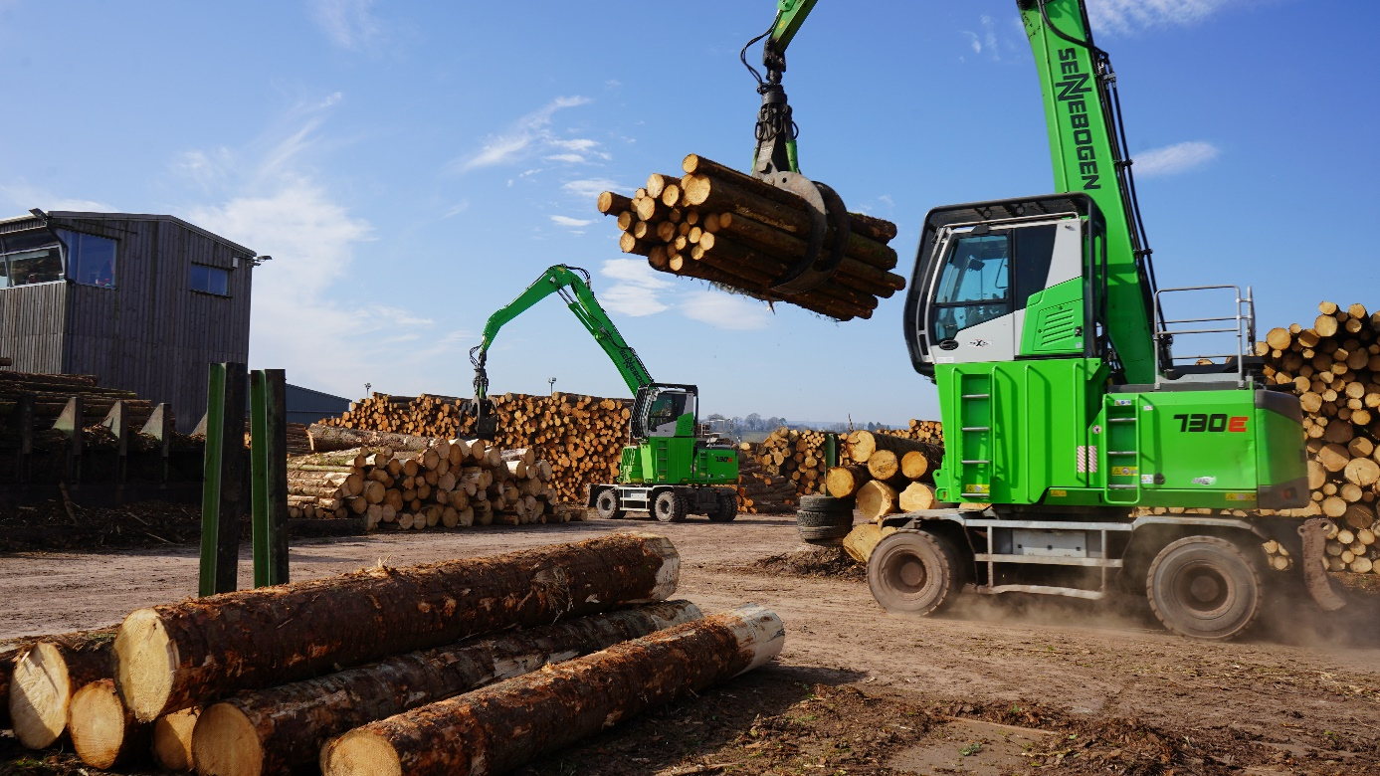

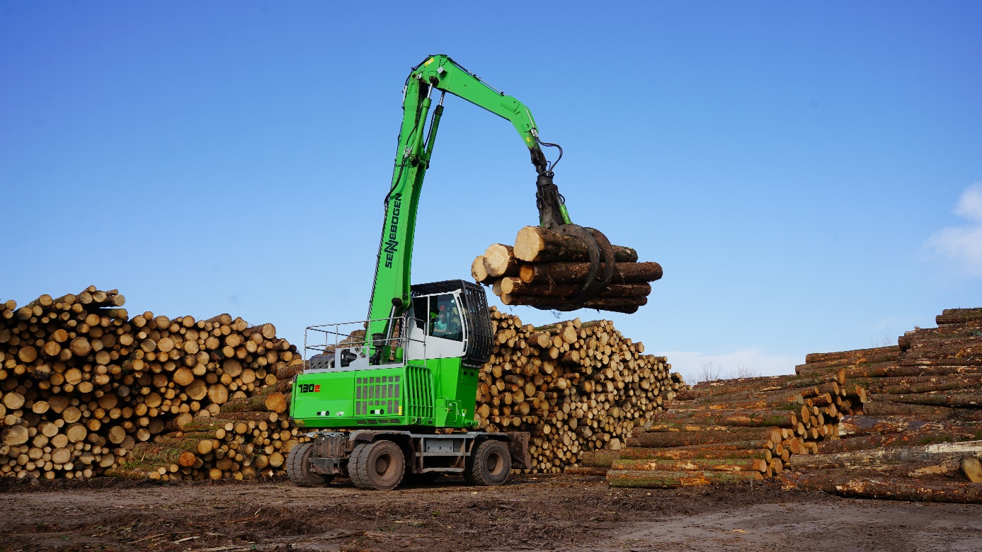

The SENNEBOGEN 730 E meets the high requirements of the British sawmill Pontrilas – high load capacity, maneuverability, and excellent ease of operation.

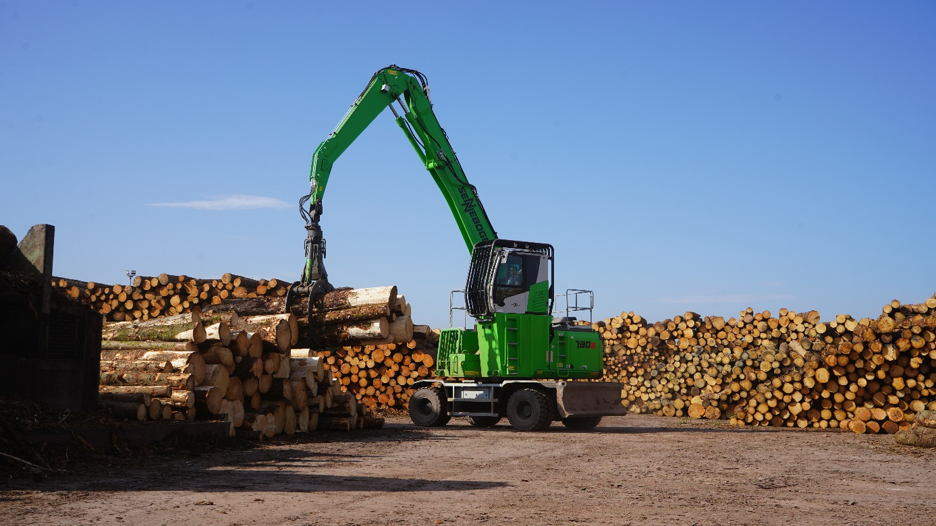

Impressive endurance runners: SENNEBOGEN machines operate reliably in two shifts, seven days a week, thanks to their robust technology, the SENtrack telematics system, and the impressive support provided by service partner Molson Group.

