tt Bild:
Photo Foto:
Daniela Fidalgo Caballero
Isabella Wild
Editor Autor: Daniela Fidalgo Caballero,
Location Ort: Spanien
Date Datum: 10/2025

Which excavator is suitable for traffic safety work?
At an exclusive demo event, MYCSA, SENNEBOGEN’s official sales partner in Spain, invited selected customers to a demonstration day to showcase the 718 E tree care handler.
On the test site, participants were able to observe up close how the machine mastered demanding tree and landscape maintenance as well as trimming work along roads and green areas with impressive precision.

Tree care work along roads, railway lines, or in urban green spaces
The SENNEBOGEN 718 E was specifically developed for tree care operations along roads, railway tracks, or in urban green areas.
The 13 m telescopic boom ensures maximum reach, ideal for working safely even at great heights. Thanks to the hydraulically elevating Maxcab cabin, the operator always has a perfect view of the working area while benefiting from an ergonomic, safe workplace.
The machine’s versatility was particularly convincing: whether equipped with a mulcher, grapple saw, or other attachments, the 718 E can be flexibly adapted to different tasks. This makes the machine a true all-round solution for maintenance, felling, and loading operations in a wide range of environments—hedges, plants, and shrubs—from urban areas to zones close to forests.

Safety and comfort in focus
Alongside performance, SENNEBOGEN always places operator safety at the forefront. The comfortable cab with optimal all-round visibility, modern control concept, and high noise insulation ensures focused, fatigue-free work.
“The machine provides full control with every movement and gives the operator a secure feeling—especially a decisive advantage when working at great heights,” explained one participant at the demonstration.

Developed for use in demanding environments
Whether on highways, in cities, or along utility lines, the SENNEBOGEN 718 E proves that productivity and safety can go hand in hand when it comes to tree felling.
With its combination of power, precision, and adaptability, the machine sets new standards for efficient tree care and traffic safety operations.

For these reasons, the SENNEBOGEN 718 E is perfectly equipped for any traffic safety task:
• large reach thanks to the 13 m telescopic boom
• high flexibility with versatile attachments such as mulcher and grapple saw
• optimal visibility and ergonomics through the elevating cab
• maximum safety when working at great heights
• powerful and precise operation for efficient trimming, maintenance, and felling tasks

Bildunterschriften:

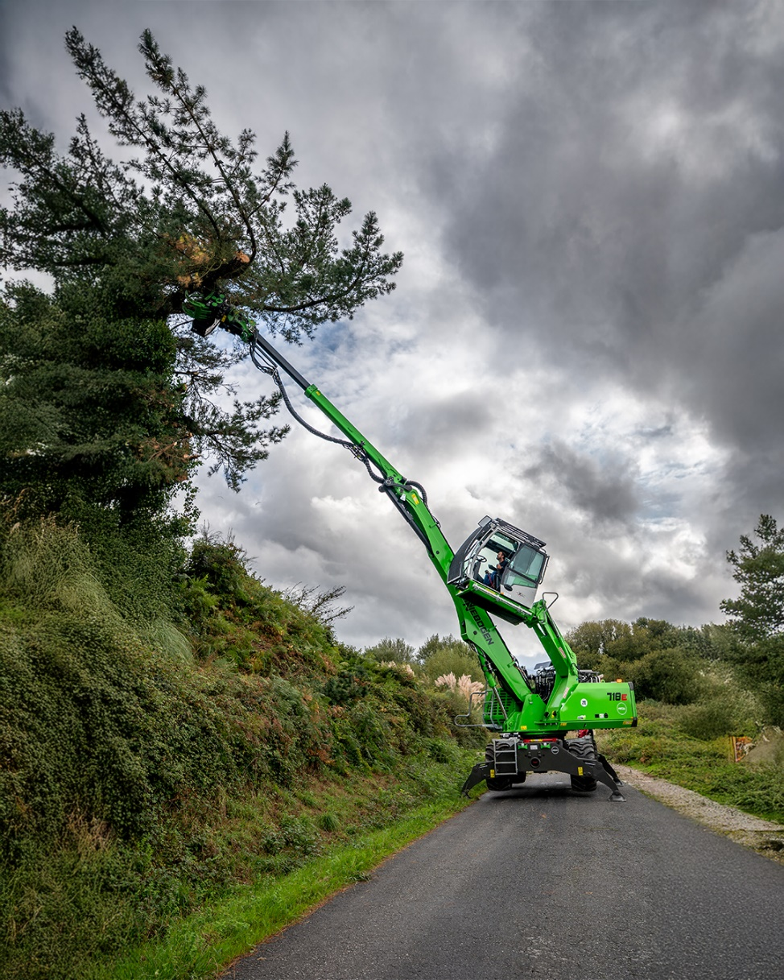

Headerbild

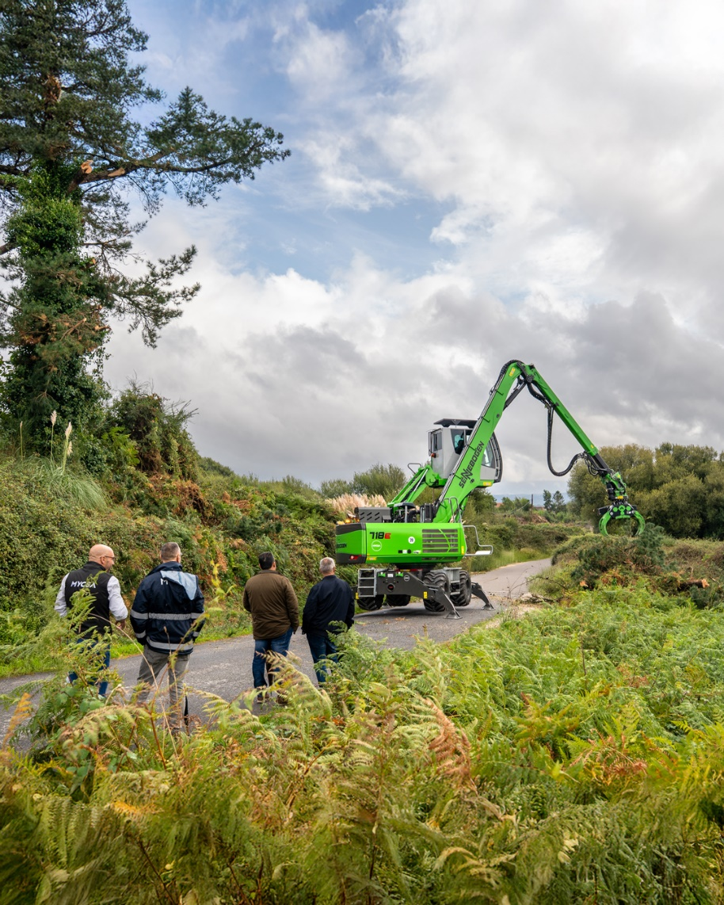
Tree Care Handler 718 E at Customer Demo in Spain.

