Bild:
Date Datum: 2023
Location: DE
Photo Foto: SENNEBOGEN
Editor Autor: Sandra Hartl

The last of its kind – the last 880 EQ leaves the factory

The first 880 EQ balance material handler was delivered 16 years ago. Since then, the impressive machine has attracted a great deal of attention in various countries due to its performance and versatility. Now the successful model is being retired from the SENNEBOGEN product portfolio and is being replaced by its worthy successor, the 885 G, with the latest generation of technology.

SENNEBOGEN delivered the first 880 EQ to Turkey in 2007 via its sales partner Forsen Machinery Services & Trading Inc. The last of its kind will also find its workplace at the port of Iskenderun. In future, the machine will be used for port handling by one of the largest and longest-standing customers in Turkey, DILER Holding, which has been using Balance material handlers for many years. The popular EQ models have already been in use for up to 50,000 operating hours. In addition to Turkey, one of the most important markets for Balance material handlers, many units have been delivered to Canada, the USA, India, Finland, Australia and the United Arab Emirates.

From port handling to recycling: a wide variety of applications possible
"With the 880 EQ, we have opened up completely new markets and applications for ourselves and made many customers very happy," says partner Erich Sennebogen. Just recently, a new 880 EQ went into operation at one of the world's leading metal recycling companies, EMR in Rotterdam. Here, too, they have been relying on the proven Balance material handling concept for many years. Site manager Edwin van der Heiden confirms: "With the Balance material handlers, we mainly load and unload ships with larger draughts, which has not worked well with other machines in the past."

An unbeatable concept - Balance material handlers as a technological milestone
The Balance 880 EQ material handler was one of the first machines to be built in this size range. The special Balance concept achieved ranges of up to 35 m that were previously not possible, enabling many new applications to be developed. "For us, the 880 EQ was and is a technological milestone that has significantly changed the entire material handling industry," explains Erich Sennebogen. Designed for continuous operation and optimized for energy efficiency and performance, the Balance material handler concept was developed with the aim of placing the machine in a balanced position with the equipment in the middle position. "The issue of fuel savings in particular is a decisive argument for balancers. Some customers have achieved fuel savings of around half compared to previous machines."

Great popularity with customers and employees
"The 880 EQ was not only very popular with our customers. Such machine orders have also always been welcomed at the factory. For us, the 880 EQ required little support and there were never any serious problems," says Ali Gülyaz, design engineer for large machines.

The new SENNEBOGEN 885 G, which was presented for the first time at bauma in October 2022, is the successor to the proven 880 EQ and thus complements the port material handler portfolio. Equipped with the Green Hybrid energy recovery system, this machine works particularly efficiently and economically and achieves equally high fuel savings. With a reach of up to 38 m, particularly challenging port handling operations can be completed effortlessly.

[Caption:]
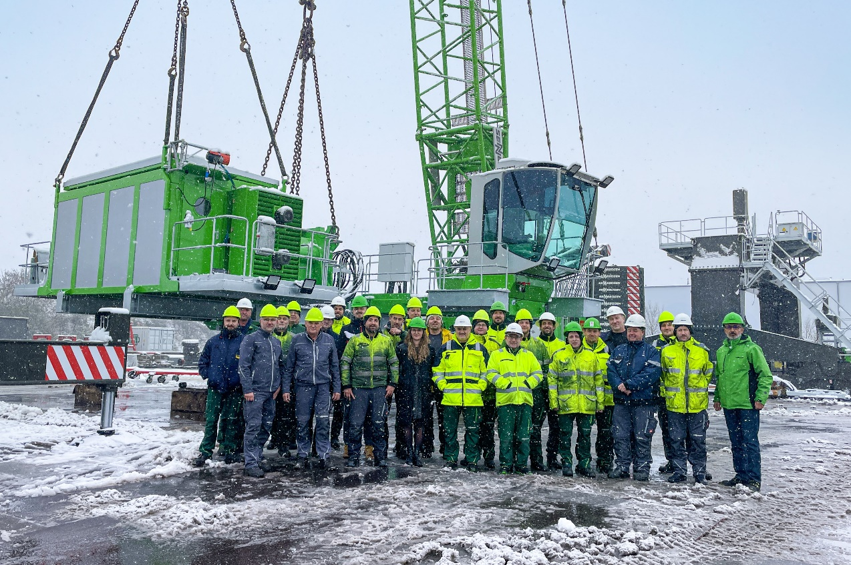
A large team of employees has accompanied the 880 EQ from production to sales over the years and said goodbye to the last of its kind before it was shipped out
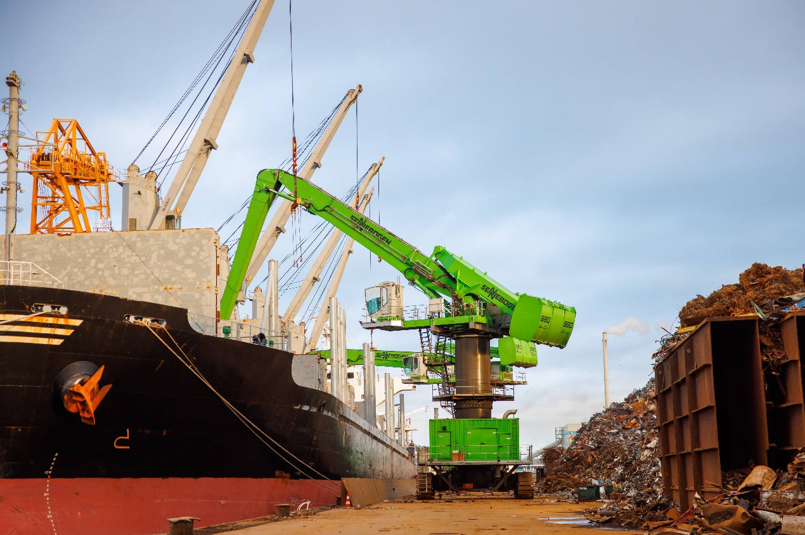

880 EQ in operation at the well-known metal recycling company EMR in the Netherlands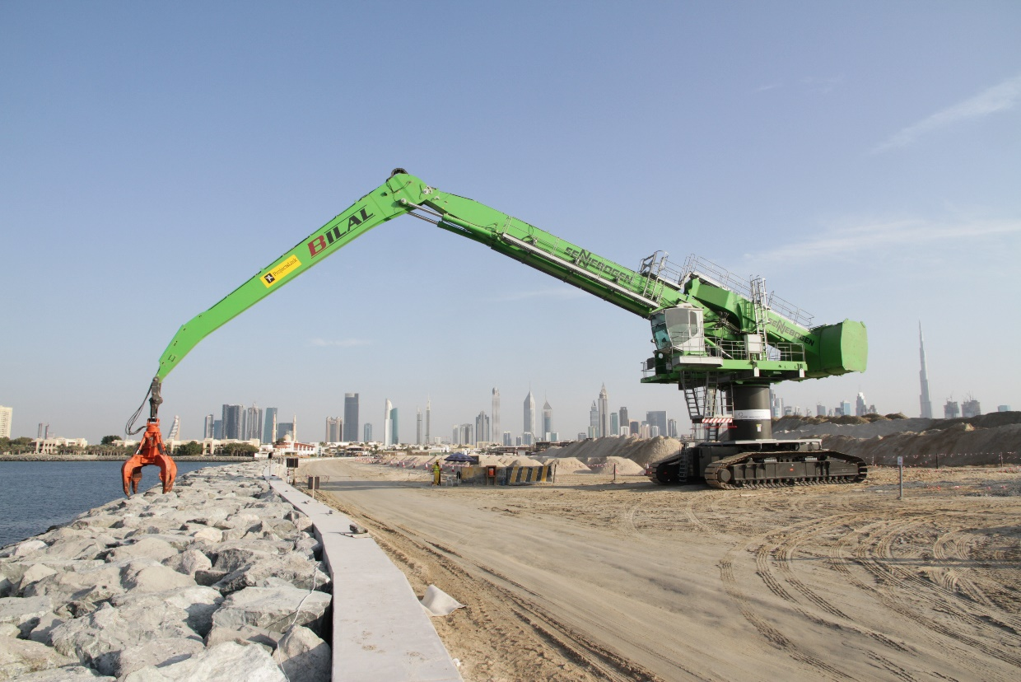
Machine for special applications: coastal fortification in Dubai 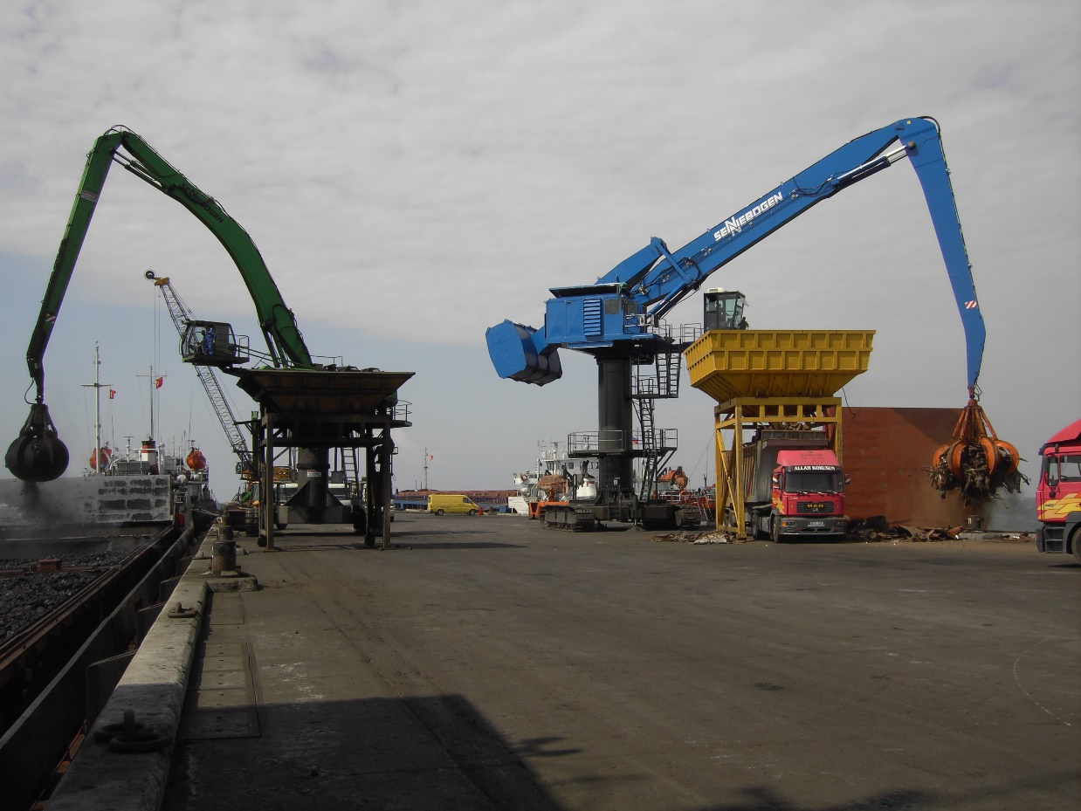
One of the first machines (right) was delivered to DILER Holding in Turkey in 2007

