Bild:
Editor Autor: Jason Ang
Location Ort: Tomakomai
Date Datum: 17.05.2023

Environmentally friendly material handler replaces ship unloader in Japan

The port of Tomakomai handles large quantities of animal feed and raw materials such as aliments from different regions of Japan and the rest of the world. With the commissioning of the SENNEBOGEN 860 E in 2020, Tomakomai Futo Co., Ltd. aims to make material handling more efficient while reducing CO2 emissions for a sustainable society.

Tomakomai Futo Co., Ltd. is a comprehensive logistics company contributing to the development of the food industry in Hokkaido, based on the management philosophy of "contributing to the community and society as a logistics enabler". An enabler refers to an entity that is indispensable to development and problem solving in the regions and for customers, an "unsung hero". The company's services include general warehousing, cold storage, raw material silos and oil terminal operations. In addition, the company operates sites in and outside Hokkaido that form a logistics network and contribute to the development of the food industry in Hokkaido. Raw materials from Japan and overseas are temporarily stored in the yard's 190,000-tonne silos, the fifth largest silo storage facility in Japan, before being resold to feed manufacturers.

Material handler replaces two machines in the port

Tomakomai Futo Co., Ltd. originally used four ship unloaders and one crane to discharge feed raw materials. One of these had an outdated pneumatic system and needed to be replaced. With the environment in mind and the requirement for a port material handler with low fuel consumption, low CO2 emissions and the ability to work quickly and efficiently, the choice fell on the SENNEBOGEN 860 E with its intelligent Green Hybrid System. "We currently use three ship unloaders and the SENNEBOGEN 860 E to discharge the majority of our cargo. Thereby the SENNEBOGEN 860 E replaces one ship unloader and one crane. As the frequency of operations requiring cranes has decreased, we have also been able to save costs," explains Seiji Hayashi, Executive Officer and General Manager of the Feed Silo Division.

Sensitivity of the machine allows safe and precise loading in the cargo hold

"With the SENNEBOGEN 860 E, it is possible to unload the material while looking directly into the cargo hold from the driver's seat. I feel much more confident in my work when I can check the surroundings myself, rather than taking instructions from the signalman," explains the person responsible for the cargo handling system and the operation of the SENNEBOGEN 860 E.
Thanks to its sensitivity and large reach depth, the material in the cargo hold can be placed and gripped particularly precisely. "This is very helpful for safely guiding other machines and personnel in the cargo hold. It saves time and increases safety in the workplace for everyone." The port material handler is equipped with a mobile undercarriage that allows it to move and work independently on the quay. This has also increased the degree of freedom in assigning ships in the port. Currently, the SENNEBOGEN 860 E is operated by three people, with two more being trained. Thanks to the machine's ease of use, new operators can be trained quickly and easily. In this way, the operation can be maintained continuously and the supply of forage to Hokkaido can be kept stable.

Environmentally friendly machine supports CO2 reduction

"By using the SENNEBOGEN 860 E, we have been able to significantly reduce our fuel consumption. In addition, its lower energy consumption also decreases our CO2 emissions, which is a high priority for Tomakomai Futo Co., Ltd. In the beginning, the SENNEBOGEN 860 E was mainly used for unloading, but now we use it for both loading and unloading. We have also increased the variety of loading and unloading methods,” says Seiji Hayashi, Executive Officer and General Manager of the Feed Silo Division.

Captions:
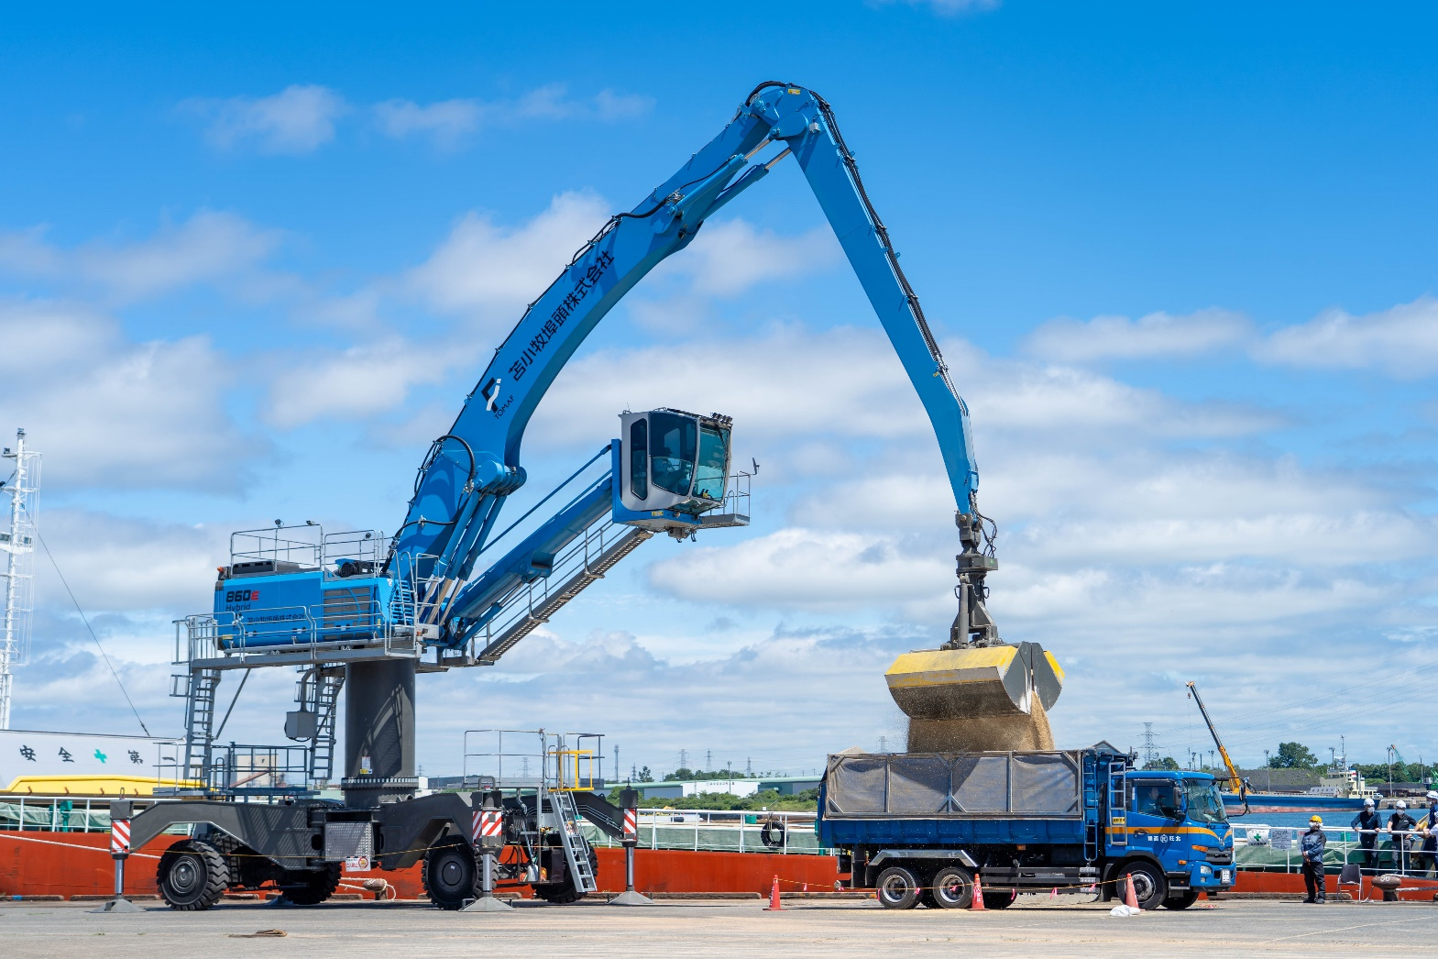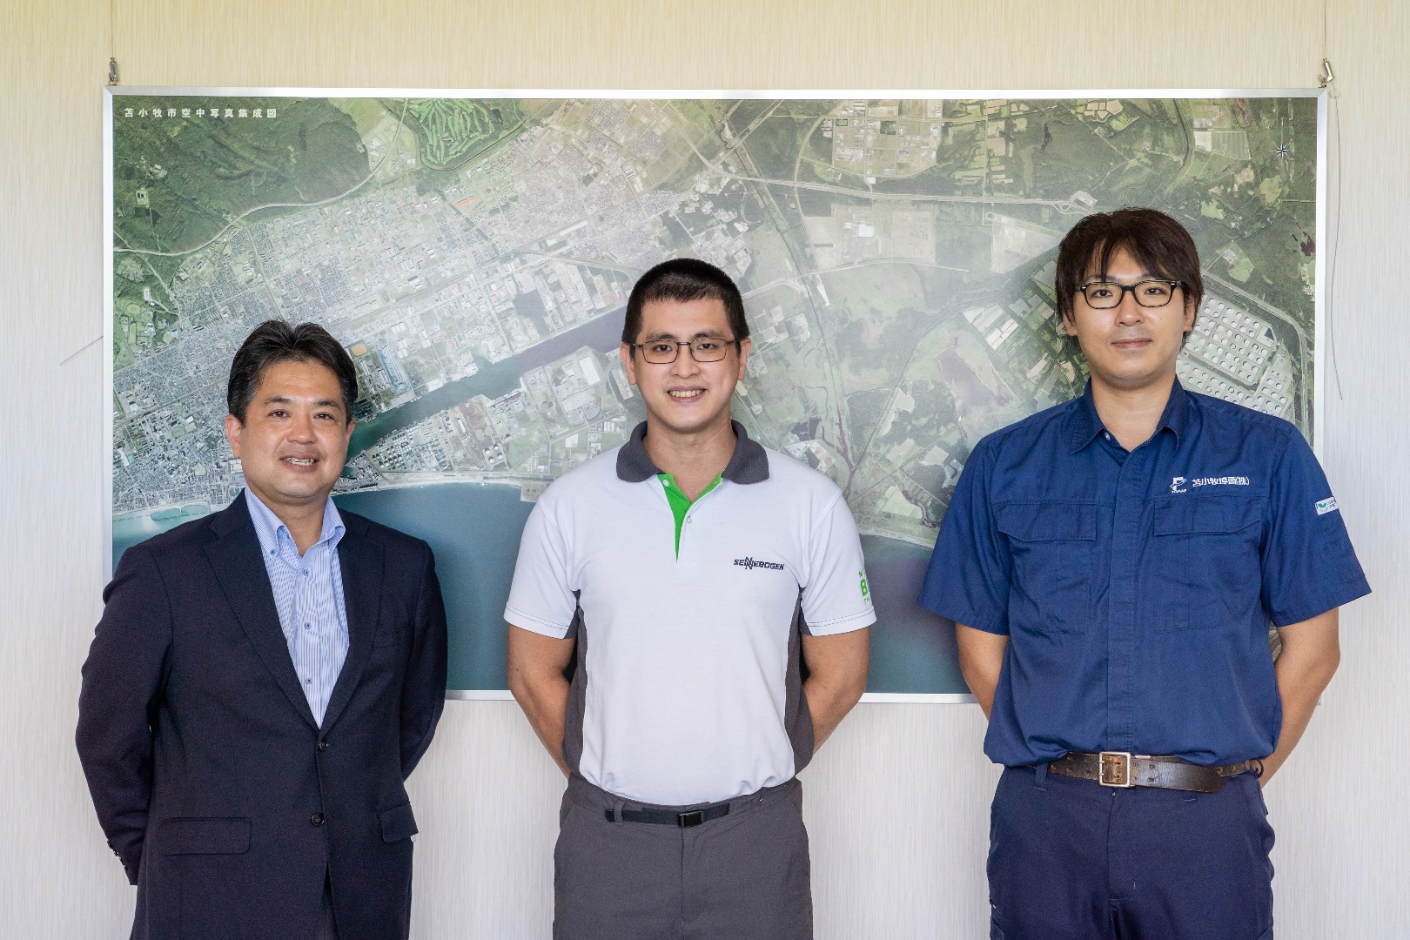
From left to right: Seiji Hayashi (Executive Officer and General Manager of Feed Silo Division, Tomakomai Futo Co., Ltd.), Jason Ang (Marketing Manager SENNEBOGEN Asia Pacific) and operator of the SENNEBOGEN 860 E, Tomakomai Futo Co., Ltd.
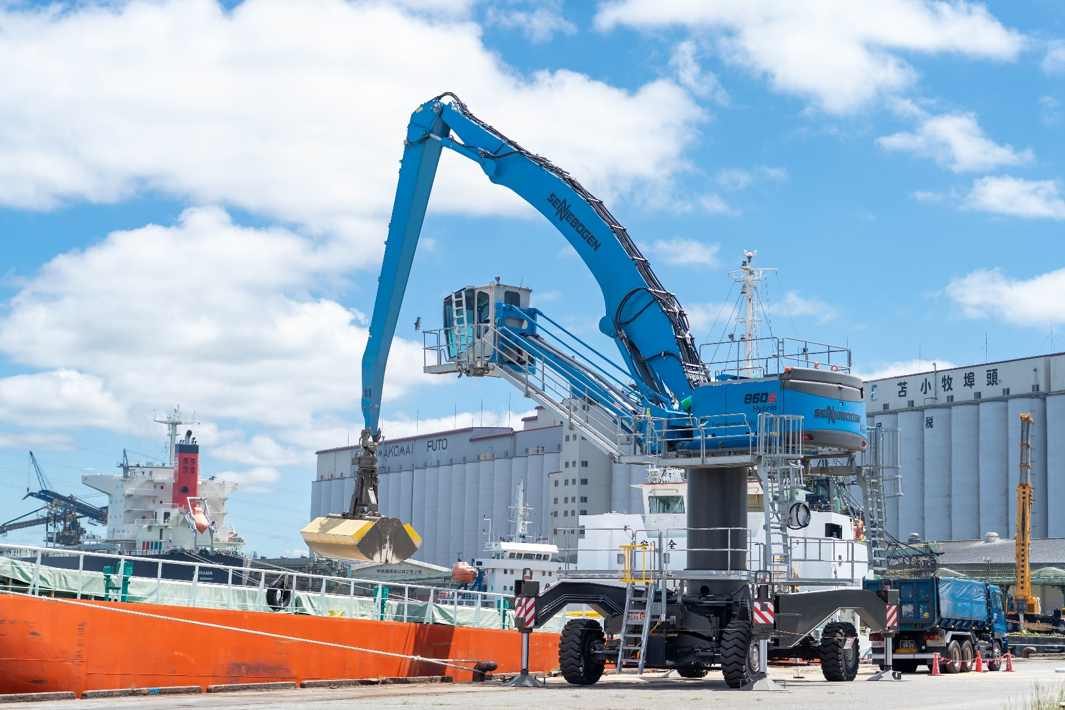

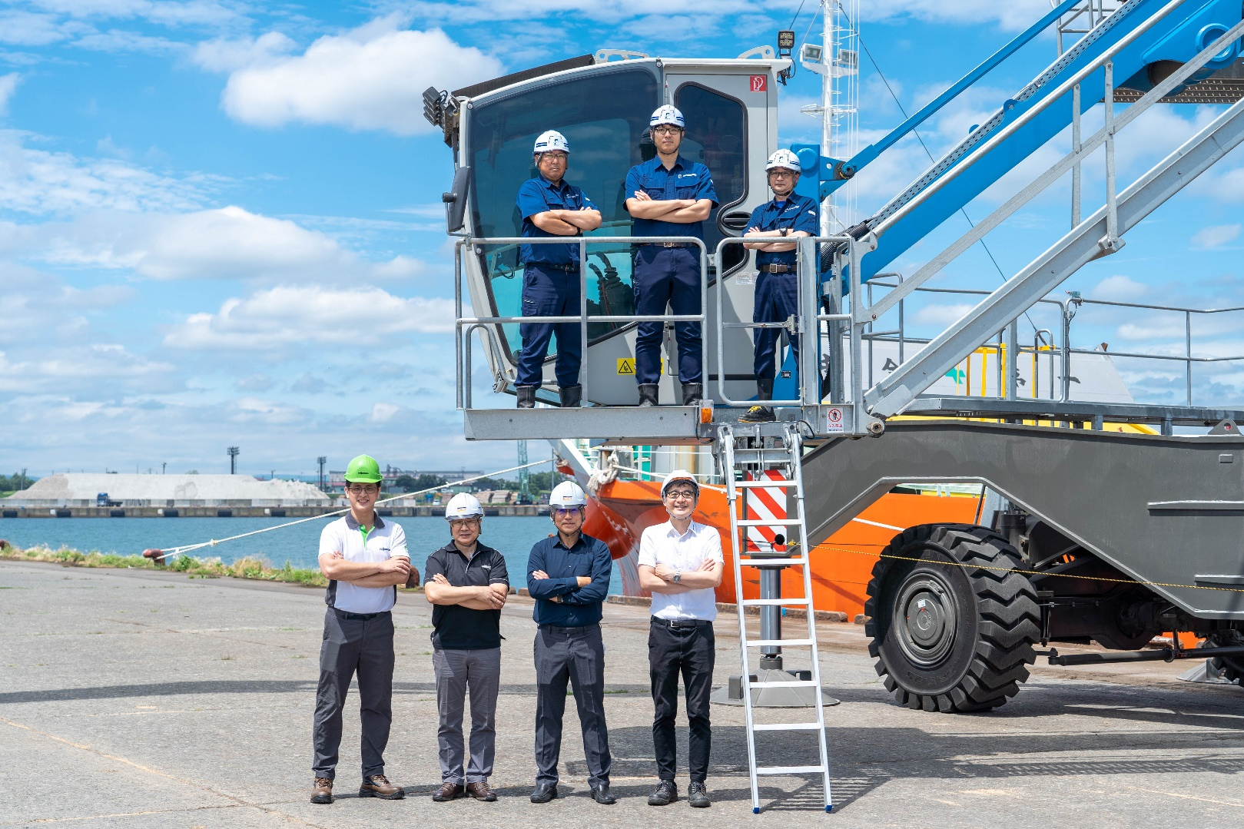
SENNEBOGEN 860 E operator (top row) with Jason Ang, Marketing Manager, SENNEBOGEN Asia Pacific (bottom row, first from left) and Iwahana, Branch Manager, Hakkaido Sales Office, Sun Earth Co., Ltd (bottom row, second from right)

