Bild:
Location Ort: Lyon, Frankreich
Editor Autor: Epvre Delquie, Jennifer Bortmes
Date Datum: 20.12.2022

Circular economy in the construction industry: electric material handlers 840 E and 855 E support efficient port handling

The principles of the circular economy gain increasing importance in the construction industry and represent an important concept for companies' sustainability efforts. In this context, resources should be returned to the cycle and reused in an environmentally friendly manner. The PRADIER Group, a French family-owned company located between the Rhône and Vaucluse departments, puts this principle into practice every day with the help of the SENNEBOGEN electric port material handlers 840 E and 855 E.

The PRADIER Group is a manufacturer of materials for the construction and housing industry based in the Rhône valley in France. The family-owned company produces aggregates, precast concrete elements and blocks as well as mixed asphalt products and recycles inert materials obtained from demolition work. To increase the environmental friendliness of these processes, the company's management spent years developing a logistics system in which the river acts as the center of all business operations. The result is a circular economy principle that has been in place for several months now, according to which the company keeps various resources and goods circulating between the two sites along the Rhône by ship. The two electrically driven material handlers 840 E and 855 E serve as the hub and focal point of the processes, ensuring efficient and energy-saving material handling.

Circular economy along the Rhône River: from Mondragon to Lyon and back

Starting in Mondragon, located in the department of Vaucluse, the company's barges transport materials from the local quarries upriver towards Lyon. Here, the raw materials arriving at the port of Edouard Herriot are unloaded by the 840 E electric material handler and in this course supplied to various construction sites along the Rhône, the concrete plant and the precast plant of PRADIER in Lyon. Downstream, inert materials obtained from deconstruction and demolition operations from various contractors are transported back to Mondragon. After arriving at the site, the 855 E unloads the barges and the material is processed at the recycling plant. The recycled materials are then shipped back to Lyon.

Machines support the optimal implementation of the project through high performance and energy efficiency

In order to find the optimal machines for the implementation of the circular economy, the Chairman of the Group Roland Pradier and Director of the Strategy Committee Maxime Cendres relied on the strong cooperation of SENNEBOGEN with the local service and sales partner SYGMAT, which delivered the material handlers to the Group. The machines had to fulfill the high requirements of the logistics scheme to be implemented and ensure a fast and efficient flow of materials between the sites in Lyon and Mondragon. In addition to a high working radius, in order to be able to unload the ships safely and quickly from the jetties built above the shore, the machines had to work in a particularly energy-saving and environmentally friendly manner at the same time. The choice quickly fell on the two SENNEBOGEN electric material handlers 840 E and 855 E that meet the company's high standards. Both machines are installed stationary on the docks and are supplied directly from the facility's power grid. At the same time, the machines operate noise- and emission-free and ensure a pleasant working environment despite the demanding continuous operation. Equipped with the intelligent Green Hybrid energy recovery system, the additional hydraulic cylinder on the 855 E allows stored energy to be used in every lifting process, saving up to 30% in operating costs. During lowering of the boom, the energy is stored in compressed gas cylinders placed in the rear of the machine. The energy is available again almost without any loss for the next lifting process. The system is especially convincing with the existing height difference to the river on the shore, which requires a certain reach depth and performance of the machine - an optimal opportunity to benefit from the sophisticated technology.

Maxime Cendres is satisfied with their implemented principle of the circular economy: "Our ships now run regularly between Lyon and our sites in the Vaucluse. With their excellent level of serviceability and efficiency, the SENNEBOGEN machines fully contribute to overcome our environmental and logistical challenges. Ultimately, we can avoid daily truck traffic in the Rhône Valley and thus save significant amounts of CO₂ emissions."
Captions:

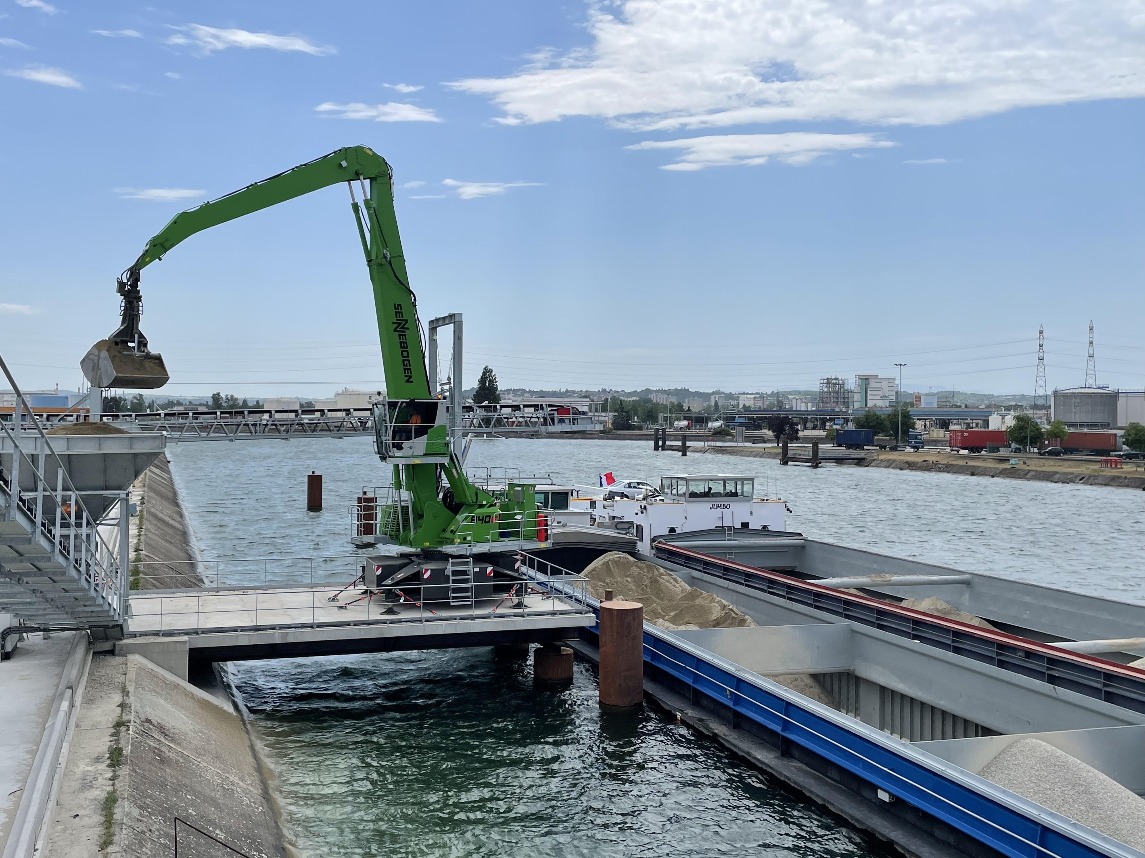
The 840 E unloads bulk material arriving at the Port of Edouard Herriot in Lyon and ensures efficient and fast supply to PRADIER's end customers and plants.
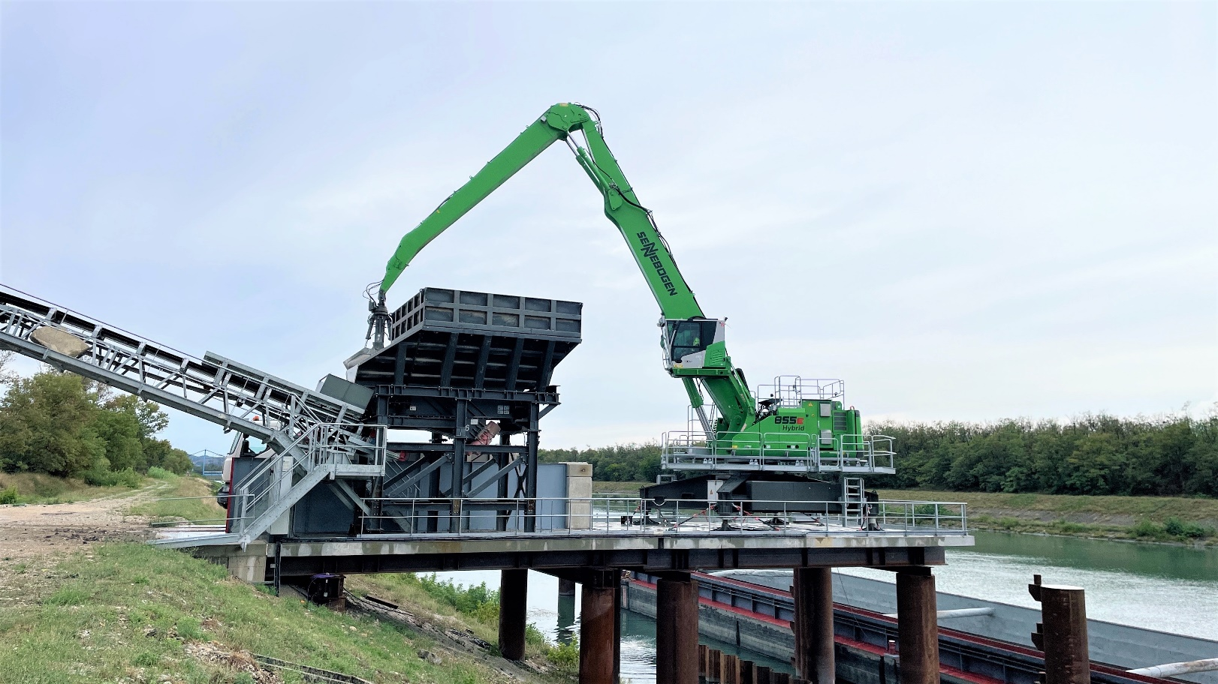
In Mondragon, the 855 E unloads the material for further processing in the recycling plant.

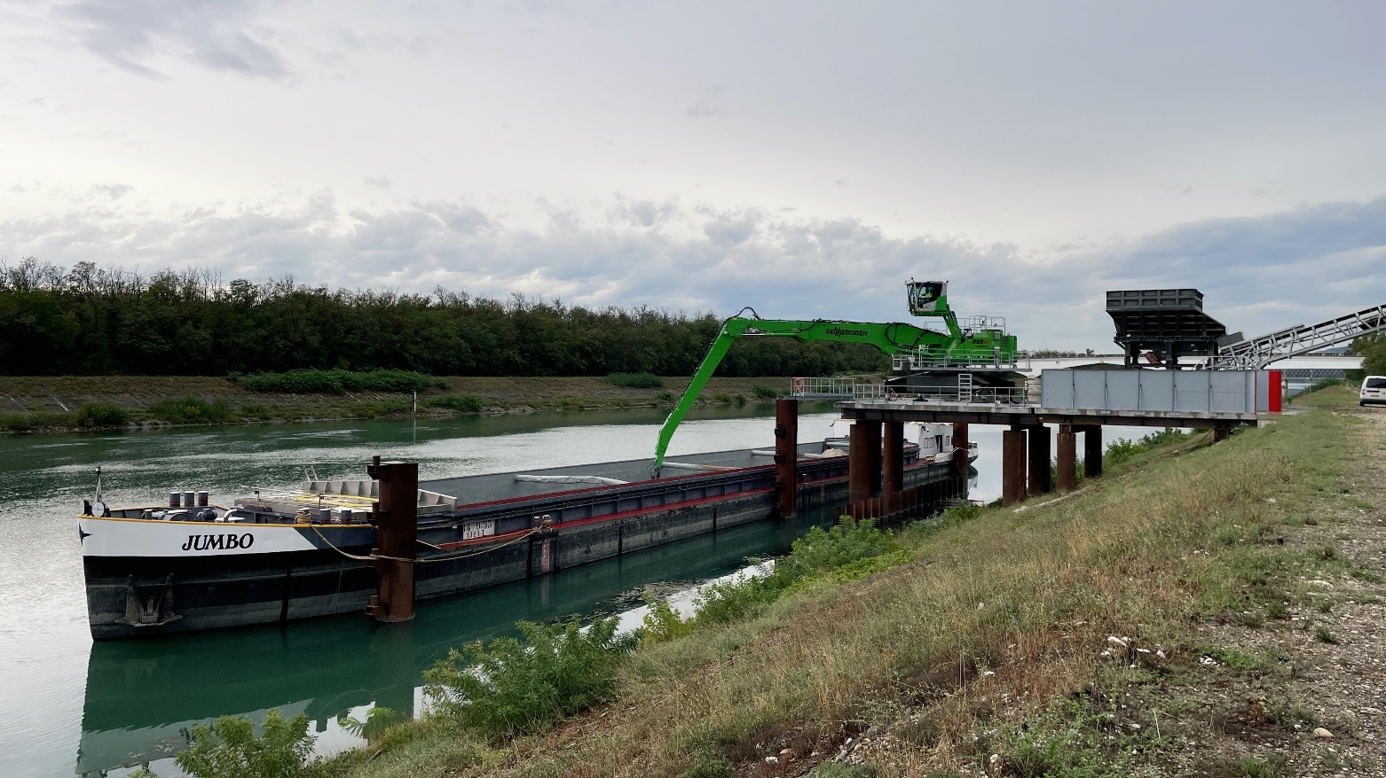
The 855 E easily unloads the hull and feeds containers as well as the elevated hopper that pours onto the recycling plant's conveyor belts. Thanks to the proven Green Hybrid energy recovery system, stored energy can be used efficiently during each lifting process.

