Bild:
Editor Autor: Andrea Heinrich-Jobst
Location Ort: Straubing, Deutschland
Date Datum: 06.06.2023

Immediate night-time use for the SENNEBOGEN 830

A horror scenario for every night shift: a machine breaks down and the whole operation comes to a standstill.
This is what happened at the port of Erlangen. The cable crane there broke down in the middle of the night due to a defect during the unloading of a ship - and on the weekend, too.
Since a standstill during the unloading of a ship is associated with many costs, a quick solution was needed.

Rapid availability of rental and used machines

A quick call to SENNEBOGEN and a rescue is already in sight. At two o'clock in the morning, an 830 E material handler from the SENNEBOGEN sales company was made ready for dispatch and brought to the new site in Erlangen.
The 830 E was equipped with a clamshell bucket and was able to take over the work of the failed machine at the beginning of the next shift. Thus, the laytime of the ship could be kept as short as possible.
The SENNEBOGEN 830 E is a multifunctional machine that is available as a tracked or mobile machine and offers many advantages.
The wide support square offers high stability. The massive cylinders that are installed also offer high payloads with maximum reach.

The ability to react quickly is one of the strengths of the SENNEBOGEN sales company, which has many machines immediately available in its portfolio with its large rental and used machine park.
With the selection of available handling or demolition machines, telescopic cranes, telescopic loaders or cable excavators, there is the right machine for many areas of application.
Used and rental machines have a lower investment cost and are available in a very short time.

The port of Erlangen is connected to the Main-Danube Canal, an important water connection in southern Germany. Mainly bulk goods such as gravel and coal, ores and scrap are handled here.
Bilder:
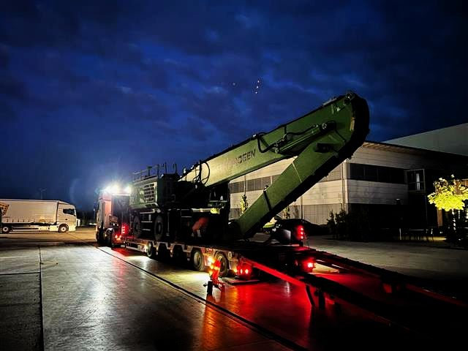
Loading of the SENNEBOGEN replacement machine with destination port of Erlangen.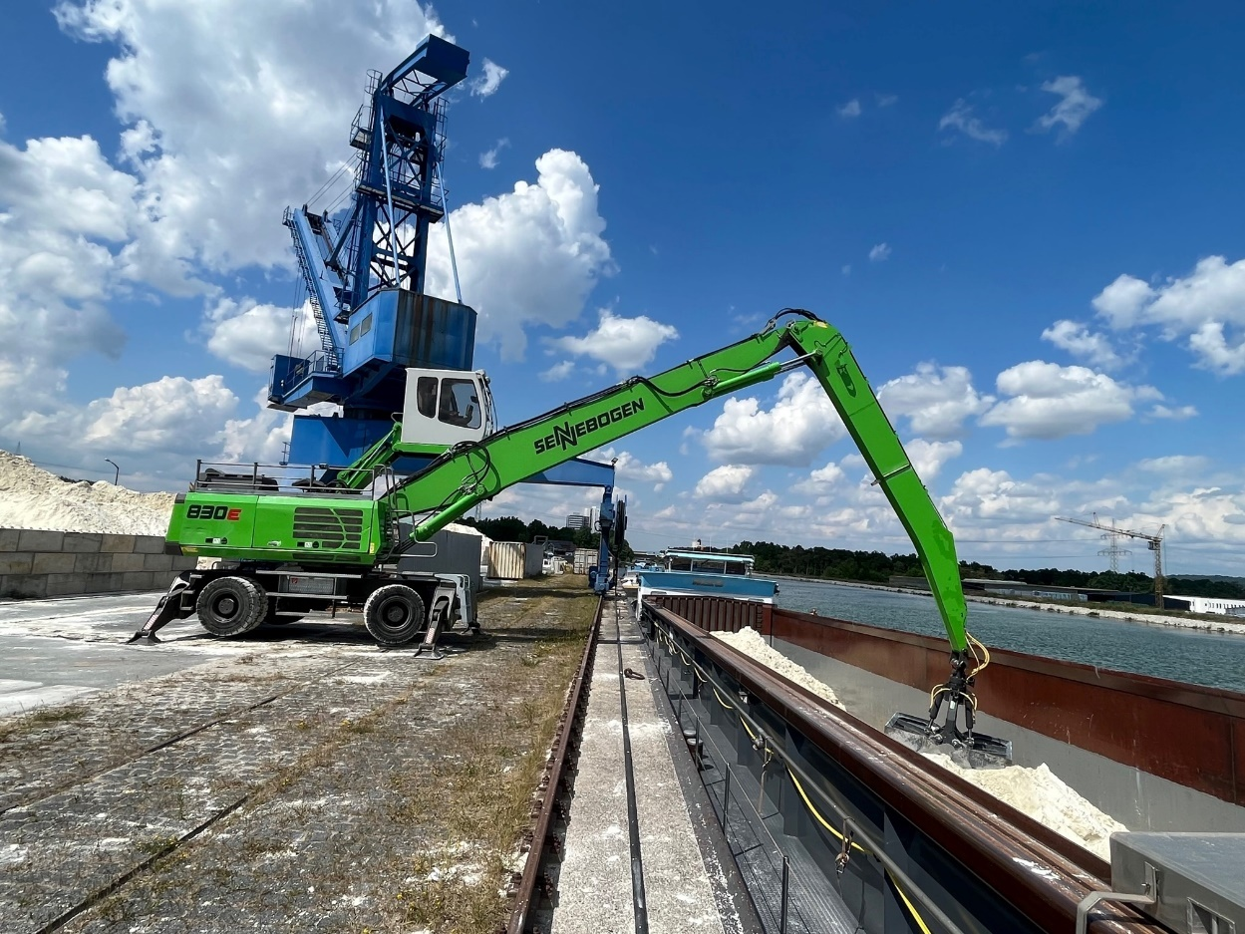
The SENNEBOGEN 830 E at its work site in the port of Erlangen. In the background, the failed harbour crane.
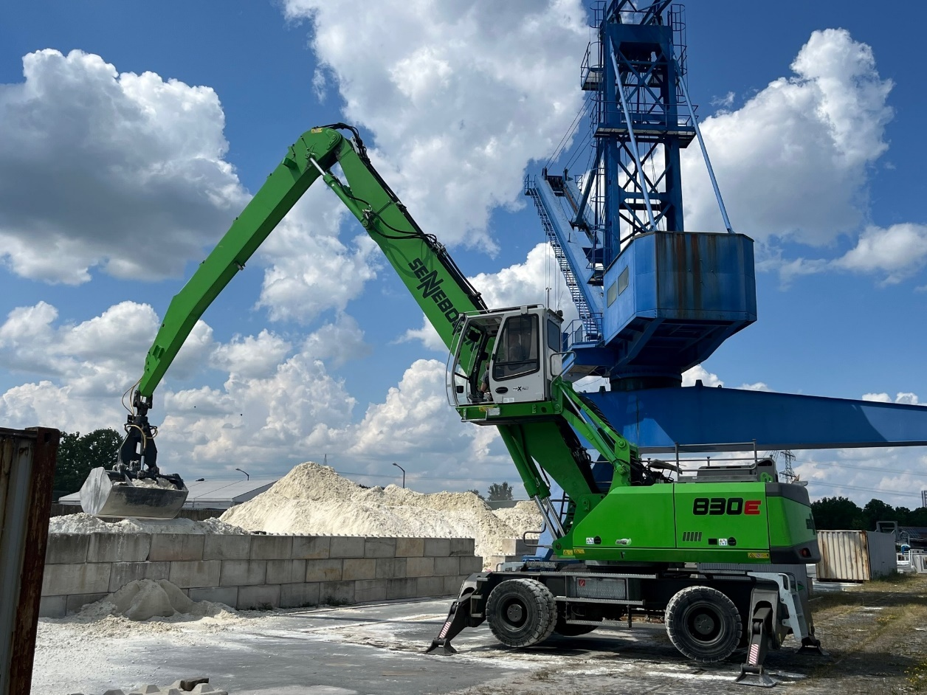
The elevating cab, which can be tilted by 30°, ensures optimum visibility.

